Chapter 23

The Economics of Resources

chapter Objectives
Check off these skills when you feel that you have mastered them.
 Track the changing rate of a population growing geometrically at a fixed rate.
 Understand the meaning of a population’s carrying capacity.
 Understand the difference between the static reserve of a nonrenewable resource and its exponential reserve, and calculate the exponential reserve from the formula.
 Understand the meaning of a reproduction curve, and explain why a sustainable yield policy is needed for a harvestable resource.
 Estimate the maximum sustainable yield for a harvestable resource from its reproduction curve.
 Describe chaos and the butterfly effect.
 Use the logistic population model to calculate the fraction of a population after a period of time.
 Explain the relationship of chaos to the logistic population model.
Guided Reading
Introduction
As individuals and as a society, we are faced with the need to find a balance between using resources and conserving them. Some of these resources replenish themselves but some are nonrenewable. This chapter explores models for the decay or depletion of resources.
Section 23.1 Growth Models for Biological Populations

 Key idea
If we use a geometric growth model to describe and predict human (or other species) populations, the effective rate of growth is the difference between population increase caused by births and decrease caused by deaths. This difference is called the rate of natural increase.
 Example A
To predict the population of the US in the year 2010, we can use the following census information from 1990.
P = 255 million, r = 0.7% = 0.007.
With annual compounding, we can predict that the population 20 years later, in 2010 would be the following.
At this rate, the population would double in about 100 years.

 Key idea
Small changes in the birth or death rate will affect the rate of natural increase, and this changes our prediction significantly.
 Example B
Consider three countries A, B, and C, each of whose population in 1995 was 120 million. Country A is growing at a rate of 0.5%, country B at 1%, and country C at 2%.
a) What would you predict the population of each country to be in 2010?
b) What would you predict for 2025?
Solution
a) The year 2010 is 15 years later than 1995, so the following formula for r = 0.005, 0.01, and 0.02 for countries A, B, and C, respectively, as follows.
b) The year 2025 is 30 years later than 1995 so the following formula for r = 0.005, 0.01, and 0.02 for countries A, B, and C, respectively, as follows.
The table of population values for the three countries looks like the following.
Country 1995 2010 2025
A 120 million 129 million 139 million
B 120 million 139 million 162 million
C 120 million 162 million 217 million

 Key idea
A population cannot keep growing without limit. The resources available to the population limit the size of that population. A population limit in a particular environment is called the carrying capacity.

 Key idea
The closer a population gets to its carrying capacity, the more slowly the population will grow. The logistics model for population growth takes carrying capacity into account by reducing the annual increase of by a factor of how close the population size P is to the carrying capacity M. It is given by the following.
 Example C
A salmon fishery has a carrying capacity of 100,000 fish. The natural rate of increase for the population is 3% per year. What is the growth rate of the population if the population is at 52,000 fish?
Solution
1.44% per year.
Section 23.2 How Long Can a Nonrenewable Resource Last?

 Key idea
A nonrenewable resource, such as a fossil fuel or a mineral ore deposit, is a natural resource that does not replenish itself.

 Key idea
A growing population is likely to use a nonrenewable resource at an increasing rate. The regular and increasing withdrawals from the resource pool are analogous to regular deposits in a sinking fund with interest, and the same formula applies to calculate the accumulated amount of the resource that has been used, and is thus gone forever. The static reserve is the time the resource will last with constant use; the exponential reserve is the time it will last with use increasing geometrically with the population.

 Key idea
The formula for the exponential reserve of a resource with supply S, initial annual use U, and usage growth rate r is as follows.
Here, ln is the natural logarithm function, available on your calculator.
 Example D
Imagine that a certain iron ore deposit will last for 200 years at the current usage rate. How long would that same deposit last if usage increases at the rate of 4% each year?
Solution
The static reserve, is 200 years, so we can plug that value into the formula to solve for n, using the assumed 4% = .04 for r. We obtain
 Question 1
In 2005, the Acme corporation had non-renewable resources of 3479 million pounds of materials. The annual consumption was 98 million pounds. The projected company consumption will increase 2.3% per year, through 2020.
a) What is the static reserve in 2005?
b) What is the exponential reserve in 2005?
Answer
a) 35.5 years
b) 26.25 years
Section 23.3 Sustaining Renewable Resources

 Key idea
A renewable natural resource replenishes itself at a natural rate and can often be harvested at moderate levels for economic or social purposes without damaging its regrowth. Since heavy harvesting may overwhelm and destroy the population, economics and conservation are crucial ingredients in formulating proper harvesting policies.

 Key idea
We keep track of the population (measured in biomass) from one year to the next using a reproduction curve. Under normal conditions, natural reproduction will produce a geometrically growing population, but too high a population level is likely to lead to overcrowding and to strain the available resources, thus resulting in a population decrease. This model leads to a reproduction curve looking something like this:
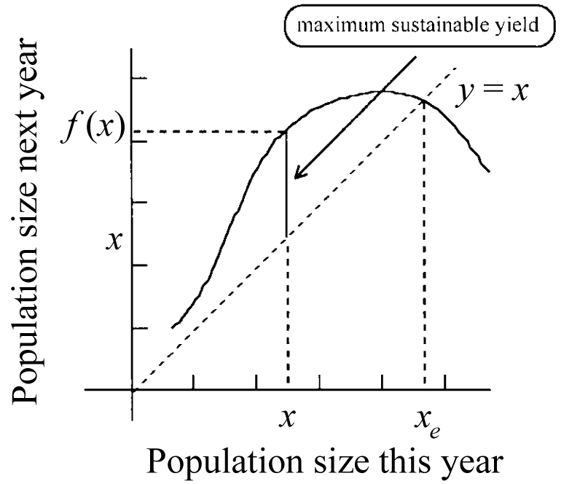

 Key idea
The dotted 45° diagonal line is the set of points where the population would be unchanged from year to year, and any point where it intersects the reproduction curve is an equilibrium population size.

 Key idea
The marked population value x is the level which produces maximum natural increase or yield in a year, and the difference between x and (the population level a year later) is the maximum sustainable yield (or harvest) This amount is the maximum that may be harvested each year without damaging the population, and represents a good choice for a sustained-yield harvesting policy.
Section 23.4 The Economics of Harvesting Resources

 Key idea
If our main concern is profit, we must take into account the economic value of our harvest and the cost of harvesting. If we also include in our model economy of scale (denser populations are easier to harvest), then the sustainable harvest which yields a maximum profit may be smaller than the maximum sustainable yield.

 Key idea
Finally, if we also take into account the economic value of capital and consider profit as our only motivation, it may be most profitable to harvest the entire population, effectively killing it, and invest the profits elsewhere. The history of the lumbering and fishing industries demonstrates this unfortunate fact.

Section 23.5 Dynamical Systems and Chaos

 Key idea
In some populations, the state of the population depends only on its state at previous times. This kind of system is called a dynamical system. For example, a population’s size in a given year may depend entirely upon its size in the previous year.

 Key idea
Behavior that is determined by preceding events but is unpredictable in the long run is called chaos.

 Key idea
In some systems a small change in the initial conditions can make a huge difference later on. This is the butterfly effect.

 Key idea
The logistic population model can illustrate chaos in biological population. Consider the current year’s population as a fraction x of the carrying capacity, and next year’s population as a fraction The amount by which the population is multiplied each year is where r is the population’s annual growth rate. Then the logistic model can be written as
 Example F
A population grows according to a logistic growth model, with population parameter and for the first year. What is the next population fraction?
Solution

 Key idea
The logistic model illustrates chaotic behavior when the population parameter is equal to 4. In this case, for any starting population fraction, the population fraction changes year after year in no predictable pattern.
 Question 2
Let the sum of the cubes of the digits of n. Start with 371 and apply f repeatedly. Start with 234 and apply f repeatedly. Start with 313 and apply f repeatedly. Are the three behaviors the same?
Answer
no
Homework Help
Exercises 1 – 10
Carefully read Section 23.1 before responding to these exercises.
Exercises 11 – 20
Carefully read Section 23.2 before responding to these exercises.
Exercises 21 – 38
Carefully read Sections 23.3 and 23.4 before responding to these exercises.
Exercises 39 – 45
Carefully read Section 23.5 before responding to these exercises.

Do You Know the Terms?

Cut out the following 25 flashcards to test yourself on Review Vocabulary. You can also find these flashcards at http://www.whfreeman.com/fapp7e.

Chapter 23  The Economics of Resources  Biomass | Chapter 23  The Economics of Resources  Butterfly effect
Chapter 23  The Economics of Resources  Carrying capacity | Chapter 23  The Economics of Resources  Chaos
Chapter 23  The Economics of Resources  Cobweb design | Chapter 23  The Economics of Resources  Compound interest formula
Chapter 23  The Economics of Resources  Deterministic | Chapter 23  The Economics of Resources  Dynamical system

A small change in initial conditions of a system can make an enormous difference later on. | A measure of a population in common units of equal value.
Complex but deterministic behavior that is unpredictable in the long run. | The maximum population size that can be supported by the available resources.
Formula for the amount in an account that pays compound interest periodically. For an initial principal P and effective rate r per year, the amount after n years is | A kind of graphical portrayal of the evolution of a dynamical system, such as a population.
A system whose state depends only on its states at previous times. | A system is this if its future behavior is completely determined by its present state, past history, and known laws.

Chapter 23  The Economics of Resources  Economy of scale | Chapter 23  The Economics of Resources  Equilibrium population size
Chapter 23  The Economics of Resources  Exponential reserve | Chapter 23  The Economics of Resources  Iterated function system (IFS)
Chapter 23  The Economics of Resources  Logistic model | Chapter 23  The Economics of Resources  Maximum sustainable yield
Chapter 23  The Economics of Resources  Natural increase | Chapter 23  The Economics of Resources  Nonrenewable resource

A population size that does not change from year to year. | Costs per unit decrease with increasing volume.
A sequence of elements (number or geometric shapes) in which the next element is produced from the previous one according to a function (rule). | How long a fixed amount of a resource will last at a constantly increasing rate of use. A supply S, as an initial rate of use U that is increasing by a proportion r each year, will last years.
The largest harvest that can be repeated indefinitely. | A particular population model that begins with near-geometric growth but then tapers off toward a limiting population (the carrying capacity).
A resource that does not tend to replenish itself. | The growth of a population that is not harvested.

Chapter 23  The Economics of Resources  Population structure | Chapter 23  The Economics of Resources  Rate of natural increase
Chapter 23  The Economics of Resources  Renewable natural resource | Chapter 23  The Economics of Resources  Reproduction curve
Chapter 23  The Economics of Resources  Savings formula | Chapter 23  The Economics of Resources  Static reserve
Chapter 23  The Economics of Resources  Sustainable yield | Chapter 23  The Economics of Resources  Sustained-yield harvesting policy

Birth rate minus death rate; the annual rate of population growth without taking into account net migration. | The division of a population into subgroups.
A curve that shows population size in the next year plotted against population size in the current year. | A resource that tends to replenish itself; examples are fish, forests, wildlife.
How long a fixed amount of a resource will last at a constant rate of use; a supply S used at an annual rate U will last S/U years. | Formula for the amount in an account to which a regular deposit is made (equal for each period) and interest is credited, both at the end of each period. For a regular deposit of d and an interest rate i per compounding period, the amount A accumulated is
A harvesting policy that can be continued indefinitely while maintaining the same yield. | A harvest that can be continued at the same level indefinitely.

Chapter 23

The Economics of Resources

Yield

The amount harvested at each harvest.

Practice Quiz
1. The Italian population was 47,105 in 1950. This population was said to be increasing at an average growth rate of 0.6% per year. In 1960, the Italian census reported a population of 50,198. This number represents ____________________________.
a. substantially more than the expected population growth for the 10-year period.
b. substantially less than the expected population growth for the 10-year period.
c. approximately the expected population growth for the 10-year period.
2. Which of the following is true?
a. An equilibrium population size changes from year to year.
b. In the logistic model, if the population exceeds the carrying capacity, the population decreases.
c. The static reserve is how long a supply will last at an initial rate of use that is increasing by a proportion each year.
3. Production of oil exploration peaked in 1962. The remaining reserves are expected to last another 44 years at the current rate of use. Approximately how long would the supply last if the rate of use increased 3% per year?
a. 44 years
b. 9 years
c. 28 years
4. Imagine that a certain iron ore deposit will last for 400 years at the current usage rate. How long would that same deposit last if usage increases at the rate of 5% each year?
a. 53 years
b. 62 years
c. It never will be deleted.
5. For the following model, if the starting population fraction is 0.1, what is the next population fraction?
a. 0.76
b. 0.01
c. 0.41
6. Given the reproduction curve below
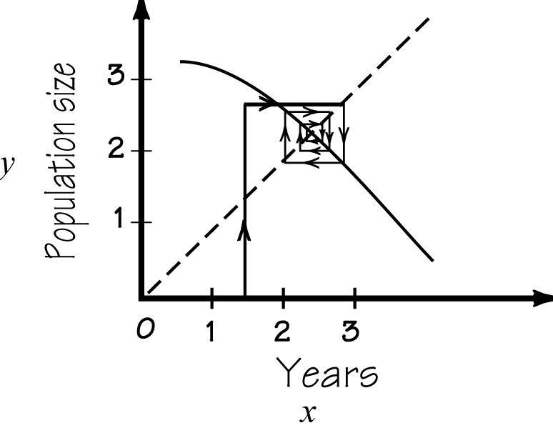
where x represents years and y the population in millions, the dynamics, over time, for an initial starting population of approximately 1.3 million would indicate ________________________.
a. after an initial adjustment, the population goes to the equilibrium population and stays there.
b. after an initial adjustment, the population cycles between values over and under the equilibrium population.
c. the population spirals in toward the equilibrium population.
7. An optimal harvesting policy for renewable resources depends on ____________.
a. price
b. cost
c. both a and b
8. You notice that the coworkers in your office complex have not been looking too happy of late. You decide to go into work the next day and smile at everyone you see. By the end of the work day you notice that this has created a rippling effect and most of your coworkers are smiling. This phenomenon is an example of ________________.
a. chaos
b. the butterfly effect
c. a dynamical system
9. Maximum Sustainable Yield (MSY) has become a common practice in fisheries management. MSY is dependent on _________________.
I. growth rates and over-fishing.
II. birth rates and mortality rates.
a. I only
b. II only
c. both I and II
10. Which of the following statements is true?
I. Chaotic behavior is not predictable in the short term.
II. Chaotic behavior is predictable in the long term.
a. I only
b. II only
c. neither I nor II
Word Search
Refer to pages 885 – 886 of your text to obtain the Review Vocabulary. There are 25 hidden vocabulary words/expressions in the word search below. This represents all 25 words/expressions in the Review Vocabulary. It should be noted that spaces and hyphens, are removed as well as apostrophes. Also, the abbreviations do not appear in the word search. The backside of this page has additional space for the words/expressions that you find.
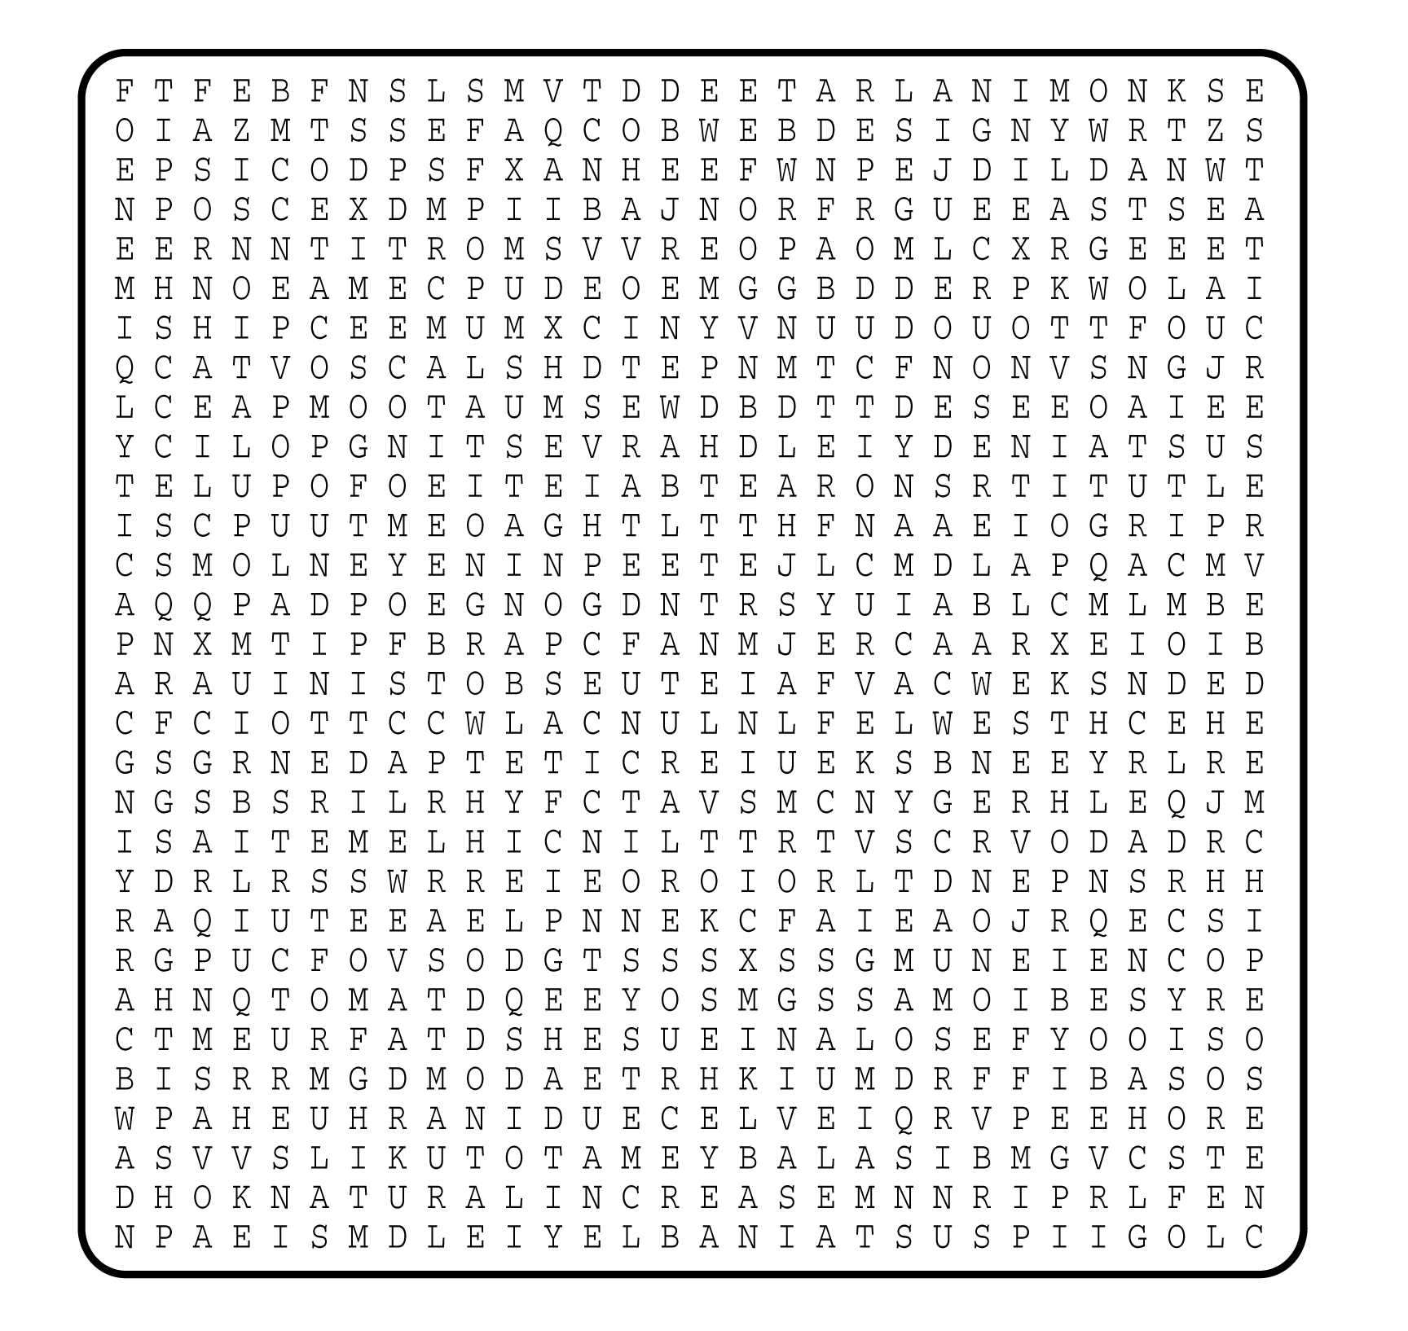

1. __________________________
2. __________________________
3. __________________________
4. __________________________
5. __________________________
6. __________________________
7. __________________________
8. __________________________
9. __________________________
10. __________________________
11. __________________________
12. __________________________
13. __________________________
14. __________________________
15. __________________________
16. __________________________
17. __________________________
18. __________________________
19. __________________________
20. __________________________
21. __________________________
22. __________________________
23. __________________________
24. __________________________
25. __________________________

