Chapter 22

Borrowing Models

chapter Objectives
Check off these skills when you feel that you have mastered them.
 Know the basic loan terms principal and interest.
c Be able to solve the simple interest formula to find the amount of a loan over time.
c Know the difference between a discounted loan and an add-on loan.
c Understand the compound interest formula and use it to find the amount of a loan over time.
c Use loan terminology to explain the difference between the nominal rate, effective rate, effective annual rate (EAR), and the annual percentage rate (APR).
c Use the amortization formula to determine the payments required to fully amortize a loan.
c Find the APR and EAR for a loan.
c Understand how an annuity functions and be able to use the annuity formula.
Guided Reading
Introduction
Financial institutions would not be able to offer interest-bearing accounts such as savings accounts unless they had a way to make money on them. To do this, financial institutions use the money from savings accounts to make loans. The loans provide interest for the loaning institution and also enable individuals to make major purchases such as buying a house or a car. Using a credit card is also a way of taking out a loan. This chapter looks at some of the common types of loans.
Section 22.1 Simple Interest

 Key idea
The initial amount borrowed for a loan is the principal. Interest is the money charged on the loan, based on the amount of the principal and the type of interest charged.

 Key idea
Simple interest uses a fixed amount of interest, which is added to the account for each period of the loan. The amount of interest owed after t years for a loan with principal P and annual rate of interest r is given by The total amount A of the loan after this time is

 Example A
A bank offers a $2500 loan and charges 6% simple interest. How much interest will be charged after four years? What is the amount of the loan after four years?
Solution
Because P = $2500, r = 0.06, and t = 4 years, we have The amount of the loan after 4 years is

 Key idea
An add-on loan is borrowed at an amount P that is to be repaid with n payments in t years. The interest is simple interest at an annual rate of r. Since the total amount of the loan is
each payment, d, will be
 Example B
A 7% add-on loan is to be repaid in monthly installments over 10 years. The total amount borrowed was $3000. How much is the monthly payment?
Solution
This loan will have 120 payments, because it is paid 12 times per year for 10 years. The amount of the loan will be Dividing this by the 120 payments, we have a monthly payment of
 Question 1
A 9% add-on loan is to be repaid in monthly installments over 14 years. The total amount borrowed was $4500. How much is the monthly payment?
Answer
$60.54

 Key idea
A discounted loan is borrowed at an amount P that is to be repaid in t years. The interest is simple interest at an annual rate of r, just as with an add-on loan. However, the interest is subtracted from the amount given to the borrower at the time the loan is made. So the borrower only gets but still needs to pay back the principal P.
 Example C
A 4% discounted loan is to be repaid in monthly installments over 10 years. The total amount borrowed was $3000.
a) How much is the monthly payment?
b) How much money does the borrower actually get at the beginning of the loan?
Solution
a) The total amount to be paid over 10 years is P = $3000. Because it is being paid 12 times per year, the monthly payment is
b) The amount the borrower actually gets at the beginning of the loan is the following.
 Question 2
A 2.5% discounted loan is to be repaid in monthly installments over 5 years. The total amount borrowed was $6000.
a) How much is the monthly payment?
b) How much money does the borrower actually get at the beginning of the loan?
Answer
a) $100
b) $5250
 Example D
How much would the discount-loan borrower in Example C need to borrow to get $3000 at the start of the loan?
Solution
Call the loan amount x. The borrower will receive We want this to be equal to $3000, so solve to get
Section 22.2 Compound Interest

 Key idea
When interest is compounded, the interest that is charged is added to the principal. The next interest calculation is based on the new amount, so the interest from the previous period is now earning interest as well.
 Key idea
If a loan has a principal P with an interest rate of i per compounding period, then the amount owed on the loan after n compounding periods is This is assuming no repayments.
 Example E
Max borrows $500 at 3% interest per month, compounded monthly. If he pays the loan back in two years, how much will he owe?
Solution
Because the interest is compounded monthly for two years, So the amount owed is

 Key idea
The nominal rate for a loan is the stated interest rate for a particular length of time. The nominal rate does not take compounding into account.

 Key idea
The effective rate for a loan does reflect compounding. The effective rate is the actual percentage that the loan amount increases over a length of time.

 Key idea
When the effective rate is given as a rate per year, it is called the effective annual rate (EAR).

 Key idea
The nominal rate for a length of time during which no compounding occurs is denoted as i. The annual percentage rate (APR) is given by the rate of interest per compounding period, i, times the number of compounding periods per year, n. Thus, APR
 Example F
A credit card bill shows a balance due of $750 with a minimum payment of $15 and a monthly interest rate of 1.62%. What is the APR?
Solution
Because the monthly interest rate is i = 0.0162 and the account is compounded monthly, the APR is The balance due and minimum payment information is not needed to solve this.
Section 22.3 Conventional Loans

 Key idea
When the regular amounts d are payments on a loan, they are said to amortize the loan. The amortization formula equates the accumulation in the savings formula with the accumulation in a savings account given by the compound interest formula. This is a model for saving money to pay off a loan all at once, at the end of the loan period.

 Key idea
For a loan of A dollars requiring n payments of d dollars each, and with interest compounded at rate i in each period, the amortization formula is as follows.
or
 Example G
David takes out a conventional loan to purchase a car. The interest rate is 4.8% compounded quarterly and David has five years to repay the $8000 he borrowed. What are David’s monthly payments?
Solution
In this case, A = $8000. Because there are four compounding periods for each of the five years, To find the interest rate per compounding period, divide by four because there are four compounding periods per year:. So given we have the following.
 Question 3
Ivan takes out a conventional five-year loan to purchase a $20,000 car. The interest rate is 3.6% compounded monthly. What are Ivan’s monthly payments?
Answer
$364.73 (with pure rounding) or $364.74 (with rounding up)

 Key idea
The effective annual rate (EAR) takes into account monthly compounding. For a loan with n compounding periods per year, with interest compounded at rate i in each compounding period, the EAR can be found using EAR
 Example H
A credit card bill shows a balance due of $750 with a minimum payment of $15 and a monthly interest rate of 1.62%. What is the EAR?
Solution
Because the monthly interest rate is i = 0.0162 and the account is compounded monthly, the EAR is as follows.
or 21.27%
The balance due and minimum payment information is not needed to solve this.

 Key idea
After owning a home for a period of time, one builds equity in the home. One can use the amortization formula, to determine the amount of equity given the number of payments originally required, the number of payments made, the amount of each payment, the original loan amount, and the interest per payment period. Here, n is the number of payments left to be made on the life of the loan (number of payments originally required minus the number of payments made).
 Question 4
A couple buys a house for $250,000 at 4.5% interest. After making payments for a year and a half, they decide to sell their home. If the original mortgage was for 30 years, how much equity do they have? Round to the nearest $100.
Answer
$6100
Section 22.4 Annuities
 Example I
An annuity has a value of $50,000 and will be paid in equal monthly payments over 30 years at 6% annual interest. How much would each monthly payment be?
Solution
Because the annual rate is 6%, Set up the annuity formula with
Homework Help
Exercises 1 – 8
Carefully read Section 22.1 before responding to these exercises.
Exercises 9 – 14
Carefully read Section 22.2 before responding to these exercises.
Exercises 15 – 42
Carefully read Section 22.3 before responding to these exercises.
Exercises 43 – 47
Carefully read Section 22.4 before responding to these exercises.

Do You Know the Terms?

Cut out the following 19 flashcards to test yourself on Review Vocabulary. You can also find these flashcards at http://www.whfreeman.com/fapp7e.

Chapter 22  Borrowing Models  Add-on loan | Chapter 22  Borrowing Models  Adjustable rate mortgage (ARM)
Chapter 22  Borrowing Models  Amortization formula | Chapter 22  Borrowing Models  Amortize
Chapter 22  Borrowing Models  Annual percentage rate (APR) | Chapter 22  Borrowing Models  Annuity
Chapter 22  Borrowing Models  Compound interest formula | Chapter 22  Borrowing Models  Compounding period

One whose interest rate can vary during the course of a loan. | A loan in which you borrow the principal and pay back principal plus total interest with equal payments.
To repay in regular installments. | Formula for installment loans that relates the principal A, the interest rate i per compounding period, the payment d at the end of each period, and the number of compounding periods n needed to pay off the loan:
A specified number of (usually equal) payments at equal intervals of time. | The rate of interest per compounding period times the number of compounding periods per year.
The fundamental interval for compounding, within which no compounding is done. | Formula for the amount in an account that pays compound interest periodically. For an initial principal P and effective rate i per compounding period, the amount after n compounding periods is

Chapter 22  Borrowing Models  Conventional loan | Chapter 22  Borrowing Models  Discounted loan
Chapter 22  Borrowing Models  Effective annual rate (EAR) | Chapter 22  Borrowing Models  Effective rate
Chapter 22  Borrowing Models  Equity | Chapter 22  Borrowing Models  Interest
Chapter 22  Borrowing Models  Nominal rate | Chapter 22  Borrowing Models  Principal

A loan in which you borrow the principal minus the interest but pay back the entire principal with equal amounts. | A loan in which each payment pays all the current interest and also repays part of the principal.
The actual percentage rate, taking into account compounding. | The effective rate per year.
Money earned on a loan. | The amount of principal of a loan that has been repaid.
Initial balance. | A stated rate of interest for a specified length of time; a nominal rate does not take into account any compounding.

Chapter 22  Borrowing Models  Savings formula | Chapter 22  Borrowing Models  Simple interest

The method of paying interest on only the initial balance in an account and not on any accrued interest. For a principal P, an interest rate r per year, and t years, the interest I is | Formula for the amount in an account to which a regular deposit is made (equal for each period) and interest is credited, both at the end of each period. For a regular deposit of d and an interest rate i per compounding period, the amount A accumulated is

Practice Quiz
1. A 30-year U.S. Treasury bond with a yield of 4.91% was issued on February 15, 2001, for $10,000. How much interest would the Treasury pay on it through February 15, 2031?
a. $1,473
b. $24,730
c. $14,730
2. Suppose you need to borrow $2,752 to pay for your Fall 2006 tuition. The credit union offers you a 6% add-on loan to be repaid in quarterly installments over two years. What is your quarterly payment?
a. $385.28
b. $770.56
c. $128.43
3. Suppose that you owe $1000 on your credit card, which charges 0.8325% interest per month, and you just let the balance ride. After 12 months of letting your balance ride (neglecting any finance charges), your new balance is
a. $1008.36
b. $2610.62
c. $1104.60
4. You are required to pay back a loan of $2275. You work three months in the summer and each month deposit an amount, d, into a savings account that pays 4.5% per year. How much money do you need to deposit each month to have enough to pay off the loan at the end of the summer?
a. $725.21
b. $755.50
c. $565.56
5. A platinum credit card is currently offering a fixed introductory annual percentage rate (APR) of 2.99% on purchases and balance transfers. Find the effective annual rate (EAR).
a. 3.03%
b. 1.002%
c. 4.24%
6. If you buy a home by taking a 30-year mortgage for $80,000, and an interest rate of 8% compounded monthly, how much will the monthly payments be?
a. about $805
b. about $587
c. about $640
7. The Hochwalds purchased a home in 1984 for $110,000. They made a down payment of $50,000 and financed the balance with a 30-year mortgage at an interest rate. How much were their monthly payments?
a. $393.35
b. $674.40
c. $472.02
8. Using the information from Problem 7, how much equity did the Hochwalds have in their home after exactly 18 years? (Assume the house is still worth $110,000.)
a. $91,994.78
b. $68,005.22
c. $41,994.78
9. Which type of annuity best describes the following arrangement: equal payments over the life of the annuity?
I. Ordinary annuity
II. Life Income annuity
a. I only
b. II only
c. both I and II
10. Which statement is true?
I. Monthly annuity payments to men and women are approximately equal.
II. Monthly annuity payments to men are generally higher than monthly annuity payments to women.
a. I only
b. II only
c. neither I nor II

Word Search
Refer to page 850 of your text to obtain the Review Vocabulary. There are 18 hidden vocabulary words/expressions in the word search below. All vocabulary words/expressions are represented in the word search. It should be noted that spaces are removed as well as hyphens. Also, abbreviations do not appear in the word search.
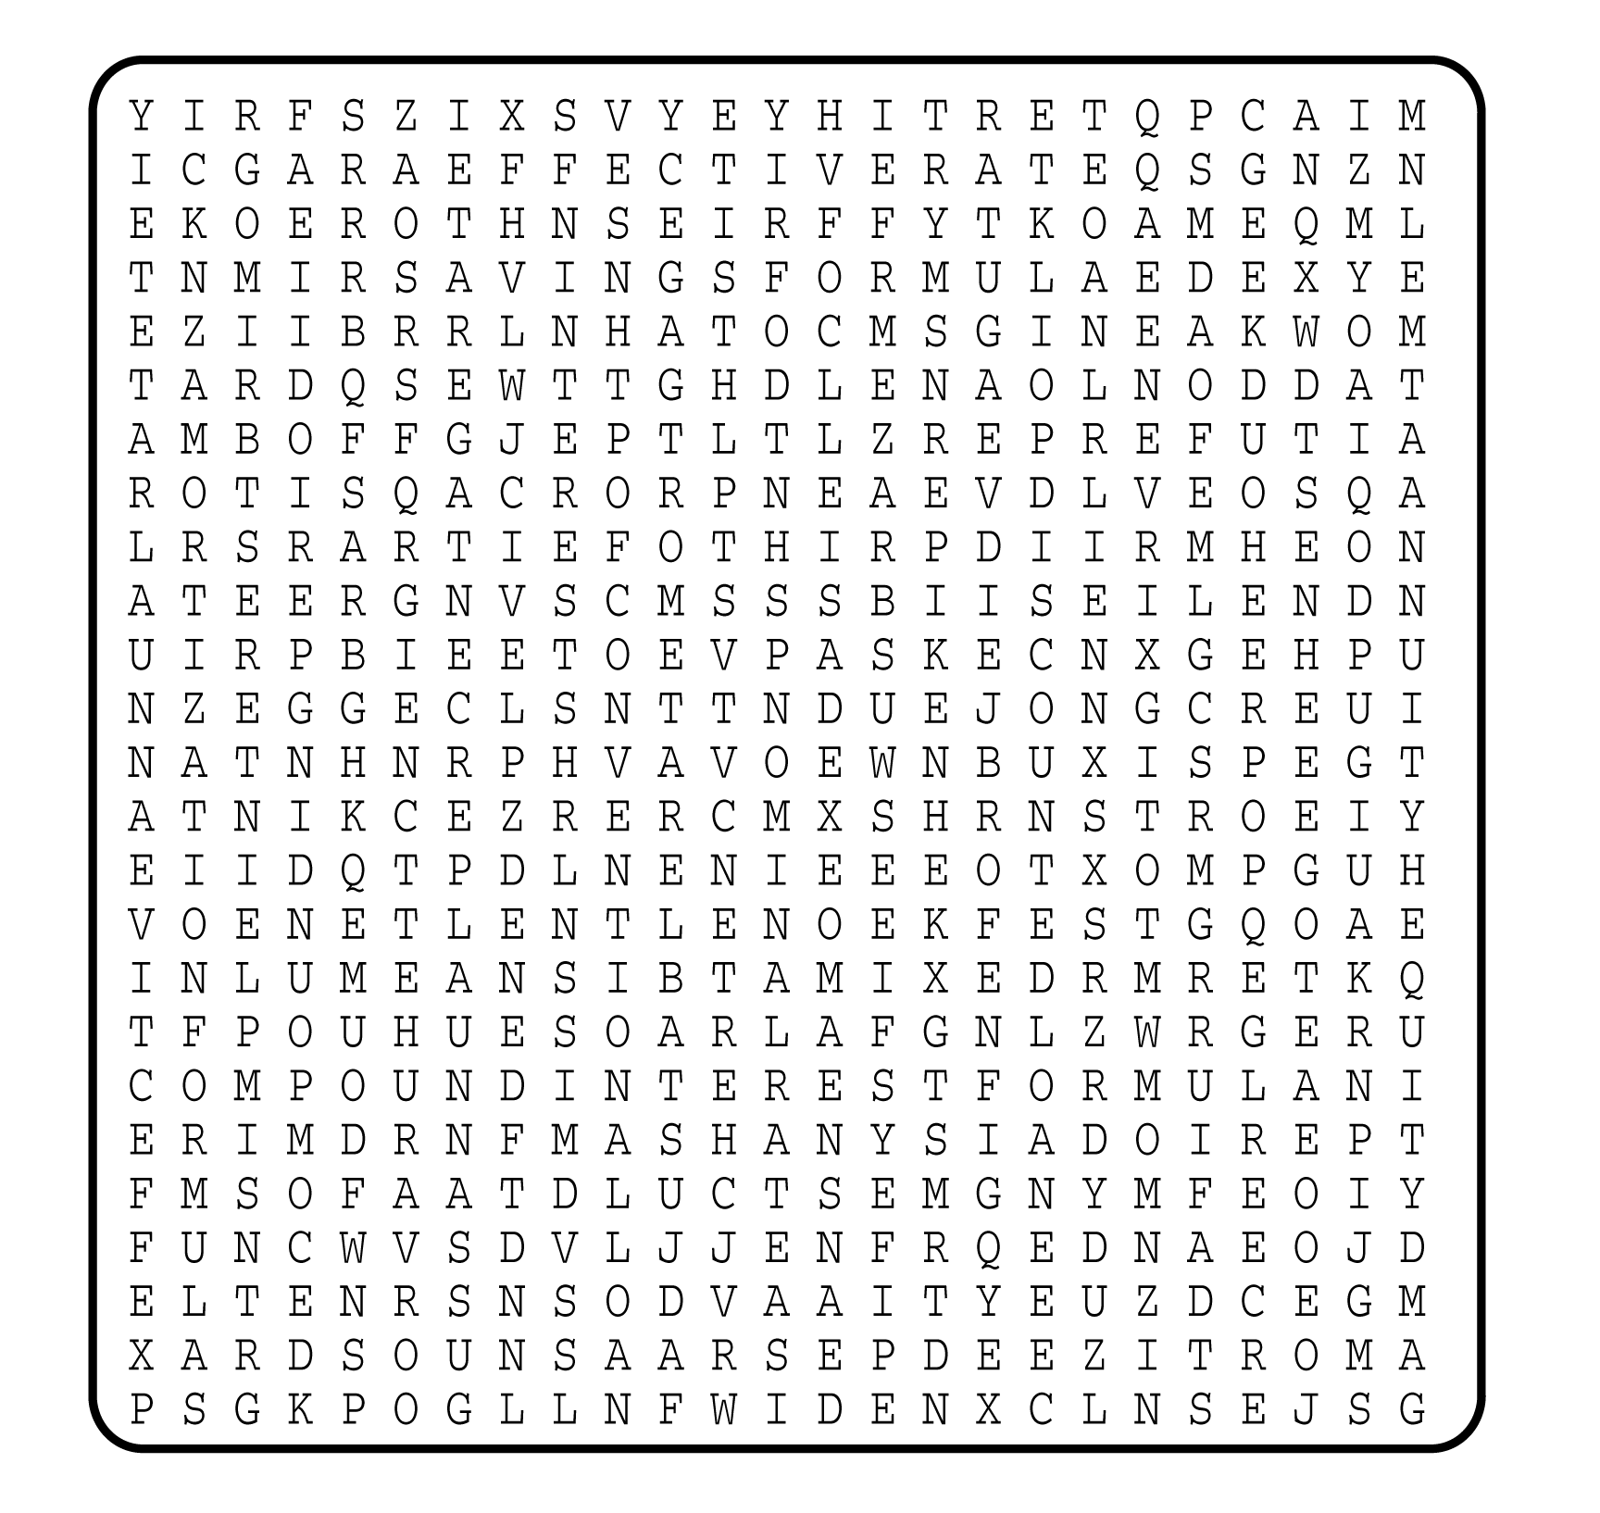

1. __________________________
2. __________________________
3. __________________________
4. __________________________
5. __________________________
6. __________________________
7. __________________________
8. __________________________
9. __________________________
10. __________________________
11. __________________________
12. __________________________
13. __________________________
14. __________________________
15. __________________________
16. __________________________
17. __________________________
18. __________________________

