Chapter 19

Symmetry and Patterns

chapter Objectives
Check off these skills when you feel that you have mastered them.
 List the first ten terms of the Fibonacci sequence.
 Beginning with the number 3, form a ratio of each term in the Fibonacci sequence with its next consecutive term and simplify the ratio; then identify the number that these ratios approximate.
 List the numerical ratio for the golden section.
 Name and define the four transformations (rigid motions) in the plane.
 Analyze a given rosette pattern and determine whether it is dihedral or cyclic.
 Given a rosette pattern, determine which rotations preserve it.
 Analyze a given strip pattern by determining which transformations produced it.
Guided Reading
Introduction
We study certain numerical and geometric patterns of growth and structure that can be used to model or describe an amazing variety of phenomena in mathematics and science, art, and nature. The mathematical ideas the Fibonacci sequence leads to, such as the golden ratio, spirals, and selfsimilar curves, have long been appreciated for their charm and beauty; but no one can really explain why they are echoed so clearly in the world of art and nature. The properties of selfsimilarity, and reflective and rotational symmetry are ubiquitous in the natural world and are at the core of our ideas of science and art.

 Key idea
Plants exhibiting phyllotaxis have a number of spiral forms coming from a special sequence of numbers. Certain plants have spirals that are geometrically similar to one another. The spirals are arranged in a regular way, with balance and “proportion”. These plants have rotational symmetry.

Section 19.1 Fibonacci Numbers and the Golden Ratio

 Key idea
Fibonacci numbers occur in the sequence {1, 1, 2, 3, 5, 8, 13, 21, 34, 55, 89, . . . }. They are generated according to the recursion formula that states that each term is the sum of the two terms preceding it. If the Fibonacci number is then for and we have the following.
 Example A
Fill in the next five terms in the Fibonacci sequence {1, 1, 2, 3, 5, 8, 13, 21, 34, 55, 89, . . .}.
Solution
Using the recursion formula we have the following.
 Question 1
Suppose a sequence begins with numbers 2 and 4, and continues by adding the previous two numbers to get the next number in sequence. What would the sum of the 10th and 11th terms in this sequence be?
Answer
466, the 12th term

 Key idea
As you go further out in the sequence, the ratio of two consecutive Fibonacci numbers approaches the famous golden ratio . For example, 89/55 = 1.61818... and 377/233 = 1.618025.... . The number is also known as the golden mean. The exact value is
 Example B
Calculate the square of , subtract 1, and compare the result to What do you get?
Solution
Since satisfies the algebraic equation
 Example C
Calculate the reciprocal add 1, and compare to What do you get?
Solution
If you divide both sides of the equation by you get

 Key idea
A golden rectangle (which is considered by many to be visually pleasing) is one such that the ratio of height to width is 1 to
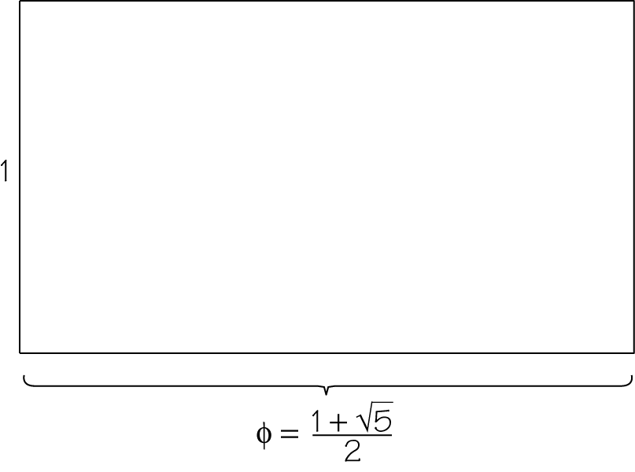

 Key idea
The geometric mean of two positive numbers, a and b, is the square root of their product.
In general, the geometric mean of n numbers is the root of their product.
 Question 2
a) What is the geometric mean of 5 and 7? (round to three decimal places)
b) What is the geometric mean of 5, 6, and 7? (round to three decimal place)
Answer
a) 5.916
b) 5.944

Section 19.2 Symmetries Preserve the Pattern

 Key idea
Balance refers to regularity in how repetitions are arranged. Along with similarity and repetition, balance is a key aspect of symmetry.

 Key idea
Rigid motions are translations, rotations, reflections, and glide reflections.
 Example D
Classify each of these rigid motions (within the given rectangle).
a)  b) 
c)  d) 
Solution
a) This symmetry reverses left and right. This is a reflection across a vertical line.
b) This reverses left-right and up-down. This is a rotation by 180°.
c) The figure is moved to the left with the same orientation. This is a translation to the left.
d) The figure is moved to the left and simultaneously reversed up-down. This is a glide reflection.

 Key idea
Preservation of the pattern occurs when the pattern looks exactly the same, with all parts appearing in the same places, after a particular motion is applied.
 Question 3
Which of the following letters has a shape that is preserved by reflection or rotation?
A E I S
Answer
All four letteres

Section 19.3 Rosette, Strip, and Wallpaper Patterns

 Key idea
Patterns are analyzed by determining which rigid motions preserve the pattern. These rigid motions are called symmetries of the pattern.

 Key idea
Rosette patterns contain only rotations and reflections.

 Key idea
Wallpaper patterns repeat a design element in more than one direction.

 Key idea
Strip patterns repeat a design element along a line, so all of them have translation symmetry along the direction of the strip and may also contain glide reflections.
 Example E
Which of the following linear designs are periodic strip patterns?
a) 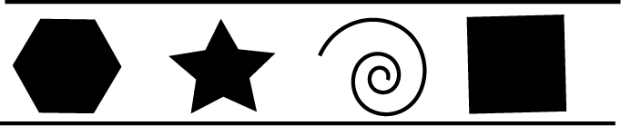
b) 
c) 
Solution
In choice b, the design element consisting of two sets of bars is repeated at regular intervals. In choice a, there is no fixed repeated design element. In choice c, the intervals between repetitions are irregular. The answer is pattern b.

 Key idea
Other possible symmetries for a strip pattern are horizontal or vertical reflection, rotation by 180°, or glide reflection.

Section 19.4 Notation for Patterns

 Key idea
We can classify strip patterns according to their symmetry types; there are exactly seven different classes, designated by four symbols p * * *. The first symbol is always the p. The second symbol is either m or 1 indicating the presence or absence of a vertical line of reflection. The third symbol is m if there is a horizontal line of reflection, a if there is a glide reflection but no horizontal reflection, or 1 if there is horizontal or glide reflection. The fourth symbol is a 2 if there is half-turn rotational symmetry; otherwise it is a 1.
 Example F
What is the symbolic notation for each of these patterns? You may need to refer to the flow chart (Figure 19.12) on page 729 of your text to help answer this question.

a)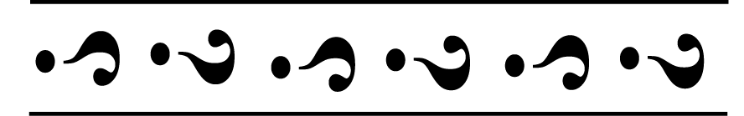
b) 

Solution
a) No vertical or horizontal reflection, or rotation. However, each figure matches the next one over with a horizontal flip; that is, it has glide reflection symmetry. This would be p1a1.
b) This design has all possible symmetries for strip patterns. This would be pmm2

 Key idea
It is useful to have a standard notation for patterns, for purposes of communication. Crystallographer’s notation is the one most commonly used.

 Key idea
In applying notation to patterns, it must be taken into account that patterns may not be perfectly rendered, especially if they are on a rounded surface.

Section 19.5 Symmetry Groups

 Key idea
A group is made up of a set of elements and an operation that has the following properties.
- Closure: The result of an operation on any two elements of the set yields an element of the set.
- Identity: The set has a special element I such that if the operation is performed with any element of the set, say A, the result of which is A.
- Inverse: For any element A, there exists an element of the set such that
- Associatively: For any three elements of the set, A, B, and C, we have the following.

 Key idea
The full list of symmetries of any pattern forms a symmetry group. Symmetry of a pattern has the following properties.
- The combination of two symmetries A and B is written This combination is another symmetry.
- The “null” symmetry doesn’t move anything. It is considered the identity.
- Every symmetry has an inverse or an opposite that “undoes” the effect of the original symmetry.
- In applying a number of symmetries one after another, we may combine consecutive ones without affecting the result.

 Key idea
The symmetries of a rectangle are as follows.
- I: leaves every point unchanged in location
- R: A half-turn through the center)
- V: A reflection in a vertical line through the center
- H: A reflection in a horizontal line through the center
 Example G
What is
Solution
The answer is R. H reverses up and down, V reverses left and right. R reverses both, as does the combination symmetry
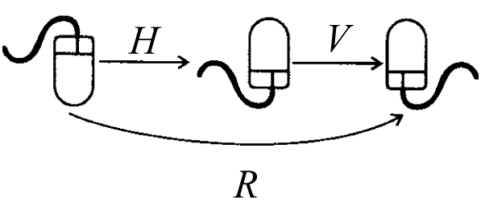
 Example H
a) List the four elements of the symmetry group of a rectangle.
b) What is the combined result of applying all four of them consecutively?
Solution
a) The four elements that form the group are I, H, V, and R. A rectangle is symmetrical across a vertical and horizontal axis, but not across the diagonals. It is, therefore, also symmetrical if rotated 180°, since
b) To calculate the combination first note Then and finally Thus, the answer is I.

 Key idea
Symmetry groups of rosette patterns contain only rotations and reflections.
 Example I
What are the symmetries of these rosettes?
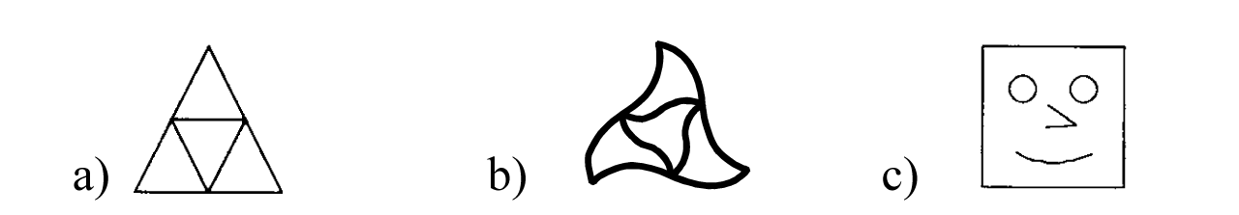
Solution
The answer is:
a) Three rotations where R is a rotation and three reflections across the axes a, b, v shown below.
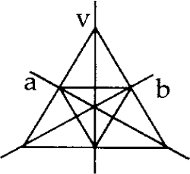
b) Three rotations where R is a rotation but no reflections, since the figure has a “right-handed” twist, and any reflection would change it to a “left-handed” one.
c) No symmetries other than I. The figure is totally asymmetric.

Section 19.6 Fractals Patterns and Chaos

 Key idea
A fractal is a kind of pattern that exhibits similarity at ever finer scales. When you “zoom in”, the resulting figure looks like the original figure.

 Key idea
Fractals can be created with a replication rule called an iterative function system (IFS). One particular geometric pattern is called Sierpinski’s triangle. It starts with a triangle and the “middle triangle” is removed. This process is repeated for the resulting triangles.
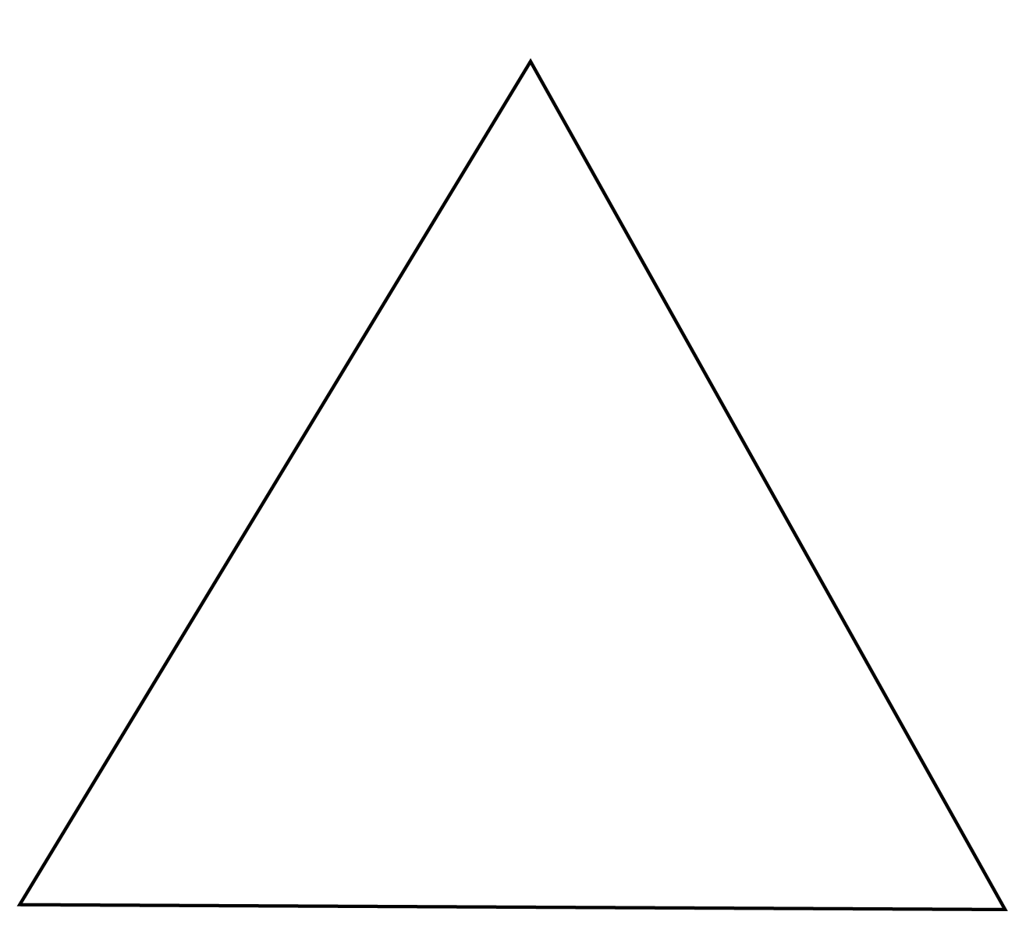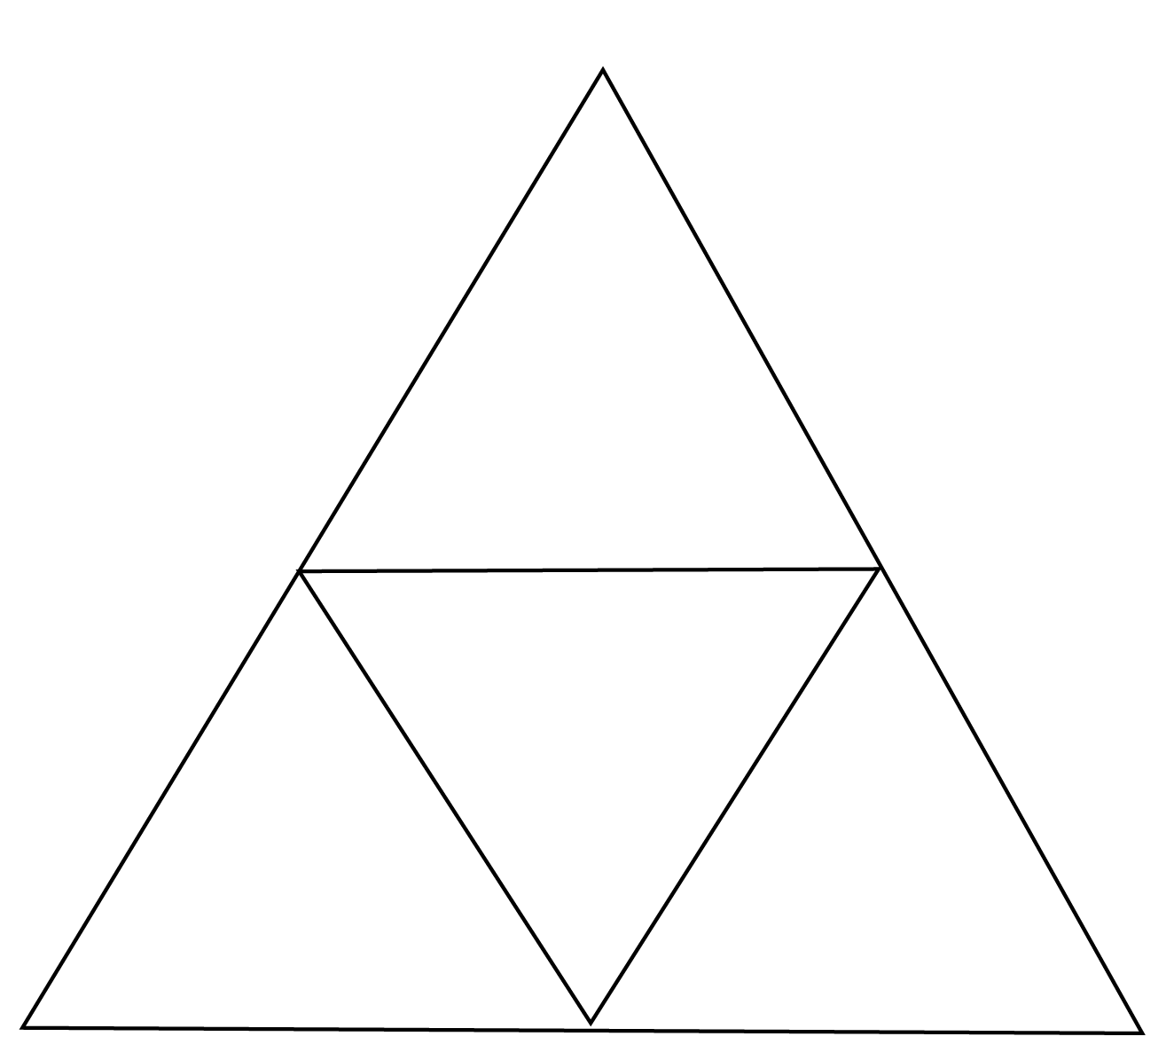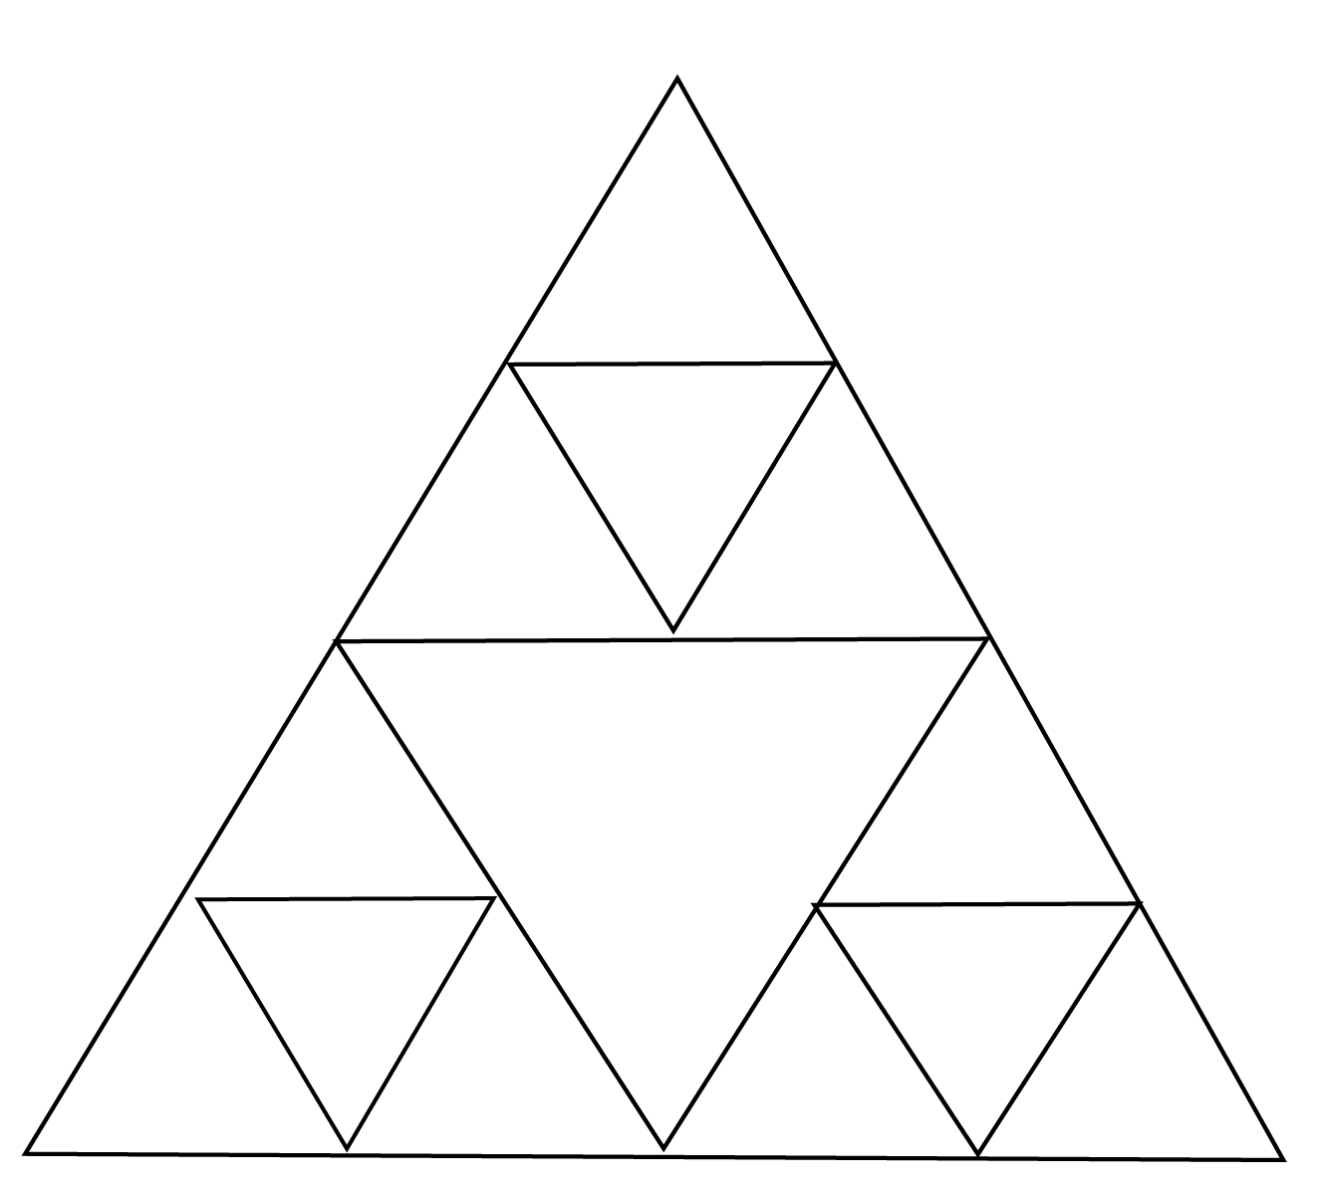
After a few more iterations the figure looks like the following.
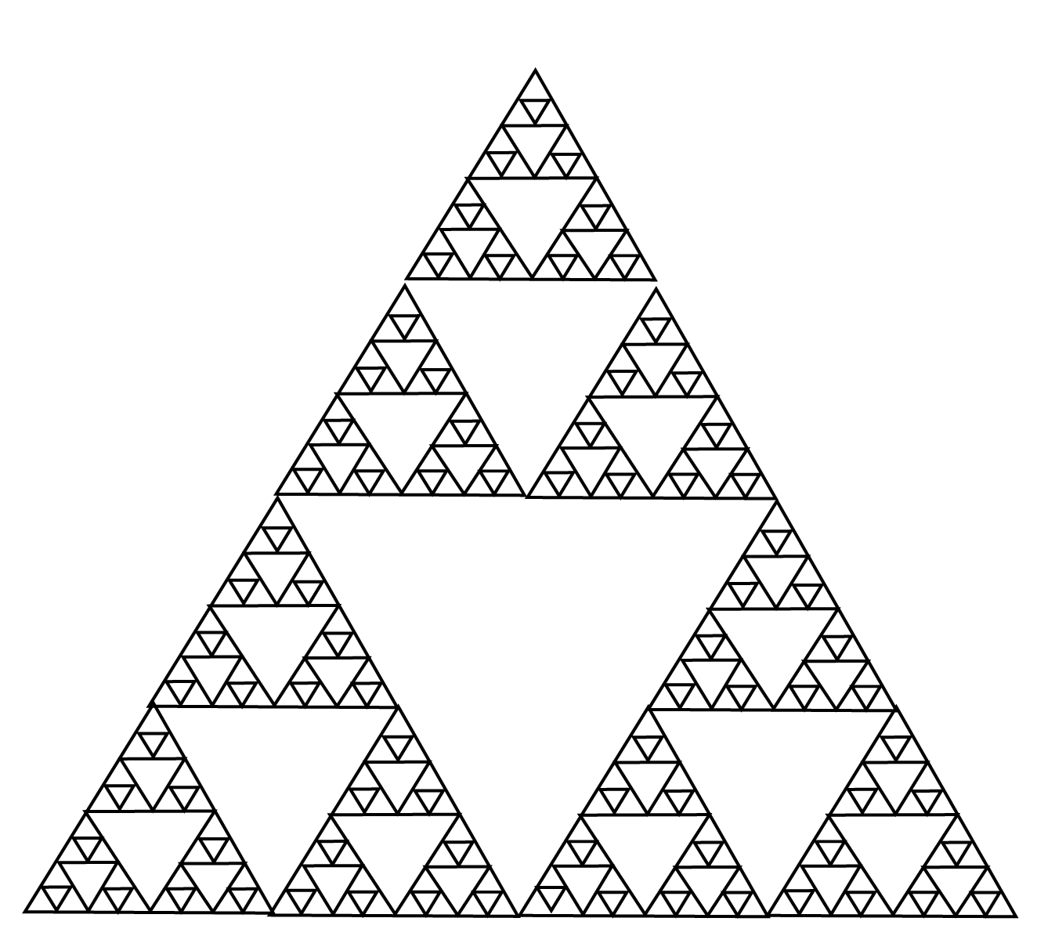
This process continues.
 Question 4
A fractal known as the Koch snowflake starts with an equilateral triangle. Each side of the triangle is cut into three parts with the middle section removed. The removed segment is replaced by two line segments of the same length as that was removed. If the following is a picture of what occurs after doing this process twice, draw the first two pictures and the one that follows (the first is the equilateral triangle).

Is the area in the interior of the figure increasing as you do each iteration?
Answer
yes
Homework Help
Exercises 1 – 18
Carefully read Section 19.1 before responding to these exercises.
Exercises 19 – 26
Carefully read Section 19.2 before responding to these exercises.
Exercises 27 – 34
Carefully read Section 19.3 before responding to these exercises.
Exercises 35 – 48
Carefully read Section 19.4 before responding to these exercises.
Exercises 49 – 61
Carefully read Section 19.5 before responding to these exercises.
Exercises 62 – 68
Carefully read Section 19.6 before responding to these exercises.

Do You Know the Terms?

Cut out the following 23 flashcards to test yourself on Review Vocabulary. You can also find these flashcards at http://www.whfreeman.com/fapp7e.

Chapter 19  Symmetry and Patterns  Divine proportion | Chapter 19  Symmetry and Patterns  Fibonacci numbers
Chapter 19  Symmetry and Patterns  Fractal | Chapter 19  Symmetry and Patterns  Geometric mean
Chapter 19  Symmetry and Patterns  Glide reflection | Chapter 19  Symmetry and Patterns  Golden ratio, golden mean
Chapter 19  Symmetry and Patterns  Golden rectangle | Chapter 19  Symmetry and Patterns  Generated, generators

The numbers in the sequence 1, 1, 2, 3, 5, 8, 13, 21, 34, . . . (each number after the second is obtained by adding the two preceding numbers). | Another term for the golden ratio.
The geometric mean of two numbers a and b is | A pattern that exhibits similarity at ever-finer scales.
The number 1.618034. . . . | A combination of translation ( = glide) and reflection in a line parallel to the translation direction.
A group is generated by a particular set of elements if composing them and their inverse in combinations can produce all elements of the group. | A rectangle the lengths of whose sides are in the golden ratio.

Chapter 19  Symmetry and Patterns  Group | Chapter 19  Symmetry and Patterns  Isometry
Chapter 19  Symmetry and Patterns  Iterated function system (IFS) | Chapter 19  Symmetry and Patterns  Phyllotaxis
Chapter 19  Symmetry and Patterns  Preserves the pattern | Chapter 19  Symmetry and Patterns  Recursion
Chapter 19  Symmetry and Patterns  Rigid motion | Chapter 19  Symmetry and Patterns  Rosette pattern

Another word for rigid motion. Angles and distances, and consequently shape and size, remain unchanged by a rigid motion. | A collection of elements with an operation on pairs of them such that the collection is closed under the operation, there is an identity for the operation, each element has an inverse, and the operation is associative.
The spiral pattern of shoots, leaves, or seeds around the stem of a plant. | A sequence of elements (number or figures) in which each successive element is determined recursively by applying the same function (rule) to the previous element.
A method of defining a sequence of numbers, in which the next number is given in terms of previous ones. | A transformation does this if all parts of the pattern look exactly the same after the transformation has been performed.
A pattern whose only symmetries are rotations about a single point and reflections through that point. | A motion that preserves the size and shape of figures; in particular, any pair of points is the same distance apart after the motion as before.

Chapter 19  Symmetry and Patterns  Rotational symmetry | Chapter 19  Symmetry and Patterns  Strip pattern
Chapter 19  Symmetry and Patterns  Symmetry of the pattern | Chapter 19  Symmetry and Patterns  Symmetry group of the pattern
Chapter 19  Symmetry and Patterns  Translation | Chapter 19  Symmetry and Patterns  Translation symmetry

Chapter 19

Symmetry and Patterns

Wallpaper pattern

A pattern that has indefinitely many repetitions in one direction. | A figure has this symmetry if a rotation about its “center” leaves it looking the same.
The group of symmetries that preserve the pattern. | A transformation of a pattern is this if it preserves the pattern.
An infinite figure has this symmetry if it can be translated (slid, without turning) along itself without appearing to have changed. | A rigid motion that moves everything a certain distance in one direction.
 | A pattern in the plane that has indefinitely many repetitions in more than one direction.

Practice Quiz
1. The numbers 21 and 34 are consecutive numbers in the Fibonacci sequence. What is the next Fibonacci number after 34?
a. 46
b. 55
c. 59
2. What is the geometric mean of 8 and 32?
a. 20
b. 16
c. 6.32
3. The shorter side of a golden rectangle is 7 inches. How long is the longer side?
a. 8.6 inches
b. 9.5 inches
c. 11.3 inches
4. Which figure has rotation symmetry?
I. 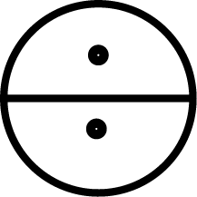 II. 
a. I only
b. II only
c. Both I and II
5. Assume the following patterns continue in both directions. Which has a reflection isometry?
II. TTTTTTTTTTTTT II. >>>>>>>
a. I only
b. II only
c. Both I and II
6. Assume the following two patterns continue in both directions. Which of these patterns has a glide reflection isometry?
I. <><><><><><><> II. ZZZZZZZZZZZZZ
a. I only
b. II only
c. Neither I nor II
7. Use the flowchart in Figure 19.11 of For All Practical Purposes to identify the notation for the strip pattern below.
a. pma2
b. p1a1
c. p112
8. What isometries does this wallpaper pattern have?
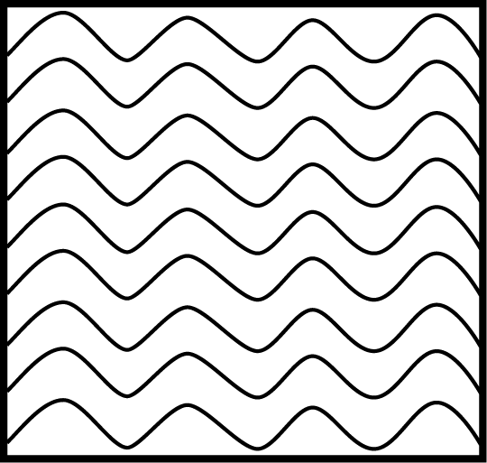
a. translation only
b. translation and reflection only
c. translation, reflection, and rotation
9. What isometries does this wallpaper pattern have?
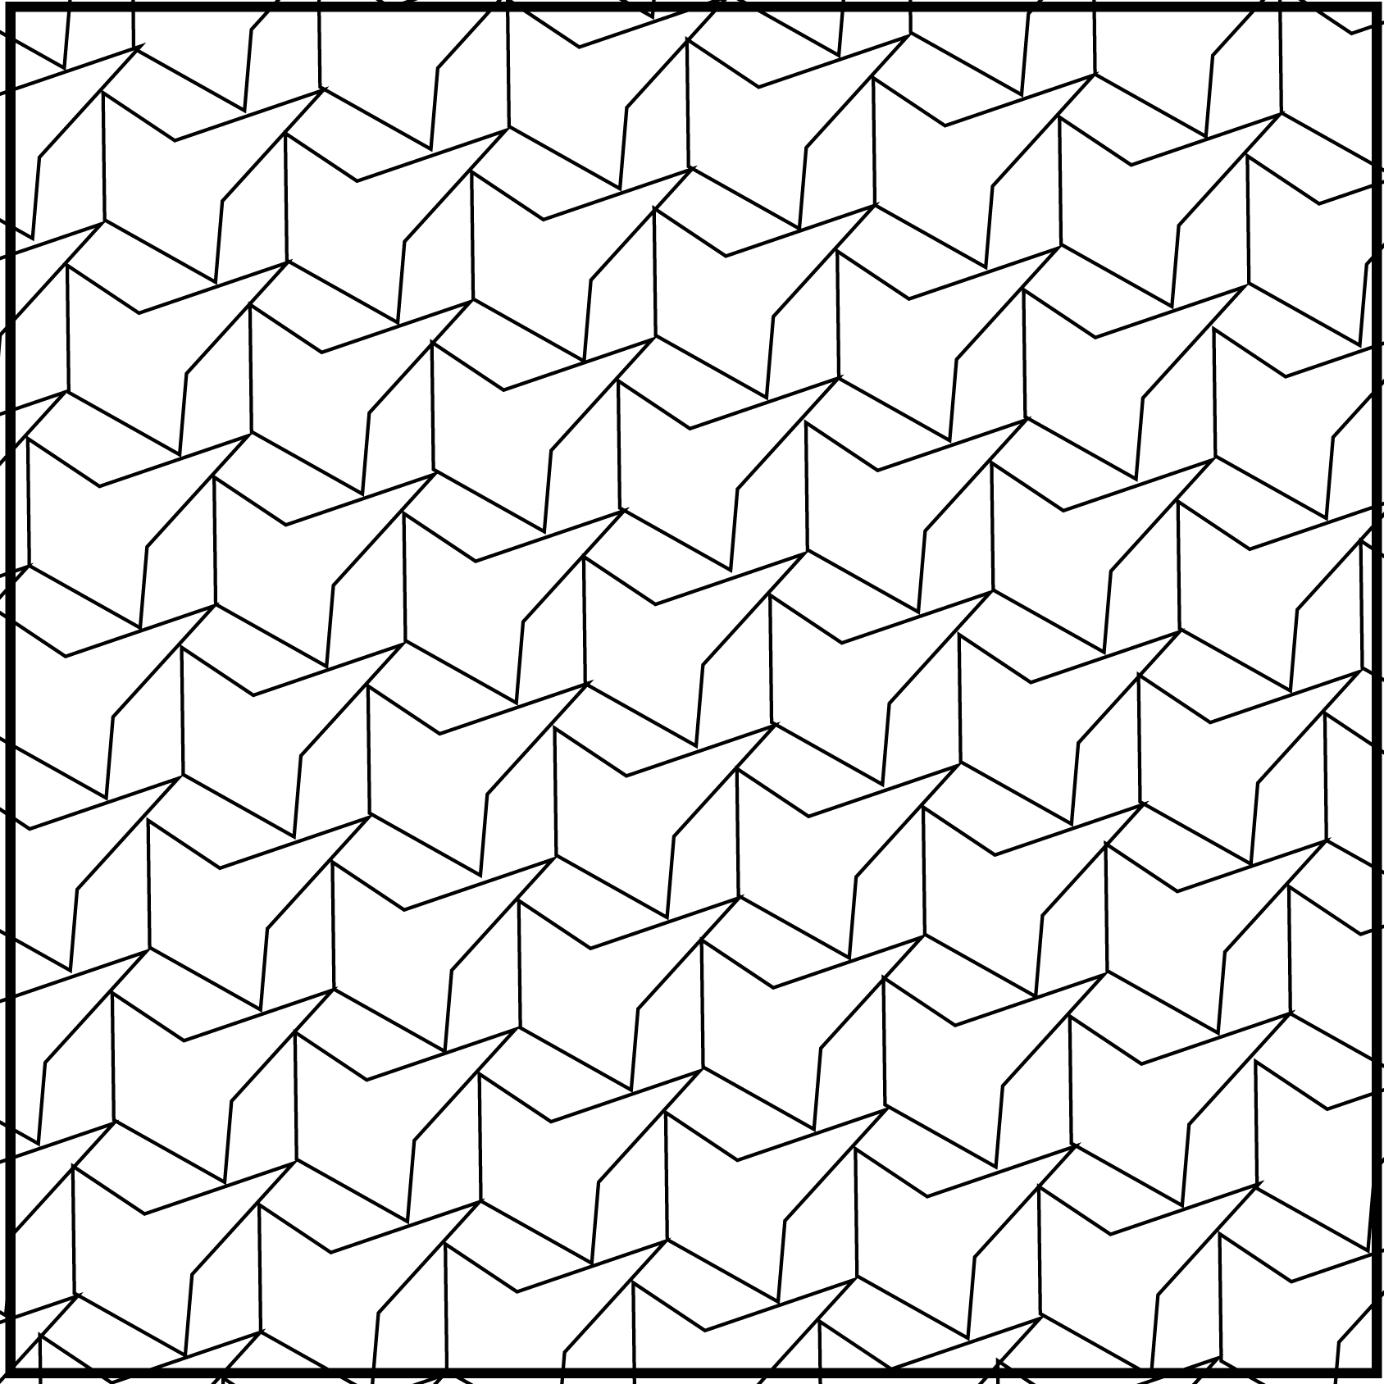
a. translation only
b. translation and reflection only
c. translation, reflection, and rotation
10. How many elements are in the symmetry group of a regular hexagon?
a. 6
b. 12
c. more than 12

Word Search
Refer to pages 740 – 741 of your text to obtain the Review Vocabulary. There are 25 hidden vocabulary words/expressions in the word search below. Golden ratio, Golden mean, Generated, Generators, Translation, and Translation symmetry all appear separately. It should be noted that spaces are removed. Also, abbreviations do not appear. There is additional space on the back of this page for vocabulary words/expressions.
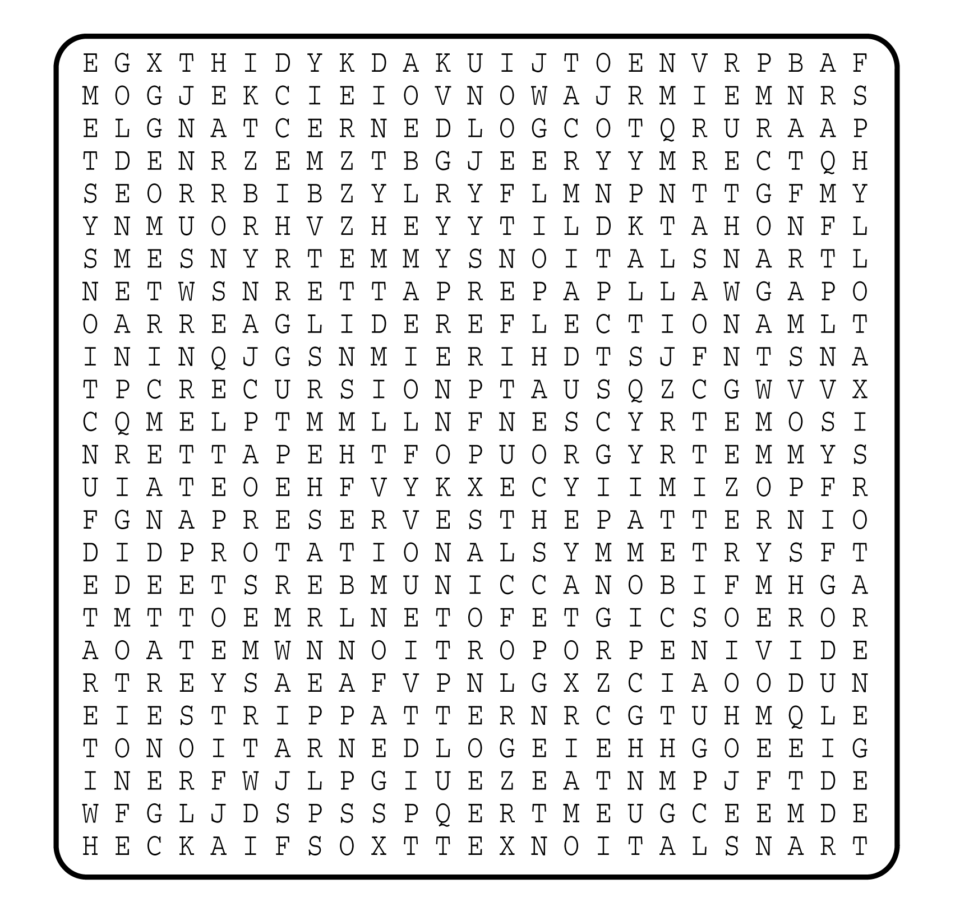

1. __________________________
2. __________________________
3. __________________________
4. __________________________
5. __________________________
6. __________________________
7. __________________________
8. __________________________
9. __________________________
10. __________________________
11. __________________________
12. __________________________
13. __________________________
14. __________________________
15. __________________________
16. __________________________
17. __________________________
18. __________________________
19. __________________________
20. __________________________
21. __________________________
22. __________________________
23. __________________________
24. __________________________
25. __________________________

