Chapter 16

Identification Numbers

chapter Objectives
Check off these skills when you feel that you have mastered them.
 Understand the purpose of a check digit and be able to determine one for various schemes.
 Given an identification number and the scheme used to determine it, be able to decide if the number is a valid number for that scheme.
 Given an identification number and the scheme, use it to decipher the information such as birth date and sex.
 Be able to convert a given ZIP code to its corresponding bar code, and vice versa.
 Be able to convert a given UPC number to its corresponding bar code.
Guided Reading
Introduction

 Key idea
Almost everything we encounter in daily life consumer goods, credit cards, financial records, people, organizations, mail is somehow identified or classified by a numeric or alphanumeric code. Of course, this code must unambiguously identify the individual or object it names. But since humans and machines are fallible, the system used for creating the code must be designed to minimize errors. Also, since errors will certainly occur, the system should include a mechanism for detecting and, if possible, correcting the most common errors.

Section 16.1 Check Digits

 Key idea
Many frequently used types of error-detecting code for identification numbers include an extra digit (usually the last digit) called a check digit. The check digit can be compared to the rest of the number to check for validity.

 Key idea
For a postal service money order, the check digit (the last digit) is the remainder you get when you divide the sum of the other digits by 9.
 Example A
If the ID number on a postal money order is 321556738X, what is the value of X?
Solution
The other digits add up to 40; divide by 9, the remainder is 4. Thus, X = 4.

 Key idea
Some mail (UPS) and car rental services use as an extra check digit as the remainder when you divide the number by 7.
 Example B
If the ID number of a FedEx package is 321556738X, what is the value of X?
Solution
If you divide 321556738 by 7, you get 45936676 with a remainder of 6. Thus, X = 6.
 Question 1
If the ID number of a FedEx package is 3213213213X, what is the value of X?
Answer

0

 Key idea
The Universal Product Code (UPC) is a twelve-digit code, including a check digit at the end. By adding the digits and multiplying by their weight (alternately 1 for even positions, 3 for odd positions), the sum must be a number ending in 0.
 Example C
If the UPC code for a product is 43276598731X, what is the value of X?
Solution
Since the last digit (check digit) must be 7 in order to have a sum that ends in 0.
 Question 2
If the UPC code for a product is 12345678901X, what is the value of X?
Answer
2

 Key idea
The Codabar system is a variation of UPC using a similar sum with weights 2 (odd positions) and 1 (even positions). To this sum, you add the number of digits in odd positions that exceed 4; the resulting number must end in 0 to be a valid Codabar code.
 Example D
Is 4327 6598 2341 7112 a valid credit card number using Codabar?
Solution
The numbers in the odd positions are 4_2_ 6_9_ 2_4_ 7_1_. The numbers in the even positions are _3_7 _5_8 _3_1 _1_2 (the last position is the check digit). The numbers that exceed 4 in odd positions are _ _ _ _ 6_9_ _ _ _ _ 7 _ _ _.
The Codabar algorithm yields the following.
Since this number does not end in zero (103), the credit card is not a valid number using the Codabar algorithm.
 Question 3
What is the missing digit of the fictitious credit card number 1234 5678 X234 5678 using Codabar?
Answer
2

 Key idea
Another important and effective error-detecting code is the International Standard Book Number (ISBN). It is a 10-digit code, It has the following property.
is evenly divisible by 11.
 Example E
Explain why the ISBN of this Guide is valid.
Solution
The ISBN of this manual is 0-7167-6946-8. Using the algorithm we have the following.
Since 253 is divisible by 11 (), this is a valid ISBN.

Section 16.2 The ZIP Code

 Key idea
The ZIP code is a U. S. Postal Service ID that encodes geographical information about each post office. The first digit in a ZIP code represents one of the ten regions, from east to west, numbered 0–9. Each state is divided into a variable number of smaller geographical areas. The second two digits represent the central mail-distribution point in this area.

 Key idea
ZIP + 4 code is a further refinement of the ZIP code, capable of identifying small groups of mailboxes, like a floor of a building, within a given postal zone.

Section 16.3 Bar Codes

 Key idea
Bar codes use light spaces and dark bars to represent a two-symbol binary code that is easily scanned optically and decoded by a computer.

 Key idea
ZIP code bar codes use the postnet code. Each digit is represented by a group of five dark bars, two long and three short. At the beginning and end there are two long bars, which are called guard bars. The following are the bar patterns.
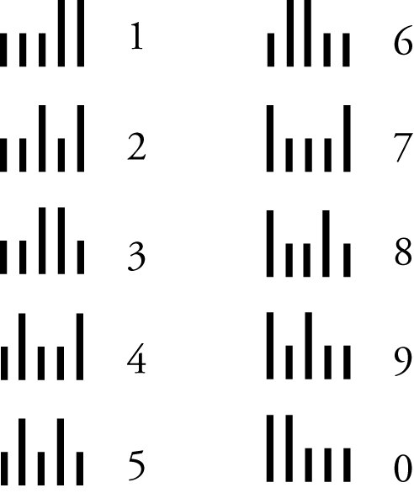
 Example F
What would the bar code look like for a ZIP of 53207?
Solution
With guard bars at the beginning and end, we have the following.
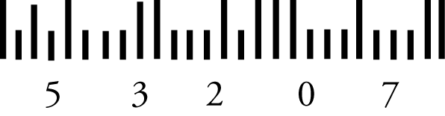

 Key idea
A ZIP + 4 number is made up of 9 digits and one check digit. Including a check digit at the end, the sum of the ZIP + 4 digits must be a number ending in 0.
 Question 4
Render a drawing of what the bar code would look like for the following postcard, including the check digit for the ZIP + 4 number. What would the check digit be for the postcard?
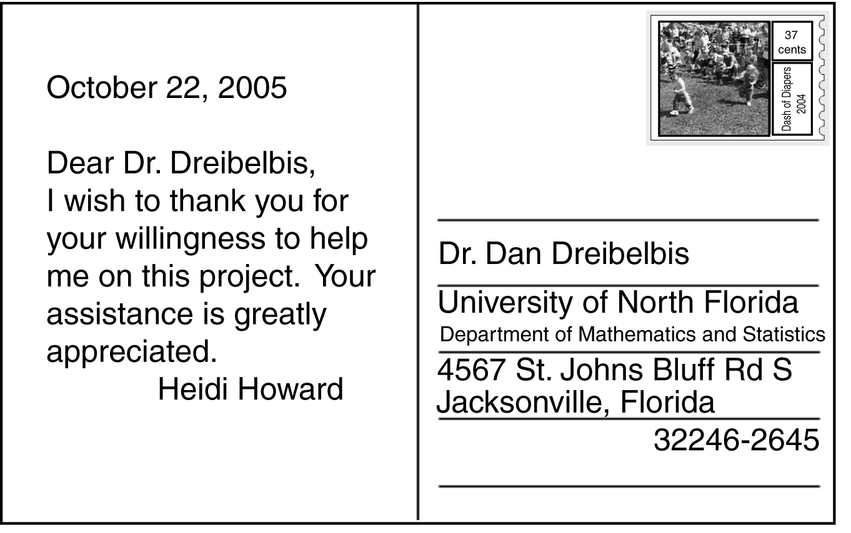
Answer
6

 Key idea
The UPC (Universal Product Code) is a familiar sight on labels for retail products. Digits are represented by sequences of light and dark bars, where adjacent dark bars blend together to make bars of different widths. In this way, seven bar spaces (“modules”) produce two light and two dark bars for each digit. There are different binary coding patterns for manufacturer numbers and product numbers. Refer to Table 16.1, page 608 of your textbook.
 Example G
How is the digit 7 represented in the UPC bar code?
Solution

For manufacturer code, 7 is equivalent to 0111011. The bar pattern would look something like the following.
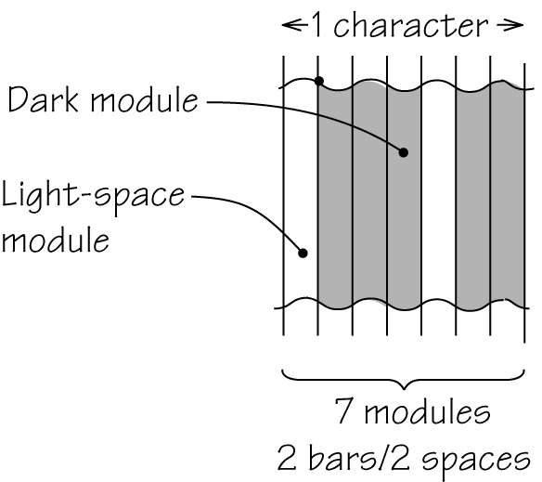
For product code, 7 is equivalent to 1000100. The bar pattern would look something like the following.
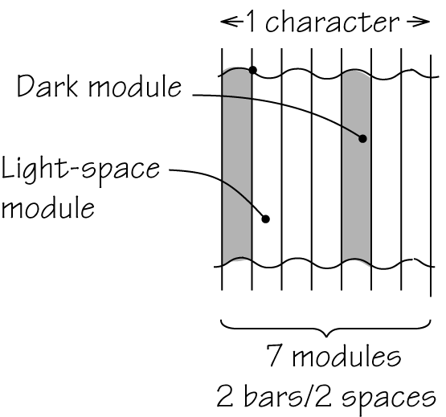

Section 16.4 Encoding Personal Data
 Key idea
Personal data such as your name, birthdate, or sex can be encoded different ways. One way to encode a surname (last name) is the Soundex Coding System. The procedure is as follows.
1. Delete all occurrences of h and w.
2. Assign numbers to the remaining letters as follows:
a, e, i, o, u, y 0
b, f, p, v 1
c, g, j, k, q, s, x, z 2
d, t3
l 4
m, n 5
r 6
3. If two or more letters with the same numeric value are adjacent, omit all but the first.
4. Delete the first character of the original name if still present.
5. Delete all occurrences of a, e, i, o, u, and y.
6. Retain only the first three digits corresponding to the remaining letters; append trailing 0’s if fewer than three letters remain; precede the three digits obtained in step 6 with the first letter of the surname.
 Example H
Encode the surname Howard using the Soundex Coding System.
Solution
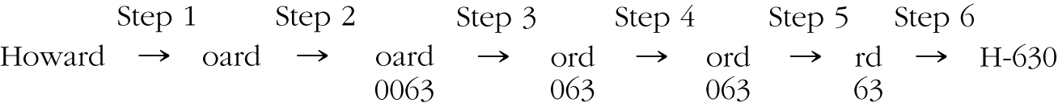
The surname Howard is encoded as H-630.
 Question 5
How would the surname Hochwald be encoded using the Soundex Coding System?
Answer
H-243
 Key idea
Florida and Illinois driver’s licenses use an encoding system that considers both the date of birth and the sex of the resident.
- Florida: A five-digit number contains the information for the resident. The first two digits are the birth year (without the 19), followed by a dash. Thus, 1966 is represented as 66. Each day of the year is assigned a three-digit number with 001 representing January 1. Each month is assigned 40 days. Thus, April 3 is 123. Added to this number is 500 if the resident is female. Thus, a female born on April 3, 1966 is given the number 66-623.
- Illinois: A five-digit number contains the information for the resident. The first two digits (separted by a dash) are the birth year (without the 19). Thus, 1966 is represented as 6-6. Each day of the year is assigned a three-digit number with 001 representing January 1. Each month is assigned 31 days. Thus, April 3 is 096. Added to this number is 600 if the resident is female. Thus, a female born on April 3, 1966 is given the number 6-6696.
 Example I
What would be the five-digit number assigned to a male driver in the state of Florida born on October 20, 1977?
Solution
77-920
 Question 6
5-3640 identifies a Florida driver of which sex and birth date?
Answer
Female born on April 20, 1953.
 Question 7
5-3640 identifies an Illinois driver of which sex and birth date?
Answer
Female born on February 9, 1953.

Homework Help
Exercises 1 – 46
Carefully read Section 16.1 before responding to these exercises. These exercises involve examining check digits. Make sure you understand clearly what method in calculating check digits is used before answering the exercise.
Exercises 47 – 53
Carefully read Sections 16.2 and 16.3 before responding to these exercises. Have the bar codes in front of you and remember that there is a guard bar at the beginning and end of each bar code. Each grouping of five bars is made up of three short and two long bars.
Exercises 54 – 56
Carefully read Section 16.3 before responding to these exercises.
Exercises 57 – 61
Carefully read Spotlight 16.4 (page 609) before responding to these exercises.
Exercises 62 – 63
Carefully read Section 16.4 before responding to these exercises. The Soundex Coding System is a six-step process as explained on page 610 of the text.
Exercises 64 – 71
Carefully read Section 16.4 before responding to these exercises. These exercises involve the sex and birthdate on driver’s licenses. The encoding scheme is either given in the problem or is explained in the last part of Section 16.4.
Exercises 72 – 75
Carefully read Section 16.4 before responding to these exercises. Answers may vary as you think about possible explanations.

Do You Know the Terms?

Cut out the following 14 flashcards to test yourself on Review Vocabulary. You can also find these flashcards at http://www.whfreeman.com/fapp7e.

Chapter 16  Identification Numbers  Bar code | Chapter 16  Identification Numbers  Binary code
Chapter 16  Identification Numbers  Check digit | Chapter 16  Identification Numbers  Codabar
Chapter 16  Identification Numbers  Decoding | Chapter 16  Identification Numbers  Encoding
Chapter 16  Identification Numbers  Error-detecting code | Chapter 16  Identification Numbers  International Standard Book Number (ISBN)

A coding scheme that uses two symbols, usually 0 and 1. | A code that employs bars and spaces to represent information.
An error-detection method used by all major creditcard companies, many libraries, blood banks, and others. | A digit included in an identification number for the purpose of error detection.
Translating data into code. | Translating code into data.
A 10-digit identification number used on books throughout the world that contains a check digit for error detection. | A code in which certain types of errors can be detected.

Chapter 16  Identification Numbers  Postnet code | Chapter 16  Identification Numbers  Soundex Coding System
Chapter 16  Identification Numbers  Universal Product Code (UPC) | Chapter 16  Identification Numbers  Weights
Chapter 16  Identification Numbers  ZIP code | Chapter 16  Identification Numbers  ZIP + 4 code

An encoding scheme for surnames based on sound. | The bar code used by the U.S. Postal Service for ZIP codes.
Numbers used in the calculation of check digits. | A bar code and identification number that are used on most retail items. It detects 100% of all single-digit errors and most other types of errors.
The nine-digit code used by the U.S. Postal Service to refine ZIP codes into smaller units. | A five-digit code used by the U.S. Postal Service to divide the country into geographic units to speed sorting of the mail.

Practice Quiz
1. Suppose a U. S. Postal Service money order is numbered 632930421#, where the last digit is obliterated. What is the missing digit?
a. 3
b. 6
c. 0
2. Suppose an American Express Travelers Cheque is numbered #293019225, where the first digit is obliterated. What is the missing digit?
a. 3
b. 4
c. 6
3. Is the number 3281924 a legitimate Avis rental car number?
a. Yes
b. No, but if the final digit is changed to a 2, the resulting number 3281922 is legitimate.
c. No, but if the final digit is changed to a 3, the resulting number 3281923 is legitimate.
4. Is the number 3234580005 a legitimate airline ticket number (assume number of digits is acceptable)?
a. Yes
b. No, but if the final digit is changed to a 4, the resulting number 3234580004 is legitimate.
c. No, but if the final digit is changed to a 2, the resulting number 3234580002 is legitimate.
5. Determine the check digit that should be appended to the UPC code 0-10010-34500.
a. 2
b. 4
c. 8
6. Determine the check digit that should be appended to the bank identification number 015 000 64.
a. 2
b. 5
c. 8
7. Determine the check digit that should be appended to the Codabar number 312580016535003.
a. 1
b. 3
c. 7
8. Suppose the ISBN 0-1750-3549-0 is incorrectly reported as 0-1750-3540-0. Which of the following statements is true?
a. The check digit will detect the error, but cannot correct it.
b. The check digit will detect and correct the error.
c. The check digit cannot detect the error.
9. How would the surname Lee be encoded using the Soundex Coding System?
a. L-000
b. L-040
c. L-400
10. Suppose that a Postnet code is incorrectly reported. You know that only one of the digits is incorrectly reported. Which of these statements is true?
a. If you know which digit is incorrect, you can always correct a single error in a Postnet code.
b. If you know which digit is incorrect, you can sometimes but not always correct a single error in a Postnet code.
c. Even if you know which digit is incorrect, you can never correct a single error in a Postnet code.

Word Search
Refer to pages 611 – 612 of your text to obtain the Review Vocabulary. There are 12 hidden vocabulary words/expressions in the word search below. It should be noted that spaces are removed as well as hyphens. Zip + 4 code and International Standard Book Number (ISBN) do not appear. Also, the abbreviations do not appear in the word search.
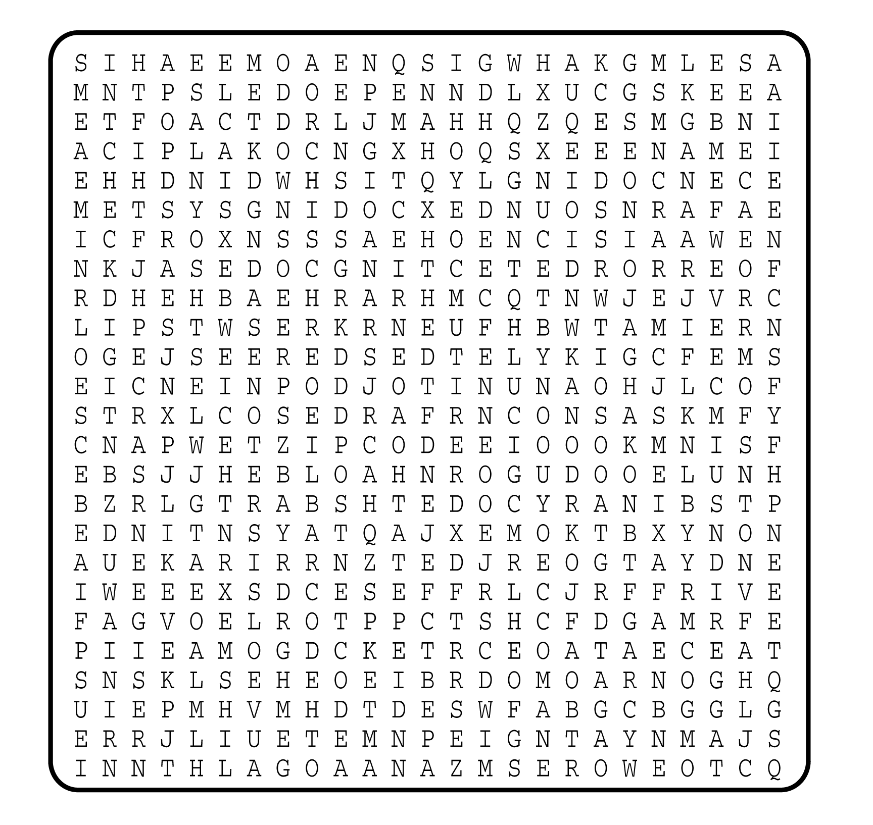

1. __________________________
2. __________________________
3. __________________________
4. __________________________
5. __________________________
6. __________________________
7. __________________________
8. __________________________
9. __________________________
10. __________________________
11. __________________________
12. __________________________

