Chapter 15

Game Theory: The Mathematics of Competition

chapter Objectives
Check off these skills when you feel that you have mastered them.
 Apply the minimax technique to a game matrix to determine if a saddlepoint exists.
 When a game matrix contains a saddlepoint, list the game’s solution by indicating the pure strategies for both row and column players and the playoff.
 Interpret the rules of a zero-sum game by listing its payoffs as entries in a game matrix.
 From a zero-sum game matrix whose payoffs are listed for the row player, construct a corresponding game matrix whose payoffs are listed for the column player.
 If a two-dimensional game matrix has no saddlepoint, write a set of linear probability equations to produce the row player’s mixed strategy.
 If a two-dimensional game matrix has no saddlepoint, write a set of linear probability equations to produce the column player’s mixed strategy.
 When given either the row player or the column player’s strategy probability, calculate the game’s payoff.
 State in your own words the minimax theorem.
 Apply the principle of dominance to simplify the dimension of a game matrix.
 Construct a bimatrix model for an uncomplicated two-person game of partial conflict.
 Determine from a bimatrix when a pair of strategies is in equilibrium.
 Understand the role of sophisticated (vs. sincere) voting and the true power of a chair in small committee decision-making.
 Construct the game tree for a simple truel.
 Analyze the game tree of a truel, using backward induction to eliminate branches.
Guided Reading
Introduction
In competitive situations, parties in a conflict frequently have to make decisions which will influence the outcome of their competition. Often, the players are aware of the options called strategies of their opponent(s), and this knowledge will influence their own choice of strategies. Game theory studies the rational choice of strategies, how the players select among their options to optimize the outcome. Some two-person games involve total conflict, in which what one player wins the other loses. However, there are also games of partial conflict, in which cooperation can often benefit the players.
Section 15.1 Two-Person Total-Conflict Games: Pure Strategies

 Key idea
The simplest games involve two players, each of whom has two strategies. The payoffs to each of the players is best described by a payoff matrix, in which a positive entry represents a payoff from the column player to the row player, while a negative entry represents a payment from the row player to the column player.
 Example A
Consider the following payoff matrix.
a) If the row player chooses C and the column player chooses B, what is the outcome of the game?
b) If the row player chooses C, what is the minimum payoff he can obtain?
c) If the row player chooses D, what is the minimum payoff he can obtain?
d) If the column player chooses A, what is the most she can lose?
e) If the column player chooses B, what is the most she can lose?
Solution
a) The payoff associated with this outcome is the entry in Row C and Column B. The outcome is 4.
b) The minimum payoff is 3
c) An outcome of means that the row player loses 5 to the column player.
d) The outcome is 3. An outcome of 3 means that the column player loses 3 to the row player.
e) The outcome is 4

 Key idea
We see in these examples that the row player can guarantee himself a payoff of at least 3 by playing C, and that the column player can guarantee that she will not lose more than three by playing A. The entry 3 is the minimum of its row, and it is larger than the minimum of the second row, 3 is thus the maximin, and choosing C is the row player’s maximin strategy. Similarly, 3 is the maximum of column A, and it is smaller than 4, which is the maximum of column B. Hence, 3 is the minimax of the columns, and if the column player chooses A, then she is playing her minimax strategy. When the maximin and minimax coincide, the resulting outcome is called a saddlepoint. The saddlepoint is the value of the game, because each player can guarantee at least this value by playing his/her maximin and minimax strategies. However, not every game has a saddlepoint. Games which do not will be studied in the next section.
 Example B
Consider a game in which each of the players (John and Jane Luecke) has a coin, and each chooses to put out either a head or a tail. (Note: The players do not flip the coins.) If the coins match, Jane (the row player) wins, while if they do not match, John (column player) wins. The payoffs are as follows.
 |  | John
 |  | Head | Tail
Jane | Head | 2
Jane | Tail |  | 5
a) What is the row player’s maximin?
b) What is the column player’s minimax?
c) Does this game have a saddlepoint?
Solution
a)
b) 2
c) No. If the maximin is different from the minimax, then there is no saddlepoint.
 Question 1
Consider the following payoff matrix.
a) What is the row player’s maximin?
b) What is the column player’s minimax?
c) Does this game have a saddlepoint?

Answer
a) 6
b) 6
c) Yes, 6.
Section 15.2 Two-Person Total-Conflict Games: Mixed Strategies

 Key idea
When a game fails to have a saddlepoint, the players can benefit from using mixed strategies, rather than pure strategies.

 Key idea
The notion of expected value is necessary in order to calculate the proper mix of the players’ strategies.
 Example C
What is the expected value of a situation in which there are four payoffs, $3, $4, $2, and $7, which occur with probabilities 0.2, 0.3, 0.45, and 0.05, respectively?
Solution
The expected value is found by multiplying each payoff by its corresponding probability and adding these products. We obtain the following.
 Question 2
What is the expected value of a situation in which there are four payoffs, $2, $4, $4, and $9, which occur with probabilities 0.25, 0.15, 0.45, and 0.15, respectively?
Answer
$3.05
 Example D
Let’s reconsider the game of matching coins, described by the following payoff matrix.
 |  | John
 |  | Head | Tail
Jane | Head | 2
Jane | Tail |  | 5
a) Suppose the row player, Jane, mixes her strategy by choosing head with probability q and tails with probability If the column player always chooses heads, what is the row player’s expected value?
b) Suppose the row player, Jane, mixes her strategy by choosing head with probability q and tails with probability If the column player always chooses tails, what is the row player’s expected value?
c) Find the best value of q, that is, the one which guarantees row player the best possible return. What is the (mixed-strategy) value in this case?
d) Is this game fair?
Solution
a) The expected value is
b) The expected value is
c) The optimal value of q can be found in this case by setting equal to and solving for q
Jane’s optimal mixed strategy is
To find the value, substitute the q into or
The value is
d) Since the value of the game is negative, it is unfair to the row player (Jane).
 Question 3
Let’s reconsider the game of matching coins, described by the following payoff matrix.
 |  | John
 |  | Head | Tail
Jane | Head | 2
Jane | Tail |  | 5
a) Suppose the column player, John, mixes his strategy by choosing head with probability p and tails with probability If the row player always chooses heads, what is the column player’s expected value?
b) Suppose the column player, John, mixes his strategy by choosing head with probability p and tails with probability If the row player always chooses tails, what is the column player’s expected value?
c) Find the best value of p, that is, the one which guarantees column player the best possible return.
Answer
a)
b)
c)

 Key idea
A game in which the payoff to one player is the negative of the payoff to the other player is called a zero-sum game. A zero-sum game can be non-symmetrical and yet fair.
 Example E
Consider a coin-matching game with the following payoff matrix.
 |  | John
 |  | Head | Tail
Jane | Head | 2 | 0
Jane | Tail
a) Is the game non-symmetrical?
b) Is it fair?
Solution
a) It is non-symmetrical because the payoffs for the row player are different from those for the column player.
b) It is fair because the value of the game is 0; that payoff, when the row player chooses “head” and the column player chooses “tail,” is a saddlepoint.

 Key idea
The minimax theorem guarantees that there is a unique game value and an optimal strategy for each player. If this value is positive, then the row player can realize at least this value provided he plays his optimal strategy. Similarly, the column player can assure herself that she will not lose more than this value by playing her optimal strategy. If either one deviates from his or her optimal strategy, then the opponent may obtain a payoff greater than the guaranteed value.

Section 15.3 Partial-Conflict Games

 Key idea
In a game of total conflict, the sum of the payoffs of each outcome is 0, since one player’s gain is the other’s loss. Variable-sum games, on the other hand, are those in which the sum of the payoffs at the different outcomes varies. These are games of partial conflict, because, through cooperation, the players can often achieve outcomes that are more favorable than would be obtained by being pure adversaries.

 Key idea
In many games of partial conflict, it is difficult to assign precise numerical payoffs to the outcomes. However, the preferences of the parties for the various outcomes may be clear. In such a case, the payoffs are ordinal, with 4 representing the best outcome, 3 the second best, 2 next, and 1 worst. The payoff matrix now consists of pairs of numbers, the first number representing the row player’s payoff, with the second number of the pair being the column player’s payoff. Now, both like high numbers.
 Example F
Consider the following matrix
 | A | B

C
D
a) If the row player chooses D and the column player chooses B, what will the payoffs be to the players?
b) Does either player have a dominant strategy?
Solution
a) The first entry in the outcome represents the payoff to the row player, and the second entry, the payoff to the column player. The payoffs will be 3 to the row player and 4 to the column player.
b) The row player gets a better payoff in both cases by choosing strategy D (4 to 1 if the column player selects strategy A, and 3 to 2 if the column player selects strategy B).
The column player gets a more desirable payoff by switching from A to B when the row player selects strategy D; however, she gets a less desirable payoff by making the same switch when the row player selects strategy C. Thus, C is a dominant strategy for the row player. The column player does not have a dominant strategy.

 Key idea
When neither player can benefit by departing unilaterally from a strategy associated with an outcome, the outcome constitutes a Nash equilibrium.
 Example G
Consider the following matrix
 | A | B

C
D
a) If this outcome in the matrix is does either of the players benefit from defecting?
b) Is there a Nash equilibrium in this matrix?
Solution
a) In the outcome the defection from C to D for the row player increases his payoff from 1 to 4. The defection from A to B for the column player, however, produces a payoff decrease. The row player benefits by defecting to D, since he then obtains his best outcome (4), rather than his worst (1).
b) Yes. is a Nash equilibrium. Neither player can benefit by changing his or her strategy.

 Key idea
Prisoners’ Dilemma is a game with four possible outcomes. Here, A stands for “arm,” and D for “disarm.”
There are four possible outcomes:
Red and Blue disarm, which is next best for both because, while advantageous to each, it also entails certain risks.
Red and Blue arm, which is next worst for both, because they spend needlessly on arms and are comparatively no better off than at (D, D).
Red arms and Blue disarms, which is best for Red and worst for Blue, because Red gains a big edge over Blue.
Red disarms and Blue arms, which is worst for Red and best for Blue, because Blue gains a big edge over Red.
 |  | Blue
 |  | A | D
Red | A
Red | D
This matrix is also used to model other situations.
 Example H
Consider the following matrix
 | A | D

A
D
a) What is the most favorable outcome for the row player? For the column player?
b) Does the row player have a dominant strategy in Prisoner’s Dilemma? What about column player?
c) Would it pay for either player to defect from the outcome
d) Would it pay for either player to defect from the outcome
e) Which outcome is a Nash equilibrium in Prisoners’ Dilemma?
Solution
a) For the row player, it is the outcome where he selects D and the column player selects A. For the column player, it is the reverse. When the row player selects D and the column player A, the row player achieves his maximum payoff: 20.
When the column player selects D and the row player A, the column player achieves her maximum payoff: 20.
b) The row player always achieves a better payoff by selecting D rather than A (20 to 10 and 1 to 0). The column player fares similarly with D as the dominant strategy.
c) No. The payoff to each defector would decrease from 1 to 0.
d) Yes. The payoff to each defector would increase from 10 to 20.
e) Neither player can benefit by defecting from the outcome because each reduces his or her payoff to 0. Thus, is the Nash equilibrium.

 Key idea
Chicken is a game with a payoff matrix such as the following.
 | Swerve | Don’t swerve

Swerve
Don’t swerve
 Example I
Consider the above matrix.
a) What is the most favorable outcome for the row player? For the column player?
b) Does the row player have a dominant strategy? How about the column player?
c) Would it pay for either player to defect from the outcome
Solution
a) For the row player it is when he doesn’t swerve and the column player does. It is the reverse for the column player. Each of these produces a maximum payoff: 4.
b) When the column player selects “swerve,” the row player does better by selecting “not swerve;” however, the opposite is true for the row player’s selection of “not swerve.” Thus neither player has a dominant strategy.
c) A defection for each player increases the payoff from 0 to 4. It would pay for either player to defect, since he or she thereby obtains his or her most preferred outcome.
 Example J
Consider the following matrix.
 | Swerve | Don’t swerve

Swerve
Don’t swerve
Are there Nash equilibria in this game of Chicken?
Solution
is a Nash equilibrium. Defecting from outcome decreases the row player’s payoff from 2 to 1 and the column player’s payoff from 2 to 1.
Section 15.4 Larger Games

 Key idea
If one of three players has a dominant strategy in a game, we assume this player will choose it and the game can then be reduced to a game between the other two players. (If no player has a dominant strategy in a three-person game, it cannot be reduced to a two-person game.)
The game is not one of total conflict, so the minimax theorem, guaranteeing players the value in a two-person zero-sum game, is not applicable. Even if the game were zero-sum, the fact that we assume the players can only rank outcomes, but not assign numerical values to them, prevents their calculating optimal mixed strategies in it.
The problem in finding a solution to the game is not a lack of Nash equilibria. So the question becomes which, if any, are likely to be selected by the players. Is one more appealing than the others?
Yes, but it requires extending the idea of dominance to its successive application in different stages of play.

 Key idea
In a small group voting situation (such as a committee of three), sophisticated voting can lead to Nash equilibria with surprising results. An example is the status quo paradox. In this situation, supporting the apparently favored outcome actually hurts.

 Key idea
The analysis of a “truel” (three-person duel) is very different when the players move sequentially, rather than simultaneously.
 Example K
Consider a sequential truel in which three perfect marksmen with one bullet each may fire at each other, each with the goal of remaining alive while eliminating the others. If the players act simultaneously, each has a 25% chance of survival. If they act sequentially, each will choose not to shoot, and all will survive.
Solution
If the players are A, B, C, taking turns in that order, A cannot choose to shoot B (or C), because then C (or B) will shoot him next. A must pass. Similarly with B, and then C; none can risk taking a shot. Thus, all survive.

 Key idea
Sequential truels may be analyzed through the use of a game tree, examining it from the bottom up through backward induction.

 Key idea
The theory of moves (TOM) introduces a dynamic element into the analysis of game strategy. It is assumed that play begins in an initial state, from which the players, thinking ahead, may make subsequent moves and countermoves. Backward induction is the essential reasoning tool the players should use to find optimal strategies.

Section 15.5 Using Game Theory

 Key idea
Game theory provides a framework for understanding the rationale behind conflict in our political and cultural world. An example is the confrontation over the budget between the Democrat President Bill Clinton and the Republican Congress that resulted in a shutdown of part of the federal government on two occasions, between November 1995 and January 1996. Government workers were frustrated in not being able to work, and citizens were hurt and inconvenienced by the shut-down.
Homework Help
Exercises 1 – 5
Carefully read Section 15.1 before responding to these exercises. Pay special attention to the example in Table 15.2. Note: The payoff matrix in Exercise 5 is
Exercises 6 – 19
Carefully read Sections 15.1 and 15.2 before responding to these exercises.
Exercises 20 – 25
Carefully read Section 15.3 before responding to these exercises.

Exercises 26 – 37
Carefully read Section 15.4 before responding to these exercises.

Do You Know the Terms?

Cut out the following 34 flashcards to test yourself on Review Vocabulary. You can also find these flashcards at http://www.whfreeman.com/fapp7e.

Chapter 15  Game Theory  Backward induction | Chapter 15  Game Theory  Chicken
Chapter 15  Game Theory  Condorcet winner | Chapter 15  Game Theory  Constant-sum game
Chapter 15  Game Theory  Dominant strategy | Chapter 15  Game Theory  Dominated strategy
Chapter 15  Game Theory  Expected value E | Chapter 15  Game Theory  Fair game

A two-person variable-sum symmetric game in which each player has two strategies: to swerve to avoid a collision, or not to swerve and cause a collision if the opponent has not swerved. Neither player has a dominant strategy; the compromise outcome, in which both players swerve, is not a Nash equilibrium, but the two outcomes in which one player swerves and the other does not are Nash equilibria. | A reasoning process in which players, working backward from the last possible moves in a game, anticipate each other’s rational choices.
A game in which the sum of payoffs to the players at each outcome is a constant, which can be converted to a zero-sum game by an appropriate change in the payoffs to the players that does not alter the strategic nature of the game. | A candidate that defeats all others in separate pairwise contest.
A strategy that is sometimes worse and never better for a player than some other strategy, whatever strategies the other players choose. | A strategy that is sometimes better and never worse for a player than every other strategy, whatever strategies the other players choose.
A zero-sum game is fair when the (expected) value of the game, obtained by using optimal strategies (pure or mixed), is zero. | If each of the n payoffs, occurs with respective probabilities then  where and

Chapter 15  Game Theory  Game tree | Chapter 15  Game Theory  Maximin
Chapter 15  Game Theory  Maximin strategy | Chapter 15  Game Theory  Minimax
Chapter 15  Game Theory  Minimax strategy | Chapter 15  Game Theory  Minimax theorem
Chapter 15  Game Theory  Mixed strategy | Chapter 15  Game Theory  Nash equilibrium

In a two-person zero-sum game, the largest of the minimum payoffs in each row of a payoff matrix. | A symbolic tree, based on the rules of play in a game, in which the vertices, or nodes, of the tree represent choice points, and the branches represent alternative courses of action that the players can select.
In a two-person zero-sum game, the smallest of the maximum payoffs in each column of a payoff matrix. | In a two-person zero-sum game, the pure strategy of the row player corresponding to the maximin in a payoff matrix.
The fundamental theorem for two-person constant-sum games, stating that there always exist optimal pure or mixed strategies that enable the two players to guarantee the value of the game. | In a two-person zero-sum game, the pure strategy of the column player corresponding to the minimax in a payoff matrix.
Strategies associated with an outcome such that no player can benefit by choosing a different strategy, given that the other players do not depart from their strategies. | A strategy that involves the random choice of pure strategies, according to particular probabilities. A mixed strategy of a player is optimal if it guarantees the value of the game.

Chapter 15  Game Theory  Nonsymmetrical game | Chapter 15  Game Theory  Ordinal game
Chapter 15  Game Theory  Partial-conflict game | Chapter 15  Game Theory  Payoff matrix
Chapter 15  Game Theory  Plurality procedure | Chapter 15  Game Theory  Prisoners’ Dilemma
Chapter 15  Game Theory  Pure strategy | Chapter 15  Game Theory  Rational choice

A game in which the players rank the outcomes from best to worst. | A two-person constant-sum game in which the row player’s gains are different from the column player’s gains, except when there is a tie.
A rectangular array of numbers. In a two-person game, the rows and columns correspond to the strategies of the two players, and the numerical entries give the payoffs to the players when these strategies are selected. | A variable-sum game in which both players can benefit by cooperation but may have strong incentives not to cooperate.
A two-person variable-sum symmetric game in which each player has two strategies, cooperate or defect. Cooperate dominates defect for both players, even though the mutual-defection outcome, which is the unique Nash equilibrium in the game, is worse for both players than the mutual-cooperation outcome. | A voting procedure in which the alternative with the most votes wins.
A choice that leads to a preferred outcome. | A course of action a player can choose in a game that does not involve randomized choices.

Chapter 15  Game Theory  Saddlepoint | Chapter 15  Game Theory  Sincere voting
Chapter 15  Game Theory  Sophisticated voting | Chapter 15  Game Theory  Status-quo paradox
Chapter 15  Game Theory  Strategy | Chapter 15  Game Theory  Theory of moves (TOM)
Chapter 15  Game Theory  Total-conflict game | Chapter 15  Game Theory  Value

Voting for one’s most-preferred alternative in a situation. | In a two-person constant-sum game, the payoff that results when the maximin and the minimax are the same, which is the value of the game. The saddlepoint has the shape of a saddle-shaped surface and is also a Nash equilibrium.
The status quo is defeated by another alternative, even if there is no Condorcet winner, when voters are sophisticated. | Involves the successive elimination of dominated strategies by voters.
A dynamic theory that describes optimal choices in strategic-form games in which players, thinking ahead, can make moves and countermoves. | One of the courses of action a player can choose in a game; strategies are mixed or pure, depending on whether they are selected in a randomized fashion (mixed) or not (pure).
The best outcome that both players can guarantee in a two-person zero-sum game. If there is a saddlepoint, this is the value. Otherwise, it is the expected payoff resulting when the players choose their optimal mixed strategies. | A zero-sum or constant-sum game, in which what one player wins the other player loses.

Chapter 15  Game Theory  Variable-sum game | Chapter 15  Game Theory  Zero-sum game

A constant-sum game in which the payoff to one player is the negative of the payoff to the other player, so the sum of the payoffs to the players at each outcome is zero. | A game in which the sum of the payoffs to the players at the different outcomes varies.

Practice Quiz
1. In the following two-person zero-sum game, the payoffs represent gains to Row Player I and losses to Column Player II.
Which statement is true?
a. The game has no saddlepoint.
b. The game has a saddlepoint of value 4.
c. The game has a saddlepoint of value 6.
2. In the following two-person zero-sum game, the payoffs represent gains to Row Player I and losses to Column Player II.
What is the maximin strategy for Player I?
a. Play the first row.
b. Play the second row.
c. Play the third row.
3. In the following two-person zero-sum game, the payoffs represent gains to Row Player I and losses to Column Player II.
What is the minimax strategy for Player II?
a. Play the first column.
b. Play the second column.
c. Play the third column.
4. In a two-person zero-sum game, suppose the first player chooses the second row as the maximin strategy, and the second player chooses the third column as the minimax strategy. Based on this information, which of the following statements is true?
a. The game definitely has a saddlepoint.
b. If the game has a saddlepoint, it must be in the second row.
c. The game definitely does not have a saddlepoint.
5. In the game of matching pennies, Player I wins a penny if the coins match; Player II wins if the coins do not match. Given this information, it can be concluded that the two-by-two matrix which represents this game
a. has all entries the same.
b. has entries which sum to zero.
c. has two 0s and two 1s.
6. In the following game of batter-versus-pitcher in baseball, the batter’s batting averages are given in the game matrix.
 |  | Pitcher
 |  | Fastball | Fastball
Batter | Fastball | 0.300 | 0.200
Batter | Curveball | 0.100 | 0.400
What is the pitcher’s optimal strategy?
a. Throw more fastballs than curveballs.
b. Throw more curveballs than fastballs.
c. Throw equal proportions of fastballs and curveballs.
7. In the following game of batter-versus-pitcher in baseball, the batter’s batting averages are given in the game matrix.
 |  | Pitcher
 |  | Fastball | Fastball
Batter | Fastball | 0.300 | 0.200
Batter | Curveball | 0.100 | 0.400
What is the batter’s optimal strategy?
a. Anticipate more fastballs than curveballs.
b. Anticipate more curveballs than fastballs.
c. Anticipate equal proportions of fastballs and curveballs.
8. Consider the following partial-conflict game, played in a non-cooperative manner.
 |  | Player II
 |  | Choice A | Choice B
Player I | Choice A
Player I | Choice B
What outcomes constitute a Nash equilibrium?
a. Only when both players select Choice A.
b. Only when both players select Choice A or both select Choice B.
c. Only when one player selects Choice A and the other selects Choice B.
9. True or False: Sequential and simultaneous trials result in different outcomes.
a. True
b. False
10. True or False: A deception strategy can help deal with the status quo paradox.
a. True
b. False
Word Search
Refer to pages 580 – 581 of your text to obtain the Review Vocabulary. There are 34 hidden vocabulary words/expressions in the word search below. This represents all vocabulary words. It should be noted that spaces and hyphens, are removed as well as apostrophes. Also, the abbreviations do not appear in the word search. The backside of this page has additional space for the words/expressions that you find.
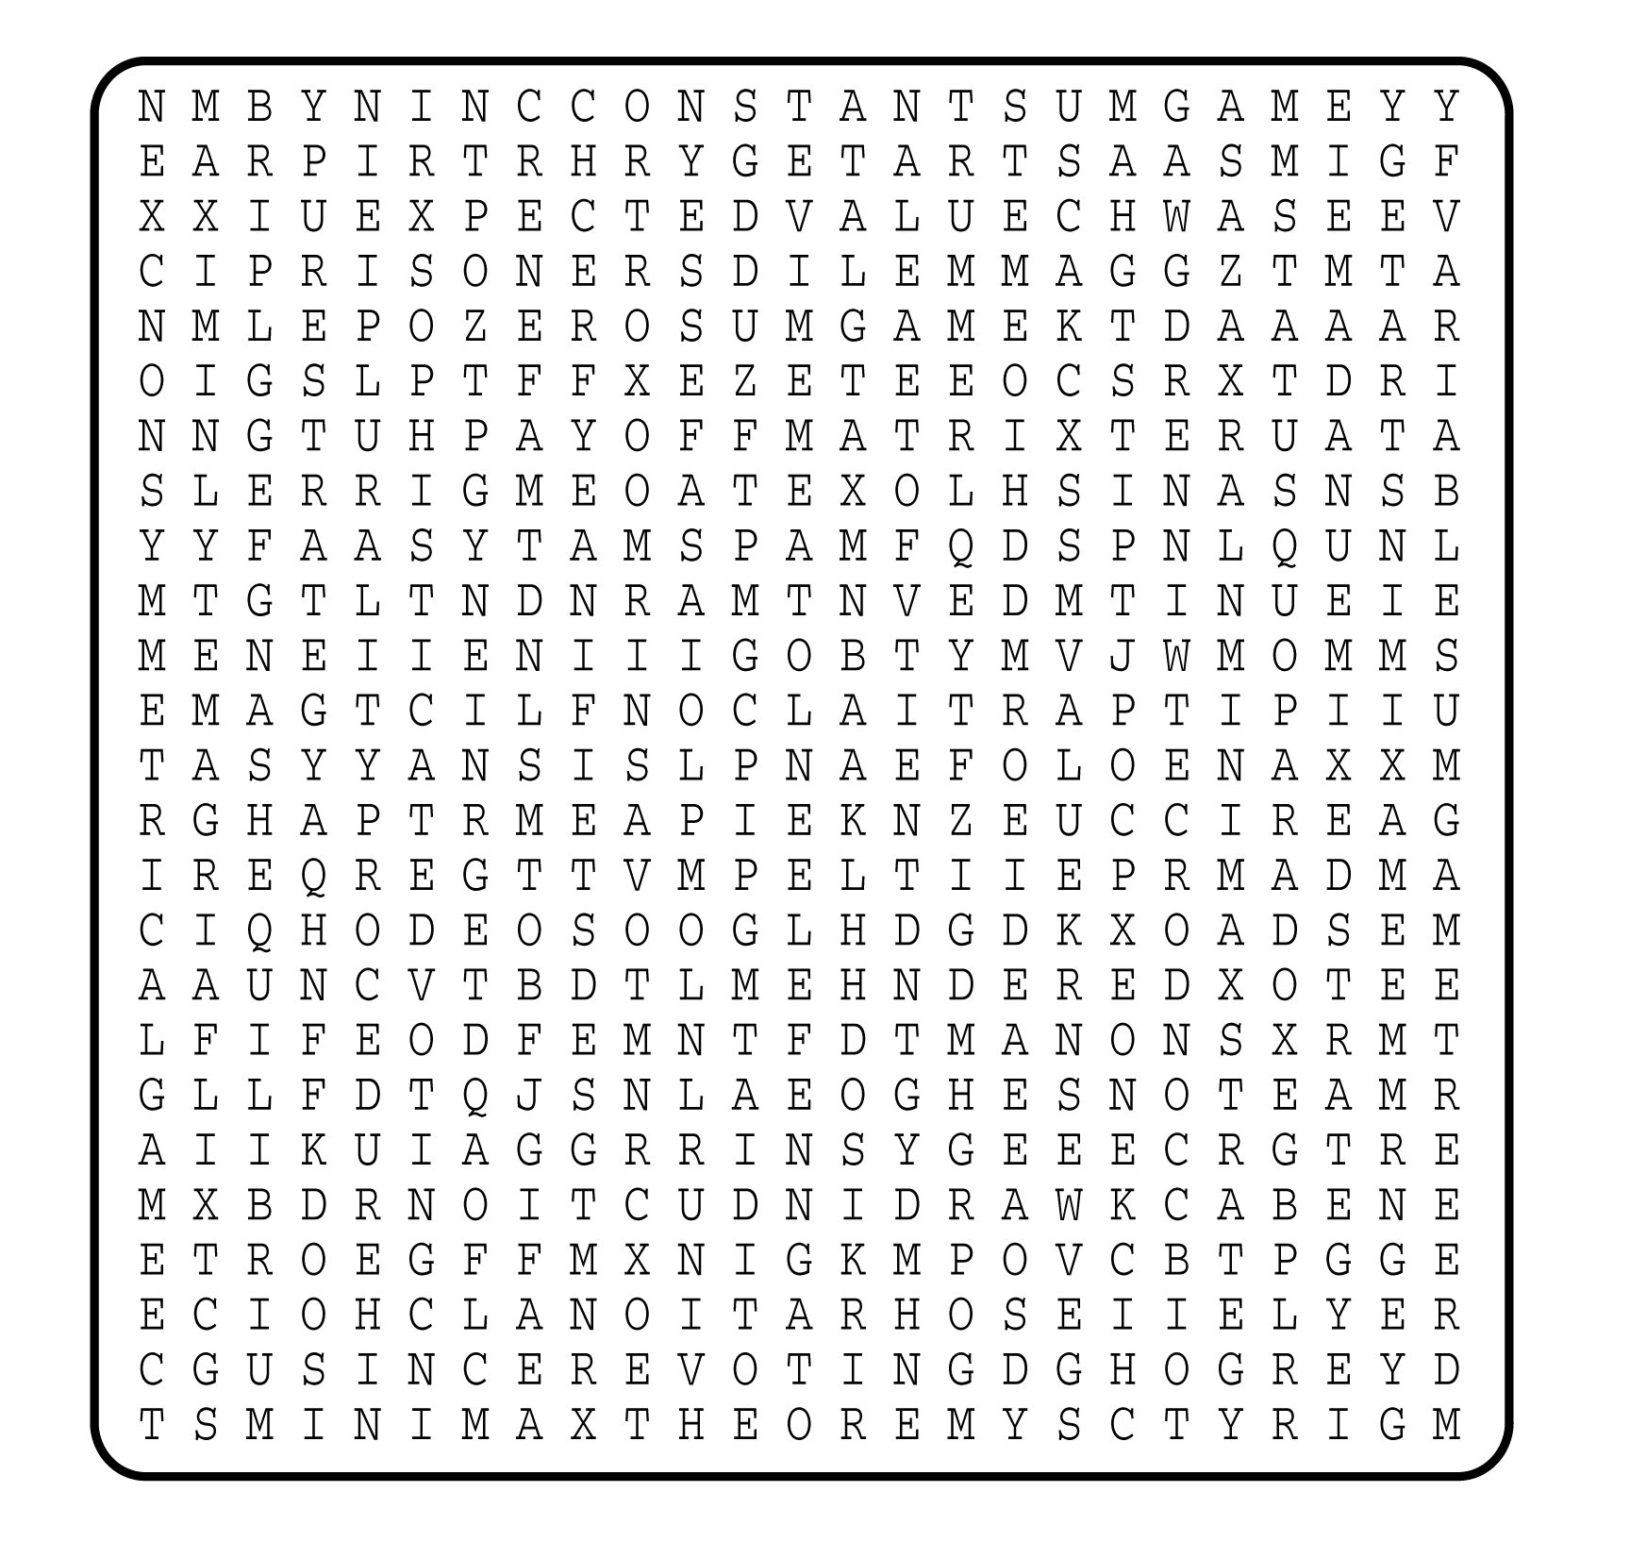

1. __________________________
2. __________________________
3. __________________________
4. __________________________
5. __________________________
6. __________________________
7. __________________________
8. __________________________
9. __________________________
10. __________________________
11. __________________________
12. __________________________
13. __________________________
14. __________________________
15. __________________________
16. __________________________
17. __________________________
18. __________________________
19. __________________________
20. __________________________
21. __________________________
22. __________________________
23. __________________________
24. __________________________
25. __________________________
26. __________________________
27. __________________________
28. __________________________
29. __________________________
30. __________________________
31. __________________________
32. __________________________
33. __________________________
34. __________________________

