Chapter 12

Electing the President

chapter Objectives
Check off these skills when you feel that you have mastered them.
 Define a voter distribution.
 Describe a symmetric voter distribution.
 Identify the modes in a voter distribution.
 Describe a unimodal voter distribution.
 Know how to find the median and mean of a voter distribution.
 Explain the meaning of a candidate’s maximin position.
 Explain the meaning of an equilibrium position.
 State the median-voter theorem.
 Understand the meaning of the 1/3-separation obstacle.
 Understand the meaning of the 2/3-separation opportunity.
 Describe the bandwagon effect.
 Describe the spoiler problem.
 Compare sincere voting to strategic voting.
 State the poll assumption.
 Determine the Condorcet winner of an election, if one exists.
 Explain how dichotomous preferences affect a voter’s dominant strategy.
 Find the expected popular vote (EPV) and the expected electoral vote (EEV).
Guided Reading
Introduction
Presidential elections can be modeled mathematically as games, in which rules and optimal strategies can change from phase to phase. Mathematical models can be used to determine good campaign strategies at each phase, and to predict the effects that election reforms might have on campaign strategies.
Section 12.1 Spatial Models for Two-Candidate Elections
 Key idea
Voters respond to the positions that candidates take on election issues. Attitudes of voters are represented along a left-right continuum, where the left indicates a very liberal outlook and the right represents a very conservative outlook. A voter distribution is a curve that shows the number of voters who have attitudes at each point along the horizontal axis. The height of the curve indicates how many voters have attitudes at that point.
 Key idea
The mode of a voter distribution is a peak in the curve. A distribution with only one such peak is unimodal.
 Key idea
The median M is the point on the horizontal axis where half of the voters have attitudes to the left of the point M and half of the voters have attitudes to the right of the point M. If the curve to the left of M is a mirror image of the curve to the right of M, the distribution is symmetric.
 Key idea
A candidate’s position is maximin if there is no other position that will guarantee more votes for that candidate, no matter what position the other candidate may take.
 Key idea
Once both candidates have chosen their positions, the positions are in equilibrium if neither candidate has motivation to change his or position independently.
 Key idea
The median-voter theorem states that for a two-candidate election with an odd number of voters, M is the unique equilibrium position.
 Key idea
In an election with n voters taking k different positions along the horizontal axis, we can call each position i and indicate the number of voters taking position i with the notation n_{i}. Using as the location of position i along the horizontal axis, we can find the mean of a voting distribution using
 Example A
Consider the following distribution of 21 voters at 5 different positions over the interval [0, 1].
Position i | 1 | 2 | 3 | 4 | 5
Location of position i | 0.1 | 0.3 | 0.5 | 0.7 | 0.8
Number of voters at position i | 1 | 5 | 5 | 6 | 4
What is the mean position?
Solution
Using the formula, we have the following.
 Question 1
Consider the following distribution of 16 voters at 4 different positions over the interval [0, 1].
Position i | 1 | 2 | 3 | 4
Location of position i | 0.1 | 0.3 | 0.5 | 0.7
Number of voters at position i | 2 | 5 | 5 | 4
What is the mean position? Round to the nearest hundredth.
Answer
0.44
Section 12.2 Spatial Models for Multi-Candidate Elections
 Key idea
Suppose a distribution of voters is symmetric and unimodal, and the first two candidates have chosen different positions A and B that are equidistant from the median such that A is below the median, B is above the median, and no more than 1/3 of the voters lie between A and B. Then a third candidate cannot possibly take a position C that will displace A and B and allow C to win. This is the 1/3-separation obstacle.
 Key idea
Suppose a distribution of voters is symmetric and unimodal, and the first two candidates have chosen different positions A and B that are equidistant from the median such that A is below the median, B is above the median, and 2/3 of the voters lie between A and B. Then a third candidate can win the election by taking a position C that lies at M, halfway between A and B. This is the 2/3-separation opportunity.
 Key idea
Suppose a distribution of voters is uniform over Candidates A and B have already entered the election and anticipate a third candidate C to enter the election later. Candidates A and B should choose positions at 1/4 and at 3/4. Then there is no position at which a third candidate C can enter such that C can win, so these positions are the optimal entry positions for two candidates anticipating a third entrant.
Section 12.3 Winnowing the Field
 Key idea
The bandwagon effect provokes voters to vote for the presumed winner of an election, independent of that candidate’s merit.
 Key idea
The spoiler problem is caused by a candidate that cannot win but influences the election in such a way that an otherwise winning candidate does not win.
Section 12.4 What Drives Candidates Out?
 Key idea
Polls publicly indicate the standings of candidates in an election. This can affect the outcome of the election.
 Key idea
In plurality voting, each voter votes for only one candidate and the candidate with the most votes wins the election. A voter is voting sincerely if the voter casts a vote for his or her favorite candidate.
 Key idea
The poll assumption presumes that voters will change their sincere voting strategy to select one of the top two candidates as indicated by the poll, voting for the one they prefer.
 Key idea
A candidate that can defeat each of the other candidates in a pairwise contest is called a Condorcet winner.
 Example B
Assume there are three classes of voters that rank three candidates as follows:
I. | 3: | A | B | C
II. | 12: | C | A | B
III. | 10: | B | A | C
Which candidate is the Condorcet winner?
Solution
There is a total of 25 voters. In a pairwise comparison of A to B, A is preferred by the 3 voters in class I and the 12 voters in class II for a total of 15 votes. Only 10 people prefer B to A, so A beats B in a pairwise contest. Comparing A to C, we see that 3 voters in class I and 10 voters in class III prefer A to C, for a total of 13 votes. Only 12 people prefer C to A, so A also beats C in a pairwise comparison. Because A beats both B and C, there is no need to compare B to C. Candidate A is the Condorcet winner.
 Key idea
A Condorcet winner will always lose if he or she is not one of the top two candidates as indicated by the poll, based on the poll assumption. A Condorcet winner will always win if he or she is one of the top two candidates as indicated by the poll.
Section 12.5 Election Reform: Approval Voting
 Key idea
Approval voting allows voters to cast one vote each for as many candidates as they wish. The candidate with the most approval votes wins the election.
 Key idea
A voter may vote for a candidate that is not his or her first choice in an attempt to elect an acceptable candidate if his or her first choice is not likely to win. This is called strategic voting.
 Key idea
If approval voting is being used in a three-candidate election, it is never rational for a voter to vote only for a second choice. He or she should vote for a first choice as well.
 Key idea
A voter with dichotomous preferences divides a set of candidates into a preferred subset and a nonpreferred subset, and is indifferent among all candidates in each subset. In this case the voter can make a rational choice by choosing a strategy that is at least as good as, if not better than, any other strategy for that voter. This strategy is called a dominant strategy.
 Key idea
Under approval voting, a Condorcet winner will always win if all voters have dichotomous preferences and choose their dominant strategies.
 Example C
Suppose there are four classes of voters that rank four candidates as shown below. For each class of voters, the preferred subset of candidates is enclosed in the first set of parentheses and the non-preferred subset in the second set of parentheses. Thus, the 4 class I voters prefer A and C, between whom they are indifferent, to B and D, between whom they are also indifferent:
I. | 4: | ( A | C ) | ( B | D )
II. | 3: | ( A | B | D ) | ( C )
III. | 7: | ( B ) | ( A | C | D )
IV. | 5: | ( C ) | ( A | B | D )
Assuming that each class of voters chooses its dominant strategy, who wins?
Solution
Candidate A will get 4 votes from the first class of voters and 3 votes from the second class of voters, for a total of 7 votes. Candidate B will get 3 votes from the second class of voters and 7 votes from the third class of voters, for a total of 10 votes. Candidate C will get 4 votes from the first class of voters and 5 votes from the fourth class of voters, for a total of 9 votes. Candidate D gets only the 3 votes from the second class of voters. Candidate B has the most votes, so B wins.
Section 12.6 The Electoral College
 Key idea
The Electoral College provides 538 electoral votes, and a candidate needs 270 of these votes to win. Each state gets one vote for each of its two senators and one vote for each of its representatives in the House of Representatives. The District of Columbia also gets 3 electoral votes.
 Key idea
A state in which an election outcome is expected to be close is a toss-up state. The expected popular vote (EPV) of the Democratic candidate in toss-up states, is given by
where t is the number of toss-up states, is the number of voters in toss-up state i, and is the probability that a voter in toss-up state i votes for the Democrat candidate.
 Key idea
The Democratic candidate should allocate his or her resources in proportion to the size of each state. If is the total number of voters in the toss-up states and is the sum of the Democrat’s expenditures across the toss-up states, then the Democrat should allocate to each toss-up state i. This assumes that the Republican behaves similarly by following a strategy of where is the sum of the Republican’s expenditures across the toss-up states. This rule is called the proportional rule.
 Example D
Assume there are three states with 7, 9, and 18 voters, and they are all toss-up states. If both the Democratic and Republican candidates choose strategies that maximize their expected popular vote (the proportional rule), and they have the same total resources what resources should be allocated for each state?
Solution
so the candidates should allocate for the first state, for the second state, and for the third state.
 Key idea
If a candidate wins more than 50% of the popular votes in a state, that candidate gets all of that state’s electoral votes. If P_{i} is the probability that the Democrat wins more than 50% of the popular votes in toss-up state i, and that state has v_{i} electoral votes, then the expected electoral vote (EEV) of the Democratic candidate in toss-up states is
where is the number of electoral votes of toss-up state i, and is the probability that the Democrat wins more than 50% of the popular votes in this state, which would give the Democrat all that state’s electoral votes,
Section 12.7 Is There a Better Way to Elect a President?
 Key idea
The use of the Electoral College to determine the outcome of the presidential election has become controversial. Other election techniques, such as approval voting, could be considered instead.
Homework Help
Exercises 1 – 15
Carefully read Section 12.1 before responding to these exercises.
Exercises 16 – 23
Carefully read Section 12.2 before responding to these exercises.
Exercises 24 – 27
Carefully read Section 12.3 before responding to these exercises.
Exercises 28 – 34
Carefully read Section 12.4 before responding to these exercises.
Exercises 35 – 44
Carefully read Section 12.5 before responding to these exercises.
Exercises 45 – 53
Carefully read Section 12.6 before responding to these exercises.

Do You Know the Terms?

Cut out the following 29 flashcards to test yourself on Review Vocabulary. You can also find these flashcards at http://www.whfreeman.com/fapp7e.

Chapter 12  Electing the President  Approval voting | Chapter 12  Electing the President  Bandwagon effect
Chapter 12  Electing the President  Condorcet candidate | Chapter 12  Electing the President  Dichotomous preferences
Chapter 12  Electing the President  Discrete distribution of voters | Chapter 12  Electing the President  Dominant strategy
Chapter 12  Electing the President  Electoral College | Chapter 12  Electing the President  Equilibrium position

Voting for a candidate not on the basis of merit but, instead, because of the expectation that he or she will win. | Allows voters to vote for as many candidates as they like or find acceptable. Each candidate approved of receives one vote, and the candidate with the most approval votes wins.
Held by voters who divide the set of candidates into two subsets — a preferred subset and a nonpreferred subset — and are indifferent among all candidates in each subset. | A candidate who can defeat each of the other candidates in pairwise contests.
A strategy that is at least as good as, and sometimes better than, any other strategy. | A distribution in which voters are located at only certain positions along the left-right continuum.
A position is in equilibrium if no candidate has an incentive to depart from it unilaterally. | A body of 538 electors that selects a president.

Chapter 12  Electing the President  Expected electoral vote (EEV) | Chapter 12  Electing the President  Expected popular vote (EPV)
Chapter 12  Electing the President  Extended median | Chapter 12  Electing the President  Global maximum
Chapter 12  Electing the President  Local maximum | Chapter 12  Electing the President  Maximin position
Chapter 12  Electing the President  Mean () | Chapter 12  Electing the President  Median (M)

In toss-up states, the number of voters in each toss-up state, multiplied by the probability that that voter votes for the Democratic (or Republican) candidate, summed across all toss-up states. | In toss-up states, the number of electoral votes of each toss-up state, multiplied by the probability that the Democratic (or Republican) candidate wins more than 50% of the popular votes in that state, summed across all toss-up states.
A maximizing strategy from which all deviations (large or small) are nonoptimal. | The equilibrium position of two candidates when there is no median.
A position is maximin for a candidate if there is no other position that can guarantee a better outcome — more votes — whatever position another candidate adopts. | A maximizing strategy from which small deviations are nonoptimal but large deviations may be optimal.
The point on the horizontal axis of a voter distribution where half the voters have attitudes that lie to the left and half to the right. | A weighted average, wherein the positions of voters are weighted by the fraction of voters at that position.

Chapter 12  Electing the President  Median-voter theorem | Chapter 12  Electing the President  Mode
Chapter 12  Electing the President  1/3-separation obstacle | Chapter 12  Electing the President  Poll assumption
Chapter 12  Electing the President  Plurality voting | Chapter 12  Electing the President  Proportional rule
Chapter 12  Electing the President  Sincere voting | Chapter 12  Electing the President  Spatial models

A peak of a distribution. A distribution is unimodal if it has one peak and bimodal if it has two peaks. | In a two-candidate election with an odd number of voters, the median is the unique equilibrium position.
Voters adjust their sincere voting strategies, if necessary, to differentiate between the top two candidates — as revealed in the poll —by voting for the one they prefer. | An obstacle for the entry of a third candidate created if two previous entrants are sufficiently close together.
Presidential candidates allocate their resources to toss-up states according to their size. This allocation rule maximizes the expected popular vote of a candidate, given that his or her opponent adheres to it. It is a global maximum | Allows voters to vote for one candidate, and the candidate with the most votes wins.
The representation of candidate positions along a left – right continuum in order to determine the equilibrium or optimal positions of the candidates. | Voting for a favorite candidate, whatever his or her chances are of winning.

Chapter 12  Electing the President  Spoiler problem | Chapter 12  Electing the President  Strategic voting
Chapter 12  Electing the President  3/2’s rule | Chapter 12  Electing the President  2/3-separation opportunity

Chapter 12

Electing the President

Voter distribution

Voting that is not sincere but nevertheless has a strategic purpose —namely, to elect an acceptable candidate if one’s first choice is not viable. | Caused by a candidate who cannot win but “spoils” the election for a candidate who otherwise would win.
An opportunity for the entry of a third candidate created if two previous entrants are sufficiently far apart. | Presidential candidates allocate their resources to toss-up states according to the 3/2’s power of their electoral votes. This allocation rule maximizes the expected electoral vote of a candidate, given that his or her opponent adheres to it. It is a local maximum.
 | Gives the number (or percentage) of voters who have attitudes at each point along the left–right continuum, which can be represented by a curve. The distribution is symmetric if the curve to the left of the median is a mirror image of the curve to the right. It is skewed if the area under the curve is concentrated more on one side of the median than the other.

Practice Quiz
1. In a two-candidate election, assume the attitudes of the voters are symmetrically distributed with median M. If candidate A takes a position at M and candidate B takes a position to the left of M, then
a. B gets the majority of the votes.
b. A gets at least 50% of the votes.
c. A and B each get 50% of the votes.
2. Find the median, M, for the discrete distribution of n = 16 voters at k = 9 different positions over the interval shown in the table below.
Position i | 1 | 2 | 3 | 4 | 5 | 6 | 7 | 8 | 9
Location of position i | 0.1 | 0.2 | 0.3 | 0.4 | 0.5 | 0.6 | 0.7 | 0.8 | 0.9
Number of voters at position i | 2 | 2 | 3 | 0 | 2 | 1 | 5 | 1 | 0
a. 0.7
b. 0.4
c. 0.5
3. Find the mean, for the discrete distribution of n = 16 voters at k = 9 different positions over the interval shown in the table below.
Position i | 1 | 2 | 3 | 4 | 5 | 6 | 7 | 8 | 9
Location of position i | 0.1 | 0.2 | 0.3 | 0.4 | 0.5 | 0.6 | 0.7 | 0.8 | 0.9
Number of voters at position i | 2 | 2 | 3 | 0 | 2 | 1 | 5 | 1 | 0
a. 0.46
b. 0.50
c. 0.70
4. In a three-candidate race, candidates A and B take a position equidistant from the median, M, of a symmetric unimodal distribution and no more than of the voters lie between them. What position should candidate C take to win?
a. C should take a position on either side of M.
b. C should take a position at M.
c. No position will result in a win for C.
5. An election procedure in which each voter votes for one candidate and the candidate with the most votes wins is called ________ .
a. plurality voting.
b. approval voting.
c. Condorcet winner.
6. Fourteen voters list their voter preference for candidates A, B, and C according to the table below.
I. | 5: | A | B | C
II. | 3: | C | A | B
III. | 6: | B | C | A
Which of the following is true?
a. The plurality winner is A.
b. The plurality winner is B.
c. The plurality winner is C.
7. Fourteen voters list their voter preference for candidates A, B, and C according to the table below.
I. | 5: | A | B | C
II. | 3: | C | A | B
III. | 6: | B | C | A
Which of the following is true?
a. The Condorcet winner is Candidate B.
b. The Condorcet winner is Candidate C.
c. There is no Condorcet winner.
8. In a four-candidate race, 34 voters list their voter approval for candidates A, B, C and D according to the table below. The candidate that wins under approval voting is ________ .
 | 10 | 13 | 11

A
B
C
D
a. Candidate A
b. Candidates B and D
c. Candidate C
9. Suppose there are four toss-up states with 2, 3, 3, and 4 electoral votes. If the Republican follows the optimal strategy of spending $60,000,000 in the proportion 2:3:3:4 and the Democrat spends in the proportion 0:3:3:4, the Republican receives on average an expected popular vote of _________ .
a. 5.45 votes
b. 6.55 votes
c. 10.0 votes
10. Suppose that states A, B, and C have, respectively, 4, 9, and 25 voters, and these are also their numbers of electoral votes. If each of these states is a toss-up state, the 3/2’s rule says that the candidates should allocate their resources in the proportions
a. 4:9:25
b. 16:81:625
c. 8:27:125
Word Search
Refer to pages 463 – 464 of your text to obtain the Review Vocabulary. There are 26 hidden vocabulary words/expressions in the word search below. 2/3-separation opportunity, 3/2’s rule, and 1/3-separation obstacle were omitted from the word search. Mode and Spatial Models appear separately. It should be noted that spaces and hyphens are removed.
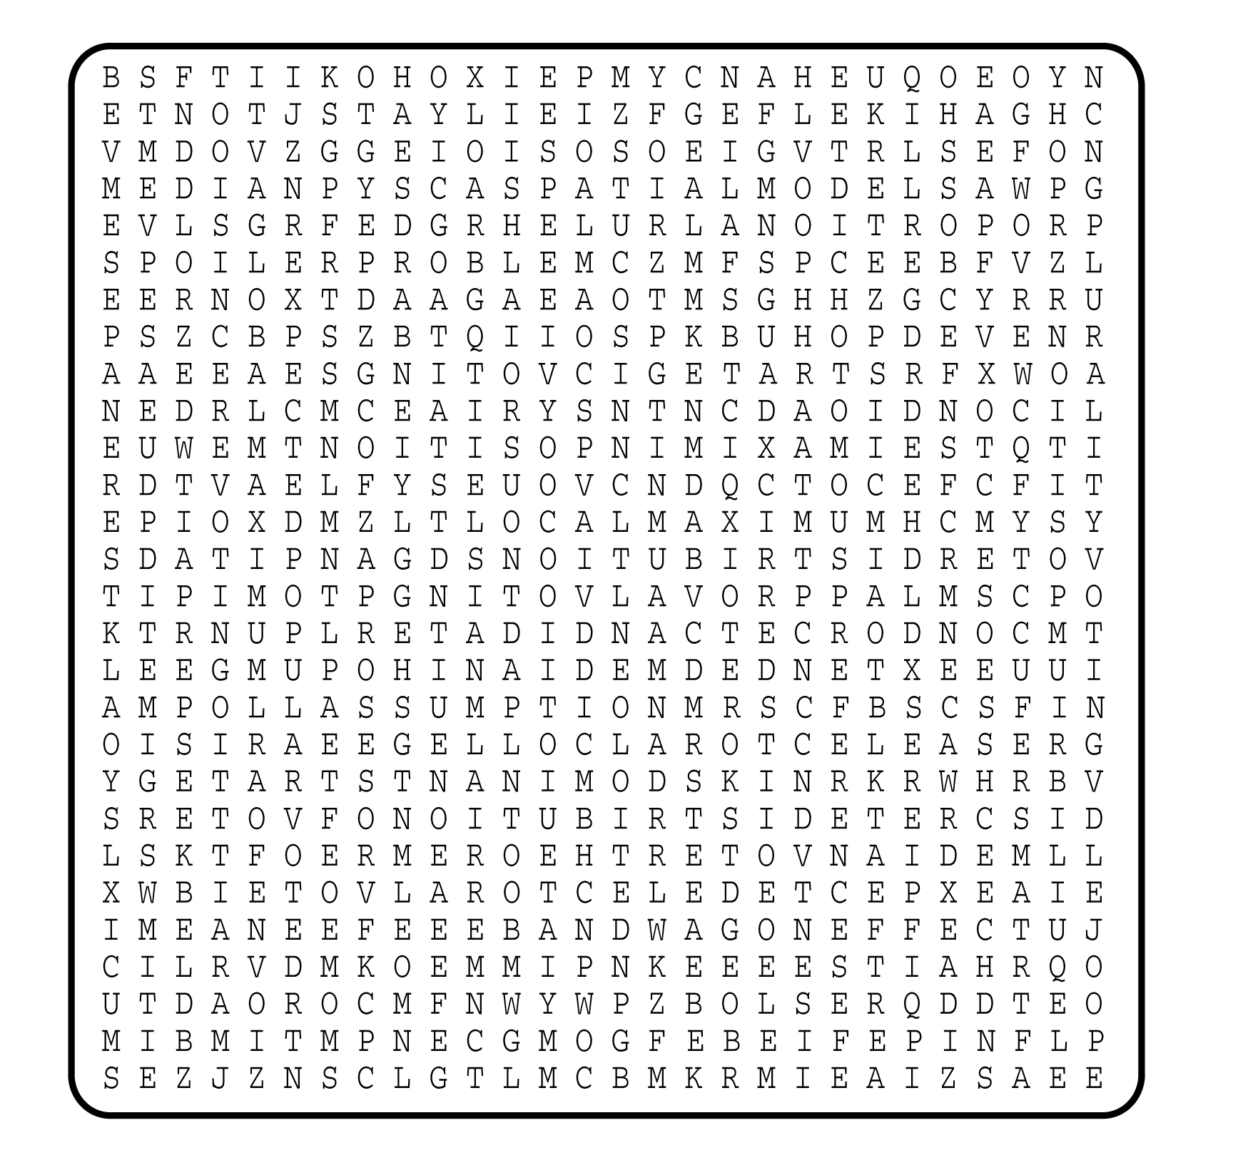

1. __________________________
2. __________________________
3. __________________________
4. __________________________
5. __________________________
6. __________________________
7. __________________________
8. __________________________
9. __________________________
10. __________________________
11. __________________________
12. __________________________
13. __________________________
14. __________________________
15. __________________________
16. __________________________
17. __________________________
18. __________________________
19. __________________________
20. __________________________
21. __________________________
22. __________________________
23. __________________________
24. __________________________
25. __________________________
26. __________________________

