Chapter 11

Weighted Voting Systems

chapter Objectives
Check off these skills when you feel that you have mastered them.
 Interpret the symbolic notation for a weighted voting system by identifying the quota, number of voters, and the number of votes each voter controls.
 Identify if a dictator exists in a given weighted voting system.
 Identify if a dummy exists in a given weighted voting system.
 Identify if a single voter has veto power in a given weighted voting system.
 Calculate the number of permutations of voters in a given weighted voting system.
 List the possible permutations for a three- or four-voter weighted voting system.
 Given a permutation of voters, identify the pivotal voter.
 Calculate the Shapley-Shubik index for a three- or four-voter weighted voting system.
 Identify winning coalitions by analyzing a given weighted voting system.
 Identify blocking coalitions by analyzing a given weighted voting system.
 When given a specific winning or blocking coalition from a weighted voting system, determine the critical voters.
 Determine the extra votes for a winning coalition.
 Calculate the Banzhaf power index for a given weighted voting system.
 Determine a specific value of by using the combination formula as well as Pascal’s triangle.
 Determine if two voting systems are equivalent and when given a voting system, find an equivalent system.
 Explain the difference between a winning coalition and a minimal winning coalition.

Guided Reading
Introduction

There are many settings, such as shareholder elections, in which people who are entitled to vote have varying numbers of votes. In such situations, the actual number of votes each can cast may not reflect the voter’s power, that is, his ability to influence the outcome of the election. Several measures of power have been introduced and two of them are studied in this chapter, the Banzhaf Power Index and the Shapley–Shubik Power Index.

 Key idea
A weighted voting system is one in which each voter has a number of votes, called his or her weight. The number of votes needed to pass a measure is called the quota. If the quota for a system with n voters is q, and the weights are then we use the notation,
 Example A
Consider the weighted voting system Determine the number of voters and their weights. State the quota.
Solution
There are 4 voters. Their weights are 17, 28, 15, and 22. The quota is 43.

 Key idea
A dictator is a voter whose weight is greater than or equal to the quota. Thus, if the dictator is in favor of a motion, it will pass. Moreover, a motion will fail if the dictator is against it, independent of how the other voters vote.

 Key idea
A dummy is one whose vote will never be needed to pass or defeat any measure. Independent of how the dummy voter votes, the outcome will not change.
 Example B
List any dummy in the weighted voting system
Solution
Voter D is a dummy voter. If D joined forces with any other single voter, their combined weight is not enough to win. If D joined forces with any other two voters, D’s weight is not enough to alter the result. If a motion was to pass (A and B or A and C) then D has no influence, it will still pass. If the motion was to fail (B and C) then D has no influence, it will still fail. If D joins all three other voters, again D has no influence. The motion will pass.

 Key idea
With different quotas, the distribution of power can be altered.
 Example C
Consider the weighted voting system Do we have any dummy voters?
Solution
There are no dummy voters. In Example B, voter D was a dummy because he or she had no influence on the outcome. With a quota of 13, voter D can make a motion pass by joining A and C.

 Key idea
A single voter has veto power if no issue can pass without his or her vote. Note that this is different from a dictator because the voter with veto power does not need to have a weight of the quota or greater.
 Example D
Consider the weighted voting system Does any voter have veto power.
Solution
Voter A has veto power. Even if all the other voters B, C, and D all vote for a motion to pass, the sum of their weights is less than the quota.
Section 11.1 The Shapley-Shubik Power Index

 Key idea
A permutation of voters is an ordering of all the voters. There is (n factorial) permutations of n voters where
 Example E
Consider the weighted voting system How many permutation of voters are there?
Solution
There are 5 voters. Thus, there are permutations of voters.

 Key idea
The first voter in a permutation who, when joined by those coming before him or her, would have enough voting weight to win is called the pivotal voter of that permutation. Each permutation has exactly one pivotal voter.

 Key idea
The Shapley–Shubik power index of a voter is the fraction of the permutations in which that voter is pivotal.
 Example F
Calculate the Shapley–Shubik power index for each of the voters in the weighted voting system
Solution
There are 3 voters. Thus, there are permutations of voters.
Permutations | Weights
A B C | 6 9 11
A C B | 6 8 11
B A C | 3 9 11
B C A | 3 5 11
C A B | 2 8 11
C B A | 2 5 11
Since A is the pivotal voter 4 times, B is pivotal 1 time, and C is pivotal 1 time, the Shapley–Shubik power index for this weighted system is
 Question 1
Calculate the Shapley–Shubik power index for each of the voters in the weighted voting system
Answer
 Question 2
Calculate the Shapley–Shubik power index for each of the voters in the weighted voting system
Answer

 Key idea
When the number of voters is large, then the number of permutations is large. If there are 5 voters then there are permutations. If there are 6 voters then there are permutations and a direct calculation of the Shapley–Shubik index would be difficult. If, however, many of the voters have equal votes, it is possible to compute this index by counting the number of permutations.
 Example G
Calculate the Shapley–Shubik power index for each of the voters in the weighted voting system
Solution
There are 5 voters. Thus, there are permutations of voters. A is pivotal in the following three types of permutations.
Permutations |  |  |  |  | Weights
 | A |  |  |  | 1 | 4 | 5 | 6 | 7
 |  | A |  |  | 1 | 2 | 5 | 6 | 7
 |  |  | A |  | 1 | 2 | 3 | 6 | 7
For each of these permutation types, there are associated permutations. Thus, there is a total of in which A is pivotal. Thus, the Shapley–Shubik power index for A is The remaining four voters share equally the remaining of the power. Thus, each of them has an index The Shapley–Shubik power index for this weighted system is therefore
 Question 3
Calculate the Shapley–Shubik power index for each of the voters in the weighted voting system without determining all possible permutations.
Answer
 Question 4
Calculate the Shapley–Shubik power index for each of the voters in the weighted voting system without determining all possible permutations.
Answer

Section 11.2 The Banzhaf Power Index
 Key idea
A coalition is a set of voters that vote collectively in favor of or opposed to a motion. A winning coalition is a combination of voters with enough collective weight to pass a measure. A blocking coalition is a group of voters who have a sufficient number of votes to block a measure from passing. Note that a one-person blocking coalition is said to have veto power.
 Example H
List all of the winning coalitions in the weighted voting system given by
Solution
None of the voters have enough votes to individually make a motion pass.
The coalition {A, B}, with 5 + 3 = 8 votes, exceeds the quota of 7.
The coalition {A, C}, with 5 + 2 = 7 votes, matches the quota of 7.
The coalition {B, C}, with 3 + 2 = 5 votes, is less than the quota of 7 and is thus a losing coalition.
The coalition {A, B, C}, with 5 + 3 + 2 = 10 votes, exceeds the quota of 7.
Thus, the winning coalitions are {A, B}, {A, C}, and all three voters, {A, B, C}.
 Key idea
A voter is critical to a winning or blocking coalition if he can cause that coalition to lose by single-handedly changing his vote. Note that some winning coalitions have several critical voters, while others have none at all.
 Example I
In the weighted voting system {A, B, D} is a winning coalition. Find the critical voters in this coalition.
Solution
The coalition {A, B, D}, with 8 + 6 + 1 = 15 votes, exceeds the quota of 12. If A drops out then the coalition {B, D}, with 6 + 1 = 7 votes, has less than the quota of 12. If B drops out then the coalition {A, D}, with 8 + 1 = 9 votes, has less than the quota of 12. If D drops out then the coalition {A, B}, with 8 + 6 = 14 votes, has more than the quota of 12. Thus, A and B are critical voters.
 Key idea
A winning coalition must have a total weight of q or more. If w is the weight of the winning coalition, then that winning coalition has extra votes. Any voter that has a weight that exceeds the number of extra votes will be critical to that coalition.
 Example J
In the weighted voting system coalition {B, C, D} is a winning coalition. How many extra votes does it have, and which are the critical voters?
Solution
The coalition {B, C, D}, with 5 + 3 + 2 = 10 votes, exceeds the quota of 8. Thus, there are 2 extra votes. Since the weights of B and C exceed 2, they are both are critical.
 Key idea
If the combined weight of all voters is n voters, then a blocking coalition must have a weight more than Since votes are integer values, the blocking coalition must have a weight of at least
 Key idea
A voter’s Banzhaf power index equals the number of distinct winning coalitions in which he is a critical voter. To determine this index for a voting system, perform the following.
- Make a list of the winning and blocking coalitions.
- Determine the number of extra votes a coalition has in order to identify the critical voters.
 Example K
Consider the weighted voting system Find the Banzhaf power index for the system. Is there a dummy in this system?
Solution
The winning coalitions are those whose weights sum to 12 or more.
Winning coalition | Weight | Extra votes | Critical votes
Winning coalition | Weight | Extra votes | A | B | C | D
{A, B} | 14 | 2 | 1 | 1 | 0 | 0
{A, C} | 12 | 0 | 1 | 0 | 1 | 0
{A, B, C} | 18 | 6 | 1 | 0 | 0 | 0
{A, B, D} | 15 | 3 | 1 | 1 | 0 | 0
{A, C, D} | 13 | 1 | 1 | 0 | 1 | 0
{A, B, C, D} | 19 | 7 | 1 | 0 | 0 | 0
 |  |  | 6 | 2 | 2 | 0
The combined weight of all voters is 19. A blocking coalition must have a weight of or more.
Blocking coalition | Weight | Extra votes | Critical votes
Blocking coalition | Weight | Extra votes | A | B | C | D
{A} | 8 | 0 | 1 | 0 | 0 | 0
{A, B} | 14 | 6 | 1 | 0 | 0 | 0
{A, C} | 12 | 4 | 1 | 0 | 0 | 0
{A, D} | 9 | 1 | 1 | 0 | 0 | 0
{B, C} | 10 | 2 | 0 | 1 | 1 | 0
{A, B, C} | 18 | 10 | 0 | 0 | 0 | 0
{A, B, D} | 15 | 7 | 1 | 0 | 0 | 0
{A, C, D} | 13 | 5 | 1 | 0 | 0 | 0
{B, C, D} | 11 | 3 | 0 | 1 | 1 | 0
{A, B, C, D} | 19 | 11 | 0 | 0 | 0 | 0
 |  |  | 6 | 2 | 2 | 0
Adding the number of times each voter is critical in either a winning coalition or blocking coalition, the Banzhaf index of this system is D has an index of 0 and is a dummy.
 Key idea
The number of winning coalitions in which a voter is critical is equal to the number of blocking coalitions in which the same voter is critical. This is known as winning/blocking duality. Thus, to calculate a voter’s Banzhaf power index, one can double the number of times that voter is critical in a winning coalition.
 Question 5
Consider the weighted voting system Find the Banzhaf power index for the system. Is there a dummy in this system?
Answer
; No.
 Key idea
A voting combination is a record of how the voters cast their votes for or against a given proposition. Since there are only two outcomes, in favor or against, n voters can have voting combinations. If a vote against (no) a proposition is cast, that voter can be represented by a 0. If a vote for (yes) a proposition is cast, that voter can be represented by a 1. Thus, a voting combination can be sequence of 0’s and/or 1’s.
 Key idea
A sequence made up of 0’s and/or 1’s (bits) can represent a binary number or a base-2 number. One should be able to express a number (base 10) in binary form (base 2) and vice versa. Generating powers of 2 is often helpful in such conversions.
 | 0 | 1 | 2 | 3 | 4 | 5 | 6 | 7
 | 1 | 2 | 4 | 8 | 16 | 32 | 64 | 128

 | 8 | 9 | 10 | 11 | 12 | 13 | 14
 | 256 | 512 | 1024 | 2048 | 4096 | 8192 | 16,384
 Example L
a) Express the binary number 1001110 in a standard form (base 10).
b) Express 10,134 in binary notation.
Solution
a)
b) Since represents the largest power of 2 that doesn’t exceed 10134, we start there.
Thus, the nonzero bits are Thus, we have the following.
 Key idea
The number of voting combinations with n voters and exactly k “yes” votes can be determined by finding This value can be found by using the combination formula, Since there is only one way to obtain all “no” votes or all “yes” votes, it should be noted that This does agree with the combination formula.
and
 Example M
Use the combination formula to find
Solution
 Key idea
The duality formula for combinations is and the addition formula is
Using the addition formula, the pattern known as Pascal’s Triangle can be justified. The first 11 rows are displayed below.
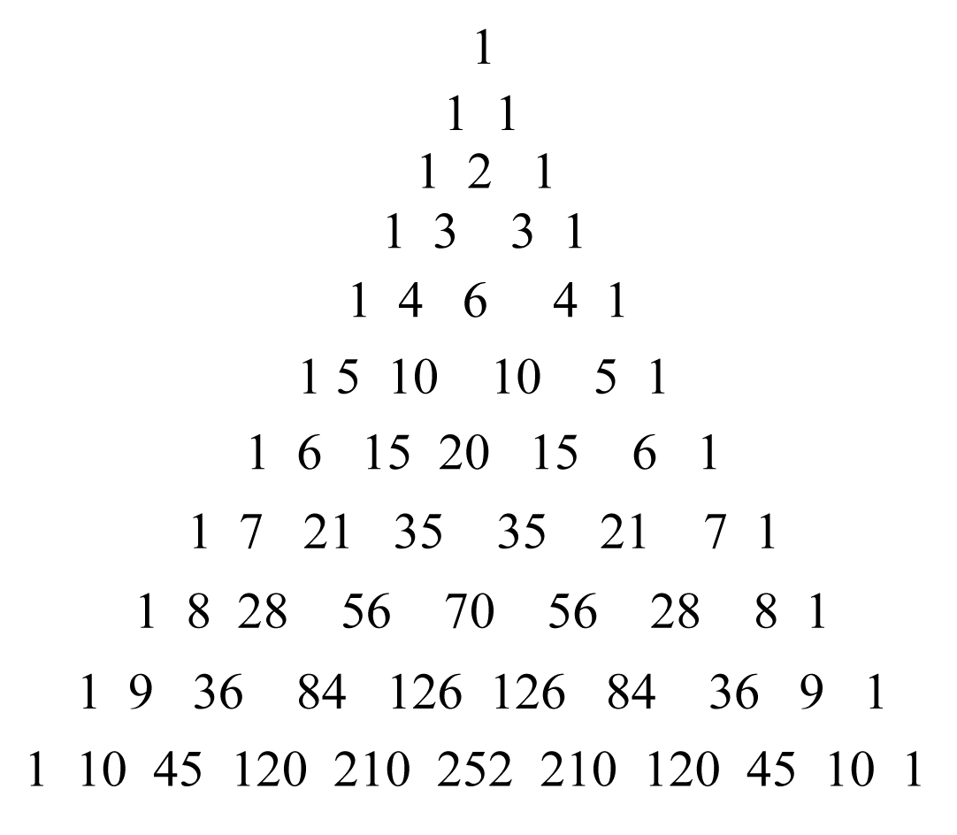
Pascal’s triangle is useful in finding values of where n is relatively small.
 Example N
Use Pascal’s triangle to find
Solution
With the very top 1 being the starting place (0th row), go down to the 7th row and to the 5th entry (starting with the 0th entry).
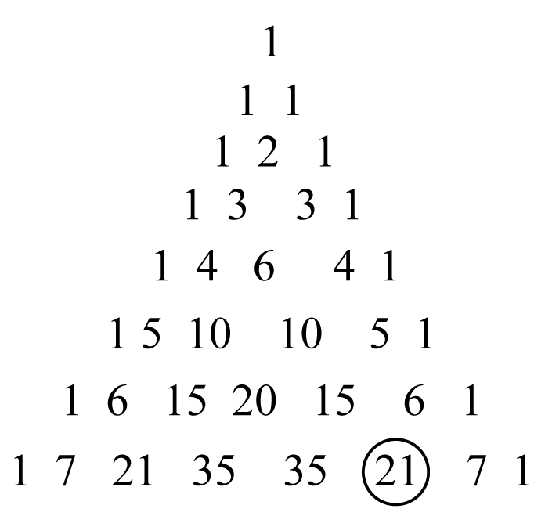
Thus,
 Key idea
When there are many voters, the number of winning coalitions can be very large, and calculating the Banzhaf index will then be cumbersome. However, there are settings in which most, but not all, of the voters have equal weights. In such situations, we can compute the Banzhaf index by means of combinations, using the numbers
 Example 0
Consider the weighted voting system Find the Banzhaf power index for the system.
Solution
A is a critical voter in just two types of winning coalitions. One in which there are no extra votes or 1 extra vote. indicates a weight-one voter, where i =1, 2, 3, or 4.
Winning coalition | Weight | Extra votes
 | 4 | 0
 | 5 | 1
In the first situation, the two additional voters are drawn from the four other voters, and there are ways of choosing these two voters. Similarly, in the second case, there are ways of choosing three voters from among four. Hence, A is critical to 10 winning coalitions, and there are 10 blocking coalitions in which he is also critical, so that his Banzhaf index is 20. Now let us consider one of the voters with just one vote, say B, who is also critical in two types of winning coalitions.
Winning coalition | Weight | Extra votes
 | 4 | 0
 | 4 | 0
In the first situation, the additional voter is drawn from three other voters. and there are ways of choosing this voter. Similarly, in the second case, there is way of choosing three voters from among three. This, together with an equal number of blocking coalitions in which he is critical, yields a Banzhaf index of 8.
Thus, the Banzhaf power index for the system
 Question 6
Consider the weighted voting system Find the Banzhaf power index for the system.
Answer

Section 11.3 Comparing Voting Systems
 Key idea
Many voting systems are not presented as weighted voting systems, but are equivalent to weighted systems. Two voting systems are equivalent if there is a way to exchange all voters from the first system with voters of the second while maintaining the same winning coalitions.
 Key idea
A minimal winning coalition is one in which each voter is critical to the passage of a measure; that is, if anyone defects, then the coalition is turned into a losing one.
 Example P
Consider the weighted voting system Find the minimal winning coalitions.
Solution
The winning coalitions are {A, B}, {A, C}, and {A, B, C} with weights 8, 7, and 10, respectively. Of these only {A, B} and {A, C} are minimal.
 Key idea
A voting system can be described completely by stating its minimal winning coalitions. There are three requirements of this list of winning coalitions.
- You must have at least one coalition on the list; otherwise, a motion can’t pass.
- A minimal coalition cannot be contained in another minimal one. This would contradict the idea that this is a minimal winning coalition.
- Every pair of minimal winning coalitions should overlap; otherwise, two opposing motions can pass.
 Example Q
A small club has 5 members. A is the President, B is the Vice President, and C, D, and E are the ordinary members. The minimal winning coalitions are A and B, A and any two of the ordinary members, and B and all three of the ordinary members. Express this situation as an equivalent weighted voting system.
Solution
There are many answers possible. Consider assigning a weight of 1 to each regular committee member. Then assign a weight to the Vice President and finally to the President with both based on the voting requirements. One possible answer is therefore Another possibility would be to assign a weight of 2 to each regular committee member. We could therefore have the following
Homework Help
Exercises 1 – 4
Carefully read the Introduction before responding to these exercises. Be familiar with how to read a weighted voting system and know the key words such as dictator, veto power, and dummy.
Exercises 5 – 6
Carefully read Section 11.1 before responding to these exercises. Be familiar with the role of a pivotal voter.
Exercises 7 – 9
Carefully read Section 11.1 before responding to these exercises. When determining permutations in which a voter is pivotal, first determine under what conditions (like position) a voter is pivotal. Then systematically list those permutations out in Exercise 7. When calculating the Shapley-Shubik power index of this weighted voting system, recall there are permutations, where n is the number of voters in the system.

Exercise 10
Calculate the ratio of Bush to Kerry votes if 1000 were taken from Bush and 1000 were added to Kerry. Interpret the results given in Table 11.2 in Section 11.1.
Exercise 11
Be consistent with the labeling of the voters. One way is to let the first bit on the left correlate to Voter A.
Exercise 12
Carefully read Section 11.2 before responding to this exercise. There are eight winning coalitions. You may find the following table helpful. Place a 1 in the voter’s column if he or she is critical to the winning coalition. Otherwise, place a 0.
Winning coalition | Weight | Extra votes | Critical votes
Winning coalition | Weight | Extra votes | A | B | C | D
Determine the weight needed for a coalition to be a blocking coalition. There are six blocking coalitions in which the weight-30 voter (Voter A) is critical. To determine a blocking coalition’s dual winning coalition in which the same voter is critical, determine the voters that don’t appear in that blocking coalition and then include the weight-30 voter (Voter A).
Exercise 13
Carefully read Section 11.2 before responding to this exercise. Let’s call the voters A, B, C, and D. This weighted voting system can be written as
(a) Copy the table of coalitions we made for Exercise 12, reducing the extra votes of each by 1. label any losing coalition.
Winning coalition | Weight | Extra votes | Critical votes
Winning coalition | Weight | Extra votes | A | B | C | D
Double to account for blocking coalitions.
(b)
We copy the table from Part (a), dropping the losing coalition and reducing quotas by 3. One more coalition will lose.
Winning coalition | Weight | Extra votes | Critical votes
Winning coalition | Weight | Extra votes | A | B | C | D
Double to account for blocking coalitions.
(c)
We copy the table from Part (b), dropping the losing coalition and reducing quotas by 3. One more coalition will lose.
Winning coalition | Weight | Extra votes | Critical votes
Winning coalition | Weight | Extra votes | A | B | C | D
Double to account for blocking coalitions.

Continued on next page
Exercise 13 continued
(d)
We copy the table from Part (c), dropping the losing coalition and reducing quotas by 15. One more coalition will lose. One of the voters will acquire veto power.
Winning coalition | Weight | Extra votes | Critical votes
Winning coalition | Weight | Extra votes | A | B | C | D
Double to account for blocking coalitions.
(e)
We copy the table from Part (d), dropping the losing coalition and reducing quotas by 3. One more coalition will lose.
Winning coalition | Weight | Extra votes | Critical votes
Winning coalition | Weight | Extra votes | A | B | C | D
Double to account for blocking coalitions.
(f)
We copy the table from Part (e), dropping the losing coalition and reducing quotas by 3. One more coalition will lose. In this system, one f the voters is a dummy.
Winning coalition | Weight | Extra votes | Critical votes
Winning coalition | Weight | Extra votes | A | B | C | D
Double to account for blocking coalitions.
(g)
Only one winning coalition is left, with 18 extra votes. This is less than the weight of each participant. All voters are critical. In this system, a unanimous vote is required to pass a motion.
Winning coalition | Weight | Extra votes | Critical votes
Winning coalition | Weight | Extra votes | A | B | C | D
Double to account for blocking coalitions.
Exercise 14
Carefully read Section 11.2 before responding to this exercise. In each system, the voters will be denoted A, B, ….
In Parts (a) – (d), determine the number of extra votes for each winning coalitions and how many times a voter is critical. Don’t forget to double the number in order to determine the Banzhaf power index. In Part (e), there are eight winning coalitions. The following table may be helpful.
Winning coalition | Weight | Extra votes | Critical votes
Winning coalition | Weight | Extra votes | A | B | C | D
Exercise 15
Carefully read Section 11.2 before responding to this exercise. A table of powers of 2 may be helpful. See Page 272 of this Guide.
Exercises 16 – 17
Carefully read Section 11.2 before responding to these exercises. You will need to use the formula where it is defined. Try to simplify as much as possible by canceling. Also, you may be able to use the duality formula.
Exercise 18
Carefully read Section 11.2 before responding to this exercise. Example 11.16 may be helpful. In Part (f), convert Table 11.2 into a table of percentages. The following blank table may be helpful.
Supervisor from | Population | Number of votes | Banzhaf power index
Quota |  |  | 65 | 72
North Hempstead
Oyster Bay
Glen Cove
Long Beach

Exercise 19 – 26
Carefully read Sections 11.2 and 11.3 before responding to these exercises
Exercise 27
Carefully read Section 11.3 before responding to this exercise. All four-voter systems can be presented as weighted voting systems. As indicated in the exercise, there are a total of nine. An example of one of the nine is the weighted voting system with minimal winning coalitions of {A, B}, {A, C}, and {A, D}.
Exercise 28
Carefully read Section 11.2 before responding to this exercise. Call the voters A, B, C, and D. This weighted voting system can be written as The following table may be helpful.
Winning coalition | Weight | Extra votes | Losing coalition | Weight | Votes needed
Exercise 29
Carefully read Section 11.3 before responding to this exercise. Call the voters A, B, C, and D and determine the minimal winning coalitions. Compare with each part.
Exercise 30
Carefully read Section 11.2 before responding to this exercise. To determine the Banzhaf index, refer to the table in answer 28(a). To determine the Shapley-Shubik power index, consider the permutations in which D is pivotal.
Exercise 31
Carefully read Sections 11.2 and 11.3 before responding to this exercise. In Part (b) use combinations to determine the winning committees in which the chairperson is critical. In Part (c) divide the permutations into 9 groups, according to the location of the chairperson.
Exercise 32
Carefully read Sections 11.1 - 11.3 before responding to this exercise. In Part (a) there are three separate groupings that will yield a minimal winning coalition. In Part (b) use combinations to determine the number of ways each type of person is critical in a winning coalition.
Exercise 33
Carefully read Sections 11.1 - 11.3 before responding to this exercise. There are three separate groupings that will yield a minimal winning coalition.
Exercise 34
Carefully read Sections 11.1 - 11.3 before responding to this exercise. In Part (a) determine the conditions in which one would have a minimal winning coalition. In Part (b), first determine the Banzhaf index of each permanent member. Use combinations to find this number. In Part (c) it will end up that each permanent member is 63 times as powerful as each non-permanent member.
Exercise 35 – 36
Carefully read Sections 11.1 - 11.3 before responding to these exercises.
Exercise 37
Carefully read the Section 11.1 before responding to this exercise
Exercise 38
Carefully read the Section 11.3 before responding to this exercise
Try to assign weights to make this a weighted voting system. Give each recent graduate (RG) a weight of 1, and let X be the weight of each of the rich alumni (RA). The quota will be denoted Q. Determine the minimal winning coalitions.
Exercise 39
Let and denote the rations for the two districts and the state as a whole, respectively, and let and be the numbers of votes cast for the Kerry-Edwards ticket in each entity.

Do You Know the Terms?

Cut out the following 28 flashcards to test yourself on Review Vocabulary. You can also find these flashcards at http://www.whfreeman.com/fapp7e.

Chapter 11  Weighted Voting Systems  Addition formula | Chapter 11  Weighted Voting Systems  Banzhaf power index
Chapter 11  Weighted Voting Systems  Bit | Chapter 11  Weighted Voting Systems  Binary number
Chapter 11  Weighted Voting Systems  Blocking coalition | Chapter 11  Weighted Voting Systems
Chapter 11  Weighted Voting Systems  Coalition | Chapter 11  Weighted Voting Systems  Critical voter
Chapter 11  Weighted Voting Systems  Dictator | Chapter 11  Weighted Voting Systems  Duality formula

A count of the winning or blocking coalitions in which a voter is a critical member. This is a measure of the actual voting power of that voter.
The expression of a number in base-2 notation | A binary digit: 0 or 1.
The number of voting combinations in a voting system with voters, in which voters say “Yes” and voters say “No.” This number, referred to as “n-choose-k,” is given by the formula | A coalition in opposition to a measure that can prevent the measure from passing.
A member of a winning coalition whose vote is essential for the coalition to win, or a member of a blocking coalition whose vote is essential for the coalition to block. | The set of participants in a voting system who favor, or who oppose a given motion. A coalition may be empty (if, for example, the voting body unanimously favors a motion, the opposition coalition is empty); it may contain some but not all voters, or it may consist of all the voters.
 | A participant in a voting system who can pass any issue even if all other voters oppose it and block any issue even if all other voters approve it.

Chapter 11  Weighted Voting Systems  Dummy | Chapter 11  Weighted Voting Systems  Equivalent voting systems
Chapter 11  Weighted Voting Systems  Extra votes | Chapter 11  Weighted Voting Systems  Extra-votes principle
Chapter 11  Weighted Voting Systems  Factorial | Chapter 11  Weighted Voting Systems  Losing coalition
Chapter 11  Weighted Voting Systems  Minimal winning coalition | Chapter 11  Weighted Voting Systems  Pascal’s triangle
Chapter 11  Weighted Voting Systems  Permutation | Chapter 11  Weighted Voting Systems  Pivotal voter

Two voting systems are equivalent if there is a way for all the voters of the first system to exchange places with the voters of the second system and preserve all winning coalitions. | A participant who has no power in a voting system. A dummy is never a critical voter in any winning or blocking coalition and is never the pivotal voter in any permutation.
The critical voters in the coalition are those whose weights are more than the extra votes of the coalition. For example, if a coalition has 12 votes and the quota is 9, there are 3 extra votes. The critical voters in the coalition are those with more than 3 votes. | The number of votes that a winning coalition has in excess of the quota.
A coalition that does not have the voting power to get its way. | The number of permutations of voters (or distinct objects) which is symbolized
A triangular pattern of integers, in which each entry on the left and right edges is 1, and each interior entry is equal to the sum of the two entries above it. The entry that is located units from the left edge, on the row units below the vertex, is | A winning coalition that will become losing if any member defects. Each member is a critical voter.
The first voter in a permutation who, with his or her predecessors in the permutation, will form a winning coalition. Each permutation has one and only one pivotal voter. | A specific ordering from first to last of the elements of a set; for example, an ordering of the participants in a voting system.

Chapter 11  Weighted Voting Systems  Power Index | Chapter 11  Weighted Voting Systems  Quota
Chapter 11  Weighted Voting Systems  Shapley –Shubik power index | Chapter 11  Weighted Voting Systems  Veto power
Chapter 11  Weighted Voting Systems  Voting Combination | Chapter 11  Weighted Voting Systems  Weight
Chapter 11  Weighted Voting Systems  Weighted voting system | Chapter 11  Weighted Voting Systems  Winning coalition

The minimum number of votes necessary to pass a measure in a weighted voting system. | A numerical measure of an individual voter’s ability to influence a decision, the individual’s voting power.
A voter has veto power if no issue can pass without his or her vote. A voter with veto power is a one-person blocking coalition. | A numerical measure of power for participants in a voting system. A participant’s Shapley – Shubik index is the number of permutations of the voters in which he or she is the pivotal voter, divided by the number of permutations ( if there are participants).
The number of votes assigned to a voter in a weighted voting system, or the total number of votes of all voters in a coalition. | A list of voters indicating the vote on an issue. There are a total of combinations in an n-element set, and combinations with k “yes” votes and n - k “no” votes.
A set of participants in a voting system who can pass a measure by voting for it. | A voting system in which each participant is assigned a voting weight (different participants may have different voting weights). A quota is specified, and if the sum of the voting weights of the voters supporting a motion is at least equal to that quota, the motion is approved.

Practice Quiz
1. What would be the quota for a voting system that has a total of 30 votes and uses a simple majority quota?
a. 15
b. 16
c. 30
2. A small company has three stockholders: the president and vice president hold 6 shares each, and a long-time employee holds 2 shares. The company uses a simple majority voting system. Which statement is true?
a. The long time employee is a dummy voter.
b. The employee is not a dummy, but has less power than the officers.
c. All three shareholders have equal power.
3. Which voters in the weighted voting system [12: 11, 5, 4, 2] have veto power?
a. no one
b. A only
c. Both A and B
4. The weighted voting system [12: 11, 5, 4, 2] has how many winning coalitions?
a. 1
b. 7
c. 8
5. If there are three voters in a weighted voting system, how many distinct coalitions of voters can be formed?
a. 6
b. 8
c. 9
6. Given the weighted voting system [6: 4, 3, 2, 1], find the number of extra votes of the coalition {A, B, C}.
a. 1
b. 2
c. 3
7. For the weighted voting system [10: 4, 4, 3, 2], which of the following is true?
a. A has more power than C.
b. A and C have equal power.
c. C has more power than D.
8. What is the value of ?
a. 210
b. 35
c. 28
9. Find the Banzhaf power index for voter B in the weighted voting system [12: 11, 5, 4, 2].
a. 4
b. 8
c. 10
10. Calculate the Shapley-Shubik power index for voter B in the system [12: 11, 5, 4, 2].
a.
b.
c.

Word Search
Refer to pages 421 – 422 of your text to obtain the Review Vocabulary. There are 26 hidden vocabulary words/expressions in the word search. Coalition, blocking coalition, weighted voting system, and weight all appear separately. and Voting Combination do not appear. Spaces and apostrophes are removed.
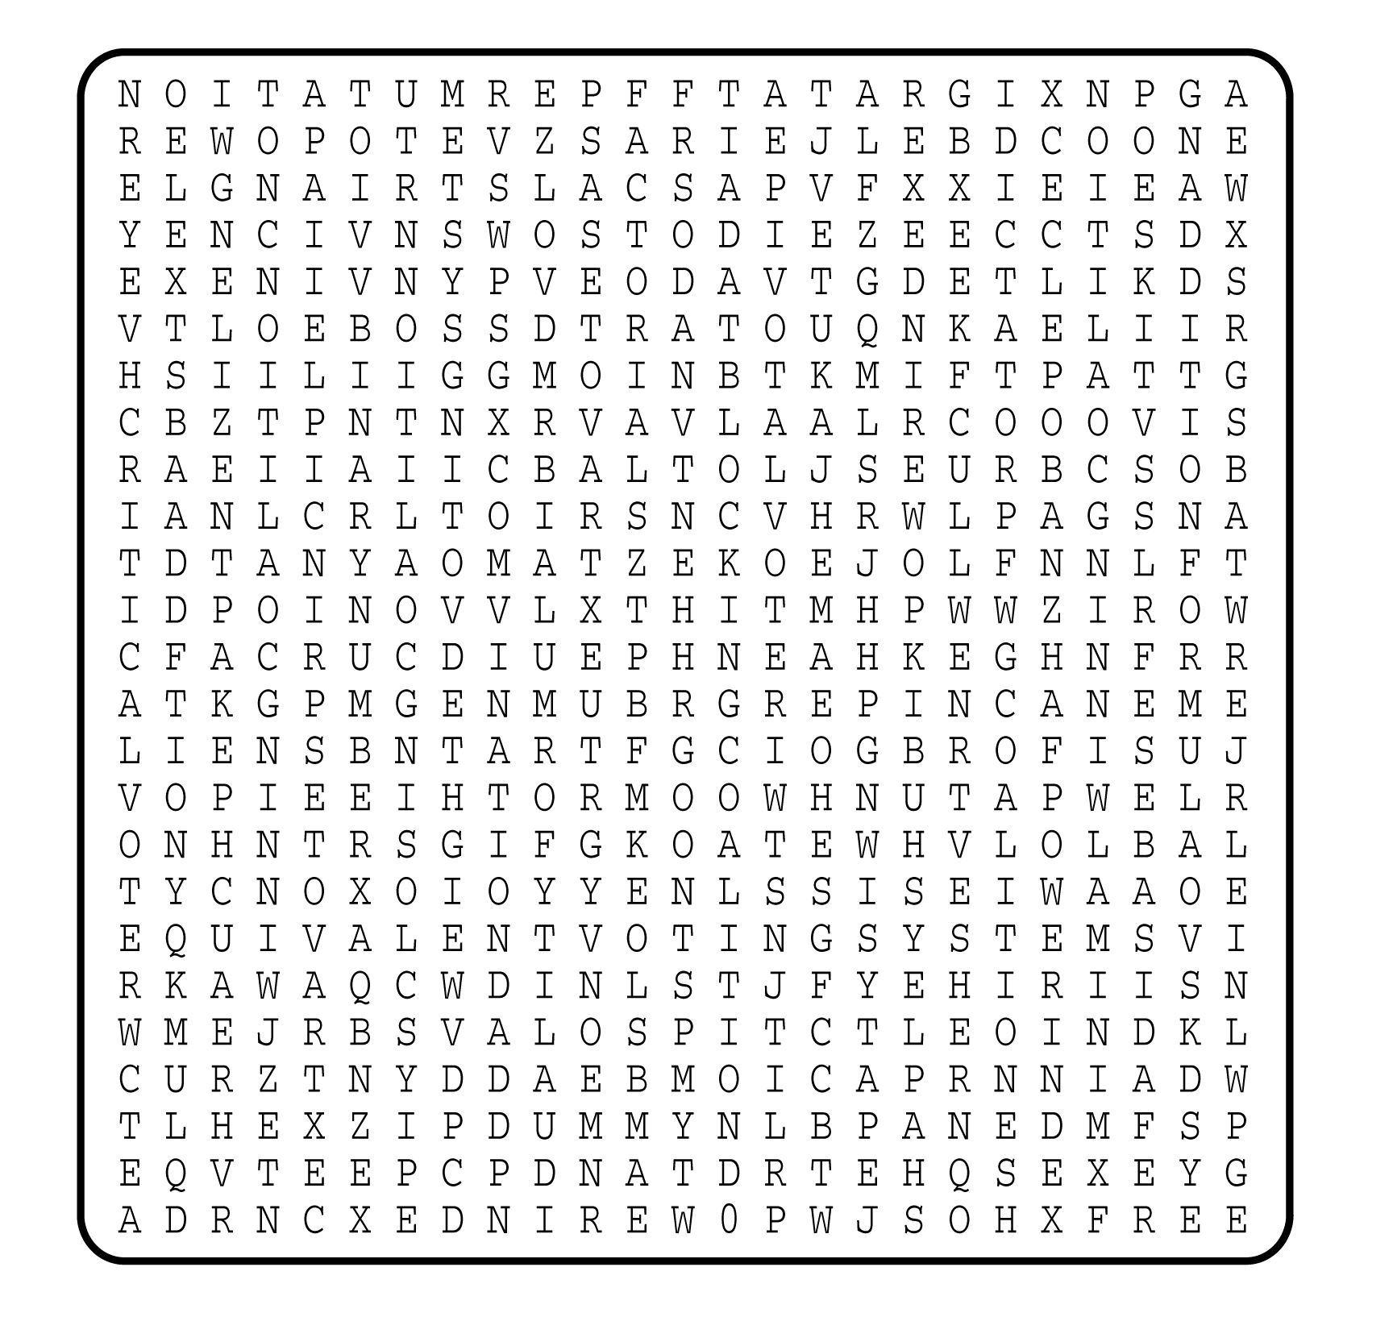

1. _________________
2. _________________
3. _________________
4. _________________
5. _________________
6. _________________
7. _________________
8. _________________
9. _________________
10. _________________
11. _________________
12. _________________
13. _________________
14. _________________
15. _________________
16. _________________
17. _________________
18. _________________
19. _________________
20. _________________
21. _________________
22. _________________
23. _________________
24. _________________
25. _________________
26. _________________

