Chapter 8

Probability: The Mathematics of Chance

chapter Objectives
Check off these skills when you feel that you have mastered them.
 Explain what is meant by random phenomenon.
 Describe the sample space for a given random phenomenon.
 Explain what is meant by the probability of an outcome.
 Describe a given probability model by its two parts.
- List and apply the four rules of probability and be able to determine the validity/invalidity of a probability model by identifying which rule(s) is (are) not satisfied.
 Compute the probability of an event when the probability model of the experiment is given.
 Apply the addition rule to calculate the probability of a combination of several disjoint events.
 Draw the probability histogram of a probability model, and use it to determine probabilities of events.
 Explain the difference between a discrete and a continuous probability model.
 Determine probabilities with equally likely outcomes.
 Use the fundamental principal of counting to determine the number of possible outcomes involved in an event and/or the sample space.
 List two properties of a density curve.
 Construct basic density curves that involve geometric shapes (rectangles and triangles) and utilize them in determining probabilities.
 State the mean and calculate the standard deviation of a sample statistic taken from a normally distributed population.
 Explain and apply the 68–95–99.7 rule to compute probabilities for the value of from a single simple random sample (SRS).
 Compute the mean and standard deviation of an outcome when the associated probability model is defined.
 Explain the significance of the law of large numbers.
 Explain the significance of the central limit theorem.
Guided Reading
Introduction
Games of chance are an application of the laws of randomness, but much more fundamental areas of human and natural activity are subject to these laws. Physics, genetics, economics, politics, and essentially any area in which large numbers of people or objects are examined or measured can best be understood via the mathematics of chance.

 Key idea
Like a roll of the dice or a coin flip, a repeatable phenomenon is random if any particular outcome is quite unpredictable, while in the long run, after a large number of repeated trials, a regular, predictable pattern emerges.
Section 8.1 Probability Models and Rules
If you perform an experiment of tossing a coin, throwing a die, or choosing a simple random sample (SRS), the outcome will not be known in advance. However, after many repetitions, a regular pattern will emerge.

 Key idea
The probability of any outcome of a random phenomenon is the proportion of times the outcome would occur in a very long series of repetitions.

 Key idea
The sample space, S, of a random phenomenon is the set of all possible outcomes.

 Key idea
An event is any outcome or any set of outcomes of a random phenomenon. That is, an event is a subset of the sample space.

 Key idea
A probability model is a mathematical description of a random phenomenon consisting of two parts as follows.
- a sample space, S
- a way of assigning probabilities to events

 Key idea
If A and B are events in sample space S, and is the probability of that event, then the following hold true.
- : Any probability is a number between 0 and 1, inclusively.
- : All possible outcomes together must have probability 1.
- : If two events (A and B) have no outcomes in common, the probability that one or the other occurs is the sum of their individual probabilities. This is the addition rule for disjoint events.
- : The probability that an event does not occur is 1 minus the probability that the event does occur. is the complement of event A, which is in sample space S.
 Example A
Consider tossing a die and flipping a coin.
a) Determine the sample space.
b) Assume a value of “0” was assigned to heads and “1” for tails. Sum together the value on the die with the assigned value on the coin. What is the probability model?
Solution
a) The sample space is {1H, 2H, 3H, 4H, 5H, 6H, 1T, 2T, 3T, 4T, 5T, 6T}.
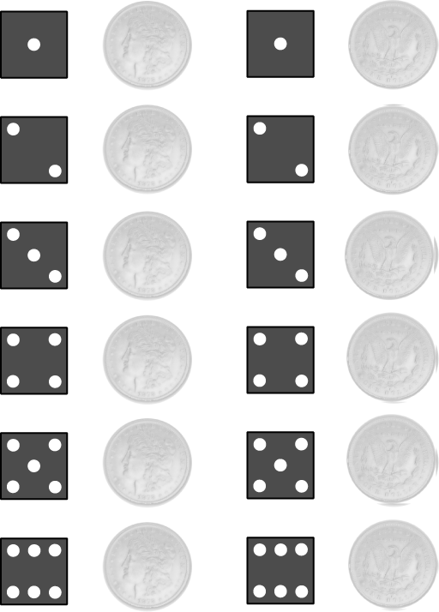
b) The probability model is as follows.
Outcome | 1 | 2 | 3 | 4 | 5 | 6 | 7
Probability
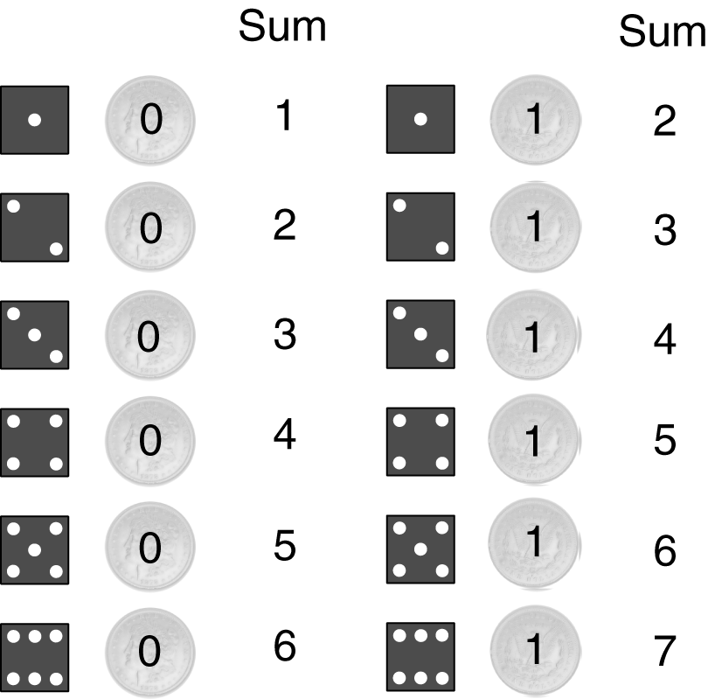
 Question 1
Consider tossing a die and flipping a coin.
a) Assume a value of “1” was assigned to heads and “3” for tails. Sum together the value on the die with the assigned value on the coin. What is the probability model?
b) What is the probability that the sum is an even number?
c) What is the complement to the event: sum is 2?
d) What is the probability that the sum is not 4?
Answer
a) The probability model is as follows.
Outcome | 2 | 3 | 4 | 5 | 6 | 7 | 8 | 9
Probability
b)
c) the sum is not 2
d)

 Key idea
The probability histogram of a probability model shows graphically the likelihood of each outcome. The height of each bar shows the probability of the outcome at its base, and the sum of the heights is 1.
 Example B
Construct the probability histogram for the probability model in Example A.
Solution
The events or obtaining a sum of 1 or 7 each have probability The other 5 events each have a probability of The probabilities are indicated by the height of each rectangle.
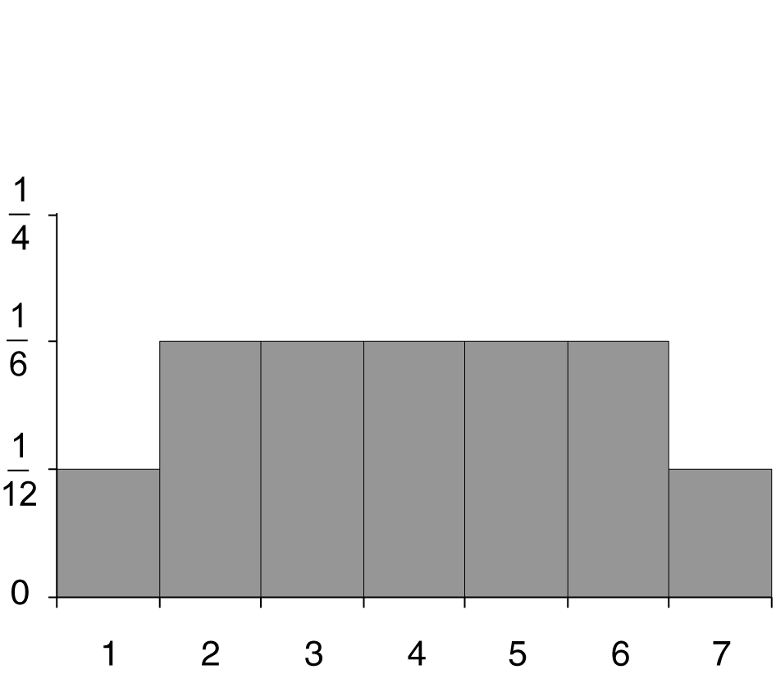
Section 8.2 Discrete Probability Models

 Key idea
A probability model with a finite sample space is called discrete. In a discrete probability model, you are able to individually list out all events in the sample space and assign probabilities to each event. These probabilities must be numbers between 0 and 1 and must have sum 1.

 Key idea
The probability of a collection of outcomes (an event) is the sum of the probabilities of the outcomes that constitute the event.
 Example C
If you roll two dice, what is the probability of rolling a sum less than or equal to 6?
Solution
A total of 6 or less means one of these events: {2, 3, 4, 5, 6}. Add up their probabilities, which can be read from the following histogram.
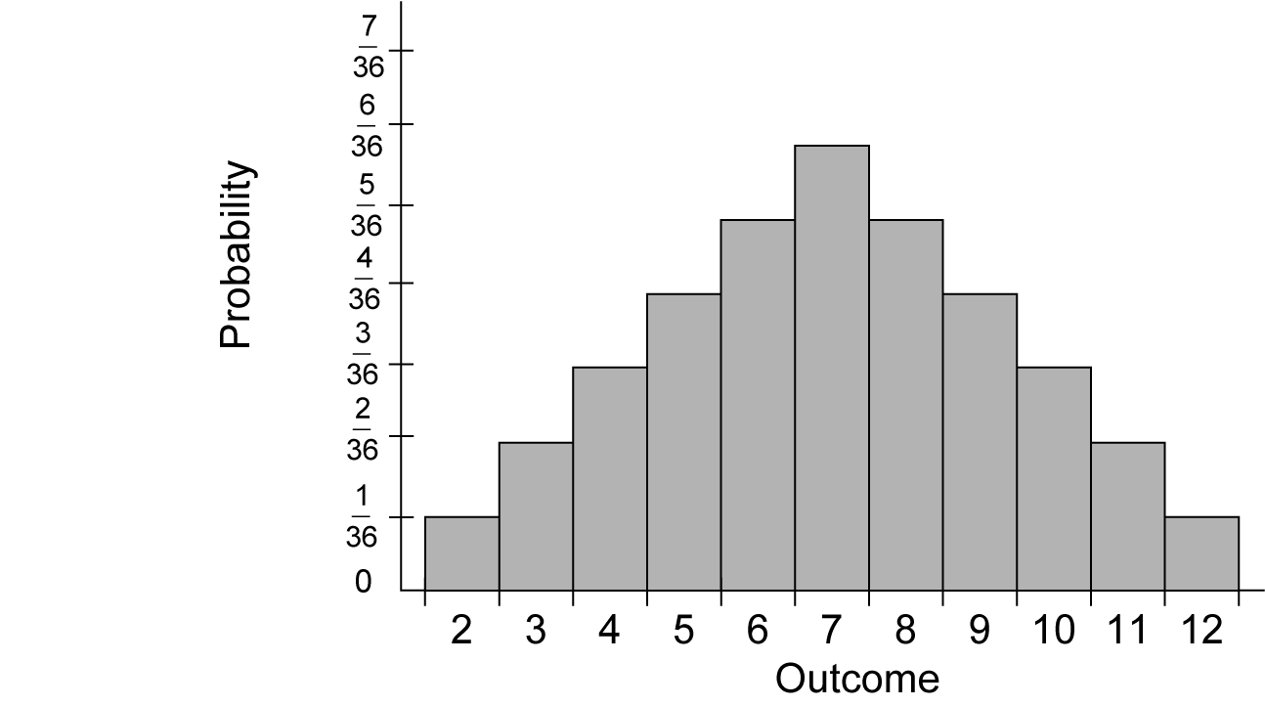
Since we have the following.
 Question 2
Consider the situation in Question 1.
a) What is the probability that the sum is more than 3?
b) What is the probability that the sum is less than 3?
c) Should the answers to Parts a and b sum to be 1? Explain.
Answer
a)
b)
c) no
Section 8.3 Equally Likely Outcomes

 Key idea
If a random phenomenon has k possible outcomes, all equally likely, then each individual outcome has probability The probability of any event A is as follows.
 Example D
When rolling two ordinary dice, there are 36 possible outcomes: and so on up to a) What is the probability of an outcome of
b) What is the probability that one of the die is a 1 and the other is a 2?
Solution
a) Since each of the outcomes is equally likely, each has the same probability. Thus,
b) Since it is possible to roll or
 Question 3
When rolling two dice, what is the probability of obtaining a sum of 10?
Answer

 Key idea
With equally likely outcomes, probability calculations come from combinatorics, or the study of counting methods.
- Rule A: Arranging k objects chosen from a set of n possibilities, with repetitions allowed, can be done in distinct ways.
- Rule B: Arranging k objects chosen from a set of n possibilities, with no repetitions allowed, can be done in (notice there are k factors here).
 Example E
a) How many code words (that is, strings of letters) of length four can be formed that use only the vowels {A, E, I, O, U, Y}?
b) How many of these words have no letter occurring more than once?
Solution
a) Since repetition is not excluded, we will use Rule A where n = 6 and k = 4.
b) Since repetition is not allowed, we will use Rule B where n = 6 and k = 4.
 Question 4
Consider an identification code, which made up of three letters of the alphabet followed by three digits. What is the probability that a randomly chosen identification code is ABC123 given that
a) repetition is allowed?
b) repetition is not allowed?
Answer

a)
b)

Section 8.4 Continuous Probability Models
 Key idea
In a continuous probability model, there are infinitely many possible events that could occur. In order to assign probabilities to events, we look at area under a density curve. The total area under the curve bounded by a horizontal axis must equal 1. The probability of a single value to occur is 0. In the case of continuous probability models, you will be looking at the probability of a range of values (an interval) to occur.
 Key idea
The uniform probability model has a density curve that creates a rectangle along a horizontal axis. The area of the rectangle will always be 1 for the continuous uniform model.
 Example F
Suppose you specify that the range of a random number generator is to be all numbers between 0 and 4. The density curve for the outcome has constant height between 0 and 4, and height 0 elsewhere.
a) Draw a graph of the density curve.
b) Suppose the generator produces a number X. Find
c) Find
Solution

a) Since the width of the base is 4, the height would be
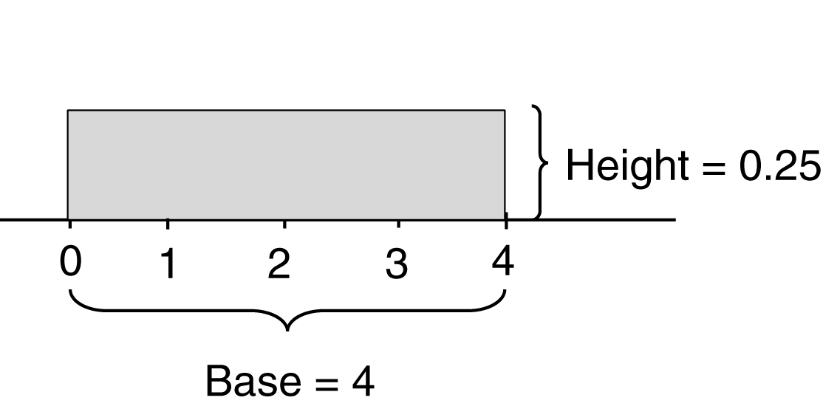

b) Since the area of a rectangle the probability will be
c) We need to determine the length of the base. It will be Thus, the probability will be Area
 Question 5
Generate two random numbers between 0 and 3 and take their sum. The sum can take any value between 0 and 6. The density curve is the triangle.
a) What is the probability that the sum is less than 2?
b) What is the probability that the sum is between 1.5 and 4?
Answer

a)
b)

 Key idea
Normal distributions are continuous probability models. The 68–95–99.7 rule applies to a normal distribution and we can use it for determining probabilities. It is useful in determining the proportion of a population with values falling in certain ranges.

 Key idea
The sample proportion, will vary from sample to sample according to a normal distribution with mean, p, and standard deviation where n is the number in the sample. (p is the population proportion.)
 Example F
Suppose 62% of all children under the age of 6 watch a certain TV show, say the Captain Buckaroo Show. You choose 210 children under the age of 6 to sample at random. What are the mean and standard deviation of the proportion of children under the age of 6 that watch the Captain Buckaroo Show?
Solution
The population proportion of children under the age of 6 that watch the Captain Buckaroo Show is The sample proportion, of children under the age of 6 that watch the Captain Buckaroo Show in a random sample of n = 210 has mean and standard deviation as follows.
 Question 6
Suppose 12% of all adults over the age of 25 watch a certain TV show, say the Captain Buckaroo Show. You choose 171 adults over the age of 25 to sample at random. By applying the 68–95–99.7 rule, determine 95% of the time the sample proportion will be in what interval? Round your answer to the nearest tenth of a percent.
Answer
7.0% to 17.0%
Section 8.5 The Mean and Standard Deviation of a Probability Model

 Key idea
The mean of a discrete probability model is the sum of the possible outcomes times the probability of each outcome. If there are k possible outcomes in the sample space, then there will be k terms in the sum. Each term will have a probability associated with it. The sum of all the probabilities will be 1.
 Example G
What is the mean sum in Example C?
Solution
There are 11 possible outcomes. Thus, there are 11 terms to sum.
Due to the symmetry of the probability histogram, this mean should be intuitively obvious.
 Question 7
Consider the situation in Question 1. What is the mean sum?
Answer
5.5

 Key idea
The law of large numbers states that as a random phenomenon is repeated a large number of times, the mean of the trials, gets closer and closer to the mean of the probability model,

 Key idea
The variance of a discrete probability model that has numerical outcomes in a sample space will have variance as follows.
where is the probability of outcome The standard deviation is the square root of the variance.
 Example H
What is the standard deviation in Example C?
Solution
There are 11 possible outcomes. Thus, there are 11 terms to sum.
Thus, the standard deviation is
 Question 8
Consider the situation in Question 1. What is the standard deviation of the sum?
Answer
1.9791
Section 8.6 The Central Limit Theorem

 Key idea
The central limit theorem says that the distribution of any random phenomenon tends to be normal if we average it over a large number of independent repetitions. It also says that a sample distribution will have the same mean, as the original phenomenon. It will also have a standard deviation equal to where is the standard deviation of a single trial and n is the number of trials.
 Example I
Suppose a marketing exam had scores which were normally distributed with a mean of 73 and a standard deviation of 12.
a) Suppose you chose 10 of the students at random and computed the mean, of their scores. What is the standard deviation of ?
b) How large a sample size n would you have to use to bring the standard deviation of down to 2?
c) By taking a large number of samples of 10 students chosen at random, what range of exam scores will contain the middle 95% of the many
Solution
a) Take the standard deviation of the original distribution, which is 12, and divide by the square root of 10; we get
b) To bring it down from 12 to 2 or less, we would have to divide by 6 or more. If the square root of the sample size n is 6 or greater, then n must be at least 36.
c) Sample means have a sampling distribution close to normal with mean and standard deviation approximately Therefore, 95% of all samples have an between and With rounding, we would say between 65 and 81.
 Example J
Consider the following spinner game. It costs $1 to play. If you spin a negative value, you lose your dollar as well as the additional amount indicated ($1 or $3). If you spin a positive value, you keep your dollar and you receive the additional amount indicated ($5 or $3).
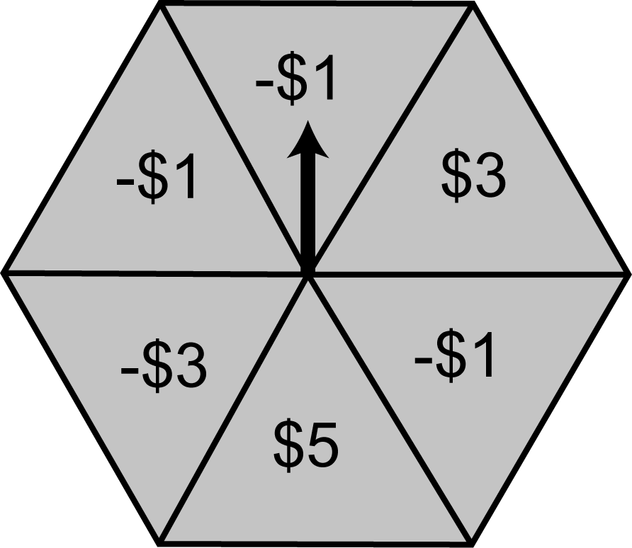
a) What is the mean of a single game?
b) What is the standard deviation?
c) What is the mean and the standard deviation of the average win/loss of the game if it was played 100 times in one day?
d) Apply the 99.7 part of the 68-95-99.7 rule to determine a range of average win/loss of playing this game 100 times per day for 1000 days.
Solution
The probability model would be as follows.
Outcome |  |  |  | $5 |  | $3
Probability
a) The mean of a single game would be as follows.
b) The variance of a single game would be as follows.
Thus, the standard deviation would be
c) From the central limit theorem, the mean would be approximately The standard deviation would be
d) Almost all, 99.7%, of all daily win/losses would fall within three standard deviations of the mean. Thus, the total win/losses after playing 100 times will fall between and With rounding, we would say between and
 Question 9
Consider the following spinner game. It costs $1 to play. If you spin a negative value, you lose your dollar as well as the additional amount indicated ($1, $2, or $3). If you spin a positive value, you keep your dollar and you receive the additional amount indicated ($4 or $7).
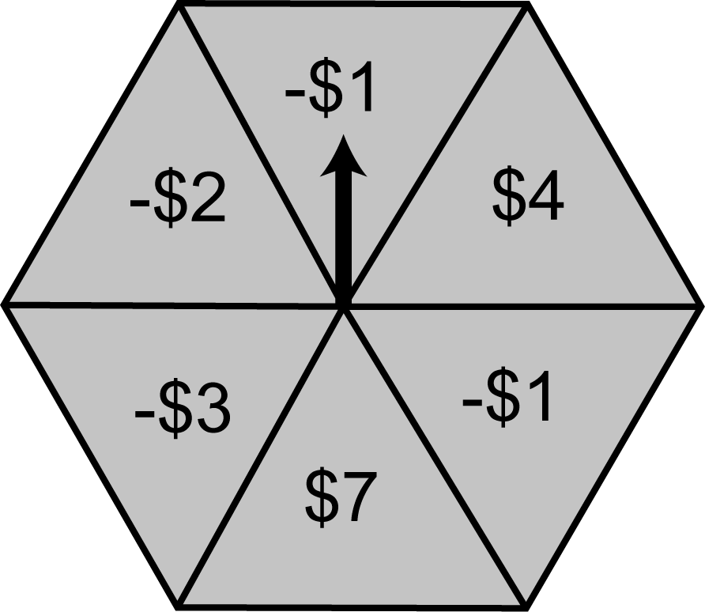
a) What is the mean and standard deviation of a single game?
b) What is the mean and the standard deviation of the average win/loss of the game if it was played 1000 times in one day?
c) Apply the 99.7 part of the 68-95-99.7 rule to determine a range of average win/loss of playing this game 1000 times per day for 1000 days.
Answer
a) and
b) The mean would be $0 and the standard deviation would be approximately
c) between and
Homework Help
To assist you in homework, a page of “blank” normal distributions appears after this section.
Exercises 1 – 2
Since these exercises involve actual experiments, results will vary.
Exercise 3
Count up the number of zeros and determine the proportion of zeros in the first 200 digits. The partial table below should be helpful.
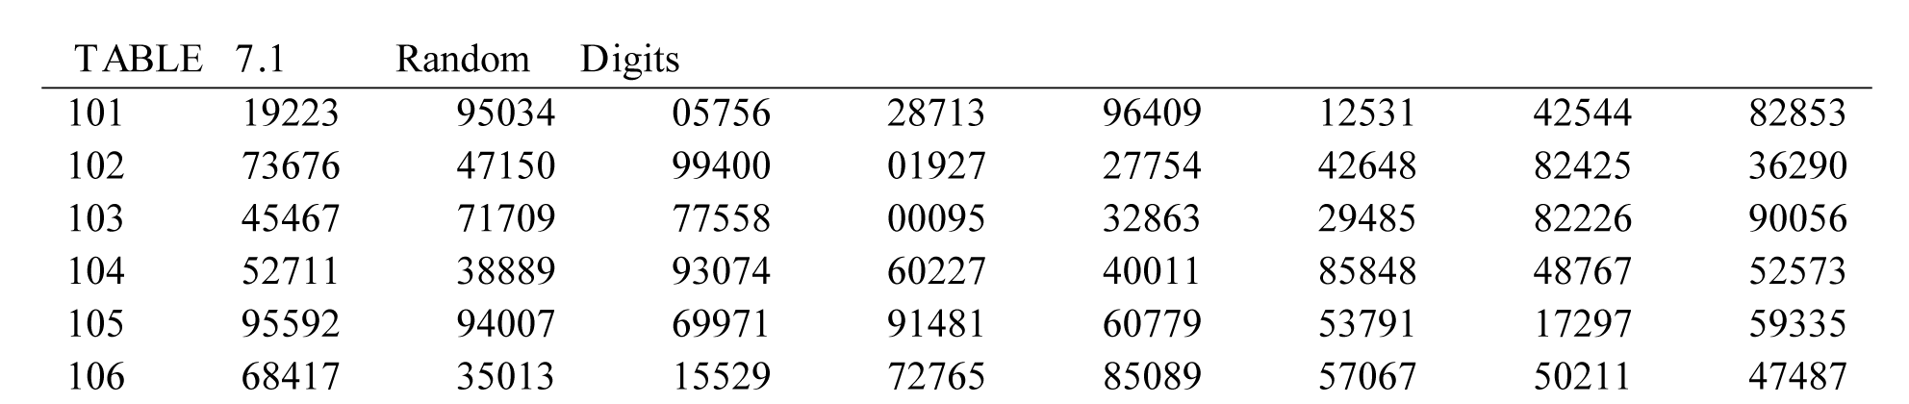
Exercise 4
Probability is a number between 0 and 1, inclusive. The higher the number, the higher the probability that the event will occur. The lower the number, the lower the probability that the event will occur.
Exercise 5
(a) There are 11 elements in this sample space.
(b) There are 11 elements in this sample space.
(c) There are 2 elements in this sample space.
Exercise 6
(a) There are 2 elements in this sample space.
(b) There are 15 elements in this sample space.
(c) Answers will vary. Use judgment for lower and upper limits.
Exercise 7
(a) There are 16 elements in this sample space. Be systematic when listing elements of the sample space.
(b) There are 5 elements in this sample space.
Exercise 8
(a) There are 2 elements in this sample space.
(b) Answers will vary. Use judgment for lower and upper limits.
(c) Answers will vary. Use judgment for lower and upper limits.
Exercise 9
(a) Sum the probabilities in the table together. Use Probability Rule 4 from Section 8.1.
(b) It is assumed in this exercise that adult and scam are disjoint events. Use Probability Rule 3 from Section 8.1.
Exercise 10
(a) Use Probability Rule 4 from Section 8.1.
(b) Use Probability Rule 4 from Section 8.1 or sum the probabilities of three disjoint events together (this relies on part a).
Exercise 11
Answers will vary. Any two events that can occur together will do.
Exercise 12
(a) Sum the probabilities in the table together. Use Probability Rule 4 from Section 8.1.
(b) Use Probability Rule 3 from Section 8.1.
Exercise 13
(a) The following may be helpful in creating a probability histogram.
(b) You will need to sum together two probabilities.
Exercise 14
The following may be helpful in creating probability histograms.
Exercise 15
For each a part make sure the probabilities are between 0 and 1, inclusively, and have sum 1.
Exercise 16
For both owner-occupied units and rented units, find by summing the appropriate probabilities.
Exercise 17
As recommended in the exercise, make a drawing showing all possibilities. There are 36 total. Determine how many times each sum occurs and fill in the following table.
Outcome | 1 | 2 | 3 | 4 | 5 | 6 | 7 | 8 | 9 | 10 | 11 | 12
Probability
Exercise 18
As recommended in the exercise, make a drawing showing all possibilities. There are 16 total. Determine how many times each sum occurs and fill in the following table.
Intelligence | 3 | 4 | 5 | 6 | 7 | 8 | 9
Probability
Determine the probability of intelligence 7 or higher by summing the appropriate 3 probabilities.
Exercise 19
Realizing that all 90 guests are equally likely to get the prize, determine
Exercise 20
(a) Use the first letters to stand for names and write the 10 possible choices.
(b) – (d) Count up the number of possible choices that satisfy each condition in order to determine the probabilities.
Exercises 21 – 25
Carefully read Section 8.3 before responding to these exercises. You will need to utilize the rules of counting arrangements of distinct items. In Exercise 25, first determine the 6 possible arrangements of the letters.
Exercises 26 – 27
Carefully read Section 8.3 before responding to these exercises. You will need to utilize the rules of counting arrangements of distinct items. In each exercise you will need to sum together the possible outcomes of the individual types in order answer each question. You will then need to apply the formula in the definition of equally likely outcomes.
Exercise 28
(a) Determine the probability for each square face. Use the fact that a face is either a square or a triangle to determine the probability of obtaining a triangle. Finally, determine the probability for each triangle.
(b) Answers will vary. Start with a different probability for squares and follow the same procedure as in part a.
Exercise 29
Draw the density curve and shade the appropriate region for each part. You will need that the area of a triangle is
Exercise 30
Draw the rectangular density curve and shade the appropriate region for each part. Determine the height of the rectangular density curve by realizing that base is of length 2 and area of a rectangle is base The area under the density curve will equal 1.
Exercise 31
The following may be helpful in this exercise.
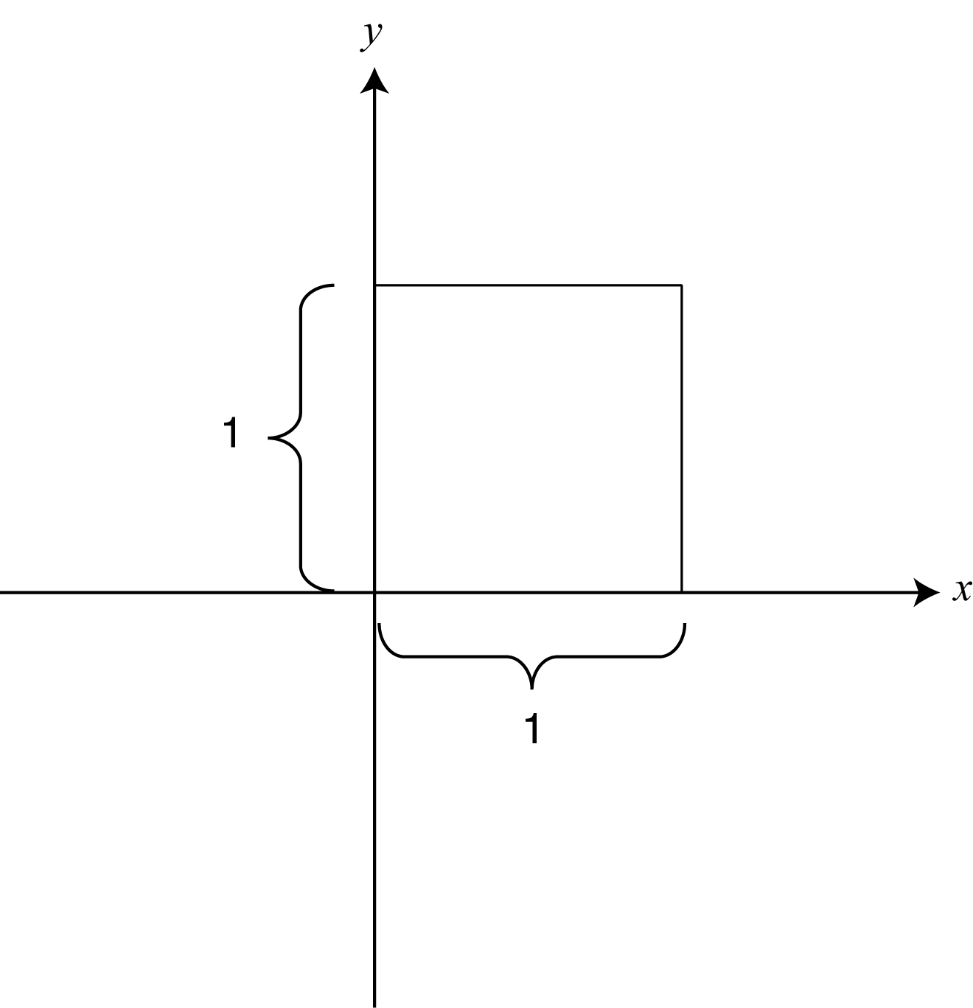
Exercise 32
Carefully read Section 8.5 before responding to this exercise. Realizing that earnings are $400 times sales, fill in the following table.
Earnings
Probability | 0.3 | 0.4 | 0.2 | 0.1
Use the definition of the mean of a discrete probability model. You will need to sum four terms.
Exercise 33
Carefully read Section 8.5 before responding to this exercise. Use the definitions of the mean of a discrete probability model and the standard deviation of a discrete probability model. For each you will need to sum five terms. To find the standard deviation, you will need to take the square root of the variance. Try to make your intermediate calculations as accurate as possible to avoid round-off error.
Exercises 34 – 36
Carefully read Section 8.5 before responding to these exercises. Use the definition of the mean of a discrete probability model. Try to make your intermediate calculations as accurate as possible to avoid round-off error. In Exercise 35, recreate (or use) the probability histograms created in Exercise 14 and locate the mean on each histogram.
Exercise 37
Note the symmetry in both density curves.
Exercise 38
Answers will vary. Use the law of large numbers in your explanation.
Exercise 39
Carefully read Section 8.5 before responding to these exercise. Fill in the following table for Part b.
 | Outcome | 2 | 3 | 4 | 5 | 6 | 7 | 8 | 9 | 10 | 11 | 12
 | Probability
Use the definition of the mean of a discrete probability model. Try to make your intermediate calculations as accurate as possible to avoid round-off error. In Part c, answers will vary. Remember though, expected values are averages, so they behave like averages.
Exercise 39
Carefully read Section 8.5 before responding to this exercise. Fill in the following table for Part a.
Outcome | Win $2 | Lose $1
Probability
In Part b, use the definitions of the mean of a discrete probability model and the standard deviation of a discrete probability model. For each you will need to sum five terms. To find the standard deviation, you will need to take the square root of the variance. Try to make your intermediate calculations as accurate as possible to avoid round-off error. Use the results of Part b (mean) and the law of large numbers to answer Part c.
Exercises 41 – 42
Carefully read Section 8.5 before responding to these exercise. Use the definition of the mean of a discrete probability model. Try to make your intermediate calculations as accurate as possible to avoid round-off error.

Exercise 43
Carefully read Section 8.5 before responding to this exercise.
(a) Sum the probabilities in the table together. Use Probability Rule 4 from Section 8.1.
(b) Fill in the following table. The first five outcomes will be negative. The last outcome will be positive. The final probability is from part a.
Probability | Outcome
Use the table and the definition of the mean of a discrete probability model. Try to make your intermediate calculations as accurate as possible to avoid round-off error.
Exercise 44
As instructed, use the definitions of the mean and variance of a discrete probability model. Remember that and are outcomes.
Exercise 45
Carefully read Section 8.6 before responding to this exercise. Sample means have a sampling distribution close to normal with mean Calculate the standard deviation and use the fact that 95% of all samples have an between and
Exercise 46
(a) Use the symmetry of the normal distribution and the 68 part of the 68-95-99.7 rule.
(b) Sample means have a sampling distribution close to normal with mean Calculate the standard deviation Use the symmetry of the normal distribution and the 95 part of the 68-95-99.7 rule.
Exercise 47
(a) Calculate the standard deviation
(b) Since we want to cut the standard deviation in half (from 10 mg to 5 mg), determine what value of will make Additional answers will vary.
Exercise 48
The average winnings per bet has the mean, from Exercise 40 for any number of bets. The standard deviation of the average winnings is (where is also from Exercise 40). For both Parts a and b, calculate with the values of n. Then for each part, determine the spread of average winnings to
Exercise 49
(a) For sketch a normal curve and mark the center. The change-of-curvature points are one standard deviation from the center. Extend the curve three standard deviations in both directions. On the same graph, do the same for n = 3
(b) Use the 95 part of the 68-95-99.7 rule with
(c) Use the 95 part of the 68-95-99.7 rule with
Exercise 50
Carefully read Section 8.6 before responding to this exercise. Use the definition of the standard deviation of a discrete probability model. You will need to sum seven terms. To find the standard deviation, you will need to take the square root of the variance. Try to make your intermediate calculations as accurate as possible to avoid round-off error. Apply the central limit theorem. Sample means have a sampling distribution close to normal with mean Calculate the standard deviation and use the fact that 68% of all samples have an between and
Exercise 51
Determine the ACT exam scores that are 1, 2, and 3 standard deviations from the mean and label them on the graph below.
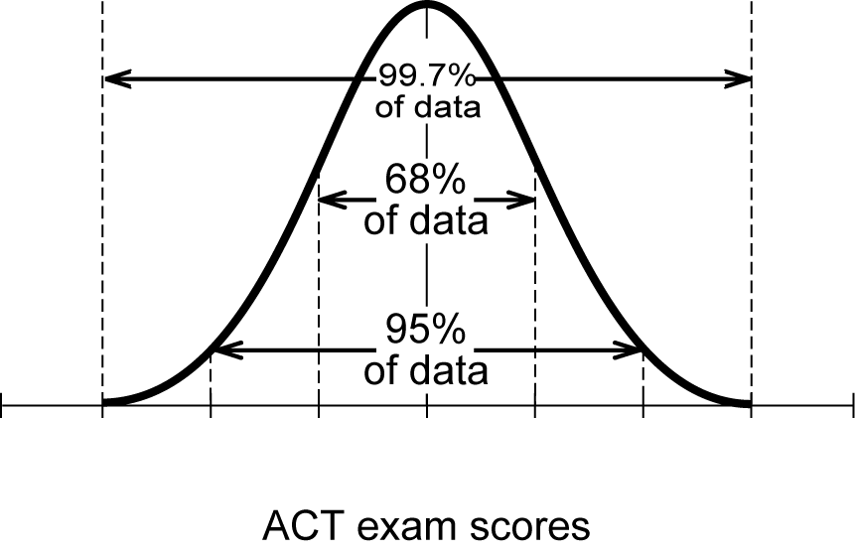
For Part b, use the fact that sample means have a sampling distribution close to normal with mean Calculate the standard deviation In Part c, use the symmetry of the normal curve along with the 68-95-99.7 rule.
Exercise 52
In Part a, the sample proportion, has mean and standard deviation In Part b, use the symmetry of the normal curve along with the 68-95-99.7 rule.
Exercises 53 – 54
Carefully read Section 8.3 before responding to these exercises. You will need to utilize the rules of counting arrangements of distinct items.
Exercise 55
(a) Use Probability Rule 3 from Section 8.1.
(b) Use Probability Rule 4 from Section 8.1.
Exercise 56
Use the definition of the standard deviation of a discrete probability model. You will need to sum eight terms. Read and apply the law of large numbers (Section 8.5).
Exercise 57
(a) Carefully read Section 8.5 before responding to this exercise. Use the definition of the standard deviation of a discrete probability model to first find the variance with You will need to sum eight terms. To find the standard deviation, you will need to take the square root of the variance. Try to make your intermediate calculations as accurate as possible to avoid round-off error.
(b) The mean, has mean and standard deviation The central limit theorem says that is approximately normal with this mean and standard deviation. Use the 95 part of the 68-95-99.7 rule.

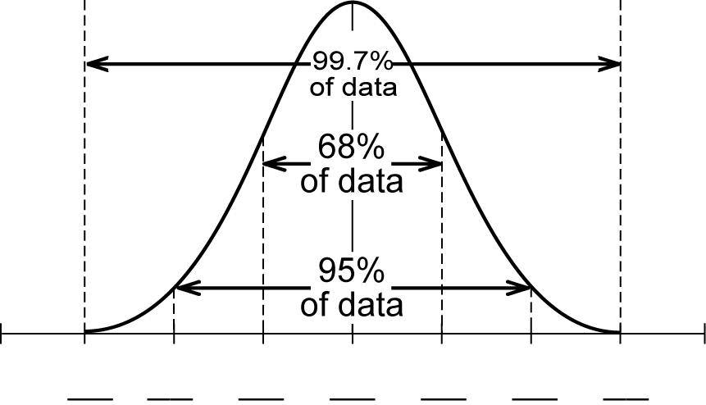

Do You Know the Terms?

Cut out the following 18 flashcards to test yourself on Review Vocabulary. You can also find these flashcards at http://www.whfreeman.com/fapp7e.

Chapter 8  Probability: The Mathematics of Chance  Addition rule | Chapter 8  Probability: The Mathematics of Chance  Central limit theorem
Chapter 8  Probability: The Mathematics of Chance  Combinatorics | Chapter 8  Probability: The Mathematics of Chance  Complement rule
Chapter 8  Probability: The Mathematics of Chance  Continuous probability model | Chapter 8  Probability: The Mathematics of Chance  Density curve
Chapter 8  Probability: The Mathematics of Chance  Discrete probability model | Chapter 8  Probability: The Mathematics of Chance  Disjoint events

The average of many independent random outcomes is approximately normally distributed. When we average n independent repetitions of the same random phenomenon, the resulting distribution of outcomes has mean equal to the mean outcome of a single trial and standard deviation proportional to . | If two events are disjoint, the probability that one or the other occurs is the sum of their individual probabilities.
The probability that an event does not occur is always one minus the probability that it does occur. | The branch of mathematics that counts arrangements of objects.
A curve that is always on or above the horizontal axis and has area exactly 1 underneath it. A density curve describes a continuous probability model. | A probability model that assigns probabilities to events as areas under a density curve.
Events that have no outcomes in common. | A probability model that assigns probabilities to each of a finite number of possible outcomes.

Chapter 8  Probability: The Mathematics of Chance  Event | Chapter 8  Probability: The Mathematics of Chance  Law of large numbers
Chapter 8  Probability: The Mathematics of Chance  Mean of a probability model | Chapter 8  Probability: The Mathematics of Chance  Probability
Chapter 8  Probability: The Mathematics of Chance  Probability histogram | Chapter 8  Probability: The Mathematics of Chance  Probability model
Chapter 8  Probability: The Mathematics of Chance  Random phenomenon | Chapter 8  Probability: The Mathematics of Chance  Sample space

As a random phenomenon is repeated many times, the mean of the observed outcomes approaches the mean of the probability model. | Any collection of possible outcomes of a random phenomenon. An event is a subset of the sample space.
A number between 0 and 1 that gives the long-run proportion of repetitions of a random phenomenon on which an event will occur. | The average outcome of a random phenomenon with numerical values. When possible values have probabilities the mean is the average of the outcomes weighted by their probabilities,
A sample space S together with an assignment of probabilities to events. The two main types of probability models are discrete and continuous. | A histogram that displays a discrete probability model when the outcomes are numerical. The height of each bar is the probability of the outcome or group of outcomes at the base of the bar.
A list of all possible outcomes of a random phenomenon. | A phenomenon is random if it is uncertain what the next outcome will be, but each outcome nonetheless tends to occur in a fixed proportion of a very long sequence of repetitions. These long-run proportions are the probabilities of the outcomes.

Chapter 8  Probability: The Mathematics of Chance  Sampling distribution | Chapter 8  Probability: The Mathematics of Chance  Standard deviation of a probability model

A measure of the variability of a probability model. When the possible values have probabilities the variance is the average (weighted by probabilities) of the squared deviations from the mean,  The standard deviation is the square root of the variance. | The distribution of values taken by a statistic when many random samples are drawn under the same circumstances. A sampling distribution consists of an assignment of probabilities to the possible values of a statistic.
Practice Quiz
1. We will roll a die and flip two coins. Then we will report the number on the die and whether the coins are heads, tails, or mixed. How many outcomes are in the sample space?
a. 8
b. 9
c. 18
2. Suppose we toss three coins and report the number of heads that appear. What is the probability of exactly two heads appearing?
a.
b.
c.
3. A sample space contains three outcomes: A, B, C. Which of the following could be a legitimate assignment of probabilities to the outcomes?
a. P(A) = 0.4 P(B) = 0.6 P(C) = 0
b. P(A) = 0.3 P(B) = 0.3 P(C) = 0.3
c. P(A) = 0.6 P(B) = –0.2 P(C) = 0.6
4. We roll two dice and report the sum of the numbers rolled. The outcomes in this space are
a. all equally likely.
b. not all equally likely.
5. A bicycle chain has a 4-digit code lock. How many possible codes are there if digits can be repeated?
a. 40
b. 5,000
c. 10,000
6. A bicycle chain has a 4-digit code lock. How many possible codes are there if digits can’t be repeated?
a. 34
b. 5,040
c. 10,000
7. Each raffle ticket costs $2. Of 400 tickets sold, one will win $250, and two others will each win $25. What is your mean value for one play?
a. –$1.25
b. –$0.75
c. $0.75
8. Suppose a random number generator produces numbers between 0 and 5. What is the probability of an outcome that is not between 1.1 and 3.2?
a. 0.65625
b. 0.42
c. 0.58
9. Given the following probability model, find the mean and standard deviation.
Outcome | 1 | 3 | 5
Probability | 0.2 | 0.5 | 0.3
a. 3.2; 1.4
b. 3.2; 77.788
c. 3; 2
10. The grades on a college-wide marketing exam were normally distributed with and Given a SRS of 16 students who took the exam, what is the approximate probability that the mean score of these 16 students is 72.45 or higher?
a. 0.003
b. 0.025
c. 0.5

Word Search
Refer to pages 323 – 324 of your text to obtain the Review Vocabulary. There are 16 hidden vocabulary words/expressions in the word search below. Continuous probability model and Standard deviation of a probability mode do not appear in the word search due to expression length. The word Probability and Event appear separately from the other phrases that contain these words in the word search. It should be noted that spaces are removed.
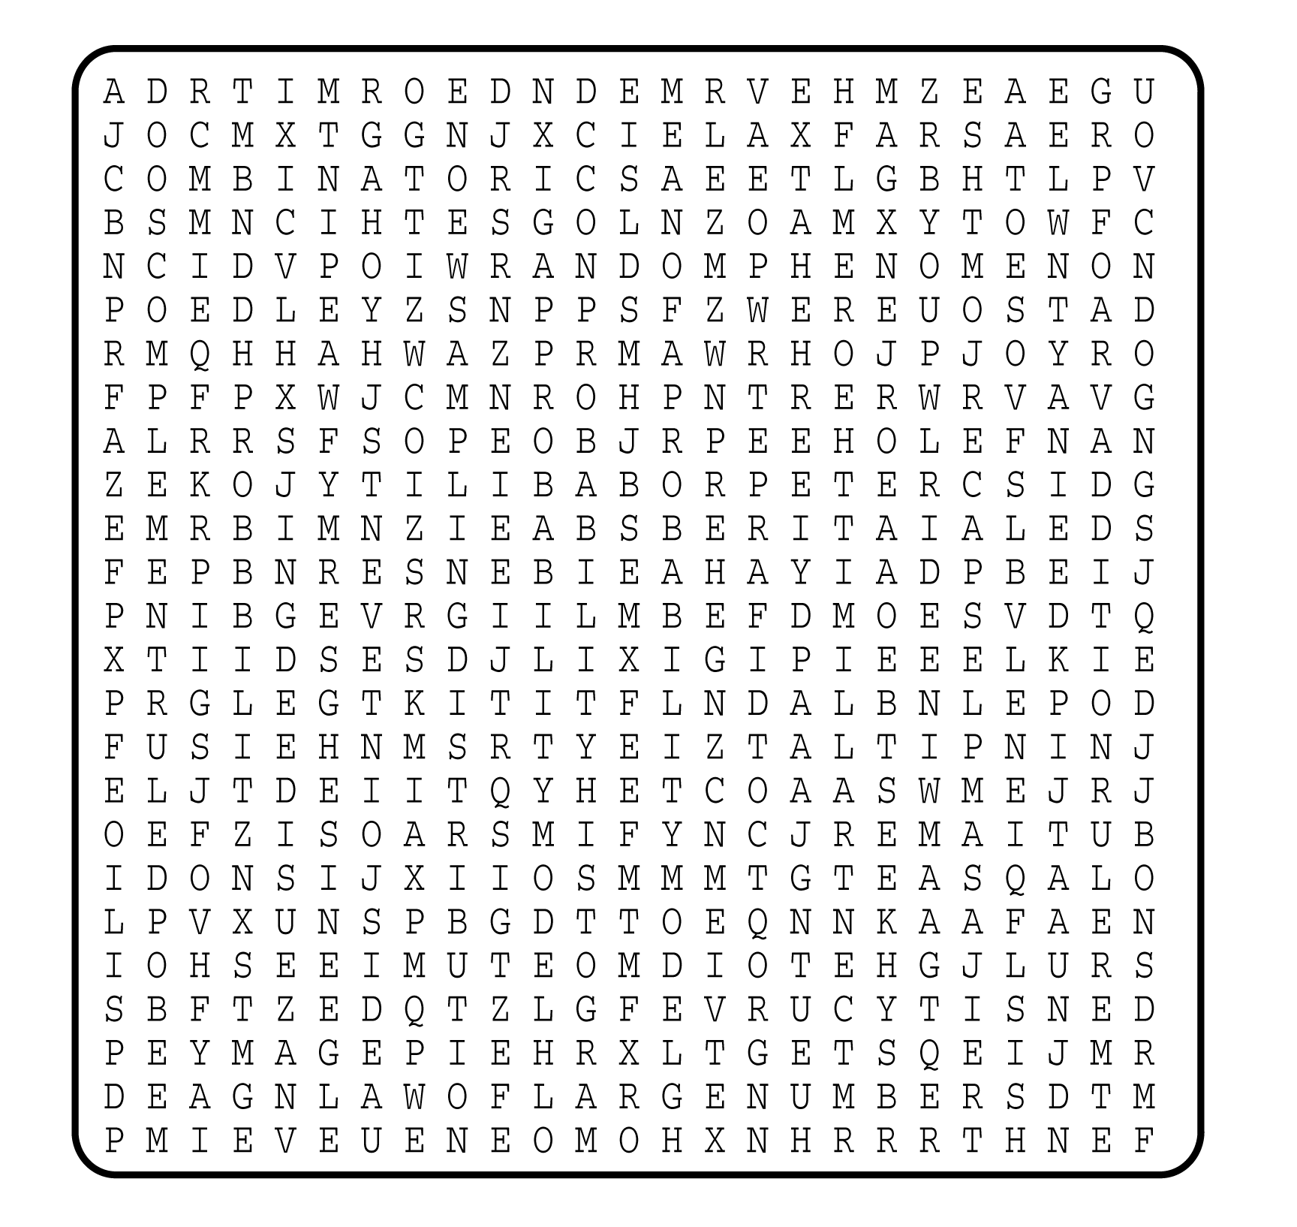

1. __________________________
2. __________________________
3. __________________________
4. __________________________
5. __________________________
6. __________________________
7. __________________________
8. __________________________
9. __________________________
10. __________________________
11. __________________________
12. __________________________
13. __________________________
14. __________________________
15. __________________________
16. __________________________

