Chapter 6

Exploring Data: Relationships

chapter Objectives
Check off these skills when you feel that you have mastered them.
 Draw a scatterplot for a small data set consisting of pairs of numbers.
 From a scatterplot, draw an estimated line of best fit.
 Describe how the concept of distance is used in determining a least-squares regression line.
 Use the given equation of a regression line to predict response (y) values from given explanatory (x) values.
 Calculate the correlation between two quantitative variables, one explanatory and one response, from a data set.
 Understand the significance of the correlation between two variables, and estimate it from a scatterplot.
 Understand correlation and regression describe relationships that need further interpretation because association does not imply causation and outliers have an effect on these relationships.

Guided Reading
Introduction
Relationships between variables exist in almost every area of our lives. For example, insurance companies use relationships between variables to determine appropriate annual rates. The medical community uses relationships between variables to help project the effects of drugs, certain foods, and exercise on certain aspects of our lives such as lifespan. By determining a relationship between variables and the strength of that relationship, one can draw reasonable conclusions.

 Key idea
We will be using data sets that have two types of variables. A response variable measures an outcome or result of a study. An explanatory variable is a variable that we think explains or causes changes in the response variable. Typically we think of the explanatory variable as x and the response variable as y.
Section 6.1 Displaying Relationships: Scatterplots

 Key idea
Graphs are useful for recognizing connections between two variables. A scatterplot is the simplest such representation, showing the relationship between an explanatory variable (on the horizontal axis) and a response variable (on the vertical axis).

 Key idea
We look for an overall pattern in the scatterplot. The pattern can be described by the following.
- form: straight – line, for example
- direction: positive association or negative association (slope of a line)
- strength: A stronger relationship would yield points quite close to the line, a weaker one would have more points scattered around the line.

 Key idea
We also look for striking deviations from the pattern in the scatterplot. An important kind of deviation is an outlier, an individual value that falls outside the overall pattern of the relationship.
 Example A
Draw a scatterplot showing the relationship between the observed variables x and y, with the data given in the table below. Make some observations of the overall pattern in the scatterplot.
x | 2 | 4 | 1 | 5 | 7 | 9 | 8
y | 2 | 5 | 2 | 7 | 4 | 8 | 6
Solution
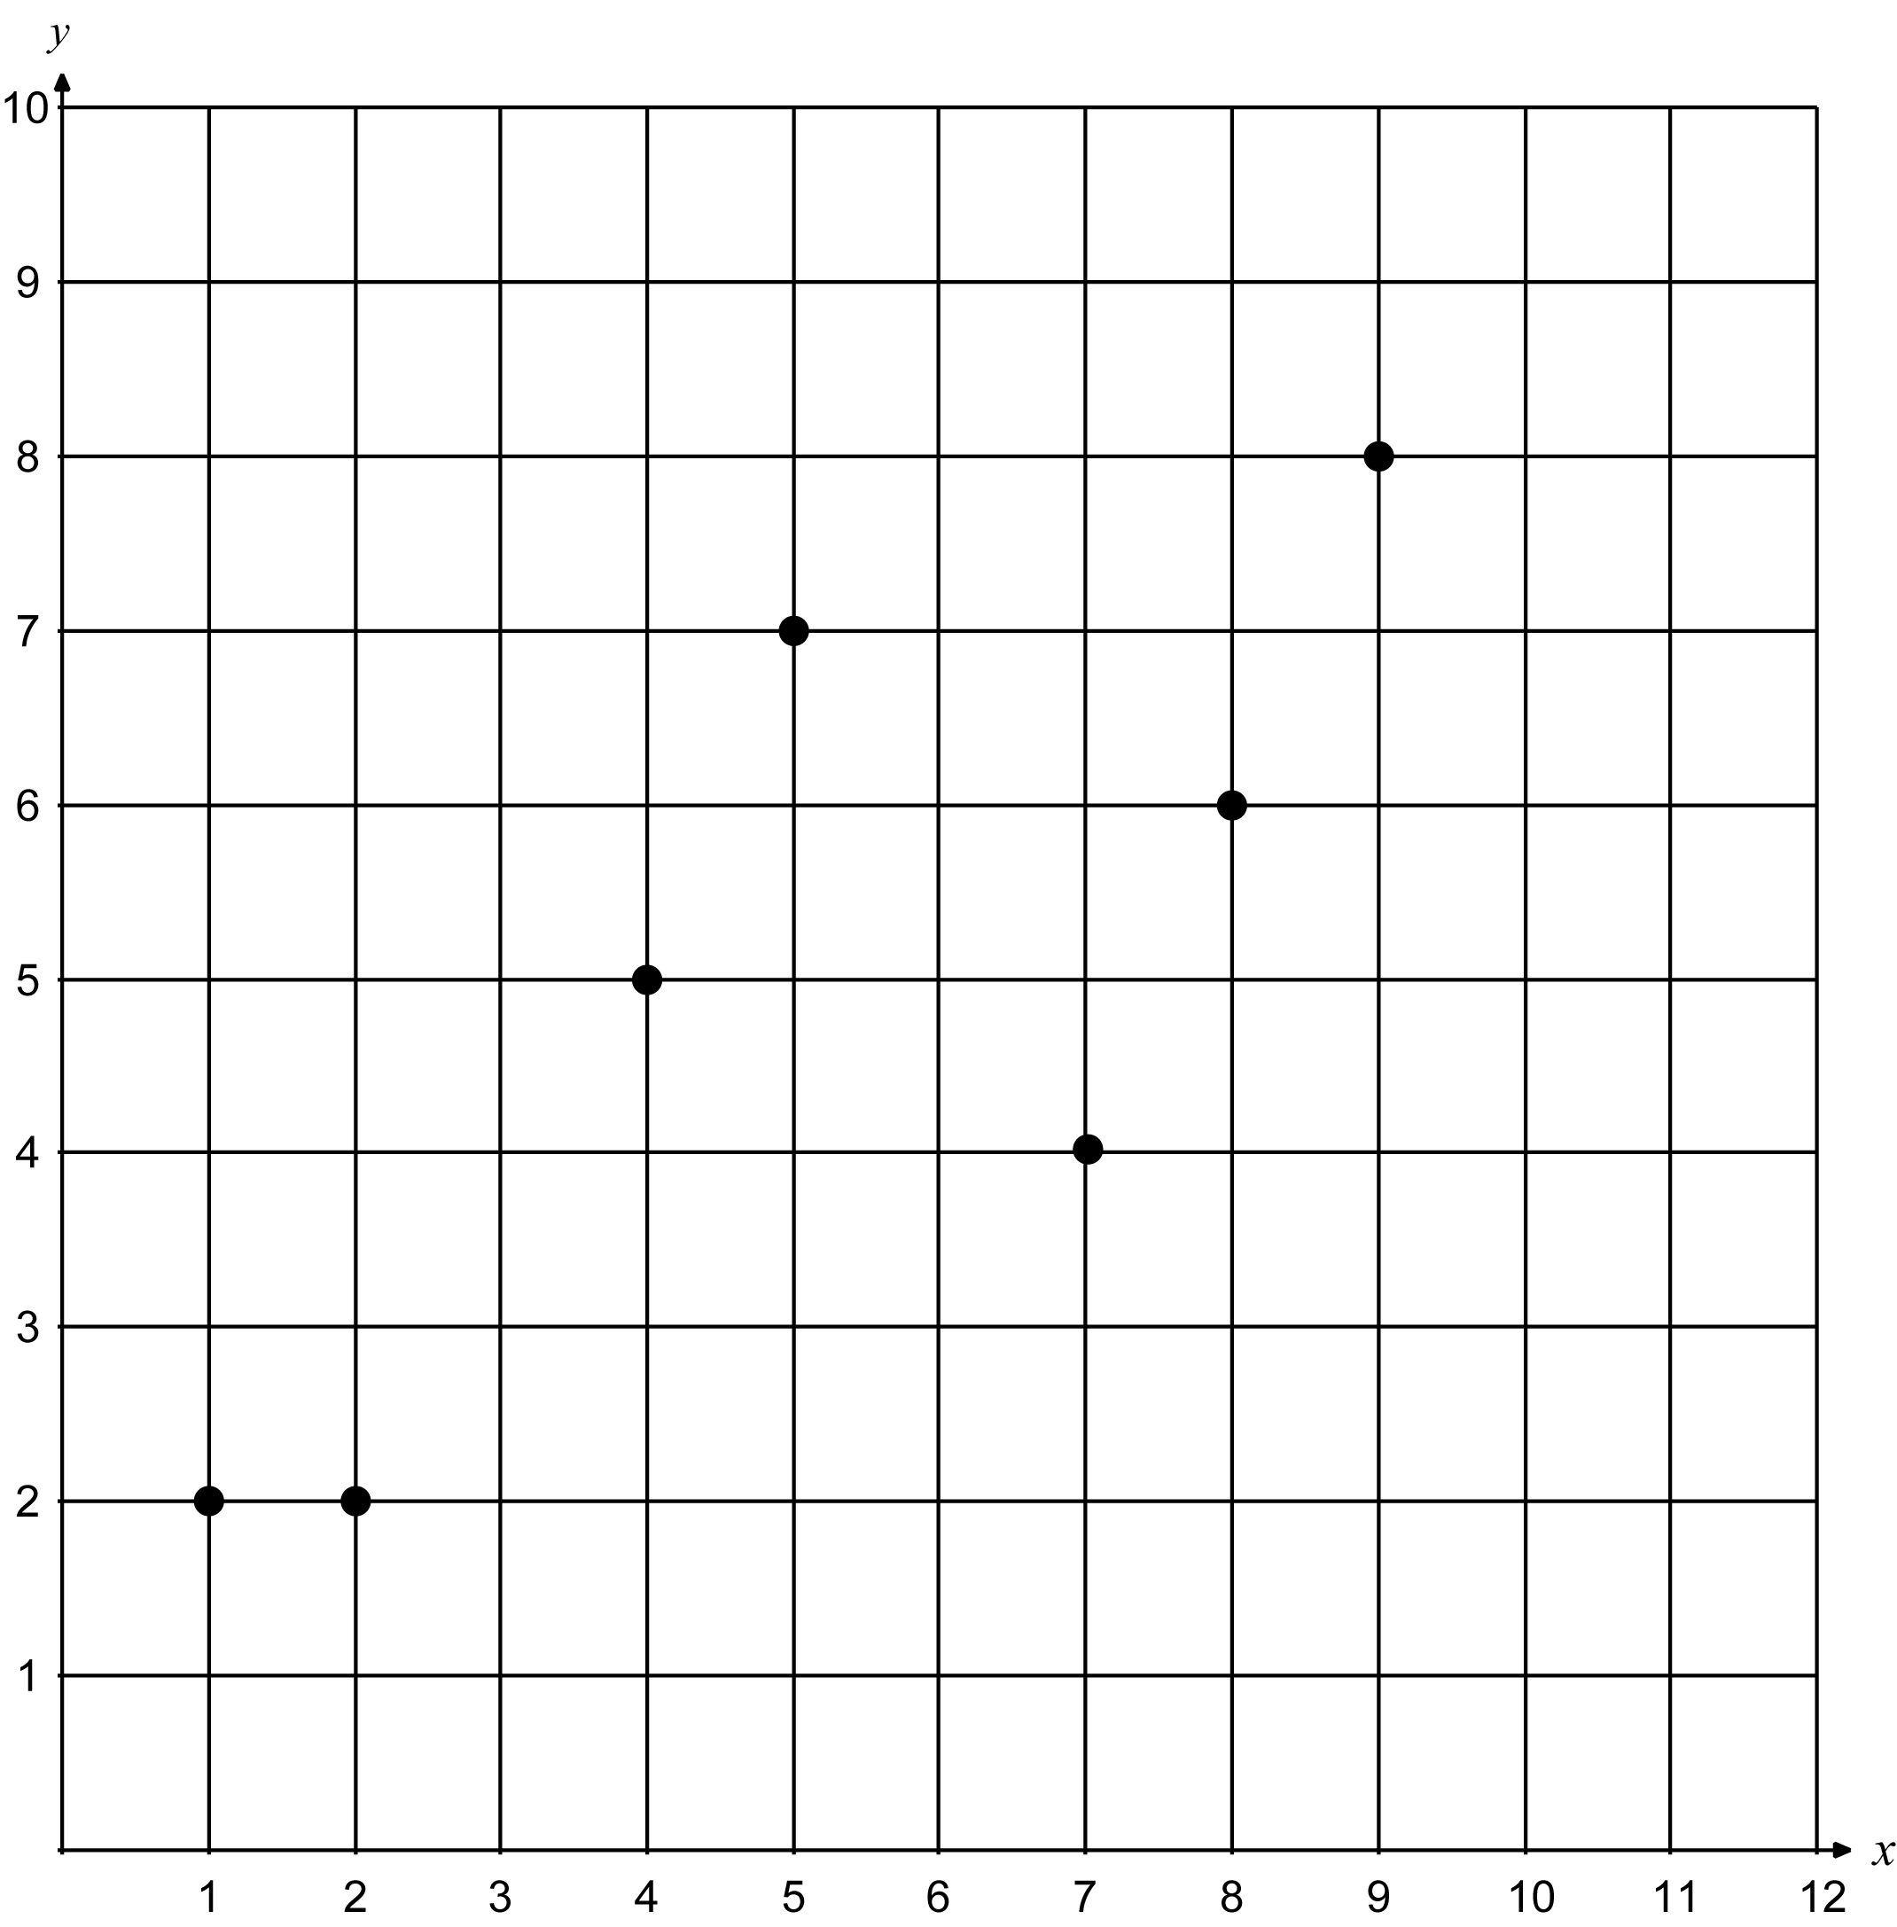
It appears that the points indicate a linear relationship with a positive association.
Section 6.2 Regression Lines

 Key idea
A straight line drawn through the heart of the data and representing a trend is called a regression line, and can be used to predict values of the response variable.

 Key idea
The equation of a regression line will be y = a + bx, where a is the y-intercept and b is the slope of the line.
 Example B
Starting with the scatterplot of the data from the previous section, draw the regression line through the data (obtained from a computer program). Use the graph to predict the value of y if the x-value is 11.
Solution
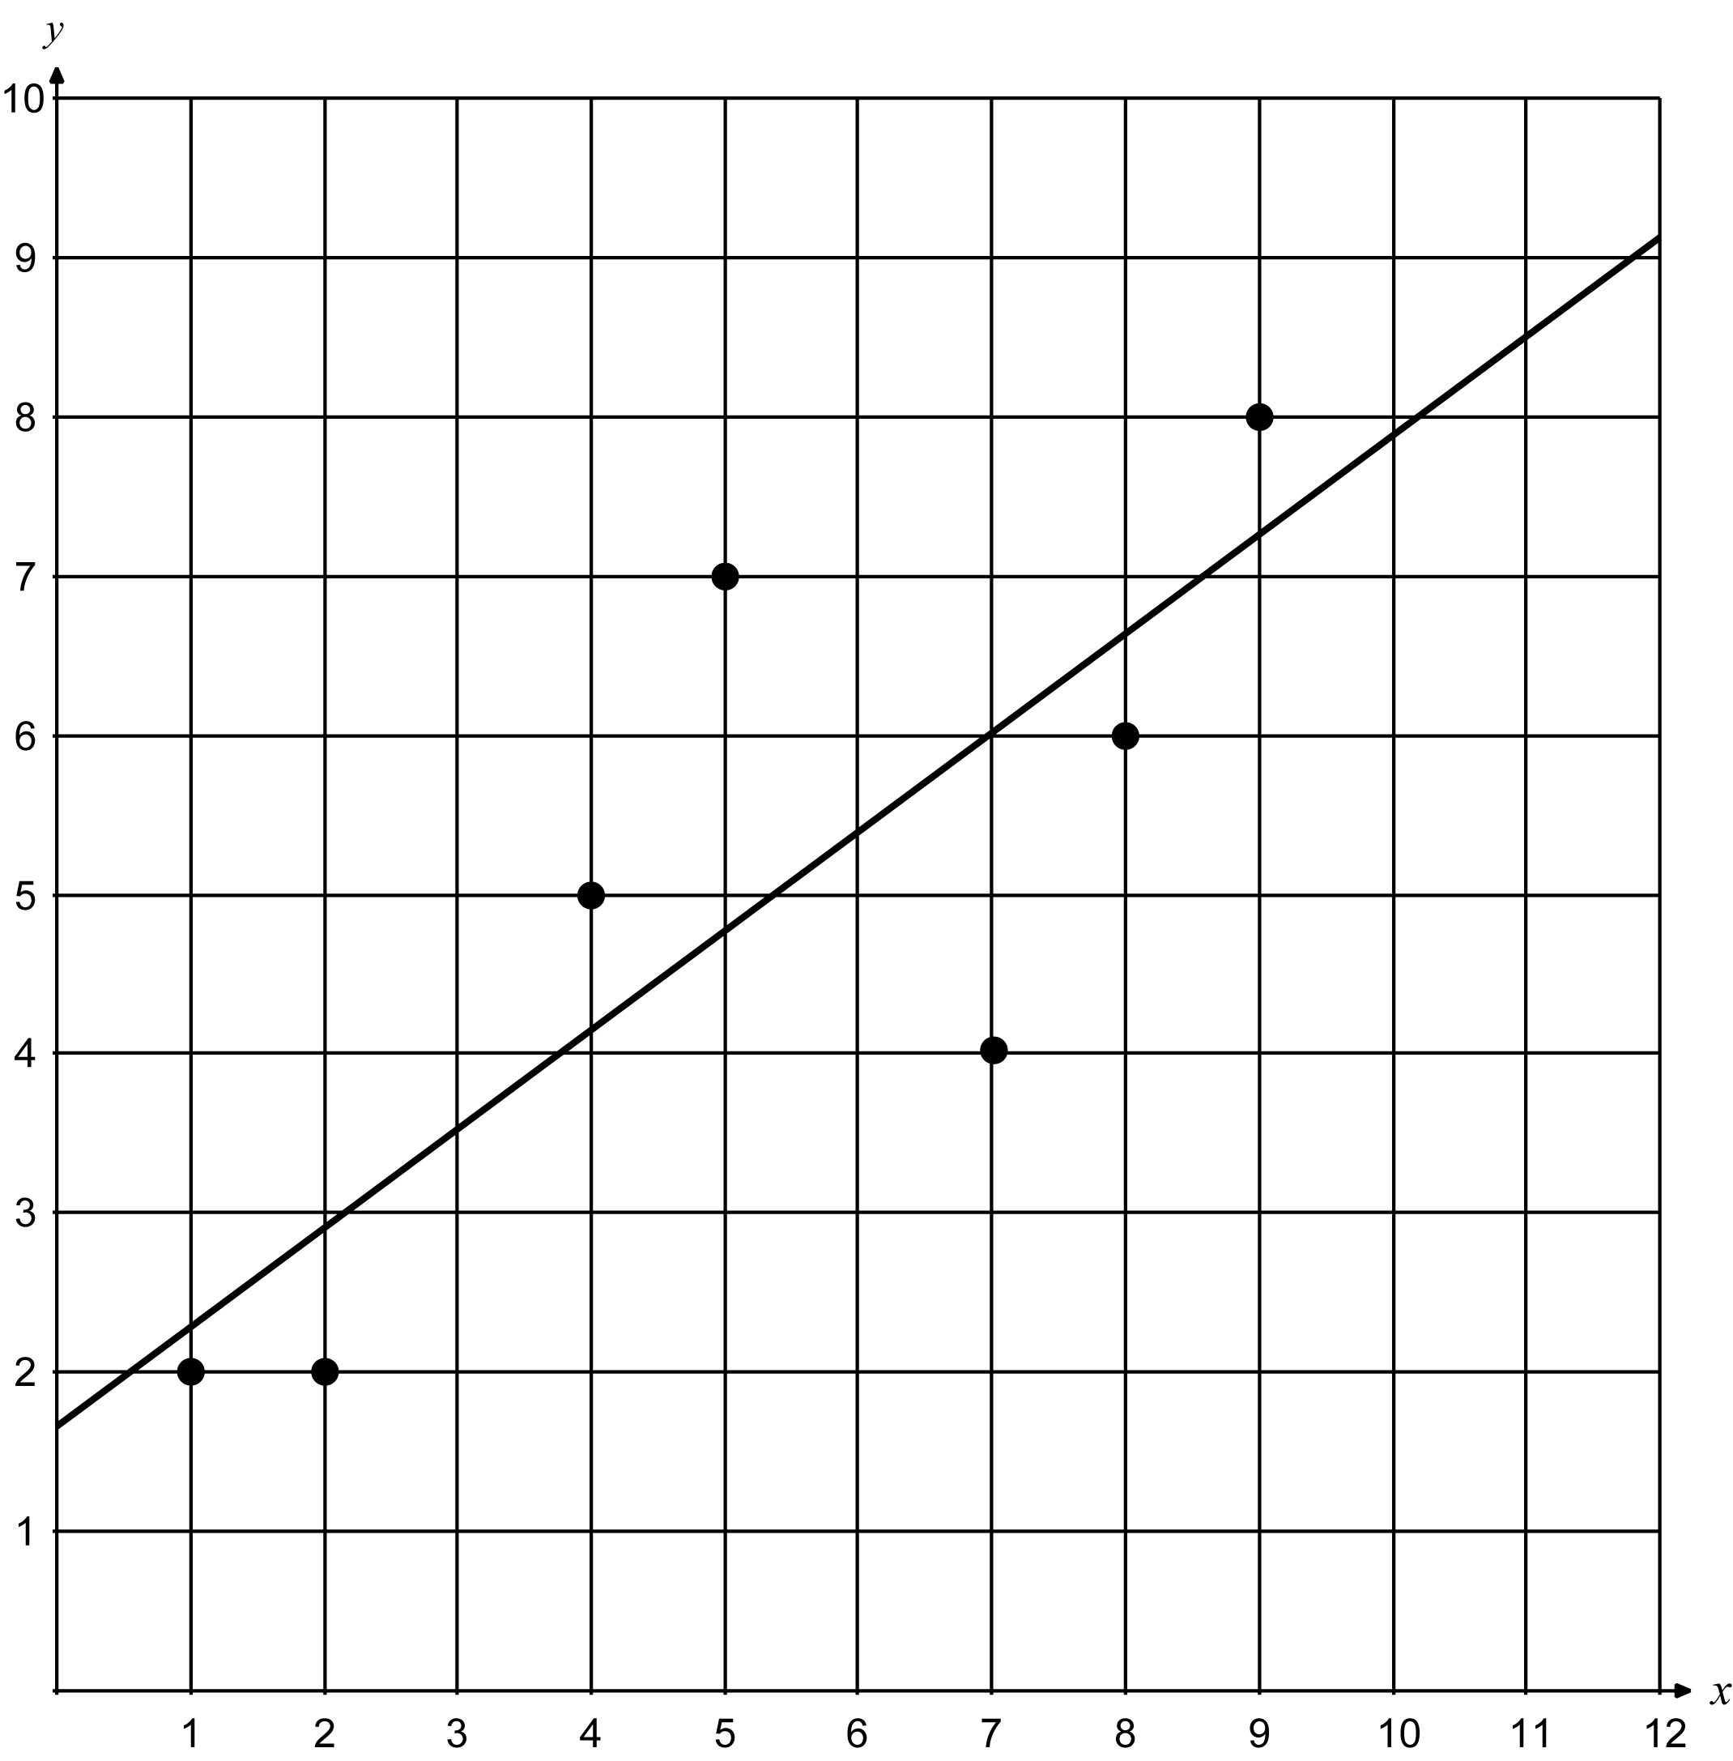
According to the graph, it appears that if the x-value is 11, the y-value would be approximately 8.5. Using the equation of the regression line we have the following.
 Question 1
Given the following data with regression line (obtained from a computer program). Determine which point is closest to the regression line and which point is farthest. Do this by making a scatterplot, drawing the regression line, and visually determining which point is closest and which point is farthest from the line.
x | 10 | 1 | 6 | 7 | 4 | 9 | 3 | 5
y | 5 | 8 | 4 | 3 | 6 | 4 | 8 | 6
Answer
appears to be farthest away and appears to be closest to the regression line.
Section 6.3 Correlation

 Key idea
The correlation, r, measures the strength of the linear relationship between two quantitative variables; r always lies between –1 and 1.

 Key idea
Positive r means the quantities tend to increase or decrease together; negative r means they tend to change in opposite directions, one going up while the other goes down. If r is close to 0, that means the quantities are fairly independent of each other.
 Example C
Give a rough estimate of the correlation between the variables in each of these scatterplots:
a) 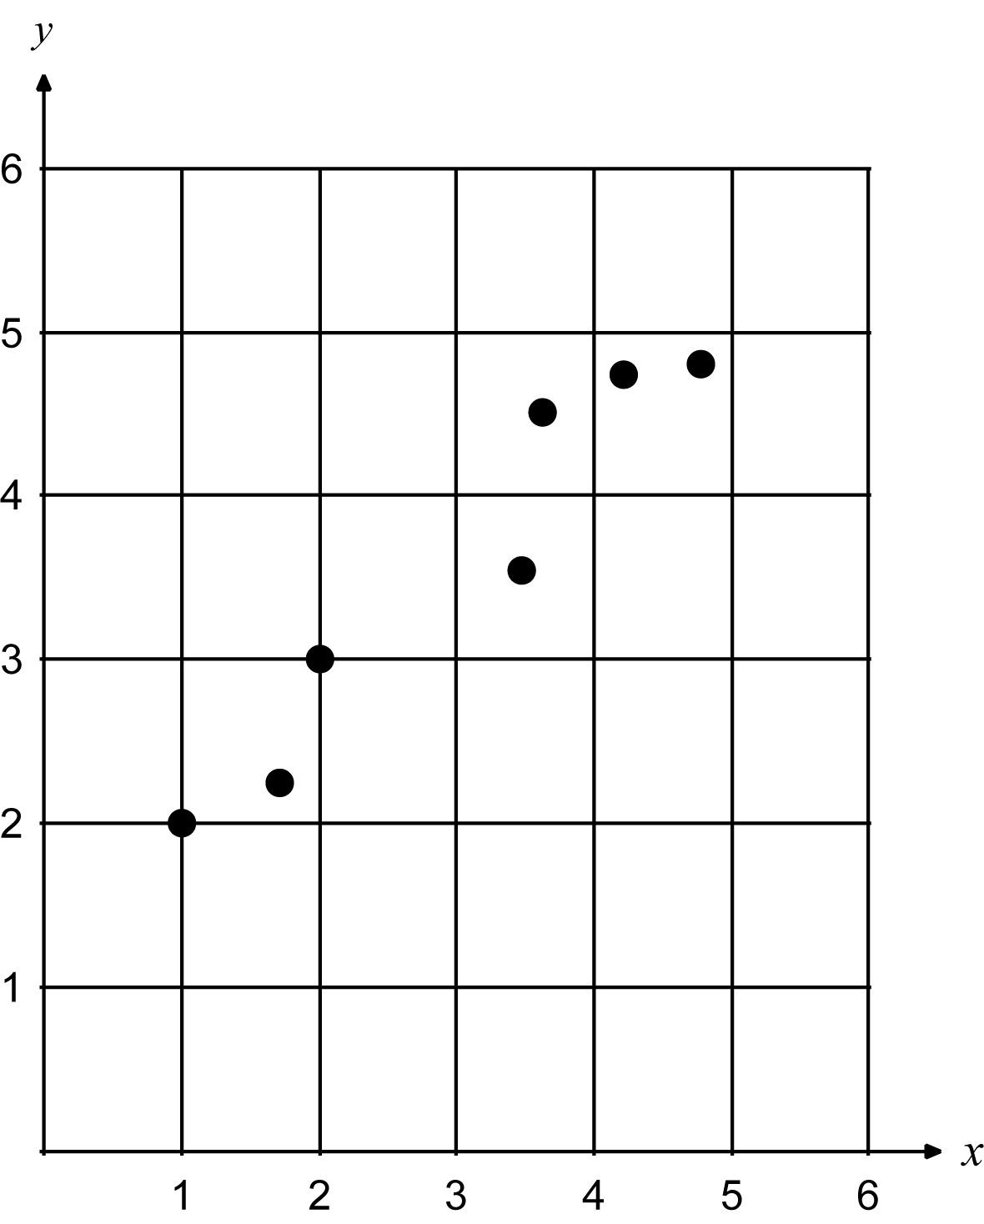b) 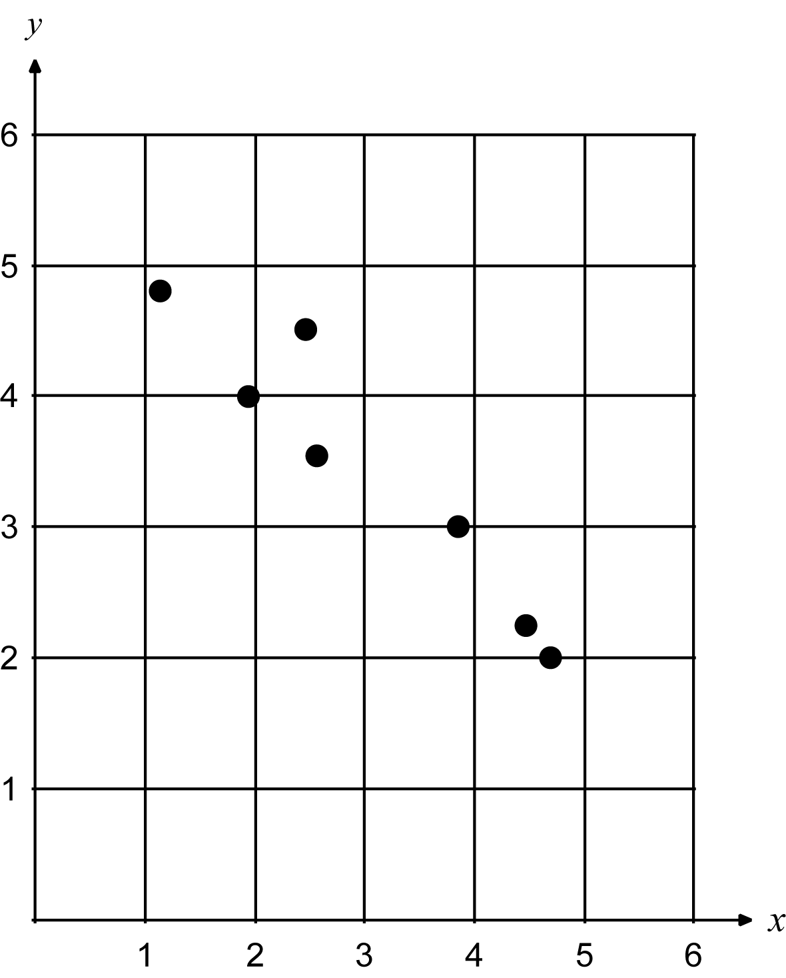c) 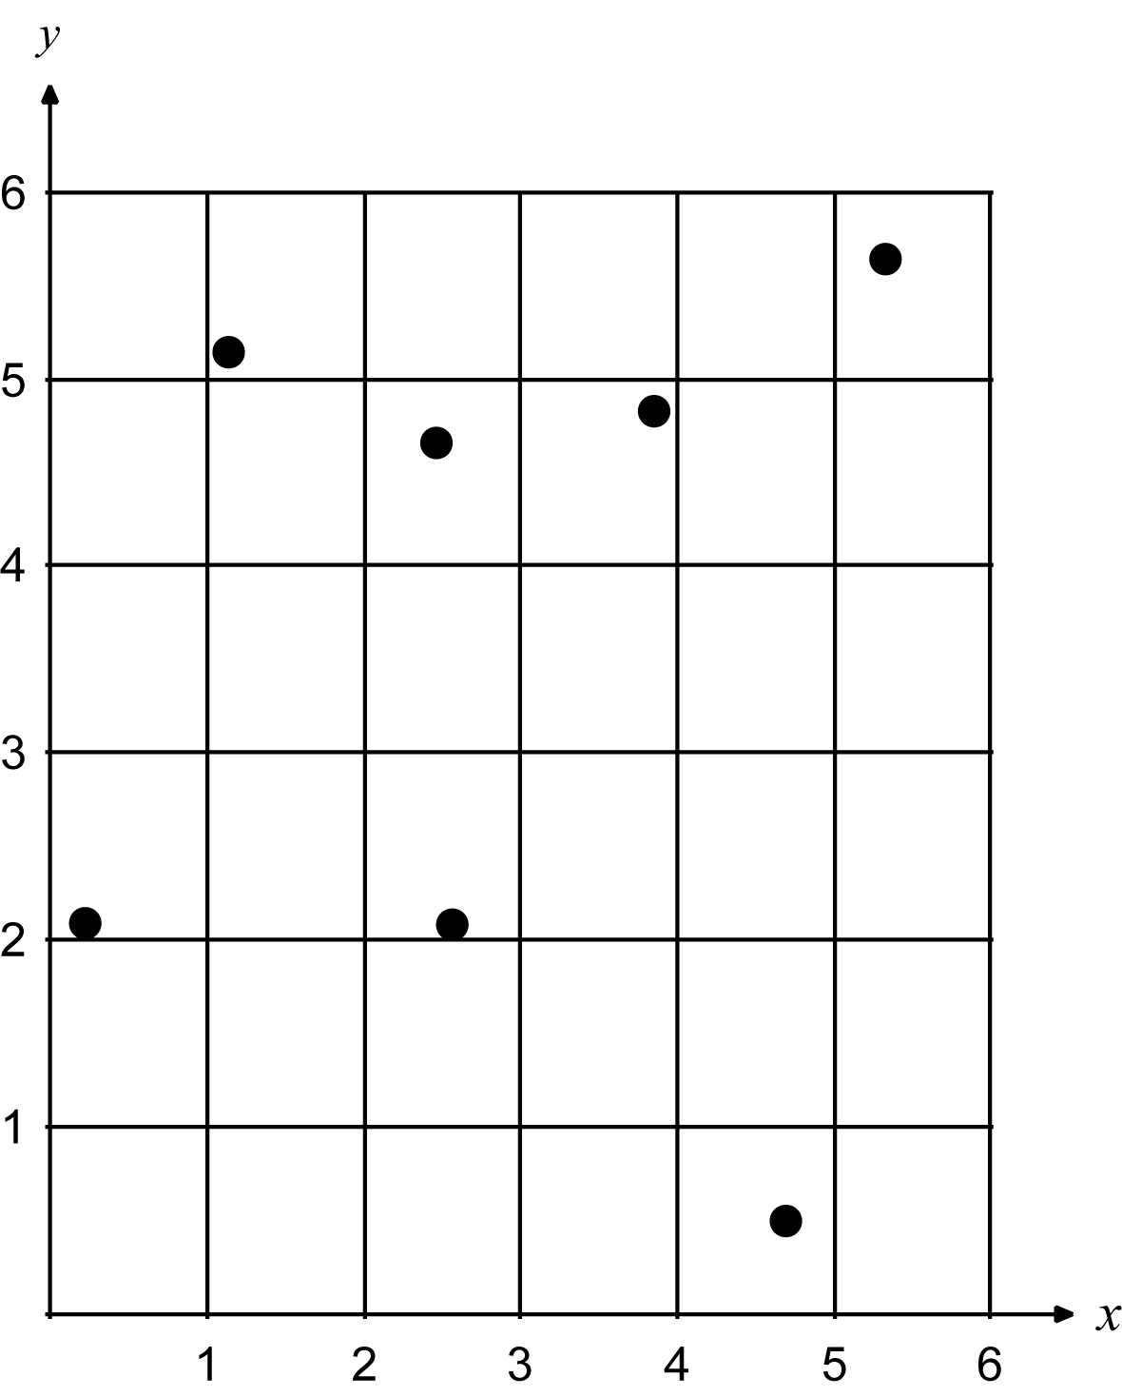
Solution
a) ; The points have a fairly tight linear relationship with a positive association, with the variables x and y increasing and decreasing together.
b) ; The points have a strong negative association, with high values of x associated with low values of y, and vice versa.
c) ; The variables x and y are fluctuating independently, with no clear correlated trend.

 Key idea
The following formula for correlation can be used given the means and standard deviations of the two variable x and y for the n individuals.
Section 6.4 Least – Squares Regression
 Key idea
The least-squares regression line runs through a scatterplot of data so as to be the line that makes the sum of the squares of the vertical deviations from the data points to the line as small as possible. This is often thought of as the “line of best fit” to the data.

 Key idea
The formula for the equation of the least-square regression line for a data set on an explanatory variable x and a response variable y depends on knowing the means of x and y, the standard deviations of x and y, and their correlation r. It produces the slope and intercept of the regression line.
The least-square regression line is predicted where (slope) and (y-intercept).
 Example D
Given the following data, compute the correlation and least-squares regression line by hand.
x | 4 | 9 | 3 | 5 | 2
y | 6 | 7 | 4 | 6 | 3
Solution
We have the following hand calculations.
i | Observations | Observations | Deviations | Deviations | Squared deviations | Squared deviations
1 | 4 | 6 | 0.6 | 0.8 | 0.36 | 0.64
2 | 9 | 7 | 4.4 | 1.8 | 19.36 | 3.24
3 | 3 | 4 | 1.6 | 1.2 | 2.56 | 1.44
4 | 5 | 6 | 0.4 | 0.8 | 0.16 | 0.64
5 | 2 | 3 | 2.6 | 2.2 | 6.76 | 4.84
sum | 23 | 26 | 0 | 0 | 29.2 | 10.8
, and
Since
we have the following.
Since and the least-square regression line is
 Question 2
Given the following data, compute the correlation and least-squares regression line by hand.
x | 1 | 2 | 3 | 4 | 5
y | 8 | 4 | 6 | 5 | 2
Answer
and
Section 6.5 Interpreting Correlation and Regression

 Key idea
Both the correlation, r, and the least-squares regression line can be strongly influenced by a few outlying points. Never trust a correlation until you have plotted the data.

 Key idea
Correlation and regression describe relationships. Interpreting relationships requires more thought.
Try to think about the effects of other variables prior to drawing conclusions when interpreting the results of correlation and regression. An association between variables is not itself good evidence that a change in one variable actually causes a change in the other!
 Example E
Measure the number of gold rings per women x and the number of deaths from breast cancer y for women of the world’s nations. There is a strong correlation: Nations that have woman with many gold rings have fewer deaths from breast cancer. What kind of correlation would this be (negative or positive)? Can woman around the world reduce the number of deaths due to breast cancer by owning rings?
Solution
This should be a negative correlation (called high negative, closer to ). Women from rich nations should have more gold rings than women from poor nations. Rich nations have better medical treatment for breast cancer and would offer lower death rates as a result. There is no cause-and-effect tie between gold rings and death rates from breast cancer.
 Question 3
The following is data from a small company. The explanatory variable is the number of years with the company and the response variable is salary. Use a calculator to determine the correlation and least-squares regression line.
x | 1 year | 2 year | 3 year | 4 year | 5 year
y | $77,500 | $29,500 | $31,000 | $34,000 | $41,000
a) Using the regression line, project the salary of an employee that has been with the company 10 years. Comment on the results.
Remove the outlier from the data and compute again the correlation and least-squares regression line.
b) Using the regression line (without the outlier), project the salary of an employee that has been with the company 10 years. Comment on the results.
Answer
a) approximately Comments will vary.
b) approximately Comments will vary.
Homework Help
Exercise 1
Carefully read the Introduction before responding to this exercise.
Exercises 2 – 3
Carefully read Section 6.1 before responding to these exercises. Reading section 6.5 may also help in guiding you in interpreting the results.
Exercises 4 – 7
Carefully read Section 6.1 before responding to these exercises. The following may be helpful in creating your scatterplots by hand.

Exercise 4
Exercise 5

Exercise 6
Exercise 7
Exercise 8
Carefully read Section 6.1 before responding to this exercise. Think of things around you such as amount of time studying for an exam (versus grade) or number of years in school (versus income) or age (versus car insurance rates). Think how if you plotted these relations whether a line would have a positive slope or a negative slope.
Exercise 9
Carefully read Section 6.1 and 6.3 before responding to this exercise. The following may be helpful in creating your scatterplots by hand.
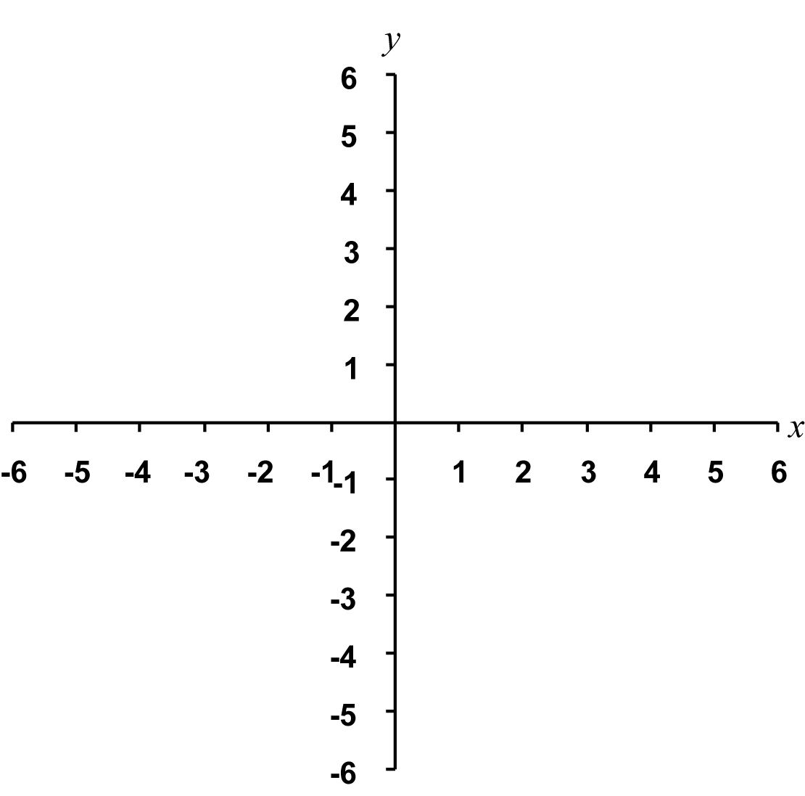
Exercises 10 – 14
Carefully read Section 6.1 before responding to these exercises. The following may be helpful in creating the graph needed in Exercise 11.
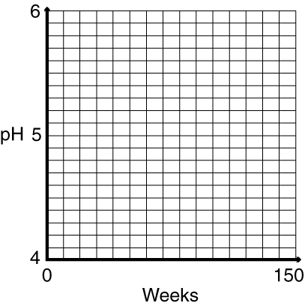
Exercises 15 – 25
Carefully read Section 6.3 before responding to these exercises. Make sure you know the course requirements regarding the use of calculators or spreadsheets in computing your answers.
Exercise 26
The following may be helpful in creating the scatterplot needed for this exercise in Part a.
Exercises 27 – 28
Carefully read Section 6.4 before responding to these exercises. Make sure you know the course requirements regarding the use of calculators or spreadsheets in computing your answers.
Exercises 29 – 31
Carefully read Section 6.4 before responding to these exercises. Make sure you know the course requirements regarding the use of calculators or spreadsheets in computing your answers. The following may be helpful in creating the scatterplot and graphing the least-squares regression lines in these exercises.
Exercise 29
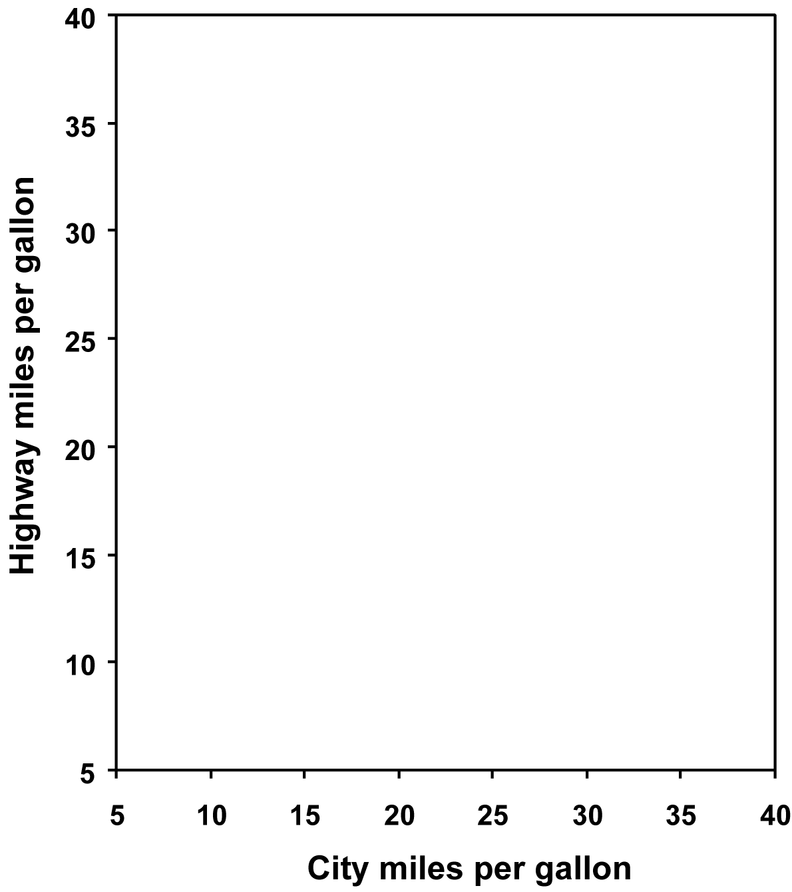
Exercise 30
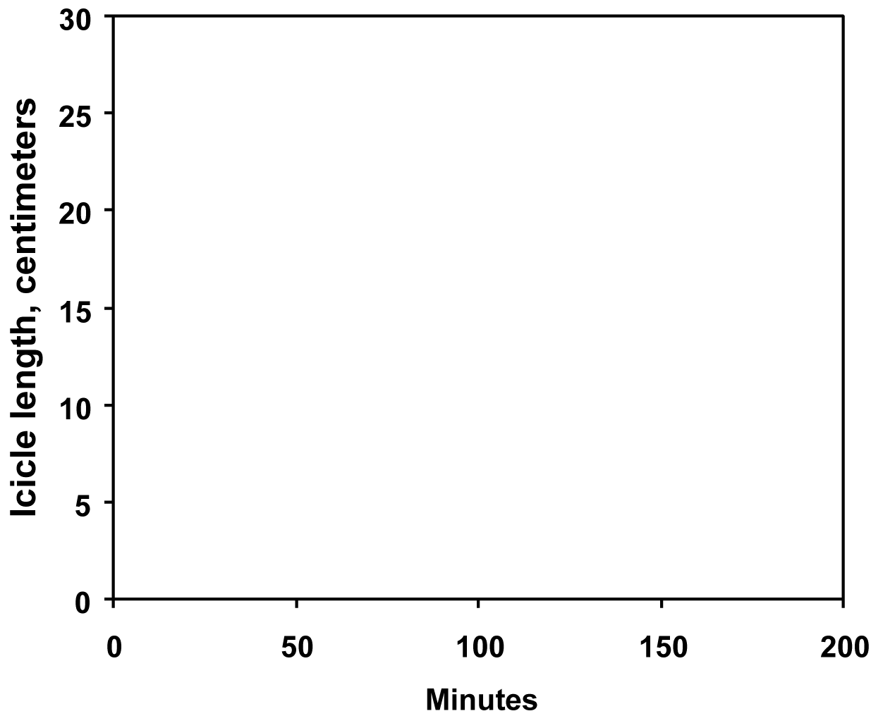
Exercise 31
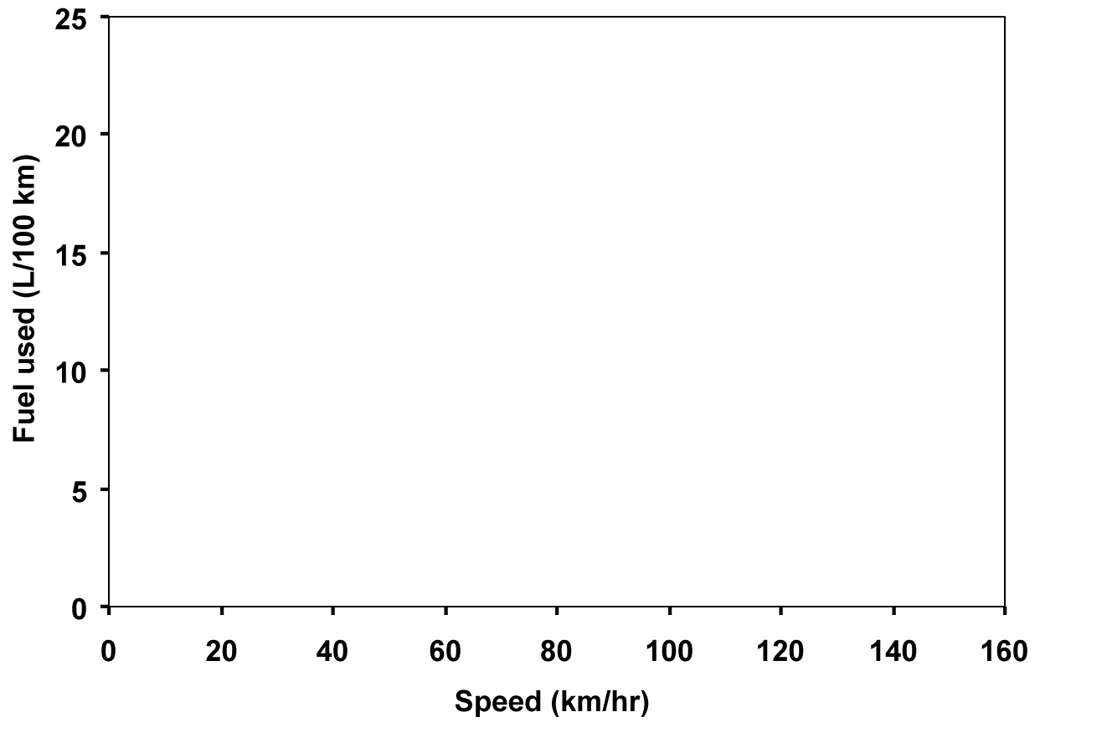
Exercises 32
Since divide the slope of the regression line by 2.54 to obtain the proper units.
Exercises 33 – 36
Carefully read Section 6.4 before responding to these exercises. Look carefully at the equation of the least-squares regression line. Also, make sure you know which variable is represented by x and which is represented by y.
Exercises 37
In this exercise you should consider doing boxplots (with five-number summary), histograms (or stemplots), scatterplots, least-squares regression, and correlation calculation in order to analyze the two data sets. Also, consider the effects of any outliers.
Exercises 38 – 39
Carefully read Sections 6.4 and 6.5 before responding to these exercises. Make sure you know the course requirements regarding the use of calculators and/or spreadsheets in computing your answers.

Exercises 40 – 44
Carefully read Section 6.4 before responding to these exercises. Answers will vary in these exercises. Try to think carefully of the potential cause and effect or alternative explanations for the effect.
Exercise 45
Carefully read Section 6.1 before responding to this exercise. Reading section 6.5 may also help in
guiding you in interpreting the results.
Exercise 46
Carefully read Section 6.1 before responding to this exercise.
Exercises 47
Carefully read Section 6.3 before responding to this exercise. Make sure you know the course requirements regarding the use of calculators and/or spreadsheets in computing your answers. The following may be helpful in creating the scatterplot for needed this exercise in Part a.
Exercise 48
Carefully read Section 6.3 before responding to this exercise. The section specifically addresses what is asked for in this question.
Exercise 49
Carefully read Section 6.2 before responding to this exercise.

Do You Know the Terms?

Cut out the following 9 flashcards to test yourself on Review Vocabulary. You can also find these flashcards at http://www.whfreeman.com/fapp7e.

Chapter 6  Exploring Data: Relationships  Correlation | Chapter 6  Exploring Data: Relationships  Intercept of a line
Chapter 6  Exploring Data: Relationships  Least-squares regression line | Chapter 6  Exploring Data: Relationships  Negative association
Chapter 6  Exploring Data: Relationships  Outlier | Chapter 6  Exploring Data: Relationships  Positive association
Chapter 6  Exploring Data: Relationships  Regression line | Chapter 6  Exploring Data: Relationships  Response variable
Chapter 6  Exploring Data: Relationships  Explanatory variable | Chapter 6  Exploring Data: Relationships  Scatterplot

The vertical (y) coordinate of the point on the line above 0 on the horizontal (x) axis. | A measure of the direction and strength of the straight-line relationship between two numerical variables. Correlations take values between 0 (no straight-line relationship) and 1 (perfect straight-line relationship).
Two variables are negatively associated if above-average values of one tend to go with below-average values of the other. The scatterplot has a northwest-to-southeast pattern, and the correlation and regression slope are both negative. | A line drawn on a scatterplot that makes the sum of the squares of the vertical distances of the data points from the line as small as possible. The regression line can be used to predict the response variable y for a given value of the explanatory variable x.
Two variables are positively associated if above-average values of one tend to go with above-average values of the other. The scatterplot has a southwest-to-northeast pattern, and the correlation and regression slope are both positive. | An outlier in a scatterplot is a point that lies outside the overall pattern of the other points. Outliers sometimes strongly influence the value of the correlation and the position of the least-squares regression line.
A variable that measures an outcome of a study. | Any line that describes how a response variable y changes as we change an explanatory variable x. The most common such line is the least-squares regression line.
A graph of the values of two variables as points in the plane. Each value of the explanatory variable is plotted on the horizontal axis, and the value of the response variable for the same individual is plotted on the vertical axis. | A variable that attempts to explain the observed outcomes.

Learning the Calculator
Example 1
Create a scatterplot given the following data.
x | 2 | 4 | 1 | 5 | 7
y | 6 | 5 | 7 | 7 | 4
Solution

First enter the data as described in Chapter 5 section of Learning the Calculator. You should have the following screen.
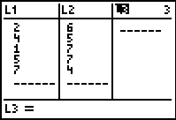
In order to display a scatterplot, you press 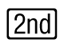 then 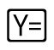. This is equivalent to 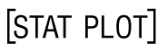. The following screen (or similar) will appear.
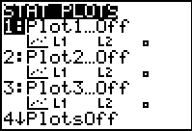

You will need to turn a stat plot On and choose the scatterplot option (). You will also need to make sure Xlist and Ylist reference the correct data. In this case L1 and L2, respectively.
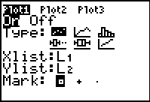
As was noted in the Chapter 5 section of Learning the Calculator, you will need to make sure that no other graphs appear on your scatterplot.
You will next need to choose an appropriate window. By pressing  you need to enter an appropriate window that includes your smallest and largest pieces of data in L1. These values dictate your choices of Xmin and Xmax. You will also need to enter an appropriate window that includes your smallest and largest pieces of data in L2. These values dictate your choices of Ymin and Ymax. Choose convenient values for Xscl and Yscl. In this case, 1 for each would be convenient.
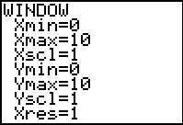
Next, we display the histogram by pressing the 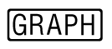 button.
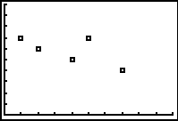
Example 2
Find and graph the least-squares regression line for the following data.
x | 2 | 4 | 1 | 5 | 7
y | 6 | 5 | 7 | 7 | 4
Solution
With data already entered, press the 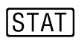button. Toggle to the right for CALC. Toggle down to 8:LinReg(a+bx) and press .
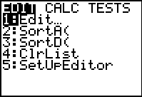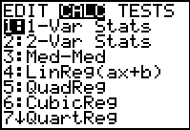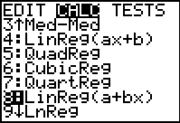
Instead of toggling down to 8:LinReg(a+bx) and pressing , you could alternatively press the 8 button (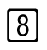). In either case the following screen will appear.
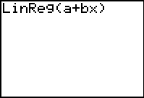
By pressing , you may get the following screen. Your screen may have more information.
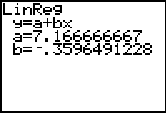
There are several ways to obtain the following graph of the least-squares line along with the scatterplot.
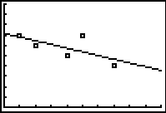
In all three methods, you will need to press in order to enter the equation.
Method I: Type in the equation of the regression line, by rounding the values of a and b.
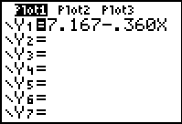
Press in order to obtain the graph. This is the easiest method.
Method II: Place the equation of the regression line, up to the accuracy of the calculator.
To do this, you press  then toggle down to 5:Statistics and press . You could alternatively press the 5 button ().
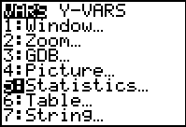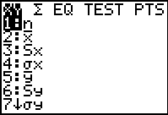
Toggle to the right to the EQ menu and press .
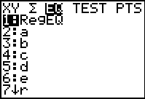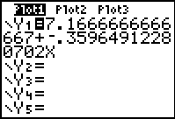
Press in order to obtain the graph.
Method III: Place the equation of the regression line, in general into your equation editor. To do this, you press .
Toggle down to 5:Statistics and press . You could alternatively press the 5 button ().
Continued on next page
Toggle to the right to the EQ menu and toggle down to 2:a and press . You could alternatively press the 2 button (). After pressing the plus button (), press again and run through the similar procedure to insert b.
Finally, press 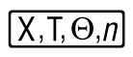 to get the following screen.
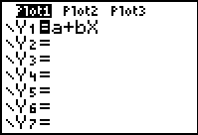
Press in order to obtain the graph. Although this is the hardest method, you only need to do it once. When you don’t wish for the equation to be graphed, simply de-select the relation by the method described in Chapter 5 of Learning the Calculator.
Example 3
Find the correlation for the following data.
x | 2 | 4 | 1 | 5 | 7
y | 6 | 5 | 7 | 7 | 4
Solution
You may have already obtained the correlation when you obtained the least-squares line in Example 2. If not, you need to activate the DiagnosticOn feature. To do this, press then . This will take you to the CATALOG menu.
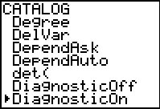

Toggle down to DiagnosticOn and press twice. You should get the following screen.
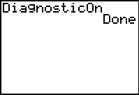
Finally, follow the instructions in Example 2 to obtain the least-squares line. The correlation is
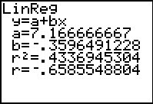

Practice Quiz
1. The park wants to predict the amount of ice used each day, based on the predicted high temperature. Which variable would be the explanatory variable?
a. the amount of ice used
b. the predicted high temperature
c. the actual high temperature
2. The daily ice consumption (in pounds) y at a park is related to the predicted high temperature (in degrees F) x. Suppose the least-squares regression line is y = 250 + 25x. Today’s predicted high temperature is 90 degrees F. This means that
a. at least 2500 pounds of ice will be needed today.
b. approximately 2500 pounds of ice will be needed today.
c. exactly 2500 pounds of ice will be needed today.
3. The daily ice consumption (in pounds) y at a park is related to the predicted high temperature (in degrees F) x. Suppose the least-squares regression line is y = 250 + 25x. Suppose 2300 pounds of ice were used yesterday. This leads you to believe that yesterday’s high temperature was closest to
a. 52 degrees F.
b. 82 degrees F.
c. 92 degrees F.
4. Draw a scatterplot showing the relationship between the observed variables x and y, with the data given in the table below.
x | 2 | 4 | 1 | 5 | 7 | 9 | 8
y | 10 | 5 | 8 | 7 | 4 | 6 | 6
Based of the scatterplot, you can state that
a. the y-intercept of the least – squares regression line is about 3.
b. the correlation, r, is between – 1 and 0.
c. the slope of the least – squares regression line is about 0.45.
5. Find the equation of the least – squares regression line for the data below.
x | 2 | 4 | 5 | 2 | 3 | 6 | 7 | 1
y | 5 | 6 | 6 | 1 | 5 | 8 | 7 | 3
a.
b.
c.
6. Suppose you collected data for the number of hours individuals practice bowling, x, versus their bowling score, y. What is the best conclusion that can be drawn?
a. The correlation should be close to zero.
b. The correlation should be positive.
c. The correlation should be negative.
7. Which one of the following statements is true?
a. Possible values for correlation, r, are between 0.1 and 0.8.
b. For a data set on an explanatory variable x and a response variable y, the least-square regression line is predicted where and (y-intercept).
c. If you obtain a correlation of – 1.3, then one of your data points must be incorrect.
8. Choose the best estimate of the equation of the least – squares regression line for the scatterplot:
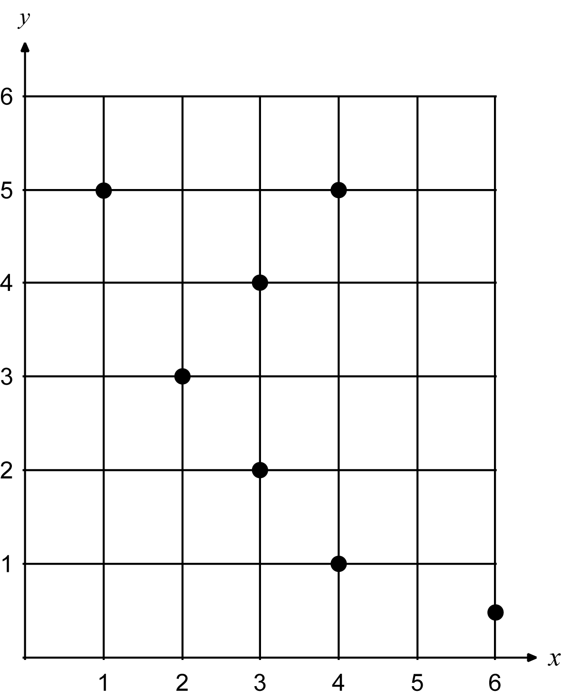
a.
b.
c.
9. Choose the best estimate of the correlation between the variables in the following scatterplot:
a. 0.32
b.
c.
10. The number of cavities that children in elementary school have and the number of words in their vocabulary have a strong positive correlation. Which of the following is the best statement that can be made.
a. If you want your child to have a large vocabulary, allow them to get cavities.
b. Sally has a small vocabulary because she takes good care of her teeth.
c. Since both number of cavities and vocabulary size relate to age, one cannot imply that the number of cavities affects the vocabulary size of elementary school children.

Word Search
Refer to pages 239 – 240 of your text to obtain the Review Vocabulary. There are 9 hidden vocabulary words/expressions in the word search below. Intercept of a line does not appear. Least-squares regression line and regression line appear separately in the word search. Also, response variable and explanatory variable appear separately in the word search. It should be noted that spaces and hyphens are removed.
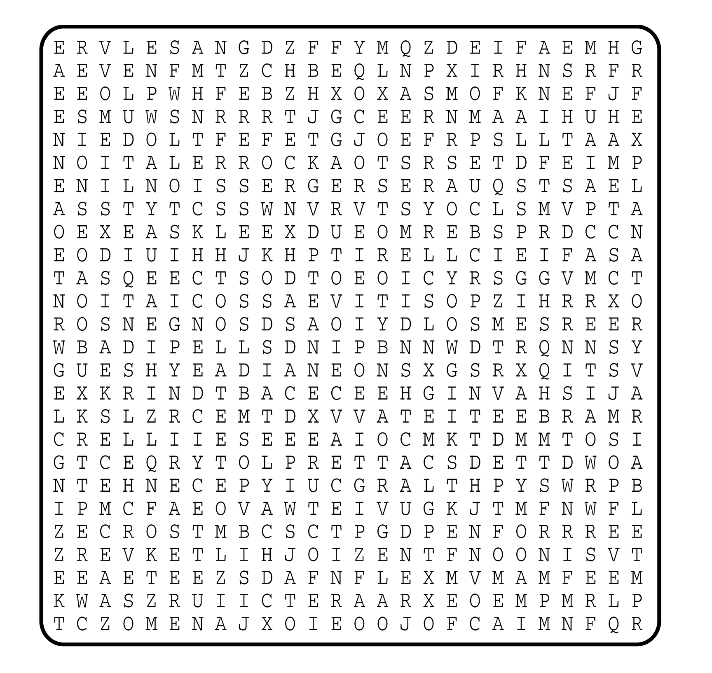

1. __________________________
2. __________________________
3. __________________________
4. __________________________
5. __________________________
6. __________________________
7. __________________________
8. __________________________
9. __________________________

