Chapter 4

Linear Programming

chapter Objectives
Check off these skills when you feel that you have mastered them.
 From its associated chart, write the constraints of a linear programming problem as linear inequalities.
 List two implied constraints in every linear programming problem.
 Formulate a profit equation for a linear programming problem when given the per-unit profits.
 Describe the graphical implications of the implied constraints listed in the third objective (above).
 Draw the graph of a line in a coordinate-axis system.
 Graph a linear inequality in a coordinate-axis system.
 Determine by a substitution process whether a point with given coordinates is contained in the graph of a linear inequality.
 Indicate the feasible region for a linear programming problem by shading the graphical intersection of its constraints.
 Locate the corner points of a feasible region from its graph.
 Evaluate the profit function at each corner point of a feasible region.
 Apply the corner point theorem to determine the maximum profit for a linear programming problem.
 Interpret the corner point producing the profit maximum as the solution to the corresponding linear programming problem.
 List two methods for solving linear programming problems with many variables.
 Given a tableau, apply the Northwest Corner Rule to find a feasible solution.
 Calculate the cost of the system found by the Northwest Corner Rule.
 Calculate the value of indicator cells.
 Use the stepping stone method to find an optimal solution.
Guided Reading
Introduction

 Key idea
Linear programming is used to make management decisions in a business or organizational environment. In this chapter, we are concerned with situations where resources—time, money, raw materials, labor—are limited. These resources must be allocated with a certain goal in mind: to do a job as quickly as possible, or to keep costs to a minimum, or to make a maximum profit. Such problems are modeled by systems of linear inequalities and solved by a combination of algebraic and numerical methods. We will focus on examples in the context of business, with the objective of making the largest possible profit.
Section 4.1 Mixture Problems: Combining Resources to Maximize Profit

 Key idea
In a mixture problem, limited resources are combined to produce a product at maximum profit. In trying to solve a mixture problem, we create a mixture chart.

 Key idea
The two properties of an optimal production policy are:
- it does not violate any of the limitations under which the manufacturer operates, such as the availability of resources;
- it produces the maximum profit.

 Key idea
In a mixture problem we define the variables (usually two) and set up a mixture chart. The mixture chart has a row for each product and a column for each resource, the minimums of each product, and profit from each product. Unless minimums are specified, the natural assumption is made that all variables must be of value zero or greater. Note that resources are indicated in the columns and products in rows.
 Example A
Dan runs a small creamery shop, named Dippy Dan’s, in which he gets a shipment of 240 pints (30 gallons) of cream every day. Each container of ice cream requires one-half pint of cream and sells at a profit of $.75. Each container of sherbet requires one-quarter pint of cream and sells at a profit of $.50.
a) Define the variables.
b) Set up a mixture chart.
Solution
a) Let x be the number of containers of ice cream and y be the number of containers of sherbet.
b) |  | Cream (240 pints) | Minimums | Profit
 | Ice cream, x containers |  | 0 | $0.75
 | Sherbet, y containers |  | 0 | $0.50

 Key idea
The mixture chart can be translated into a set of inequalities (resource constraints and minimum constraints) along with a relation (often profit) to maximize.
 Example B
Write the resource constraints for cream and minimal constraints and the profit formula that applies to Dippy Dan’s creamery shop.
Solution
Constraints:
Profit formula:

 Key idea
In a mixture problem, we seek an optimal production policy for allocating limited resources to make a maximum profit. The resource constraints, together with the minimum constraints, can be used to draw a graph of the feasible region. A production policy is represented by a point in the feasible set, also called the feasible region.

 Key idea
In determining a feasible region, you will need to graph a set of linear inequalities in the plane which involves the following:
- Graphing lines by the intercept method and determining which side to shade by using a test point (generally the origin);
- Graphing vertical and horizontal lines and determining which side to shade;
- Realizing that the minimum constraints of imply that your graph is restricted to the upper right quadrant (quadrant I);
- Determining what region to finally shade, considering all inequalities.
 Example C
Draw the feasible region for Dippy Dan’s creamery shop.
Solution
The minimum constraints imply we are restricted to quadrant I.
We need to first graph
The y-intercept of can be found by substituting
The y-intercept is
The x-intercept of can be found by substituting
The x-intercept is
Continued on next page
We draw a line connecting these points. Testing the point we have the statement or This is a true statement, thus we shade the half-plane containing our test point, the down side of the line in quadrant I.
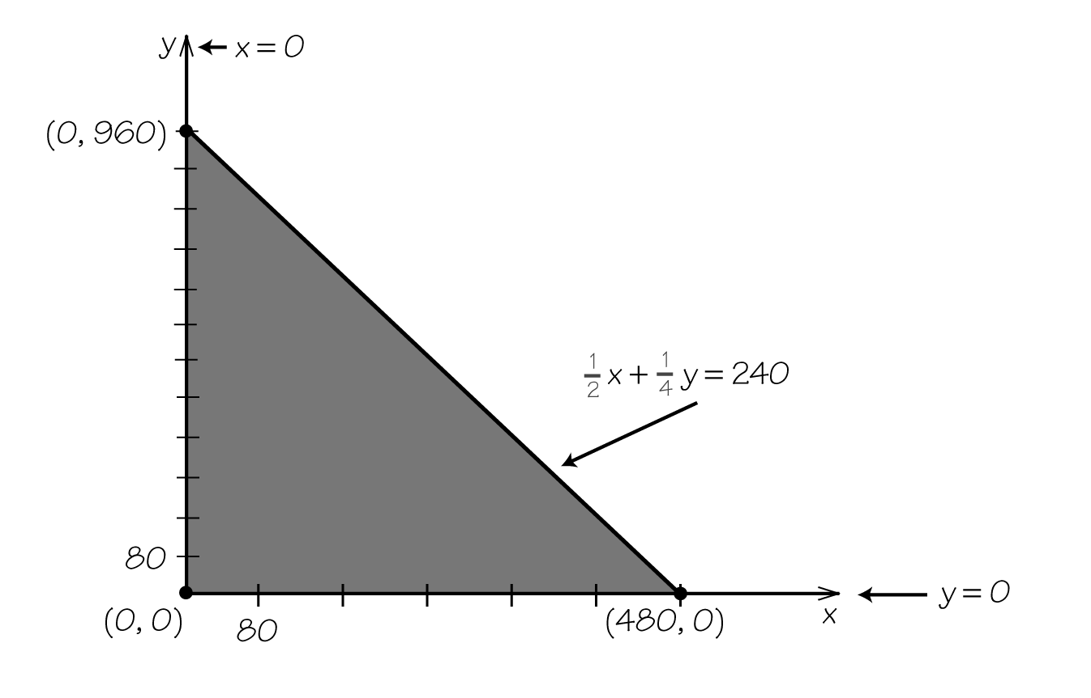
Section 4.2 Finding the Optimal Production Policy

 Key idea
According to the corner point principle, the optimal production policy is represented by a corner point of the feasible region. To determine the optimal production policy, we find the corner points of our region and evaluate the profit relation. The highest value obtained will indicate the optimal production policy that is, how many of each product should be produced for a maximum profit.
 Example D
Find the Dippy Dan’s creamery shop optimal production policy.
Solution
We wish to maximize
Corner Point | Value of the Profit Formula:
Dan’s optimal production policy: Make 0 containers of ice cream and 960 containers of sherbet for a profit of $480.

 Key idea
If one or more of the minimums are greater than zero, you will need to find a point of intersection between two lines. This can be done by substitution.
 Example E
Find the point of intersection between and
Solution
By substituting into we have the following.
Thus the point of intersection is
 Question 1
a) Find the point of intersection between and
b) Find the point of intersection between and
Answer
a)
b)
 Example F
Dan has made agreements with his customers that obligate him to produce at least 100 containers of ice cream and 80 containers of sherbet. Find the Dippy Dan’s creamery shop optimal production policy.
Solution
The minimums need to be adjusted in the mixture chart.
 |  | Cream (240 pints) | Minimums | Profit
 | Ice cream, x containers |  | 100 | $0.75
 | Sherbet, y containers |  | 80 | $0.50
Constraints:
Profit formula:
The point of intersection between and is
The point of intersection between and can be found by substituting into We have Thus, the point of intersection is
The point of intersection between and can be found by substituting into We have Thus, the point of intersection is

Continued on next page

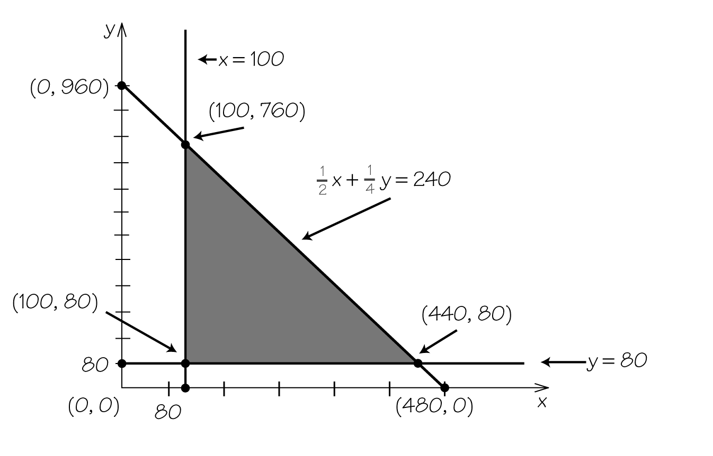
We wish to maximize
Corner Point | Value of the Profit Formula:
Dan’s optimal production policy: Make 100 containers of ice cream and 760 containers of sherbet for a profit of $455.
 Example G
Suppose a competitor drives down Dan’s price of sherbet to the point that Dan only makes a profit of $.25 per container. What is Dan’s optimal production policy?
Solution
The feasible region and corner points will not change. However, we need to now maximize
Corner Point | Value of the Profit Formula:
Dan’s optimal production policy: Make 440 containers of ice cream and 80 containers of sherbet for a profit of $350.

 Key idea
With two resources to consider, there will be two resource constraints. The feasible region will generally be quadrilateral, with four corners to evaluate. To find the point of intersection between two lines (where neither are vertical or horizontal), one can use the addition method.

 Example H
Find the point of intersection between and .
Solution
We can find this by multiplying both sides of by and adding the result to
Substitute into and solve to x. We have Thus the point of intersection is therefore
 Question 2
Find the point of intersection between and
Answer
 Example I
Dan’s creamery decides to produce raspberry versions of both its ice cream and sherbet lines. Dan is limited to, at most, 600 pounds of raspberries, and he adds one pound of raspberries to each container of ice cream or sherbet. Find the Dippy Dan’s creamery shop optimal production policy. (Assume he still only makes a profit of $0.25 on a sherbet container and has non-zero minimums.)
Solution
The mixture chart is now as follows.
 | Cream (240 pints) | Raspberries (600 lb) | Minimums | Profit
Ice cream, x containers |  | 1 | 100 | $0.75
Sherbet, y containers |  | 1 | 80 | $0.25
Constraints:
Profit formula:
The y-intercept of is and the x-intercept of is
The point of intersection between and can be found by substituting into We have Thus, the point of intersection is
The final new corner point is the point of intersection between and We can find this by multiplying both sides of by and adding the result to
Substitute into and solve for y. We have, Thus, the point of intersection is
Continued on next page
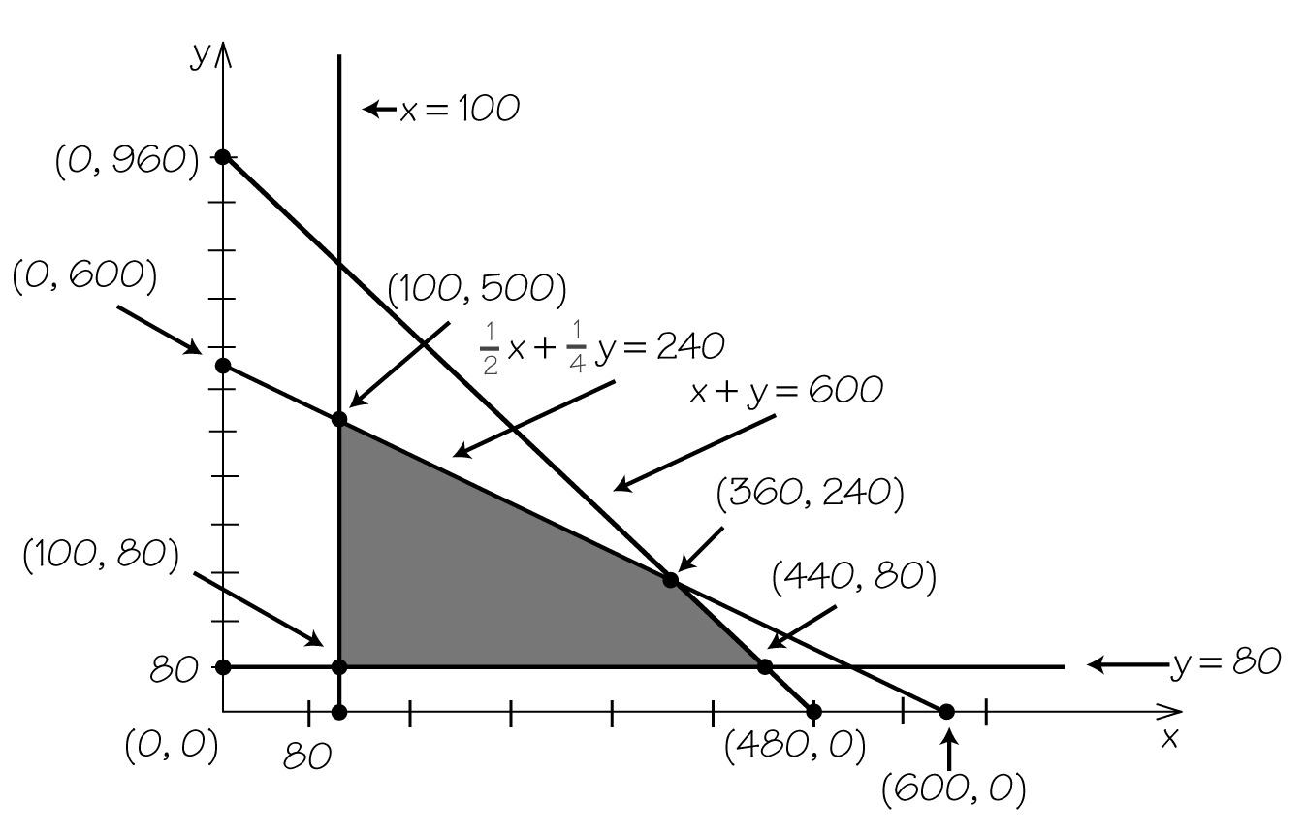
We wish to maximize
Corner Point | Value of the Profit Formula:
Dan’s optimal production policy: Make 440 containers of ice cream and 80 containers of sherbet for a profit of $350.
Note: With the additional constraint, there was no change because the optimal production policy already obeyed all constraints.

Section 4.3 Why the Corner Point Principle Works

 Key idea
If you choose a theoretically possible profit value, the points of the feasible region yielding that level of profit lie along a profit line cutting through the region.

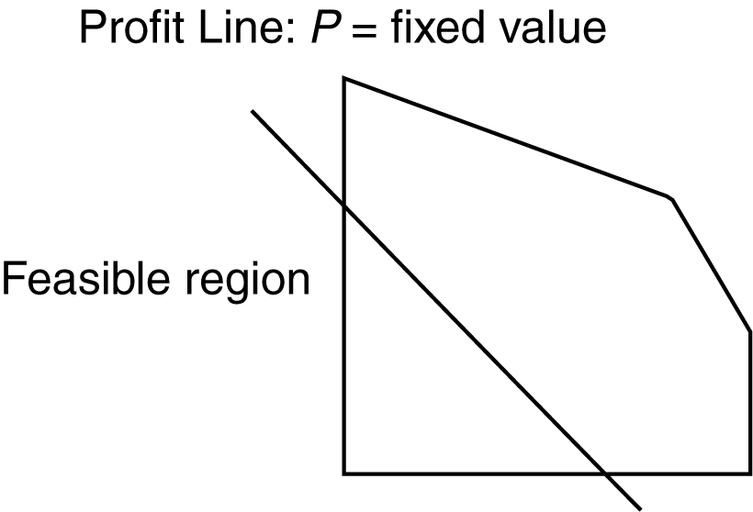

 Key idea
Raising the profit value generally moves the profit line across the feasible region until it just touches at a corner, which will be the point with maximum profit, the optimal policy.
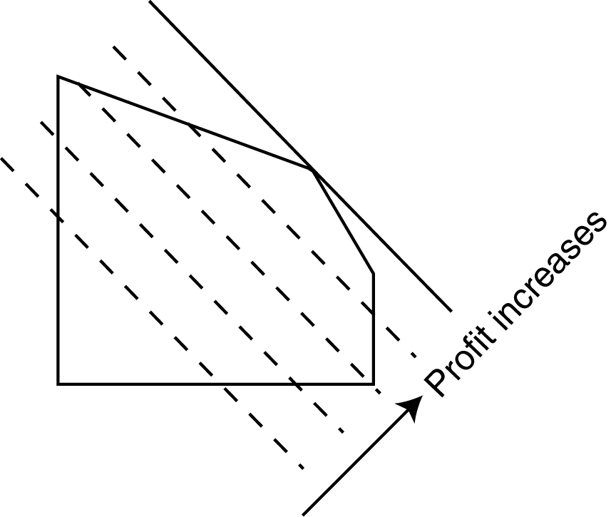

 Key idea
This explains the corner point principle; it works because the feasible region has no “holes” or “dents” or missing points along its boundary.
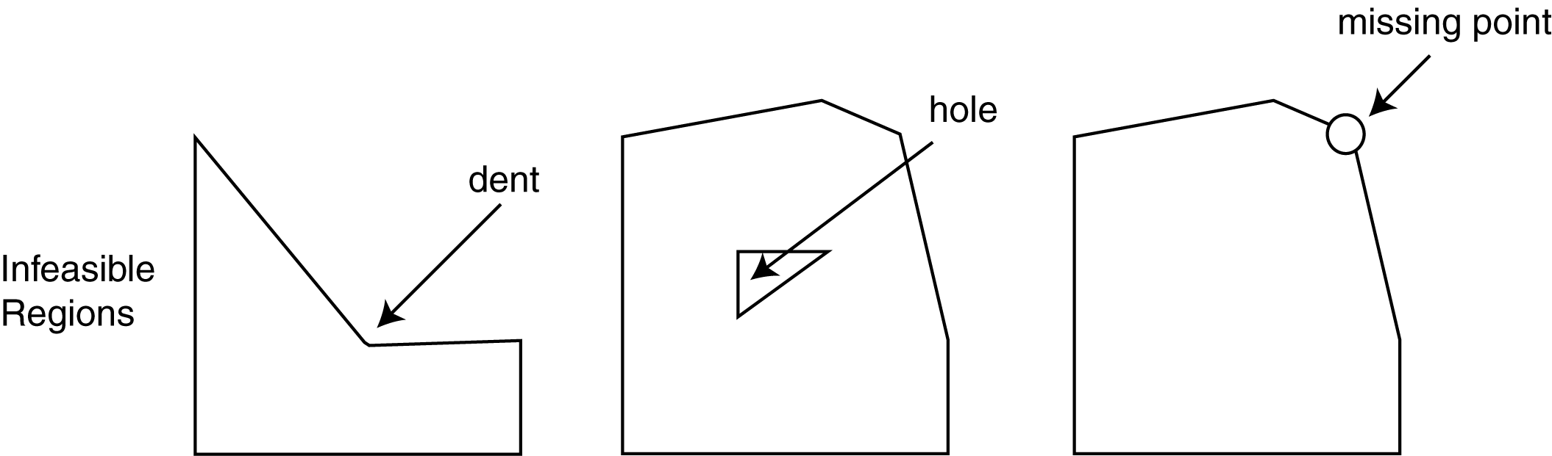
Section 4.4 Linear Programming: Life Is Complicated

 Key idea
For realistic applications, the feasible region may have many variables (“products”) and hundreds or thousands of corners. More sophisticated evaluation methods, such as the simplex method, must be used to find the optimal point.

 Key idea
The simplex method is the oldest algorithm for solving linear programming. It was devised by the American mathematician George Dantzig in the 1940’s. Years later, Narendra Karmarker devised an even more efficient algorithm.
 Example J
Dan’s creamery decides to introduce a light ice cream (a third product) in his shop. Assume that a container of this light ice cream will require one-eighth pint of cream and sells at a profit of $1.00. There is no minimum on this new product, and it does not contain raspberries. Given all the constraints in Example I, determine the resource constraints and minimal constraints and the profit formula that applies to Dippy Dan’s creamery shop.
Solution
Let x be the number of containers of ice cream, y be the number of containers of sherbet, and z be the number of containers of light ice cream.
 | Cream (240 pints) | Raspberries (600 lb) | Minimums | Profit
Ice cream, x containers |  | 1 | 100 | $0.75
Sherbet, y containers |  | 1 | 80 | $0.25
Light ice cream, z containers |  | 0 | 0 | $1.00
Profit formula:
Constraints:

 Key idea
In order to solve applications with more than two products, you will need to access a program. Many of these are readily available on the Internet.
Section 4.5 A Transportation Problem: Delivering Perishables

 Key idea
A transportation problem involves supply, demand, and transportation costs. A supplier makes enough of a product to meet the demands of other companies. The supply must be delivered to the different companies, and the supplier wishes to minimize the shipping cost, while satisfying demand.

 Key idea
The amount of product available and the requirements are shown on the right side and the bottom of a table. These numbers are called rim conditions. A table showing costs (in the upper right-hand corner of a cell) and rim conditions form a tableau.
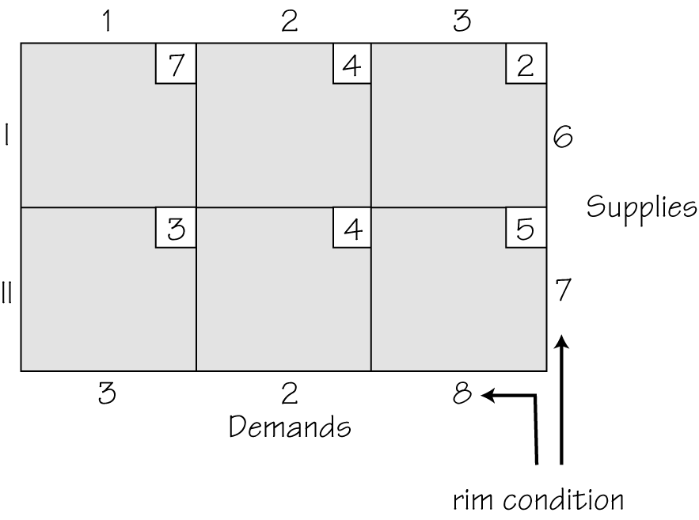
Each cell is indicated by its row and column. For example, the cell with a cost of 2 is cell (I, 3).

 Key idea
The northwest corner rule (NCR) involves the following.
- Locate the cell in the far top left (initially that will be cell (I,1) ).
- Cross out the row or column that has the smallest rim value for that cell.
- Place that rim value in that cell and reduce the other rim value by that smaller value.
- Continue that process until you get down to a single cell.
- Calculate the cost of this solution.
 Example K
Apply the Northwest Corner Rule to the following tableau and determine the cost associated with the solution.
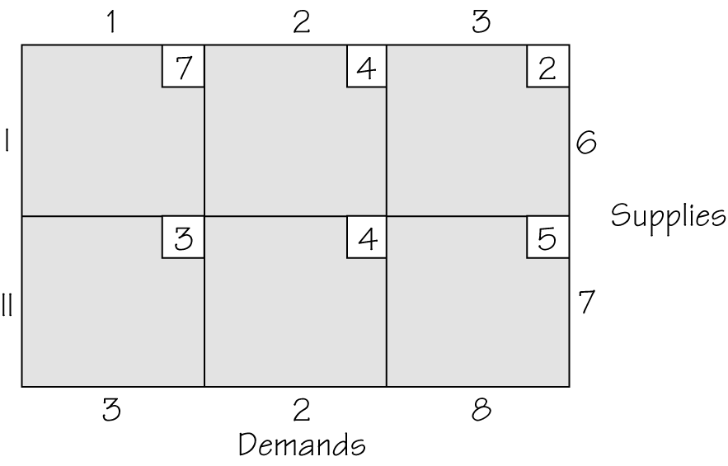
Solution
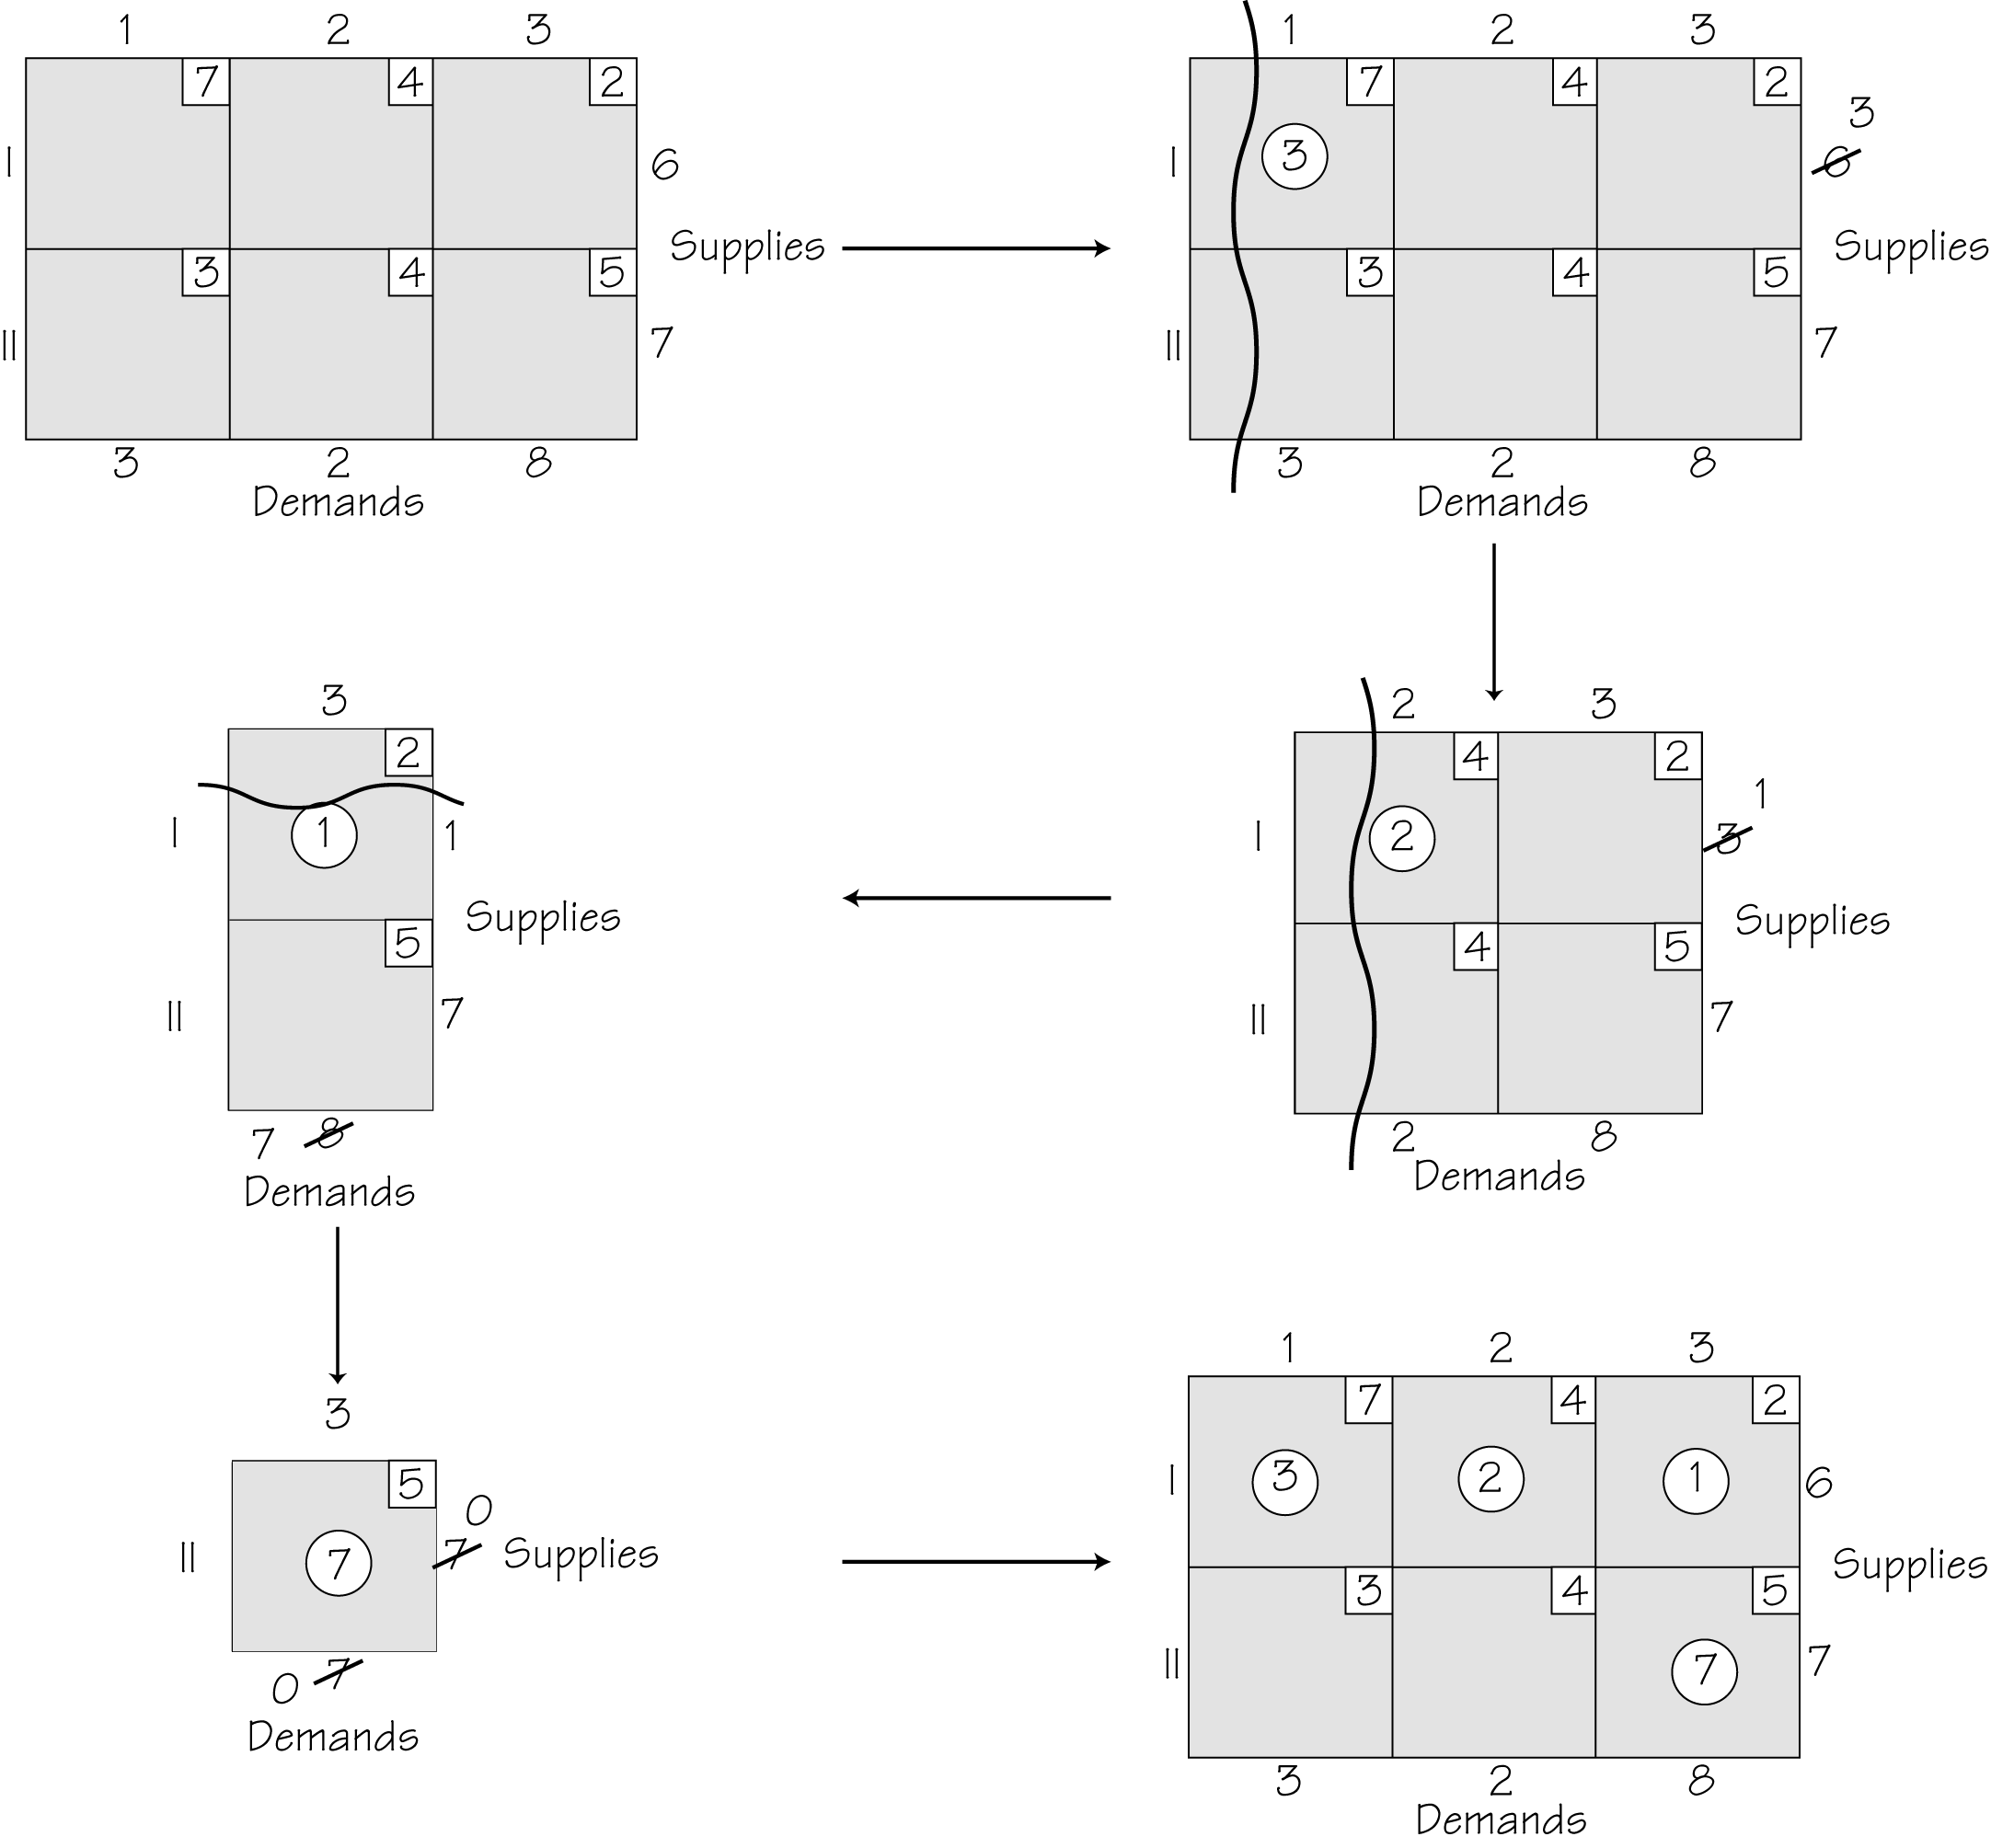
The cost is
 Question 3
Apply the Northwest Corner Rule to the following tableau to determine the cost associated with the solution.
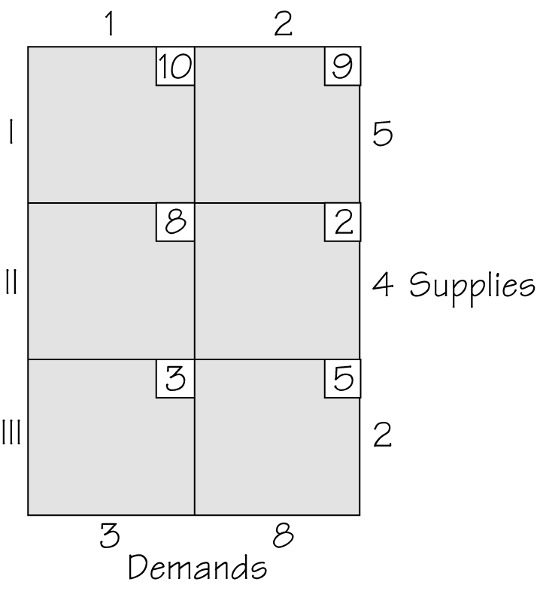
Answer
66

 Key idea
The indicator value of a cell C (not currently a circled cell) is the cost change associated with increasing or decreasing the amount shipped in a circuit of cells starting at C. It is computed with alternating signs and the costs of the cells in the circuit.
 Example L
Determine the indicator values of the non-circled cells in Example K.
Solution
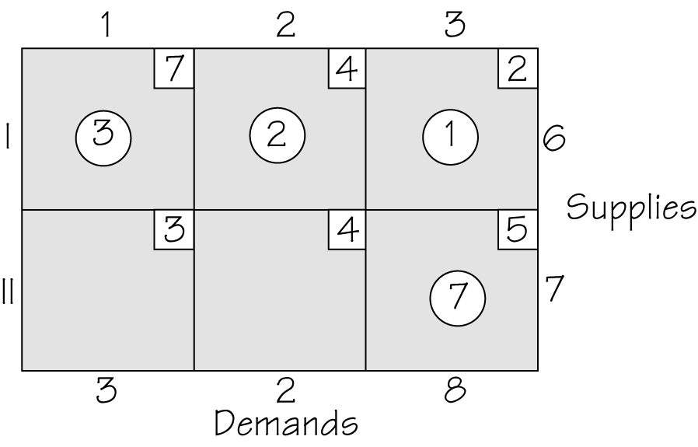

The indicator value for cell is 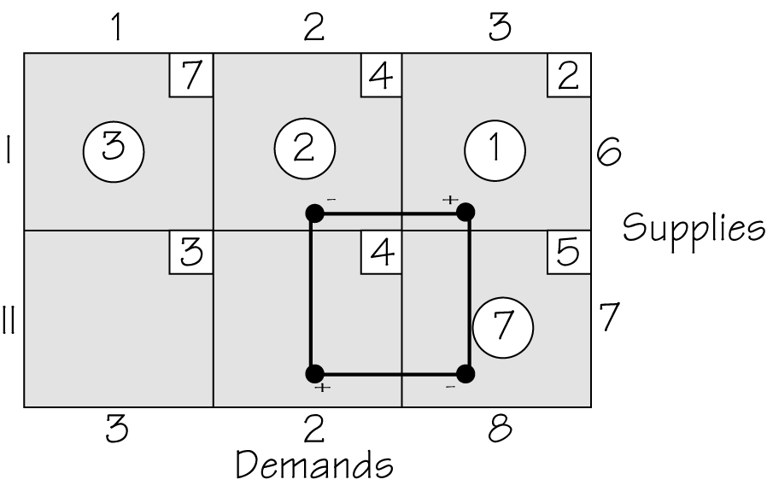

The indicator value for cell is
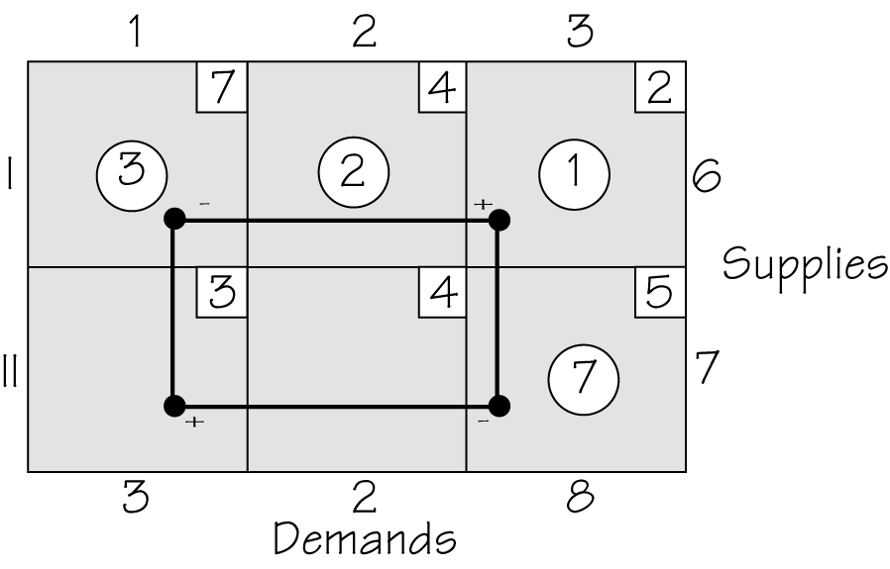

 Question 4
What is the indicator value of each of the non-circled cells in Question 3?
Answer
The indicator value for cell is and for cell is 5.

 Key idea
If some indicator cells are positive and some are zero, there are multiple solutions for an optimal value.

Section 4.6 Improving on the Current Solution

 Key idea
The stepping stone method improves on some non-optimal feasible solution to a transportation problem. This is done by shipping additional amounts using a cell with a negative indicator value.
 Example M
Apply the stepping stone algorithm to determine an optimal solution for Example L. Consider both cells with negative indicator values, determine the new cost for each consideration and compare to the solution found using the Northwest Corner Rule.
Solution

Increasing the amount shipped through cell we have the following.
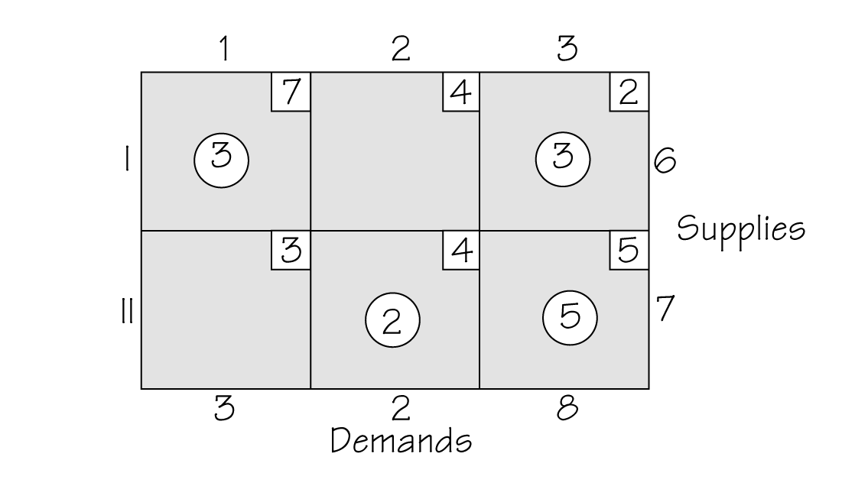
The cost is as follows.
Increasing the amount shipped through cell we have the following.
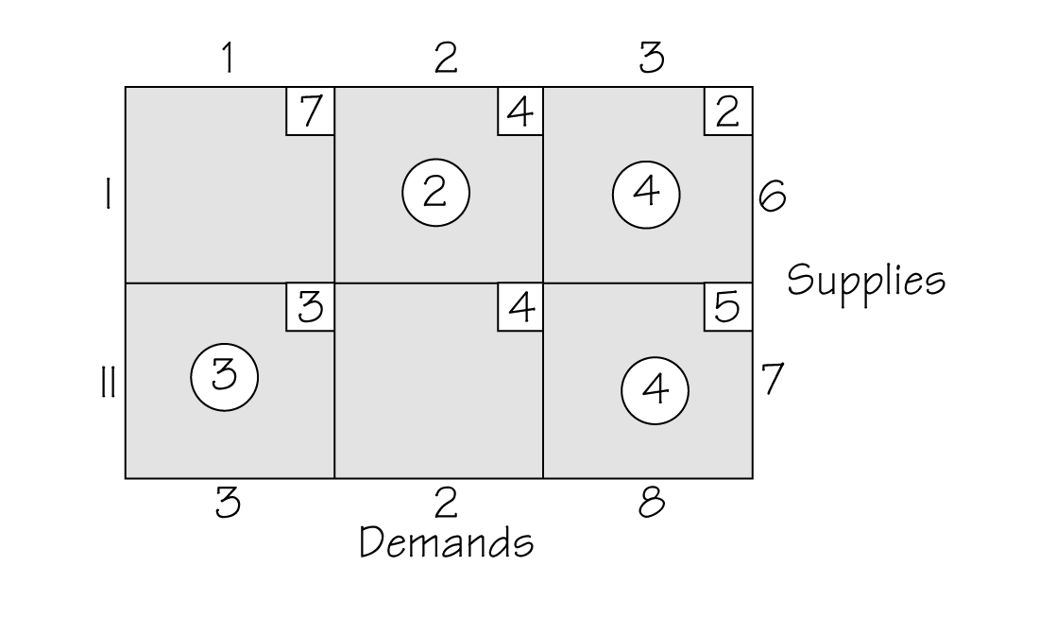
The cost is follows.

The cost can be reduced to 45 (compared to 66) when increasing the amount shipped through cell
 Question 5
Determine the cost involved when applying the stepping stone method to determine an optimal solution for Question 4 when compared to the cost found by the Northwest Corner Rule.
Answer
The cost can be reduced to 60 (compared to 66).

Homework Help
Exercise 1
In this exercise you will need to graph 6 lines. The first four are graphed by finding x- and y- intercepts and connecting these points. Recall, to find a y-intercept, substitute To find an x-intercept, substitute If a line is of the form then it is a vertical line (a is some number). If a line is of the form then it is a horizontal line (b is some number).
Exercises 2 – 3
In these exercises you will need to graph lines. You can find the point of intersection in Exercises 2 and 3(b) by the substitution method. In Exercise 3(a), you can use the addition method.
Exercises 4 – 5
In these exercises you will need to graph inequalities. First graph the line and choose a test point (usually the origin) to determine which side to shade. If your line is either vertical or horizontal, the direction of shading should be clear.
Exercises 6 – 8
In these exercises you will need to set up constraints (inequalities) given information.
Exercises 9 - 14
In these exercises you will need to graph a set of inequalities. Like in earlier exercises, you will need to first graph the line and choose a test point (usually the origin) to determine which side to shade. If your line is either vertical or horizontal, the direction of shading should be clear. The final graph should reflect the region common to all individual regions. Recall that the constraints of indicate that you are restricted to the upper right quadrant created by the x-axis and y-axis.
Exercises 15 – 16
In these exercises you will need to determine if a point is in a feasible region or not. To do this, test the point in all of the inequalities. It must satisfy all of the constraints to be in the feasible region. If it does not satisfy any single constraint, it is not in the feasible region and you do not need to test any additional constraint.
Exercises 17 – 18
In these exercises you will need to evaluate each of the corner points in the profit relation. The point that yields that maximum value will determine the production policy. You should answer how many of each product should be made and what the maximum profit would be.
A table like the following may be helpful.
Corner Point | Value of the Profit Formula:
Optimal production policy: Make ____ skateboards and ____ dolls for a profit of $____.
Exercise 19
In this exercise you will need to graph two lines in the same plane. Like in earlier exercises, you will need to graph the lines by finding intercepts. To find the point of intersection, use the addition method.
Exercises 20 – 24
These exercises are essential to linear programming exercises that have two resource constraints. You will need to graph the two lines and find the points of intersection. To make the graphing process easier, find the x- and y- intercepts of both resource constraint lines. This will help you to determine a suitable scaling on the x- and y- axes. If properly drawn, you will readily see where the corner points are located. This will enable you to determine which two lines must be considered to find the corner points. In the case of the resource constraints, you will need to use the addition method to find the point of intersection. In Exercise 24, you can refer to the feasible regions in the referenced exercises or try each of the points in each constraint.
Exercises 25 – 28
These exercises take the previous type of exercises one step further. You will need to evaluate the corner points in the profit relation. The later part is like what was done in Exercises 17 – 18.
Exercise 29
In this exercise you will need to reply to each part. The goal is to consider realistic constraints where variables must be integer values.
Exercises 30 – 45
Using a simplex algorithm program will not be addressed in the solutions. If this approach is required by your instructor, ask for guidance as to where he or she expects that you obtain your solution (i.e. Internet or some other program supplied by him or her). These exercises address all the steps involved in determining the optimal solution. You must do the following.
- Define your variable;
- Set up a chart that shows the resource constraints, minimums, and profit;
- Define a set of inequalities and the profit relation that you wish to maximize;
- Draw the feasible region;
- Find all corner points (You will have two resource constraints in 36-41.);
- Evaluate the corner points in the profit relation to determine the optimal solution;
- State that solution clearly as to how many of each product should be made and what the maximum profit is.
Exercises 46 – 47
These are straightforward exercises. You are given a cost relation instead of a profit relation. You evaluate this cost relation with the same corner points of the referenced exercises. You will be seeking the minimum cost.
Exercises 48
If you think about where the x- and y- intercepts of are located (non-integer values), then the answer should be apparent.
Exercises 49 – 51
Start by working these problems out as you did Exercises 30 – 45. After you’ve determined the optimal solution, see if the additional constraints cause the corner point that yielded the optimal solution to no longer be considered. If it is still considered, it will still yield the optimal solution. Otherwise, the process of evaluating corner points must be done again (with the new corner points). You will need to find indicator values in Exercises 53 – 54.
Exercises 52 – 54
In these exercises you will be applying the Northwest Corner Rule and finding the corresponding shipping costs. Carefully read the examples in Section 4.5. You may find the process easier if you “cancel” as you go from stage to stage as was done in Example K of this guide.
Exercises 55
Follow each step of this exercise. Recall from Chapter 3 the definition of a tree and from Chapter 1 the definition of a circuit.
Exercises 56
In this exercise you will need to find a solution using two methods and then compare the results. In part (a) follow the direction given for applying the minimum row entry method. You will determine the cost involved and compare to the solution found using the Northwest Corner Rule.
Exercises 57 – 58
In these exercises you will need to find a solution using the Northwest Corner Rule. You will next need to find the indicator value for each non-circled cell. This method is shown in Section 4.5 and in Example L of this guide. In Exercise 57, if the solution has a negative indicator in a cell, then the stepping stone method (Section 4.6) should be applied by shipping more via the cell that has the negative indicator value.

Do You Know the Terms?

Cut out the following 18 flashcards to test yourself on Review Vocabulary. You can also find these flashcards at http://www.whfreeman.com/fapp7e.

Chapter 4  Linear Programming  Corner point principle | Chapter 4  Linear Programming  Feasible point
Chapter 4  Linear Programming  Feasible region | Chapter 4  Linear Programming  Feasible set
Chapter 4  Linear Programming  Indicator value of a cell | Chapter 4  Linear Programming  Linear programming
Chapter 4  Linear Programming  Minimum constraint | Chapter 4  Linear Programming  Mixture chart

A possible solution (but not necessarily the best) to a linear programming problem. With just two products, we can think of a feasible point as a point on the plane. | The principle states that there is a corner point of the feasible region that yields the optimal solution.
Another term for feasible region. | The set of all feasible points, that is, possible solutions to a linear-programming problem. For problems with just two products, the feasible region is a part of the plane.
A set of organized methods of management science used to solve problems of finding optimal solutions, while at the same time respecting certain important constraints. The mathematical formulations of the constraints are linear equations and inequalities. | The change in cost due to shipping an increased or decreased amount using the cells in a transportation tableau that form a circuit consisting of circled cells together with a selected cell that is not circled. When an indicator value is negative, a cheaper solution can be found by shipping using this cell.
A table displaying the relevant data in a linear programming mixture problem. The table has a row for each product and a column for each resource, for any nonzero minimums, and for the profit. | An inequality in a mixture problem that gives a minimum quantity of a product. Negative quantities can never be produced.

Chapter 4  Linear Programming  Mixture problem | Chapter 4  Linear Programming  Northwest corner rule (NCR)
Chapter 4  Linear Programming  Optimal production policy | Chapter 4  Linear Programming  Profit line
Chapter 4  Linear Programming  Resource constraint | Chapter 4  Linear Programming  Rim conditions

A method for finding an initial but rarely optimal solution to a transportation problem starting from a tableau with rim conditions. The amounts to be shipped between the suppliers and end users (demanders) are indicated by circling numbers in the cells in the tableau. The number of cells circled after applying the method will be equal to the number of rows plus the number of columns of the tableau minus 1. | A problem in which a variety of resources available in limited quantities can be combined in different ways to make different products. It is usually desired to find the way of combining the resources that produces the most profit.
In a two-dimensional, two-product, linear-programming problem, the set of all feasible points that yield the same profit. | A corner point of the feasible region where the profit formula has a maximum value.
The supply available (listed in a column at the right of a transportation tableau) and demands required (listed in a row at the bottom of a transportation tableau) in a transportation problem. The supply available are usually taken to exactly meet the demands required. | An inequality in a mixture problem that reflects the fact that no more of a resource can be used than what is available.

Chapter 4  Linear Programming  Simplex method | Chapter 4  Linear Programming  Stepping stone method
Chapter 4  Linear Programming  Tableau | Chapter 4  Linear Programming  Transportation Problem

A method for solving a transportation problem that improved the current solution, when it is not optimal, by increasing the amount shipped using a cell with a negative indicator value. | One of a number of algorithms for solving linear-programming problems.
A special type of linear programming problem where one has sources of supplies and users of, or demand for, these supplies. There is a cost to ship an item from a supplier to a user (demander). The goal is to minimize the total shipping cost to meet the demands from the supplies available. | A table for a transportation problem indicating the supplies available and demands required as well as the cost of shipping for a supplier to a user (demander). The amounts to be shipped from different suppliers to different users are indicated by circled cells in the tableau. The number of such circled cells is always the number of rows plus the number of columns diminished by one for the tableau.

Learning the Calculator
The graphing calculator can be used to graph a set of constraints and determine corner points.
Example
Use the graphing calculator to find the corner points for the following set of inequalities.
Solution
Although the graphing calculator can locate points on the coordinate axes, because a proper window needs to be determined, it is easier to go ahead and calculate x- and y- intercepts of the lines.
In order to enter into the calculator, we must solve each one for y.
After pressing 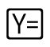, you can enter the equations.
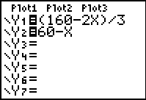
To graph the first equation as an inequality, toggle over to the left of the line and press  three times.
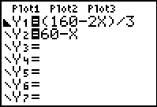
Repeat for the other inequality.
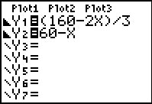
By pressing  you will enter an appropriate window for Xmin, Xmax, Ymin and Ymax. Xmin and Ymin would both be 0 in most cases. Determine the x- and y-intercepts of the lines to assist you in determining a window as well as corner points.
has an x-intercept of and a y-intercept of has an x-intercept of and a y-intercept of
The following window is appropriate.
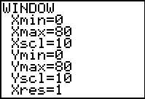
Next, we display the feasible region by pressing the 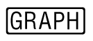 button.
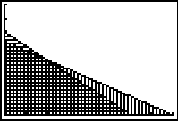
We know three of the four corner points. They are and To find the fourth corner point, you will need to find the point of intersection between the lines and To do this, you will need to press 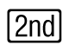 followed by . You then need to toggle down or press  followed by .
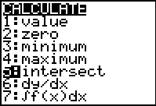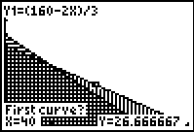
Press three times and the following three screens will be displayed.
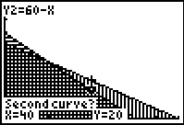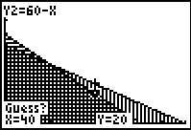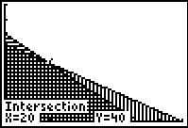
The fourth corner point is therefore
Practice Quiz
1. Where does the line cross the x-axis?
a. at the point
b. at the point
c. at the point
2. Where do the lines and intersect?
a. at the point
b. at the point
c. at the point
3. Where do the lines and
a. at the point
b. at the point
c. at the point
4. Which of these points lie in the region
I.
II.
a. both I and II
b. only II
c. neither I nor II
5. What is the resource constraint for the following situation?
Typing a letter (x) requires 4 minutes, and copying a memo (y) requires 3 minutes. A secretary has 15 minutes available.
a.
b.
c.
6. Graph the feasible region identified by the inequalities:
Which of these points is in the feasible region?
a.
b.
c.

7. What are the resource inequalities for the following situation?
Producing a bench requires 2 boards and 10 screws. Producing a table requires 5 boards and 8 screws. Each bench yields $10 profit, and each table yields $12 profit. There are 25 boards and 60 screws available. x represents the number of benches and y represents the number of tables.
a.
b.
c.
8. What is the profit formula for the following situation?
Producing a bench requires 2 boards and 10 screws. Producing a table requires 5 boards and 8 screws. Each bench yields $10 profit, and each table yields $12 profit. There are 25 boards and 60 screws available. x represents the number of benches and y represents the number of tables.
a.
b.
c.
9. Apply the Northwest Corner Rule to the following tableau and determine the cost associated with the solution.
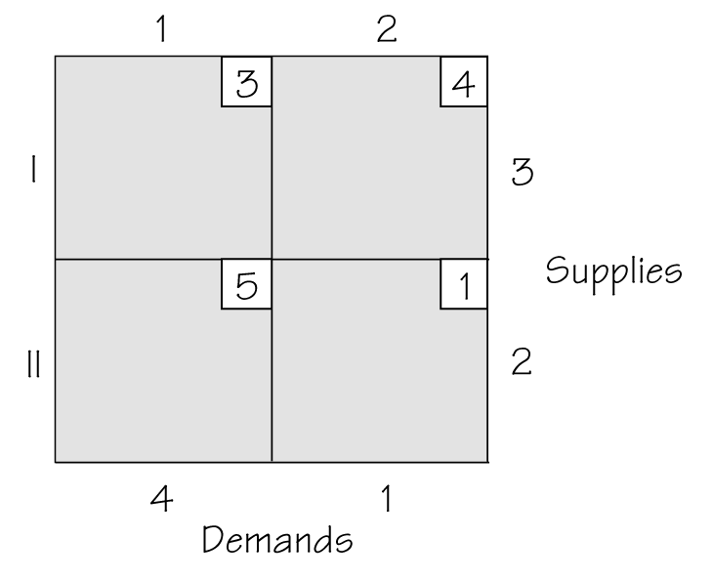
a. cost: 28
b. cost: 12
c. cost: 15
10. Can the solution found by the Northwest Corner Rule in the last question be improved on?
a. no.
b. yes.
c. not enough information.
Word Search
Refer to pages 163 – 164 of your text to obtain the Review Vocabulary. There are 18 hidden vocabulary words/expressions in the word search below. Feasible set and Feasible region will both appear. All vocabulary words/expressions appear separately. It should be noted that spaces are removed.


1. __________________________
2. __________________________
3. __________________________
4. __________________________
5. __________________________
6. __________________________
7. __________________________
8. __________________________
9. __________________________
10. __________________________
11. __________________________
12. __________________________
13. __________________________
14. __________________________
15. __________________________
16. __________________________
17. __________________________
18. __________________________

