Chapter 2

Business Efficiency

chapter Objectives
Check off these skills when you feel that you have mastered them.
 Write in your own words the definition of a Hamiltonian circuit.
 Explain the difference between an Euler circuit and a Hamiltonian circuit.
 Identify a given application as being an Euler circuit problem or a Hamiltonian circuit problem.
 Calculate n! for a given value of n.
 Apply the formula to calculate the number of Hamiltonian circuits in a graph with a given number of vertices.
 Define the term algorithm.
 Explain the term heuristic algorithm and list both an advantage and a disadvantage of using this algorithm.
 Discuss the difficulties inherent in the application of the brute force method for finding the shortest-route Hamiltonian circuit.
 Describe the steps in the nearest-neighbor algorithm.
 Find an approximate solution to the Traveling Salesman Problem by applying the nearest-neighbor algorithm.
 Describe the steps in the sorted-edges algorithm.
 Find an approximate solution to the Traveling Salesman Problem by applying the sorted-edges algorithm.
 Explain the difference between a graph and a tree.
 Determine from a weighted-edges graph a minimum-cost spanning tree.
 Identify the critical path on an order-requirement digraph.
 Find the earliest possible completion time for a collection of tasks by analyzing its critical path.
 Explain the difference between a graph and a directed graph.
Guided Reading
Introduction

 Key idea
Using a salesman’s tour from city to city as a model, we investigate efficient ways to traverse a graph while visiting each vertex only once, along with some related problems. Our goal usually is to find a tour that is as quick, or as cheap as possible.

 Key idea
A Hamiltonian circuit of a graph visits each vertex exactly once, and returns to the starting point. There is no simple way to determine if a graph has a Hamiltonian circuit, and it can be hard to construct one.

Section 2.1 Hamiltonian Circuits
 Example A
Find a Hamiltonian circuit for this graph starting at A. (Remember: unlike the Euler circuit, it is not necessary to traverse every edge.)
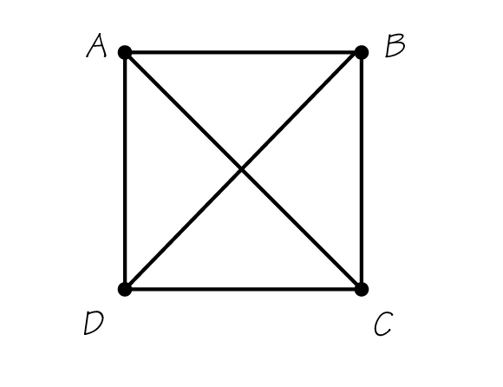
Solution
These are the six possible Hamiltonian circuits starting from A. If you got a different answer, did you add a vertex where the diagonals cross? You shouldn’t have. Since a vertex has not been indicated, edges AC and BD do not actually intersect. (You may think of AC as representing a highway overpass that is on a different level from edge BD.)
ABCDA, ACDBA, and ADBCA—as well as their reversals, ADCBA, ABDCA, and ACBDA—are all Hamiltonian circuits.
 Example B
Does this graph have a Hamiltonian circuit?
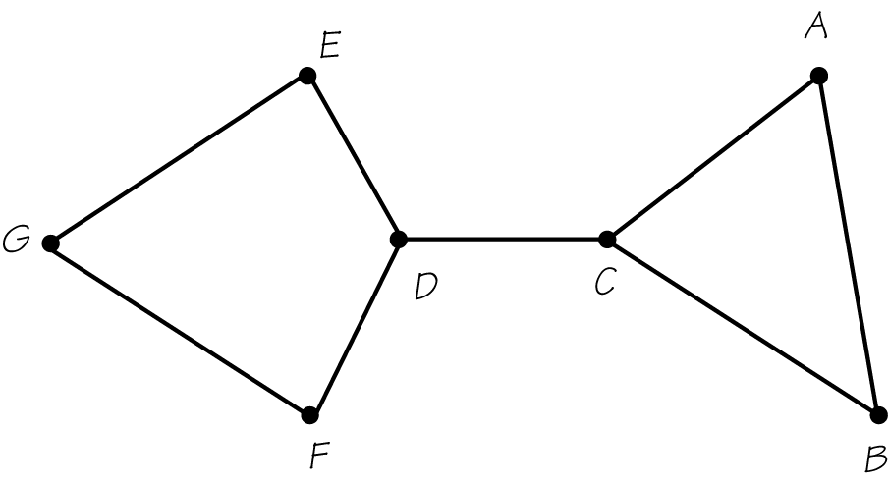
Solution
No, the graph does not have a Hamiltonian circuit. The edge CD divides the graph into two parts. If you start the tour at a vertex in one part and then cross CD, you cannot get back to the starting vertex without crossing CD again.

 Key idea
A number added to the edge of a graph is called a weight. A minimum-cost Hamiltonian circuit is one with the lowest possible sum of the weights of its edges. A step-by-step process (called an algorithm) for finding a minimum-cost Hamilton circuit is to find all circuits, find the sum of the weights, and choose the tour with the minimum sum.

 Key idea
The method of trees can be used to help generate all possible Hamilton circuits.
 Example C
Use the method of trees to find all possible Hamiltonian circuit for this graph starting at A.
Solution
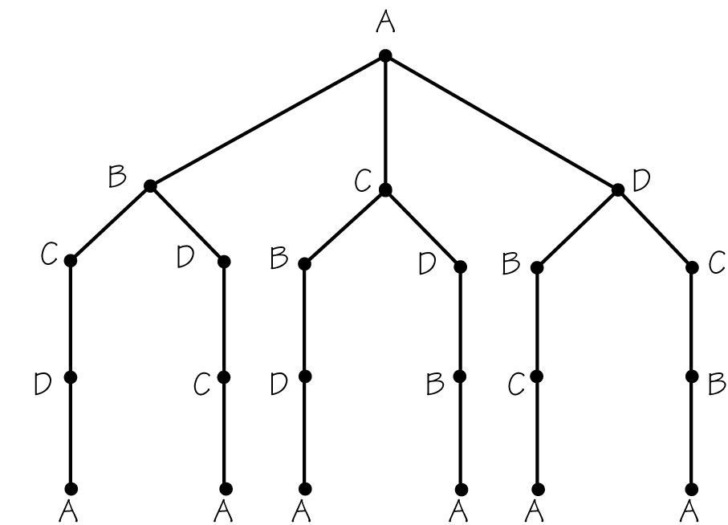
The first three branches on the left yield three distinct Hamiltonian circuits ABCDA, ABDCA, and ACBDA. The next three are their reversals, ADCBA, ACDBA, and ADBCA.
 Question 1
Use the method of trees to determine the number of distinct Hamiltonian circuits there are for this graph starting at A.
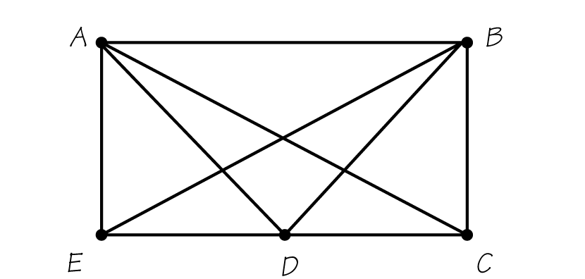
Answer
6

 Key idea
The fundamental principle of counting says that if there are a ways of choosing one thing, b ways of choosing a second after the first, …, and z ways of choosing the last item after the earlier choices then there are a total of total ways to make such choices.

 Key idea
Graphs may fail to have Hamiltonian circuits for a variety of reasons. One very important class of graphs, the complete graphs, automatically have Hamiltonian circuits. A graph is complete if an edge is present between any pair of vertices. If a complete graph has n vertices, then there are Hamiltonian circuits.
 Example D
Which of these graphs has a Hamiltonian circuit?
a) 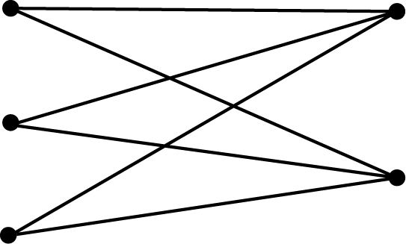 b)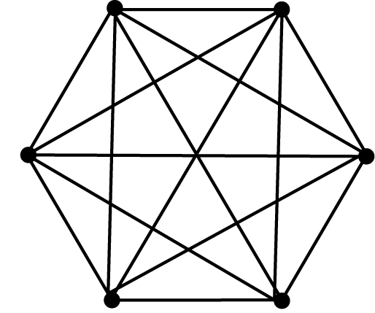
Solution
a) This graph is from a family of graphs known not to have Hamiltonian circuits: it was constructed with vertices on two parallel vertical columns with one column having more vertices than the other.
b) This graph is from a family of graphs known to have Hamiltonian circuitsthe family of complete graphs; every pair of vertices is joined by an edge.
 Example E
Determine how many Hamiltonian circuits there are for a complete graph with 10 vertices.
Solution
For n = 10, we get

 Key idea
The brute force method is one algorithm that can be used to find a minimum-cost Hamiltonian circuit, but it is not a very practical method for a large problem. This method tries all possibilities.
 Question 2
What is the minimum cost when using the brute force method to determine the minimum-cost Hamiltonian circuit for the following?
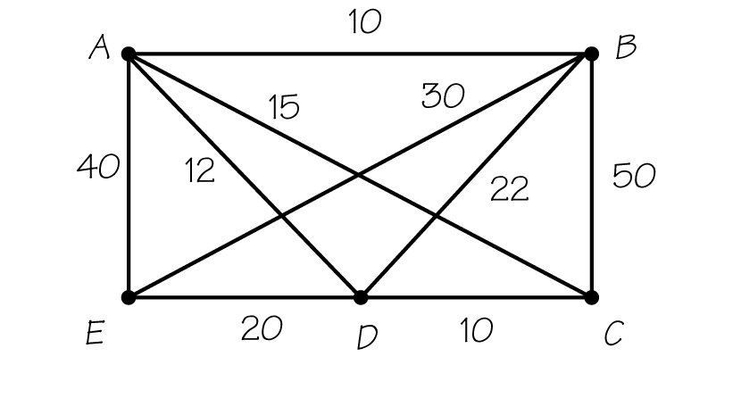
Answer
85

Section 2.2 Traveling Salesman Problem

 Key idea
The problem of finding this minimum-cost Hamiltonian circuit is called the traveling salesman problem (TSP). It is a common goal in the practice of operations research.

Section 2.3 Helping Traveling Salesmen

 Key idea
We use a variety of heuristic (or “fast”) algorithms to find solutions to the TSP. Some are very good, even though they may not be optimal. Heuristic algorithms come close enough to giving optimal solutions to be important for practical use.

 Key idea
The nearest-neighbor algorithm repeatedly selects the closest neighboring vertex not yet visited in the circuit (with a choice of edges, choose the one with the smallest weight), and returns to the initial vertex at the end of the tour.
 Example F
Using the nearest-neighbor algorithm, finish finding a Hamiltonian circuit for this graph. We started at vertex C, proceeded to D, and then to B. When you’ve finished, calculate the total.
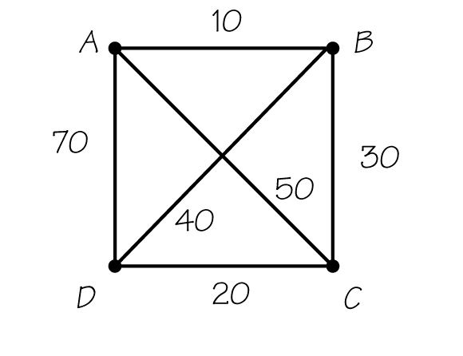
Solution
From B, the closest neighbor that has not yet been visited is A. All the vertices have thus been visited and you can return to starting point C. CDBAC is the complete circuit. The total of the weights of the edges in the path is 120.
 Question 3
Use the nearest-neighbor algorithm to find a Hamiltonian circuit for this graph starting at C. What is the total weight?
Answer
142

 Key idea
The sorted-edges algorithm (which, like nearest neighbor, is a greedy algorithm) is another heuristic algorithm that can lead to a solution that is close to optimal.
 Example G
For this graph, what are the first three edges chosen according to the sorted-edges algorithm? Complete the circuit and calculate the total cost.
Solution
The edges AB, CD, and BC are the cheapest, and they do not close a loop or meet at a single vertex. This forces the choice of the expensive edge, DA, to return to the starting vertex. The complete circuit is ABCDA. The cost of all the edges in the tour adds up to 130.
 Question 4
Use the sorted-edges algorithm to find a Hamiltonian circuit for this graph. What is the total weight?
Answer
85

Section 2.4 Minimum-Cost Spanning Trees

 Key idea
A tree will consist of one piece and contains no circuits. A spanning tree is a tree that connects all vertices of a graph to each other with no redundancy (e.g., for a communications network.)
 Example H
With a) as our original graph, which of the graphs shown in bold represent trees and/or spanning trees?
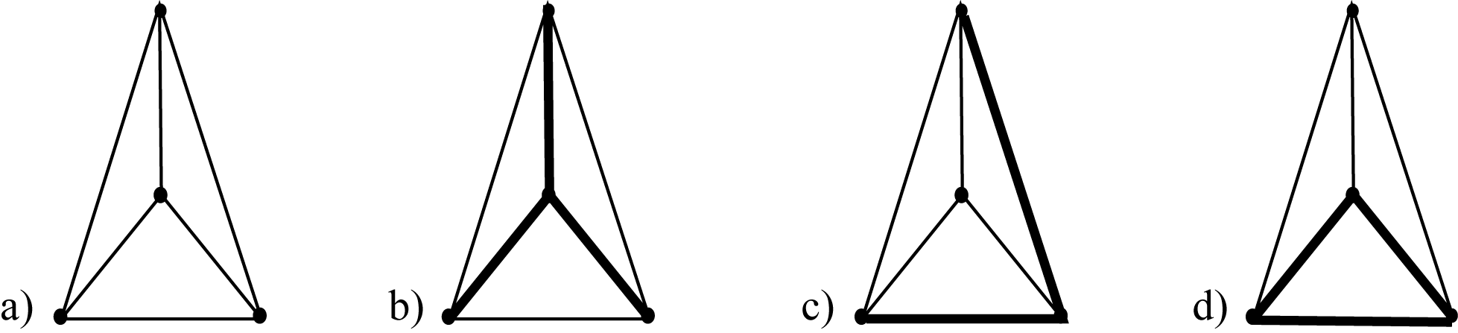
Solution
The graph in b) is a tree because it is a connected graph with no circuits, and it is a spanning tree because it includes all the vertices of the original graph; c) is a tree because it is a connected graph with no circuits, but is not a spanning tree because it does not include all the vertices of the original graph; and d) contains a circuit, so it cannot be a tree, and therefore cannot be a spanning tree.

 Key idea
Two spanning trees for graph a) are shown in b) and c).
a)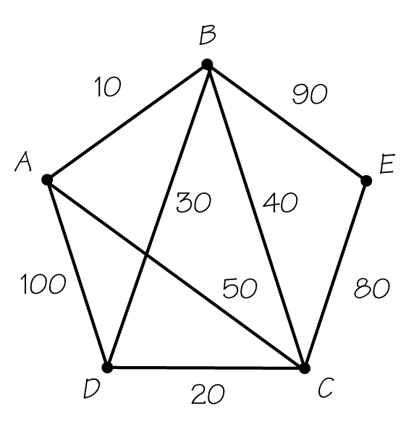 b)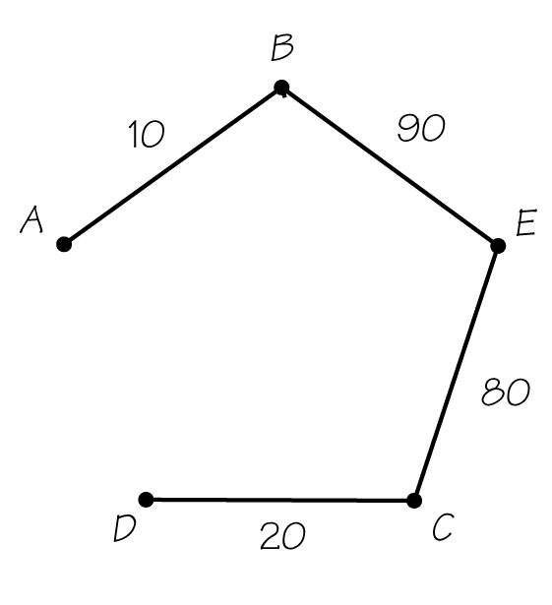 c)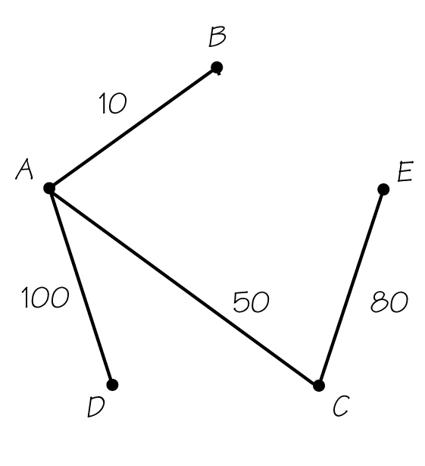
Each is an example of a minimal subgraph connecting all the vertices in the original. In each case, removal of any edge will disconnect the graph.

 Key idea
A minimum-cost spanning tree is most economical. Kruskal’s algorithm produces one quickly. This algorithm adds links together in order of cheapest cost so that no circuits form and so that every vertex belongs to some link added.
 Example I
Using this graph again, apply Kruskal’s algorithm to find a minimum-cost spanning tree.
Solution
AB, DC, and BD are the cheapest edges and are chosen first. The next cheapest ones are BC and AC, but these would close loops. EC is the next in line, and that completes the tree.
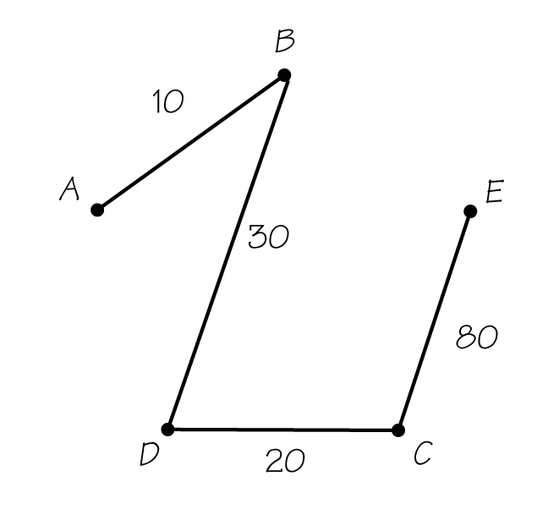
 Question 5
Using this graph again, apply Kruskal’s algorithm to find a minimum-cost spanning tree. What is the minimum cost?
Answer
52

Section 2.5 Critical-Path Analysis

 Key idea
The necessary arrangement of tasks in a complex job can be represented in an order-requirement digraph (directed graph), with arrows showing the order requirements.
 Example J
For this order-requirement digraph, are the statements true or false?
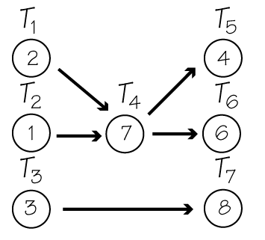
a) must be done before .
b) must be done before .
c) must be done before .
d) need not be done before .
e) need not be done before .
Solution
is independent of since no sequence of arrows connects them. Nor is there any connection between and or and However, must precede and therefore must also precede
a) False; is independent of .
b) True; precedes .
c) False; No connection between and .
d) False; precedes so must precede .
e) True; No connection between and .

 Key idea
The longest path in an order-requirement digraph is called the critical path. The length is measured in terms of summing the task times of the tasks making up the path. The length of the longest path corresponds to the earliest completion time.
 Example K
Find the critical path for this ordered-requirement digraph.
Solution
is the path through the digraph with the greatest total time:
 Question 6
What is the length of the earliest completion time for this ordered-requirement digraph?
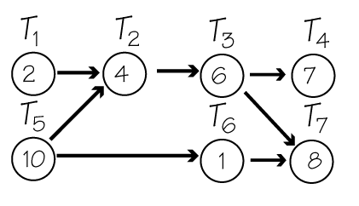
Answer
28

Homework Help
Exercises 1 – 9
Carefully read Section 2.1 before responding to these exercises. Remember that a Hamiltonian circuit visits each vertex once returning where it started.
Exercises 10 – 13
Carefully read Section 2.1 and Example B in this guide before answering these exercises.
Exercise 14
Carefully read the beginning of Section 2.1 before answering this exercise.
Exercises 15 – 16
Carefully read the definition of a Hamiltonian path in Exercise 15.
Exercise 17 – 19, 21
Review the difference between Euler circuits (Chapter 1) and Hamiltonian circuits (Section 2.1) before answering these exercises.
Exercise 20
Carefully read Section 2.1 before responding to this exercise. Graphs will vary.
Exercise 21
Carefully read the definition of a Hamiltonian path in Exercise 15.
Exercises 22 – 32
Carefully read Example 2 in Section 2.1 before responding to these exercises. These exercises involve applying the fundamental counting principle.
Exercises 33 – 67
Carefully read Section 2.3 and the examples before responding to these exercises.
Exercises 68 – 75
Carefully read Section 2.4 and the examples before responding to these exercises.

Do You Know the Terms?

Cut out the following 20 flashcards to test yourself on Review Vocabulary. You can also find these flashcards at http://www.whfreeman.com/fapp7e.

Chapter 2  Business Efficiency  Algorithm | Chapter 2  Business Efficiency  Brute force method
Chapter 2  Business Efficiency  Complete graph | Chapter 2  Business Efficiency  Critical path
Chapter 2  Business Efficiency  Fundamental principle of counting | Chapter 2  Business Efficiency  Greedy algorithm
Chapter 2  Business Efficiency  Hamiltonian circuit | Chapter 2  Business Efficiency  Heuristic algorithm

The method that solves the traveling salesman problem (TSP) by enumerating all the Hamiltonian circuits and then selecting the one with minimum cost. | A step-by-step description of how to solve a problem.
The longest path in an order-requirement digraph. The length of this path gives the earliest completion time for all the tasks making up the job consisting of the tasks in the digraph. | A graph in which every pair of vertices is joined by an edge.
An approach for solving an optimization problem, where at each stage of the algorithm the best (or cheapest) action is taken. Unfortunately, greedy algorithms do not always lead to optimal solutions. | A method for counting outcomes of multistage processes.
A method of solving an optimization problem that is “fast” but does not guarantee an optimal answer to the problem. | A circuit using distinct edges of a graph that starts and ends at a particular vertex of the graph and visits each vertex once and only once. A Hamiltonian circuit can start at any one of its vertices.

Chapter 2  Business Efficiency  Kruskal’s algorithm | Chapter 2  Business Efficiency  Method of trees
Chapter 2  Business Efficiency  Minimum-cost Hamiltonian circuit | Chapter 2  Business Efficiency  Minimum-cost spanning tree
Chapter 2  Business Efficiency  Nearest-neighbor algorithm | Chapter 2  Business Efficiency  NP-complete problems
Chapter 2  Business Efficiency  Order-requirement digraph | Chapter 2  Business Efficiency  Sorted-edges algorithm

A visual method of carrying out the fundamental principle of counting. | An algorithm developed by Joseph Kruskal (AT&T Research) that solves the minimum-cost spanning-tree problem by selecting edges in order of increasing cost, but in such a way that no edge forms a circuit with edges chosen earlier. It can be proved that this algorithm always produces an optimal solution.
A spanning tree of a weighted connected graph having minimum cost. The cost of a tree is the sum of the weights on the edges of the tree. | A Hamiltonian circuit in a graph with weights on the edges, for which the sum of the weights of the edges of the Hamiltonian circuit is as small as possible.
A collection of problems, which includes the TSP, that appear to be very hard to solve quickly for an optimal solution. | An algorithm for attempting to solve the TSP that begins at a “home” vertex and visits next that vertex not already visited that can be reached most cheaply. When all other vertices have been visited, the tour returns to home. This method may not give an optimal answer.
An algorithm for attempting to solve the TSP where the edges added to the circuit being built up are selected in order of increasing cost, but no edge is added that would prevent a Hamiltonian circuit’s being formed. These edges must all be connected at the end, but not necessarily at earlier stages. The tour obtained may not have the lowest possible cost. | A directed graph that shows which tasks precede other tasks among the collection of tasks making up a job.

Chapter 2  Business Efficiency  Spanning tree | Chapter 2  Business Efficiency  Traveling salesman problem (TSP)
Chapter 2  Business Efficiency  Tree | Chapter 2  Business Efficiency  Weight

The problem of finding a minimum-cost Hamiltonian circuit in a complete graph where each edge has been assigned a cost (or weight). | A subgraph of a connected graph that is a tree and includes all the vertices of the original graph.
A number assigned to an edge of a graph that can be thought of as a cost, distance, or time associated with that edge. | A connected graph with no circuits.

Practice Quiz
1. Which of the following describes a Hamiltonian circuit for the graph below?
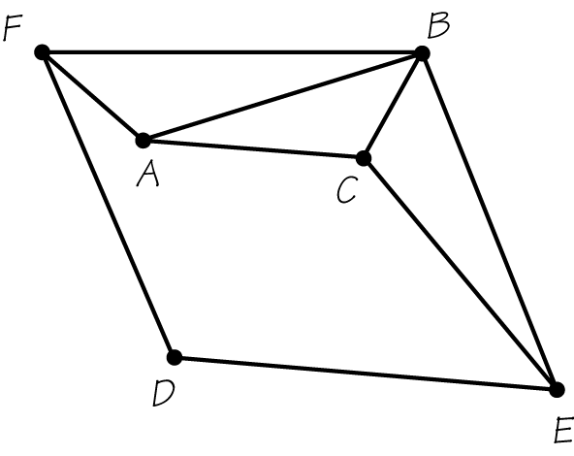
a. ABCEDCBFDA
b. ABCDEFA
c. ACBEDFA
2. Using the nearest-neighbor algorithm and starting at vertex A, find the cost of the Hamiltonian circuit for the graph below.
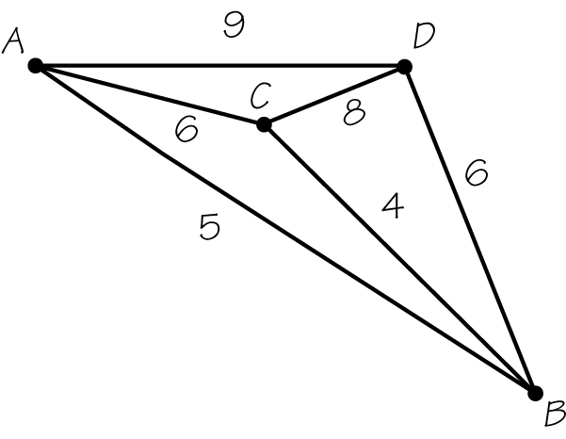
a. 25
b. 26
c. Another answer
3. Using the sorted-edges algorithm, find the cost of the Hamiltonian circuit for the graph below.
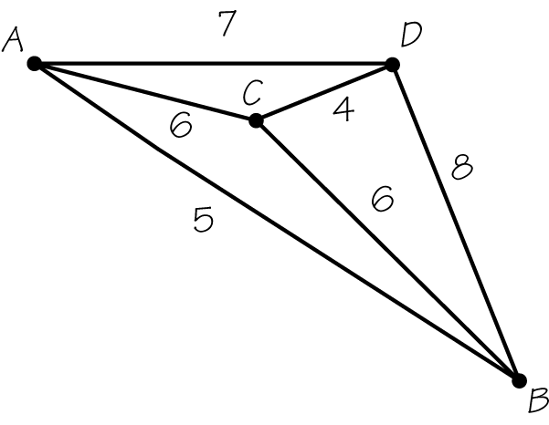
a. 20
b. 22
c. 18
4. Using Kruskal’s algorithm, find the minimum-cost spanning tree for the graph below. Which statement is true?
a. Edges AC and BD are included.
b. Edges AC and AB are included.
c. Edges CD and BD are included.
5. Which of the following statements are true?
II: It can be proved that Kruskal’s algorithm always produces an optimal solution.
II: If a graph has five vertices, its minimum-cost spanning tree will have four edges.
a. Only I is true.
b. Only II is true.
c. Both I and II are true.
6. What is the critical path for the following order-requirement digraph?
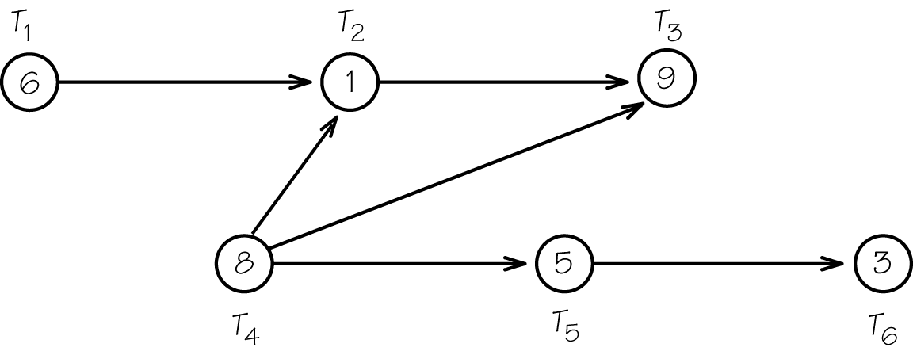
a.
b.
c. and are both critical paths.
7. What is the earliest completion time (in minutes) for a job with the following order-requirement digraph?
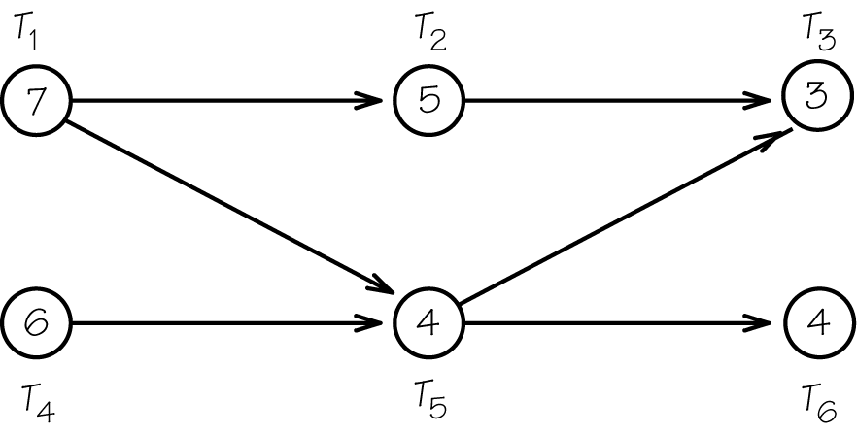
a. 13 minutes
b. 14 minutes
c. 15 minutes
8. Which of the following statements are true?
II: Trees never contain circuits.
II: Trees are always connected and always include all the vertices of the larger graph.
a. Only I is true.
b. Only II is true.
c. Neither I nor II is true.
9. Five small towns decide to set up an emergency communication system by connecting to each other with fiber optic cable. Which technique is most likely to be useful in helping them do this as cheaply as possible?
a. finding an Euler circuit on a graph
b. finding a Hamiltonian circuit on a graph
c. finding a minimum-cost spanning tree on a graph
10. Scott Hochwald has three types of bread, four kinds of deli meat, and three types of cheese. How many different sandwiches could Scott Hochwald make?
a. fewer than 15
b. between 15 and 40
c. more than 40

Word Search
Refer to pages 60 – 61 of your text to obtain the Review Vocabulary. There are 20 hidden vocabulary words/expressions in the word search below. All vocabulary appear separately. It should be noted that spaces are removed as well as apostrophes and hyphens. The abbreviation TSP does not appear in the word search.
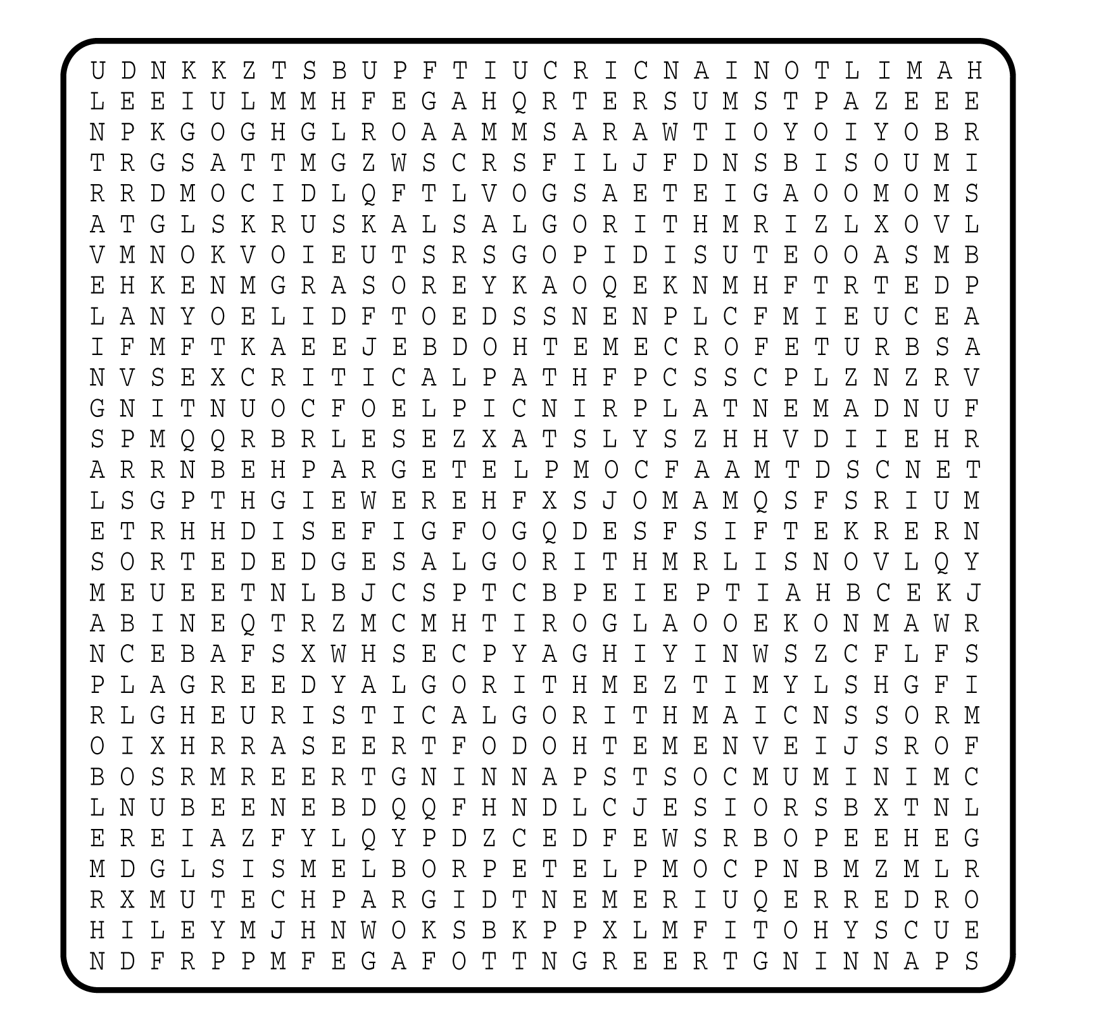

1. __________________________
2. __________________________
3. __________________________
4. __________________________
5. __________________________
6. __________________________
7. __________________________
8. __________________________
9. __________________________
10. __________________________
11. __________________________
12. __________________________
13. __________________________
14. __________________________
15. __________________________
16. __________________________
17. __________________________
18. __________________________
19. __________________________
20. __________________________

