Chapter 1

Urban Services

chapter Objectives
Check off these skills when you feel that you have mastered them.
 Determine by observation if a graph is connected.
 Identify vertices and edges of a given graph.
 Construct the graph of a given street network.
 Determine by observation the valence of each vertex of a graph.
 Define an Euler circuit.
 List the two conditions for the existence of an Euler circuit.
 Determine whether a graph contains an Euler circuit.
 If a graph contains an Euler circuit, list one such circuit by identifying the order of vertices in the circuit’s path.
 If a graph does not contain an Euler circuit, add a minimum number of edges to eulerize the graph.
 Identify management science problems whose solutions involve Euler circuits.
Guided Reading
Introduction
The management of a large and complex system requires careful planning and problem solving. In this chapter, we focus on an important management issue, one that occurs frequently in a variety of forms: the problem of traversing the network as efficiently and with as little redundancy as possible. Solutions involve mathematical principles as well as practical considerations.

Section 1.1 Euler Circuits

 Key idea
The problem of finding an optimal route for checking parking meters or delivering mail can be modeled abstractly as finding a best path through a graph that includes every edge. A graph is a finite set of dots and connecting links. A dot is called a vertex, and the link between two vertices is called an edge.

 Key idea
The problem of finding an optimal route for checking parking meters or delivering mail can be modeled abstractly as finding a best path through a graph that includes every edge.
 Example A
Represent the street network of stores to be serviced for delivery as a graph. (The  represents a store.)
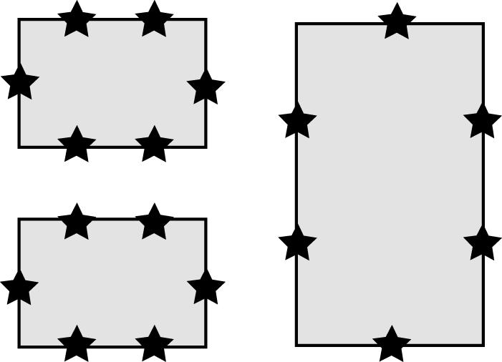
Solution

Start with the basic street network. Without the stores it looks like this:
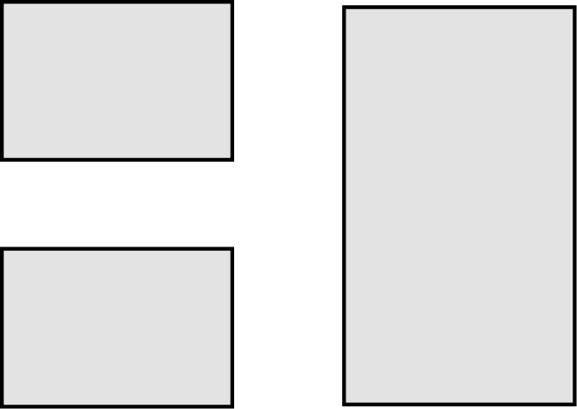
Now replace each intersection or corner with a vertex. Represent these with circles like this:
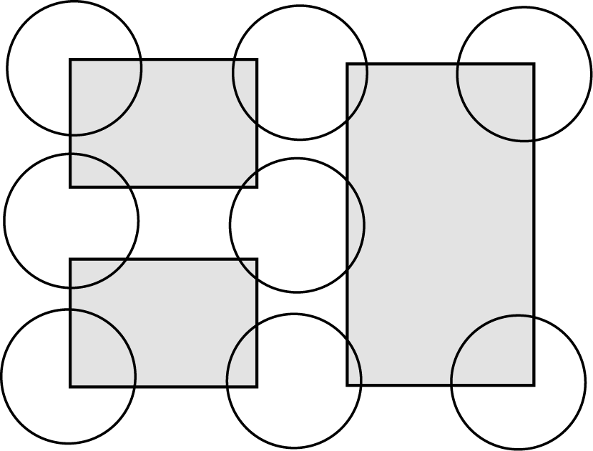

By replacing each row of stores with an edge, the graph in the answer is made.
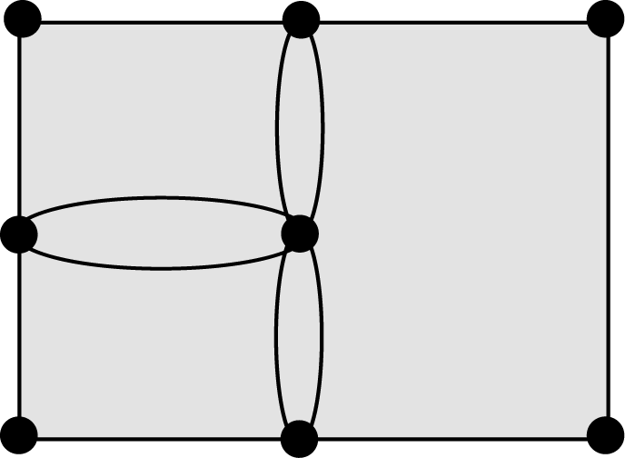

 Key idea
A path through a graph is a circuit if it starts and ends at the same vertex. A circuit is an Euler circuit if it covers each edge exactly once. (Euler is pronounced like “Oy’lur”)
 Example B
Draw an Euler circuit of the graph for the store network.
Solution
There are many correct answers.
Starting and ending with the upper left-hand corner, this circuit covers each edge exactly once. Any circuit drawn that meets these conditions (1. starts and ends at the same vertex, and 2. covers each edge exactly once) is an Euler circuit. This is one possible Euler circuit for the graph.
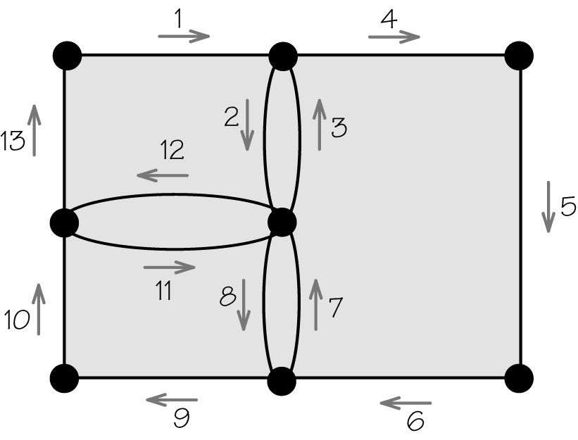
 Question 1
Given the following graph, which of the following is true?
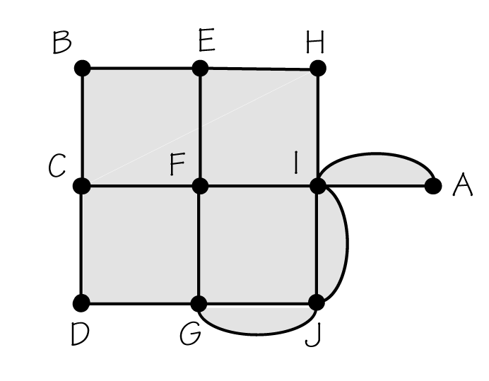
a) An Euler circuit can be found.
b) A circuit can be found if you are allowed to repeat using edges.
Answer
b

Section 1.2 Finding Euler Circuits

 Key idea
The valence of a vertex is the number of edges that meet at that vertex. This will be either an even or odd positive integer. If the vertex is isolated, then it will have valance zero.

 Key idea
A graph is connected if for every pair of vertices there is at least one path connecting these two vertices. There are no vertices with valence zero.

 Key idea
According to Euler’s theorem, a connected graph has an Euler circuit if the valence at each vertex is an even number. If any vertex has an odd valence, there cannot be an Euler circuit.
 Example C
For each of these graphs, find the valence of each vertex. Which graph has an Euler circuit?
a) 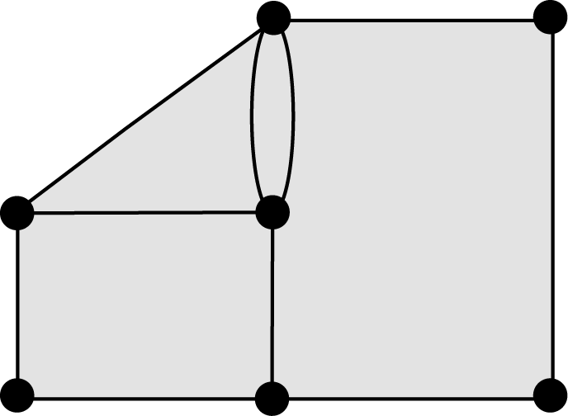 b) 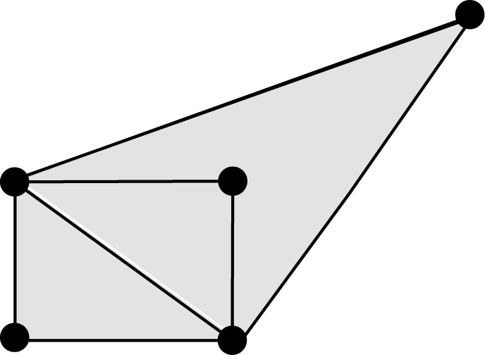 c) 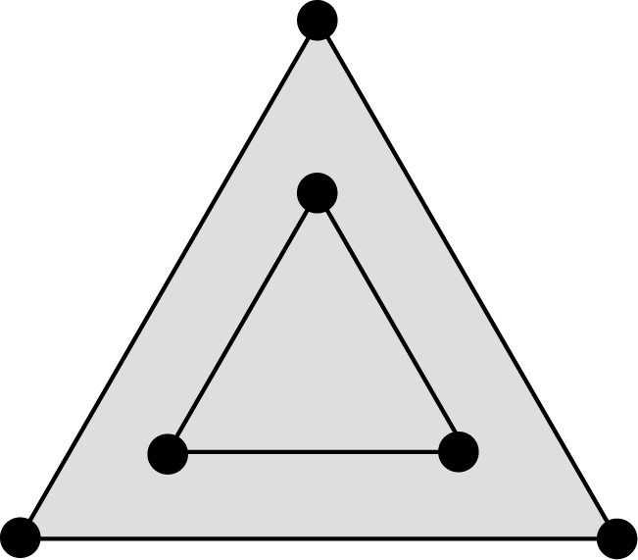
Solution
a) This graph has two odd vertices, so it cannot have an Euler circuit.
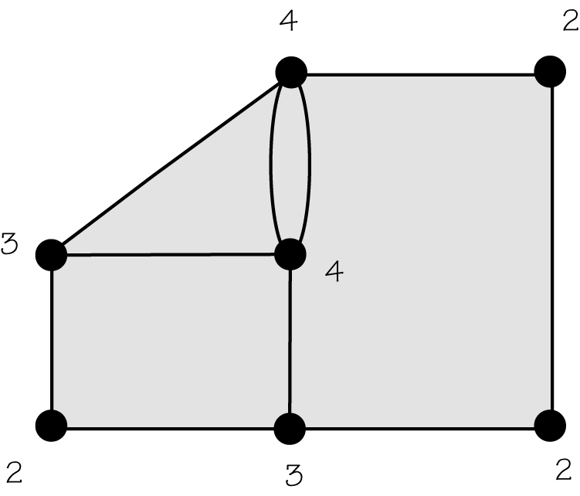
b) This graph has no odd vertices and is connected, so it must have an Euler circuit.
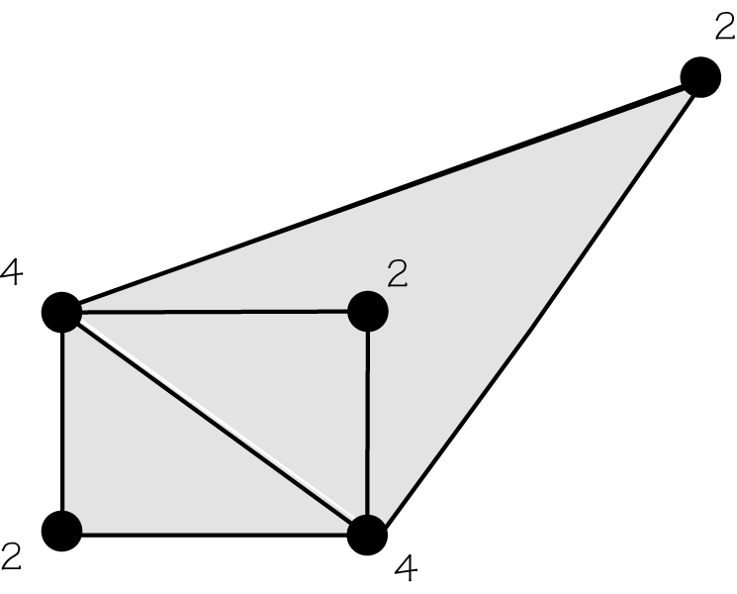
c) This graph has even valences but the graph is disconnected, so it cannot have an Euler circuit.
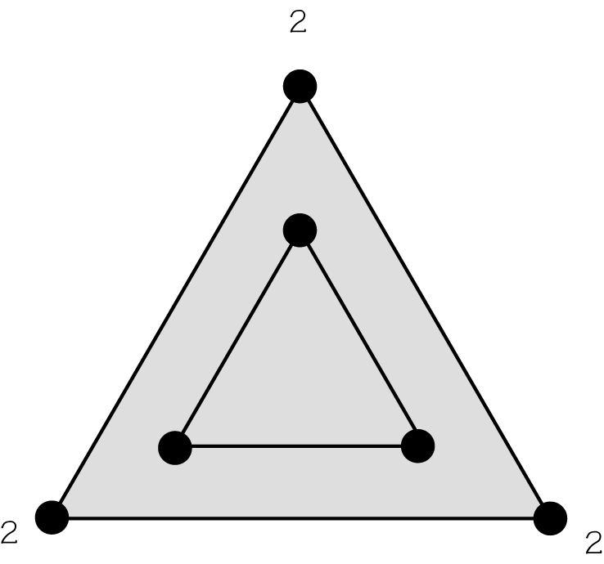
 Question 2
Which of the following (if any) have an Euler circuit?
a) 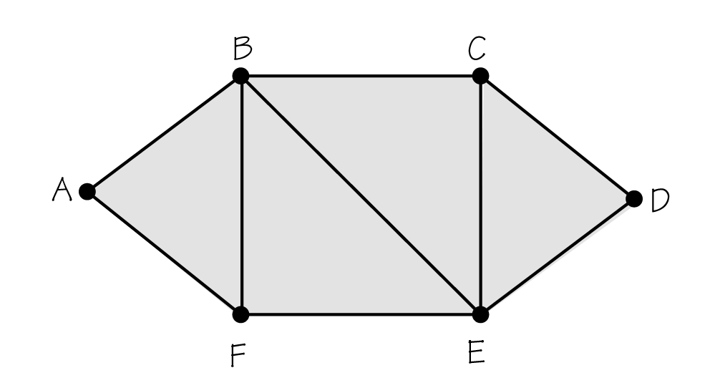 b) 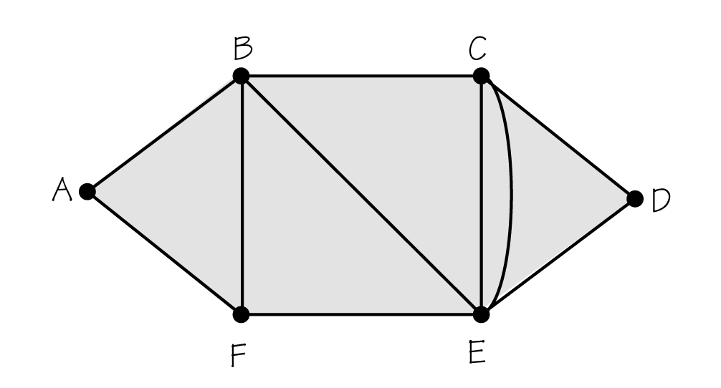
c) 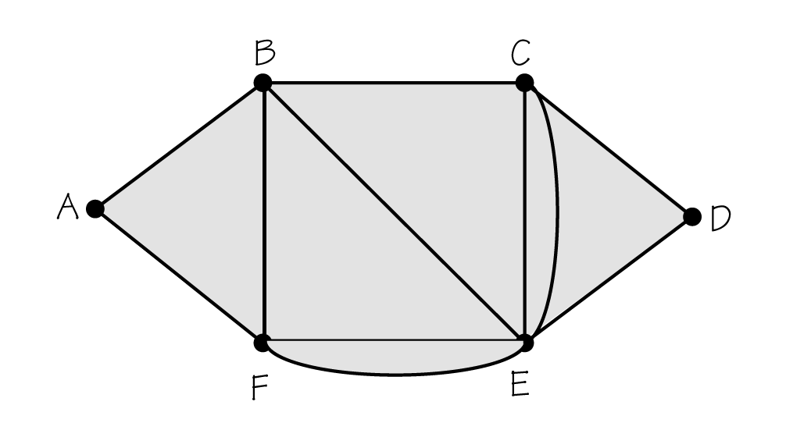
Answer
c

 Key idea
In finding an Euler circuit, never “disconnect” the graph by using an edge that is the only link between two parts of the graph not yet covered.

 Key idea
Here, we are looking for an Euler circuit. Steps 1, 2, and 3 (FBAC) have been completed, and now we must decide where to proceed at vertex C. Proceeding to E “disconnects” EF from CB, CD, and DB. Proceeding to B is permissible. Proceeding to D is also permissible.
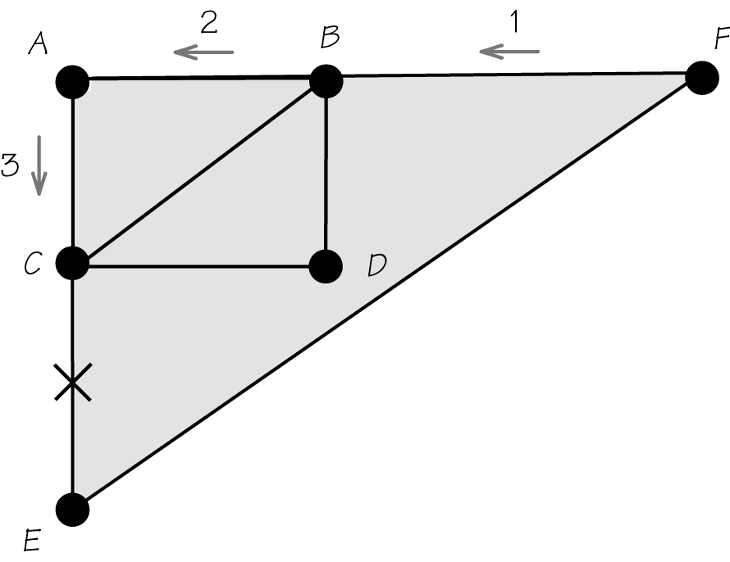

Section 1.3 Beyond Euler Circuits

 Key idea
If a graph has odd vertices, then any circuit must reuse at least one edge. The Chinese postman problem involves finding a circuit that reuses as few edges as possible.

 Key idea
This is a graph that contains odd vertices. One possible circuit follows the sequence of vertices ADCABDEBDA. This circuit reuses two edges: AD and BD. This is not the circuit that reuses the fewest edges for this graph.
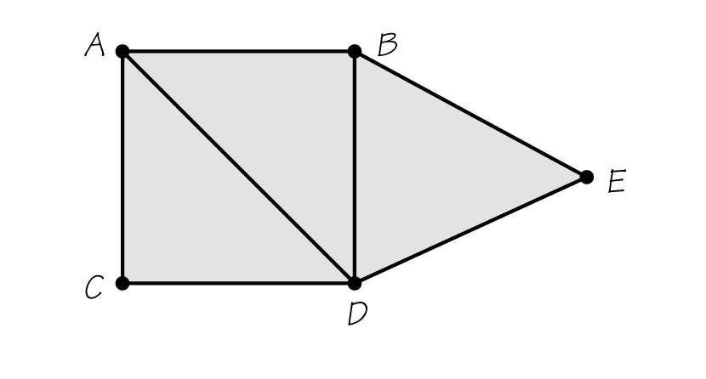
 Example D
Solve the Chinese postman problem for this graph—that is, find an Euler circuit of the graph that reuses the fewest edges.
Solution
Since the graph does not have an Euler circuit, the best possible result is a circuit that reuses only one edge. One solution would be to start at A, then follow the sequence ADBABEDCA. This circuit reuses only one edge, AB.
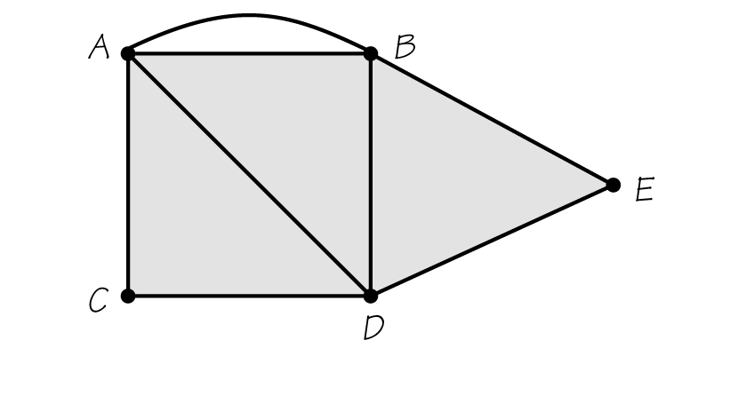

 Key idea
Reusing an edge that joins two vertices is like adding a new edge between those vertices. Adding new edges for a circuit to produce an Euler circuit of a graph is called eulerizing the original graph.
 Example E
Eulerize this graph.
Solution
This is the eulerization of the circuit offered in the answer to the previous question, with the edge AB reused once. This explains the added edge joining vertices A and B.

 Key idea
An Euler circuit on an eulerized graph can be “squeezed” into a circuit on the original graph by reusing precisely those edges that correspond to the edges added in the eulerization.

 Key idea
A systematic way to produce a good eulerization of a certain specialized “rectangular” graph is called the “edge walker” technique.
 Example F
Using the “edge walker” technique, eulerize this 2-by-3 rectangular graph.
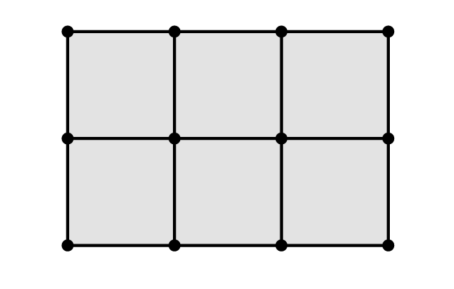
Solution
Starting with the upper left-hand corner of the graph and traveling clockwise around the boundary of the rectangle, connect each odd vertex you encounter to the next vertex using a new edge.
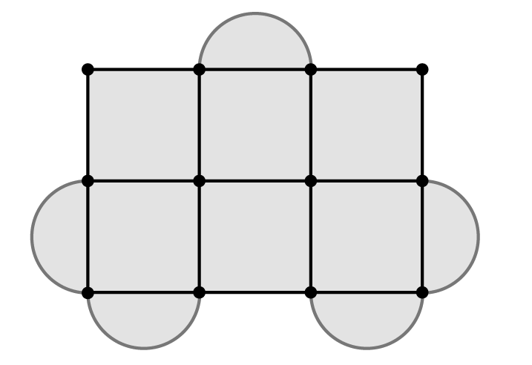
 Question 3
Use the “edge walker” technique to eulerize this 2-by-4 rectangular graph. How many edges are added?
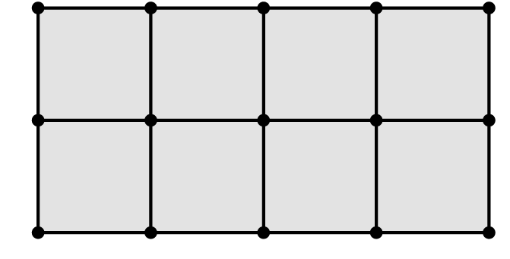
Answer
6

Section 1.4 Urban Graph Traversal Problems

 Key idea
Applying the techniques described in this chapter to specific real tasks such as collecting garbage and reading electric meters results in complications that require modification of theories. Types of complications include one-way streets, multi-lane roads, obstructions, and a wide variety of human factors. When edges of a graph indicate a direction that must be traveled, we have a directed graph or digraph.
 Example G
Suppose Amina needs to spread a written message among friends. The paper can only be given to one person at a time. Because of a restriction in the flow of communications, her 6 friends can pass messages as follows.
Friend | Can deliver to
Heidi | Nadia, Amina
Nadia | Heidi, Adam
Ali | Faiz, Bara
Faiz | Bara, Ali
Amina | Heidi, Faiz
Bara | Faiz, Ali
Adam | Heidi, Nadia
a) Is there a circuit (starting with Amina) that will have the message delivered to everybody?
b) Assuming the message has reached everybody, is it possible that Faiz knew the message before Nadia?
c) Is there a path that will have the message delivered to everybody? If so, will any of her friends definitely read the message more than once?
Continued on next page

Solution
Make a digraph such as the following.
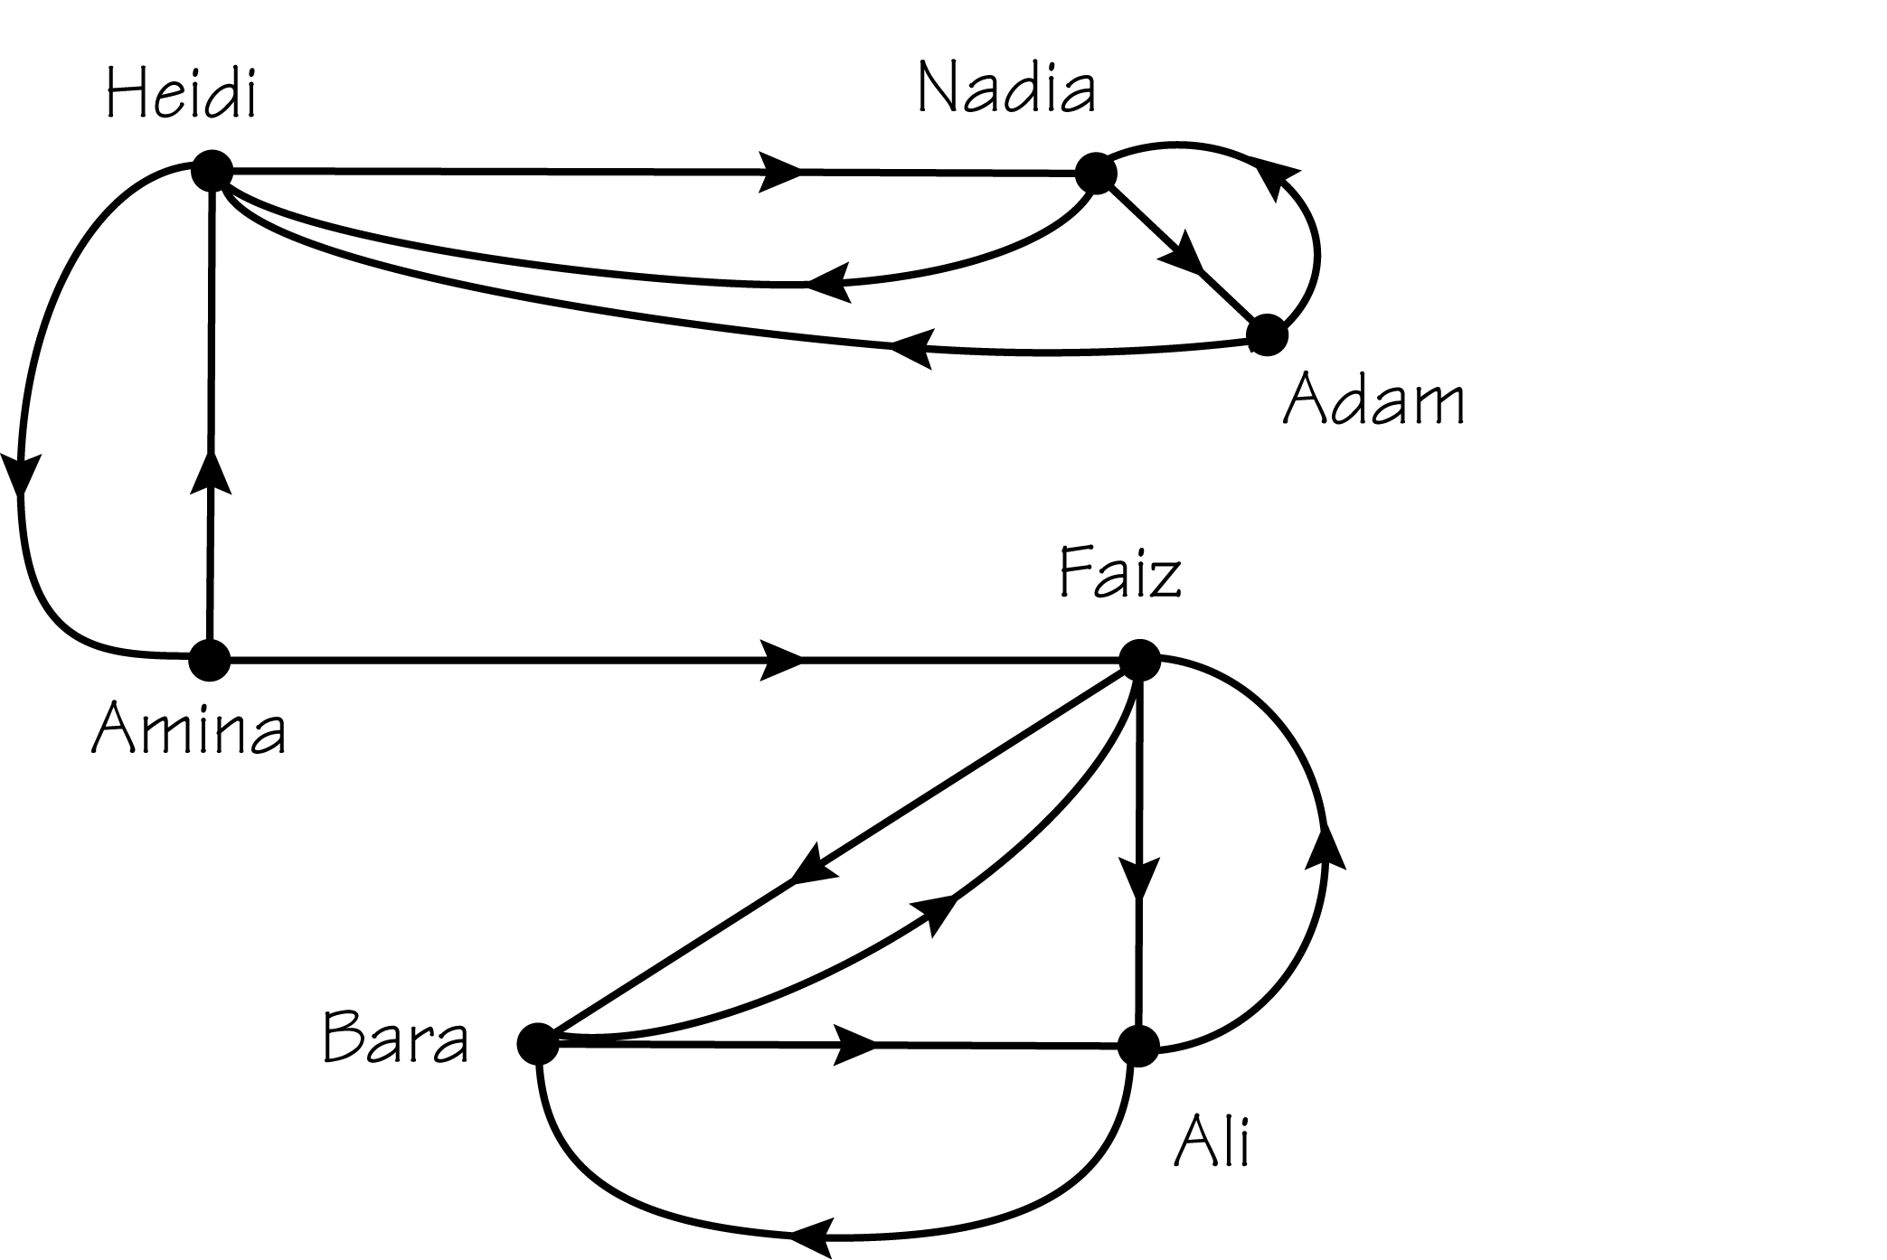
a) It is not possible to have a circuit that covers all the friends and returns back to Amina. Once the message passes from Amina to Faiz, there is no way to get the message back to Amina.
b) It is not possible since Amina can first deliver the message to Heidi or to Faiz. If she had gone to Faiz, then the message could not have reached Nadia.
c) Yes. There are many several possible answers such as the following.
Amina, Heidi, Nadia, Adam, Heidi, Amina, Faiz, Bara, Ali
In order for the message to get back to Amina to get passed onto Faiz, Heidi must hear the message twice.
 Question 4
Suppose Amina needs to spread a message among friends. Because of a restriction in the flow of communications, her 7 friends can only talk as follows.
Friend | Can Talk to
Amina | Heidi, Faiz
Nadia | Adam
Ali | Faiz, Bara
Adnan | Amina
Faiz | Bara, Ali, Adnan
Adam | Heidi, Nadia
Bara | Ali
Heidi | Nadia
If Amina initiates the message and a continuous path is created, what is the minimum number of times the message is passed on in order to reach all of her friends? (The person that Amina originally delivers the message to counts as the first, and the last person receiving it counts.)
Answer
9 times
Homework Help
Exercises 1 – 3
Carefully read the definitions in Sections 1.1 – 1.2 before responding to these exercises.
Exercises 4 – 6
Carefully read the examples in Section 1.1 before responding to these exercises.
Exercise 7
Understand the definitions of edges and vertices (Section 1.1) before answering the parts of this exercise that refer to figures in Section 1.2.
Exercise 8
Understand the definition of valances (Section 1.2) before answering the parts of this exercise that refer to figures in Section 1.2.
Exercises 9 – 10
Understand the definition of a connected graph and Figure 1.7 (a nonconnected graph) in Section 1.2 before answering these exercises.
Exercises 11 – 12, 15
Understand the definitions of edges, vertices (Section 1.1), and valances (Section 1.2) before answering the parts of these exercises.
Exercises 13 – 14
Understand the meaning of a disconnected graph (Section 1.2), the definitions of edges, vertices (Section 1.1), and valances (Section 1.2) before answering the parts of these exercises.
Exercise 16, 20
Answers will vary.
Exercise 17
Follow each of the paths in parts (a) and (b). In part (a), think about the objective of the supervisor and in part (b), picture yourself as the worker on this path.
Exercises 18 – 19, 21 – 22
Read Section 1.3 and review Figure 1.14 parts (a) and (b) before answering these exercises. In Exercise 18, consider that an efficient route would come from a graph with an Euler circuit. Also, routes without 180-degree turns are better choices.
Exercise 23
Carefully read Section 1.1 before responding to this exercise.
Exercises 24 – 30
Carefully read Section 1.2 before responding to these exercises.
Exercises 25 – 54, 56 – 57
Carefully read Section 1.3 before responding to these exercises.
Exercise 55
Try either looking in the index of a chemistry text or searching the Internet for requested reference.

Do You Know the Terms?

Cut out the following 14 flashcards to test yourself on Review Vocabulary. You can also find these flashcards at http://www.whfreeman.com/fapp7e.

Chapter 1  Urban Services  Chinese postman problem | Chapter 1  Urban Services  Circuit
Chapter 1  Urban Services  Connected graph | Chapter 1  Urban Services  Digraph
Chapter 1  Urban Services  Edge | Chapter 1  Urban Services  Euler circuit
Chapter 1  Urban Services  Eulerizing | Chapter 1  Urban Services  Graph

A path that starts and ends at the same vertex. | The problem of finding a circuit on a graph that covers every edge of the graph at least once and that has the shortest possible length.
A graph in which each edge has an arrow indicating the direction of the edge. Such directed edges are appropriate when the relationship is “one-sided” rather than symmetric (for instance, one-way streets as opposed to regular streets). | A graph is connected if it is possible to reach any vertex from any specified starting vertex by traversing edges.
A circuit that traverses each edge of a graph exactly once. | A link joining two vertices in a graph.
A mathematical structure in which points (called vertices) are used to represent things of interest and in which links (called edges) are used to connect vertices, denoting that the connected vertices have a certain relationship. | Adding new edges to a graph so as to make a graph that possesses an Euler circuit.

Chapter 1  Urban Services  Management science | Chapter 1  Urban Services  Operations research
Chapter 1  Urban Services  Optimal solution | Chapter 1  Urban Services  Path
Chapter 1  Urban Services  Valence (of a vertex) | Chapter 1  Urban Services  Vertex

Another name for management science. | A discipline in which mathematical methods are applied to management problems in pursuit of optimal solutions that cannot readily be obtained by common sense.
A connected sequence of edges in a graph. | When a problem has various solutions that can be ranked in preference order (perhaps according to some numerical measure of “goodness”), the optimal solution is the best-ranking solution.
A point in a graph where one or more edges end. | The number of edges touching that vertex.

Practice Quiz
1. What is the valence of vertex B in the graph below?
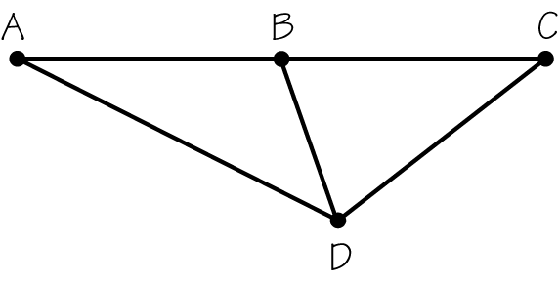
a. 2
b. 3
c. 4
2. A graph is connected only if
a. every vertex has an even valence.
b. for every pair of vertices there is a path in the graph connecting these vertices.
c. it has an Euler circuit.
3. For the graph below, which statement is correct?
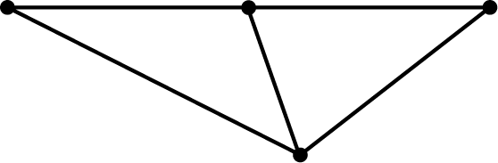
a. The graph has an Euler circuit.
b. One new edge is required to eulerize this graph.
c. Two new edges are required to eulerize this graph.
4. For which of the situations below is it most desirable to find an Euler circuit or an efficient eulerization of the graph?
a. checking all the fire hydrants in a small town
b. checking the pumps at the water treatment plant in a small town
c. checking all the water mains in a small town
5. Consider the path represented by the sequence of numbered edges on the graph below. Which statement is correct?
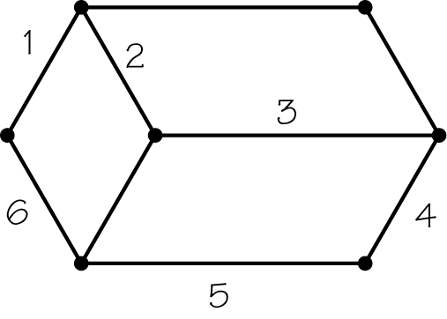
a. The sequence of numbered edges forms an Euler circuit.
b. The sequence of numbered edges traverses each edge exactly once, but is not an Euler circuit.
c. The sequence of numbered edges forms a circuit, but not an Euler circuit.
6. What is the minimum number of duplicated edges needed to create a good eulerization for the graph below?
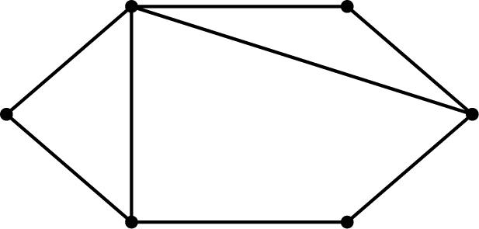
a. 4 edges
b. 3 edges
c. 2 edges
7. Suppose the edges of a graph represent streets along which a postal worker must walk to deliver mail. Why would a route planner wish to find an Euler circuit or an efficient eulerization of this graph?
a. to minimize the amount of excess walking the carrier needs to do
b. to determine where postal drop boxes should be placed
c. both a. and b.
8. If a graph has 10 vertices of odd valence, what is the absolute minimum number of edges that need to be added or duplicated to eulerize the graph?
a. 5
b. 10
c. 0
9. Which option best completes the following analogy: A circuit is to a path as
a. a vertex is to an edge.
b. a digraph is to a graph.
c. operations research is to management science.
10. Which of the following statements is true?
II. If a graph is connected and has only even valences, then it has an Euler circuit.
II. If a graph has an Euler circuit, then it must be connected and have only even valences.
a. Only I is true.
b. Only II is true.
c. Both I and II are true.

Word Search
Refer to page 22 of your text to obtain the Review Vocabulary. There are 14 hidden vocabulary words/expressions in the word search below. All vocabulary words/expressions are represented separately. Valence (of a vertex) appears as Valance. It should be noted that spaces are removed.


1. __________________________
2. __________________________
3. __________________________
4. __________________________
5. __________________________
6. __________________________
7. __________________________
8. __________________________
9. __________________________
10. __________________________
11. __________________________
12. __________________________
13. __________________________
14. __________________________

